Diversity in the Advertising and Marketing of Fashion Industries

Author: Strakeniants Vartui
Mentor: Batens Ellen

Business Management
Management & IT
Academic Year: 2020-2021
Class Group: BBM301A

Table of Contents
Table of Figures 3
Acknowledgements 4
Executive Summary 5
Introduction 6
1 Diversity 7
1.1 Defining Diversity 7
1.2 Diversity in Advertising and Marketing 8
1.2.1 Customer Perspective 9
1.2.2 Brand Perspective 11
2 History of advertising and marketing 12
3 Examples of brands 14
3.1 Positive Example: Fenty 14
3.2 Improving Example: Dolce and Gabbana 16
3.3 Negative Example: Victoria’s Secret 18
4 Changes in Revenue 21
4.1 Increase/Decrease in Sales 21
4.1.1 Fenty 21
4.1.1.1 Savage x Fenty 23
4.1.2 Dolce and Gabbana 24
4.1.2.1 China Case 24
4.1.3 Victoria’s Secret 25
4.2 Effects of Diverse Workforces 26
5 Effects on Brand Perception 28
5.1 Defining Brand Perception 28
5.1.1 Fenty 29
5.1.2 Dolce and Gabbana 30
5.1.3 Victoria´s Secret 31
5.2 Effects of Diverse Workforces 33
Conclusion 34
Cited Works 35

Table of Figures
Figure 1: Consumer response to lack of diversity in ads (Marketing Charts, 2019). 9
Figure 2: 1 in 8 U.K. adults have suicidal thoughts due to body image (Armstrong, 2019). 10
Figure 3: The power of black dollars (Nielsen, 2018). 11
Figure 4: How showing diversity in ads impacts consumers‘ purchase decisions (Marketing Charts, 2020). 13
Figure 5: Growth of size-inclusive lingerie (Marci, 2019). 15
Figure 6: Dolce and Gabbana´s ad awareness & buzz score China incident (Lim, 2018). 17
Figure 7: Victoria´s Secret fashion show viewers throughout the years (Sangeeta, 2019). 19
Figure 8: Victoria’s Secret waist-to-hip ratio throughout 1995-2018 (Boston University, 2020). 20
Figure 9: Range of shades of foundation (Christiansen, 2021). 21
Figure 10: Price structure of Savage x Fenty lingerie (Marci, 2019). 23
Figure 11: Victoria´s Secret´s net sales in million U.S. dollars from 2010 to 2020 (Sabanoglu, 2021) 25
Figure 12: McKinsey´s likelihood of financial outperformance (Dixon-Fyle, Dolan, Hunt, Prince, 2020). 27
Figure 13: The impact of positive brand perception (Brand Master Academy, 2021). 28
Figure 14: Fenty’s Instagram account engagement (Hudson, 2017) 29
Figure 15: D&G´s brand health score (YouGov, 2018). 30
Figure 16: Victoria’s Secret buzz score among U.S. women (YouGov, 2020). 31
Figure 17: Purchases among different age groups (YouGov, 2020). 32
Figure 18: Distribution of all employees by race and ethnicity and career level (Steve, 2020). 33

Acknowledgements
Throughout the writing of this thesis, I have received a great amount of support and assistance. Firstly, I would like to express my gratitude to my academic mentor, professor Ellen Batens, whose help has been really wonderful and whose insightful feedback has pushed me to bring my work to a higher level. In addition, I would like to thank all my relatives, boyfriend, friends, and others who have supported me and helped me survive all the stress this year has brought and for not letting me give up.

Executive Summary
Thus far, fashion brands have already made great efforts when it came to the diversity of their advertisement and marketing campaigns, yet we still have a long way to go. In the last couple of years fashion has been dominated by models who were either white or extremely skinny, or both. Individuals who defied social norms were overlooked and rejected by brands. Only one body type was popular, there was little to no diversity at all in ads. Consequently, many people found it difficult to relate to the industry given that there was no representation. Fortunately, the fashion industry has evolved tremendously in recent years, and we have luckily seen a celebration of various people and sizes.

In the first chapter of this thesis, the word ´diversity´ is defined along with the importance of it for both brand and customer. Throughout the second chapter, the major changes and the key players in these changes are presented. The third chapter shows which brands that the research focus lies on, i.e., Fenty, Dolce and Gabbana, and Victoria’s Secret. The next chapter concentrates on the changes in revenues of the three brands and the fifth chapter is about the effects of the perception of each given brand.

The aim of this research was to find out if companies with diversity in their ads and marketing campaigns see a positive change in their sales and brand perception.
Brands are becoming more aware that their focus on consumers of all colours, shapes, and sizes is important and that the use of diversity in advertisements can bring advantages to both company and consumer. The outcome is that diversity indeed has a positive impact on both revenue and perception based on the given data and examples.
The most important point is that when customers feel represented, they will be more eager to purchase a product as well as create a strong positive image of the brand.

For this outcome, already performed research and databanks were consulted. Additionally, there was an examination of companies who had not included diversity before but do so now and what impact this has had on their revenue and brand perception. Based on the findings in this research, implementing diversity in advertisements and marketing campaigns is highly recommended.

Introduction
It is no secret that advertising and marketing have a huge impact on a consumer, and so immediately on our society as well. Nowadays, diversity in fashion advertisements is trending upward, but there still have a long way to go as it is not a norm yet. Many advertisements in the fashion industry still showcase hat is seen as ´perfection´.
It is said that one should embrace their ´imperfections´, yet they are rarely represented in ads on TV or elsewhere. What is generally shown are photoshopped images or thin models. Historically, fashion has been centered around skeletal models. The industry has not shown much representation of body shapes, disability, or gender and racial diversity (Mindless Mag, 2020).

Many companies have gotten a lot of backlash for the lack of diversity in their way of marketing. However, that is not the case for every fashion company out there. Of course, there are also companies that do include diversity in their advertising and marketing approaches which is already a step in the right way. Consumers will feel more represented when seeing diverse ads, as a consequence, they will purchase more fashion products, which obviously serves as an advantage to the brand.

Advertisement is seen as a demonstration of beauty, uniqueness and what should be celebrated, therefore it is extremely important. If it is to truly appeal to and represent society, it must be diverse (Hamar, 2020). The types of diversity discussed in this research are racial diversity, gender diversity, disability, and body shapes. The main question that will be answered is: Will the representation of diversity in fashion advertisements and marketing campaigns result in gains in revenue and brand perception?

Diversity
To be able to talk about the necessity of diversity for brands and its customers, the word will firstly be given a definition. Afterwards, the importance of diversity in advertisements and marketing campaigns will be discussed. Lastly, perspectives from customer and brand will be given.

Defining Diversity
Thus far, most brands have chosen to ignore customers’ demand for diversity and have gotten away with it without repercussions. Today, diversity and inclusion are two very important things a customer looks for in a brand. Although the last couple of years have seen an increase in the recognition of racial inequality, diversity is not confined to race only. Diversity finds the inclusion of all social backgrounds, sizes, ages, races, genders, religions, sexual orientations, etc. mandatory (Walker, 2020).

The term ´diversity´ refers to a mix of something, it emphasizes the differences within a set of people. Different people with their life experiences and backgrounds, both ethnic and personal help shape a company (Cambridge University Press, 1995).

The different types of diversity described in this research are racial diversity, gender diversity, disability, and body shapes. Firstly, by racial diversity we mean the representation of different racial groups. According to Carleton S. Coon’s racial classification in 1962, there are four major races the world population has, i.e., white/Caucasian, Mongoloid/Asian, Negroid/black, and Australoid (Stevens, 1972).
Secondly, gender diversity is about the acknowledgement and respect of the fact that there are various ways to identify outside of the binary of male and female (A Gender Agenda, 2021). Thirdly, disability is described a physical or mental impairment that limits certain life activities (Disabled World, 2021). There are around one billion people, or 15 per cent of the global population who suffer from some sort of disability (The World Bank, 2021). Lastly, there is diversity in body shapes. This can be described as clothing sizes for persons with larger sizes than average. Plus-sized models often have sizes in the range of eight to twelve, in European sizes this is size 38 to 42. Some brands consider size six as plus sized as well; this is the European size 34 (Zagarella, 2020).

Diversity in Advertising and Marketing
In the fashion industry, advertisements and marketing campaigns can show how diverse a brand actually is. Diversity can be measured by the people that are chosen to be in these advertisements (Hamar, 2020). Companies must make sure to avoid showcasing solely one type of customer in the advertisements and marketing campaigns and all target markets should be represented. Additionally, they should avoid inconsiderate ads (Walker, 2020). Fortunately, there already are scads of brands who are implementing diversity such as Nike, Dove, Aerie, ThirdLove, etc.

Although diversity in advertising and marketing is really important, some brands simply cannot afford it. This is because an enormous amount of time and money is required to connect with the brand’s customers. In this case, community-generated content can serve as a solution as it is cheap and efficient (Walker, 2020). Community-generated content is a form of any user-generated content (UGC) , meaning that any content is created by the customer instead of the brand itself. The UGC is mostly shared on the brand’s marketing channels such as their website, social media channels, etc. The most known platform where UGC is shared on is Instagram, where people create posts that feature the brand, which will bring their goods and services to the attention of their followers (Walker, 2020).

Diversity and inclusion contribute to a more aligned culture within a company. Furthermore, it helps businesses reach out to new demographics, which boosts the company´s bottom line. To be able to embrace diversity, companies must redefine diversity and inclusion within the company as necessary components of innovation. Diverse minds tend to have diverse ideas, which has a direct impact on marketing campaigns and advertisements. Without a diverse marketing team, creating and executing a marketing plan to target diverse audiences will be a lot more challenging (Maryville University, 2021).

Representation truly matters, especially if we want to live in a safer and welcoming society. Nightclub shootings and the increase in the number of hate crimes against the LGBTQ+ community, people of color, etc. highlight the importance of representation and normalization of minority groups. These communities feel more comfortable and respected when they see people like them on TV or in magazines (Davis, 2019).

Customer Perspective
Diversity attracts customers. According to Marketing Charts, 62 per cent of U.S. consumers are of the opinion that a brand’s diversity influences how they view its products. This could be concluded from a survey of 1 012 U.S. consumers. We see that four out of ten customers are more likely to trust brands with diverse advertisements. Furthermore, 34 per cent will cease to use a brand if its advertising does not represent their identity (Miller, 2021). On figure one below, we see different groups of communities showcased along with their response to the lack of diversity in advertisements. The vast majority of the LGBTQ+ (58 per cent) community say they have stopped consuming from a brand because they did not feel represented. For Middle Eastern people, this percentage amounted to 38 per cent. In addition, a significant percentage of African-American (53 per cent) and Hispanic (40 per cent) consumers have stopped buying from a brand due to lack of representation as well. Although a recent study from PQ Media and The Association of National Advertisers (ANA) showed that Hispanics and African-Americans make up a significant portion of the U.S. population, the amount of advertising money spent on them seems to be very low (Marketing Charts, 2019), which will be shown in the second figure later on.
Figure 1: Consumer response to lack of diversity in ads (Marketing Charts, 2019).
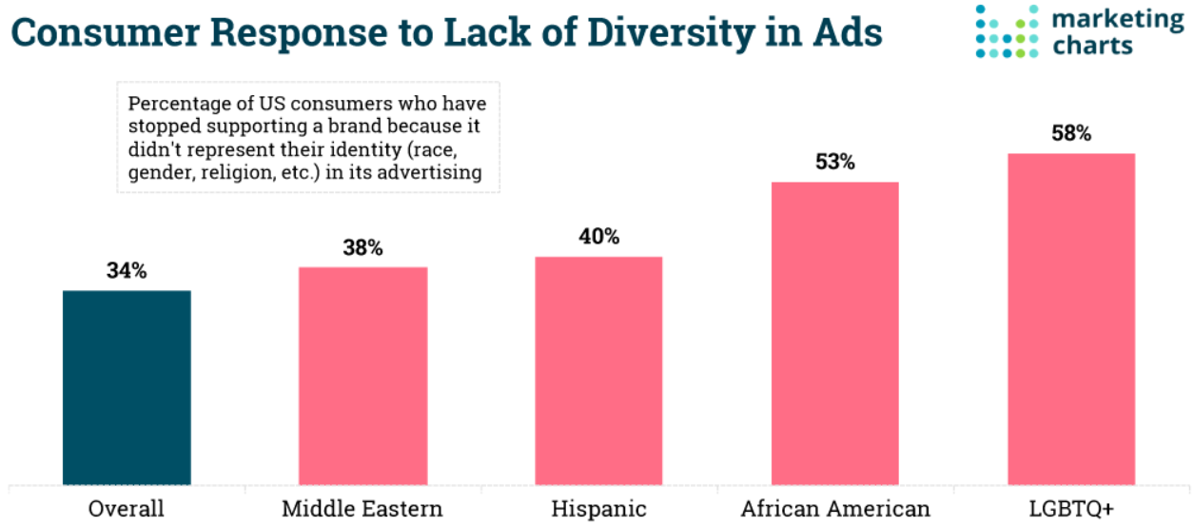
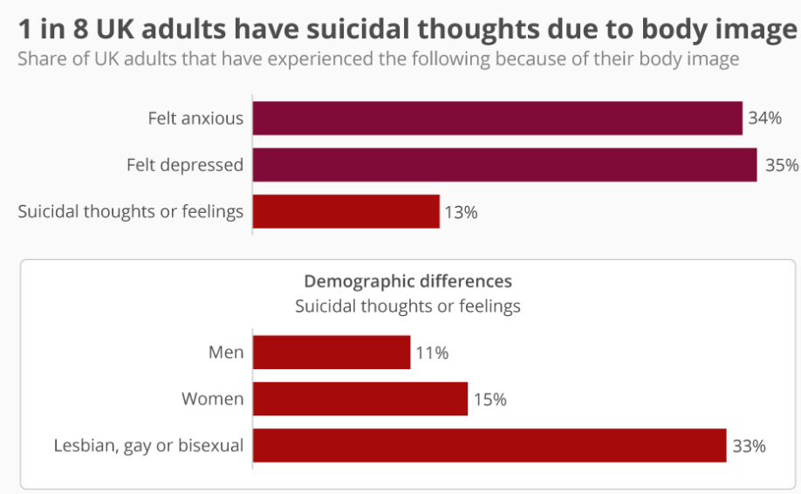
The lack of diversity in advertisements causes a lot of stress to consumers as they feel pressured to have a certain body type. According to The Guardian, myriad people have had suicidal thoughts or feelings as a result of body image issues. The Mental Health Foundation conducted a poll which found that one in every eight persons of the U.K. aged 18 and up has been so depressed about their body type that they have even considered committing suicide. Advertisements on e.g., Twitter and Instagram as well as other social media platforms play the biggest part in this as the focus mainly lies on typical external appearances. Unfortunately, not every body type is celebrated on social media, and one has to look a certain way to be able to ´fit in´. As a result, 15 per cent of the surveyed women, compared to 11 per cent of the men, shared they had harmed themselves because of their body image (Siddique, 2019). This can be seen on the figure below, figure 2.

Figure 2: 1 in 8 U.K. adults have suicidal thoughts due to body image (Armstrong, 2019).
According to Common Sense Media, an average child spends roughly nine hours on social media per day. A teenager is flooded with hundreds of messages about the ´ideal´ body. The unrealistic depictions of beauty can wreck a teenager’s body image. As a consequence, some teenagers develop eating disorders, while others suffer from depression. Some even consider committing suicide due to dissatisfaction with their bodies (Morin, 2020).

Brand Perspective
Brands should not forget that minority groups not only have a huge purchasing power but also a huge impact on mainstream media. For example, the LGBTQ+ community’s purchasing power amounted to 3.7 trillion dollars in 2019. Additionally, African Americans are expected to spend 1.8 trillion dollars on products by 2024. According to a survey by Nielsen, African American millennials are 25 per cent more likely than others to indicate they are the first of their friends/family to test new products, which confirms that minorities play an important role in establishing trends and eventually influencing purchasing decisions. They also spend up to nine times more on beauty products than white women. Ovation, a luxury haircare brand decided to test this niche market by accepting partnerships with racially diverse beauty gurus. The result exceeded their expectations, with over 18 000 visits to their website. The social manager shared that these women were their best-performing influencers ever (Walker, 2020).

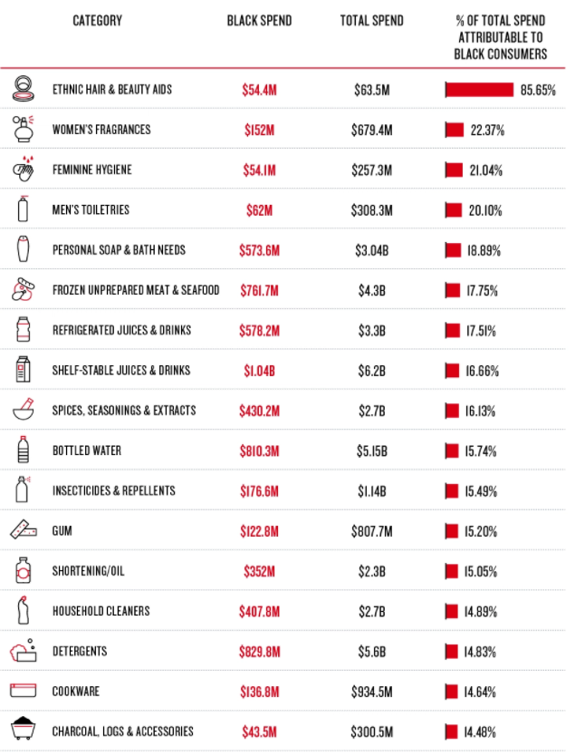
Figures suggest that multinational firms’ R&D investments in developing products that appeal to a diverse range of consumers pay off nicely. On the figure below, figure 3, we see that black consumers spend a lot of money on hair and beauty products, fragrances, etc. Furthermore, black consumers’ brand preferences are quickly becoming mainstream, demonstrating that interacting with black consumers can offer significant market benefits (Nielsen, 2018).
Figure 3: The power of black dollars (Nielsen, 2018).

History of advertising and marketing
Fashion has traditionally focused on thin models. As mentioned before, different body types, disabilities, gender and/or ethnic diversity have not been well represented in the fashion industry. The 2010s were marked as a turning point, this decade will be remembered as a period of rapid change with a series of breakthroughs that questioned the status quo and gave rise to minority groups. Fashion has since been largely reactionary; it has been impacted by social movements such as #MeToo, Gen Z’s activism, and the fourth wave of feminism (Okwodu, 2019).

Most brands started their road to diversity and inclusion around 10 years ago by casting diverse models for their advertisements. An example of this is Estée Lauder, who casted a Chinese runway model, Liu Wen. The model became the first Asian face of the brand in 2010, which consequently paved the way for a more diverse space (Okwodu, 2019). In 2015, H&M launched a campaign which promoted inclusivity. The advertisement included 23-year-old Mariah Idrissi, a Pakistani and Moroccan hijab model. This was the first time ever that a hijab had been featured in an advertisement (Thurmond, 2015). This move was very bold yet refreshing and encouraged other fashion brands to include hijab models in ads. From then on, retailers were increasingly casting minority models to appeal to new markets (Morrison, 2015).

When it comes to plus-size modelling, one woman in particular can claim to being the first plus-sized supermodel and that is Emme. She broke the size barrier in the 1980s when companies were refusing to work with models above a size six. In 1998, she landed a contract with Revlon, a major beauty company at the time. She paved the way for other plus-size models such as Ashley Graham, Paloma Elsesser, Georgia Pratt, etc who went on and made history themselves (Lubitz, 2017). In 2019, Thando Hapo became the first model with albinism to appear on a Vogue cover (Hargrove, 2019).

In 2020, Ellie Goldstein, an eighteen-year-old British model with Down’s syndrome, was casted in one of Gucci’s mascara ad campaigns. Her picture became Gucci’s most-liked picture on Instagram at that time with over 860 000 likes. She was quickly described as the pioneer for models with Down’s Syndrome (Cadogan, 2020).

We have also seen growth in the use LGBTQ+ models in advertisements by several brands. One of them being Playboy, who casted Caroline Cossey. The model made history being the first transgender to pose for a Playboy magazine in 1981 (McConnell, 2020). Another brand who set a good example was Tiffany & Co. by sharing an ad featuring a gay couple (Holley, 2015).

In 2019, one of Sephora’s employees in California called security to monitor a black R&B star, SZA. This news upset customers, which left the brands reputation scattered. Consequently, Sephora released a campaign ´Identify as We´, which featured diverse models, transgenders, non-binary models, models of racial backgrounds and disabled models. In order to prepare for the launch of this campaign, the brand closed all of its stores across the country for a diversity and inclusion training. Sephora offered free 90-minute classes to its employees at their retail locations, distribution centres and corporate offices (Bromwich, 2019).

Nowadays, many brands create gender neutral or genderfluid clothing. Such brands include H&M, Nike, and ASOS as they have launched lines with neutrality. According to Horowitz Research, there is a positive impact on multicultural consumers’ purchase decisions when seeing diversity in the advertisements of these types of brands. For example, representing Hispanic, Asian, and black people in ads has much more positive than negative impact on purchase decisions (Marketing Charts, 2020).
This can be seen on figure 4 below.

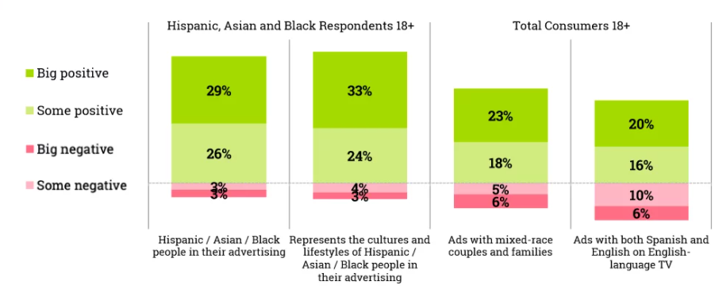
Figure 4: How showing diversity in ads impacts consumers ‘ purchase decisions (Marketing Charts, 2020).

Examples of brands

Positive Example: Fenty
Fenty is a luxury fashion house which was created by Robyn Rihanna Fenty under the luxury fashion group LVMH, Moët Hennessy Louis Vuitton, which is the largest multinational corporation and conglomerate specializing in luxury goods. Fenty is hereby placed next to LVMH’s other fashion houses, such as Christian Dior, Fendi, Givenchy, and Louis Vuitton. By virtue of this partnership, Rihanna became the first woman of colour to take helm of one the LVMH´s houses (El-Bawab, 2019).

The star decided to call her beauty and fashion brands after her paternal name, Fenty. She revealed that when it came to her non-musical projects, she would use her last name rather than her stage name. This was a conscious choice, as she did not want to turn her brand into just another celebrity-backed brand. Unlike other celebrities such as, e.g., Kim Kardashian and Gwyneth Paltrow, Rihanna does not wish to rely solely on her star power for her brand to sell and boost growth. Contrarily to other celebrities, Rihanna focuses on creating products that put the customer first and represent diversity (Harker, 2020).

Fenty Beauty, which is a cosmetics brand launched by Rihanna as well, was created with a promise of inclusion for all types of women (Fenty Beauty, 2017). The brand’s tagline ´Beauty for all´ represents products for a diverse customer base. In 2017, Fenty Beauty launched an advertisement with 40 different shades of foundation, which have now expanded to 50 shades. Consequently, it was able to offer more choices in darker and lighter shades of foundation than most of the major companies (Christiansen, 2021).

Short after Fenty Beauty launched the 40 shades of foundation, no fewer than four other makeup brands announced they would also release new foundation ranges featuring 40 shades. This is because they have been trying to emulate Fenty Beauty and more notably, match its consumers, whose skin comes in more than 10 to 20 shades, which has long been the standard offering. This is the so-called ´Fenty Effect´ (Wischhover, 2018). The term caused a chain reaction of beauty brands, as well as other industries, to challenge the status quo and be more inclusive. It was some sort of wake-up call to others (Saputo, 2019).

Next to Fenty Beauty, there is also Savage x Fenty, which is a partnership between Fenty and TechStyle Fashion Group. It mainly focuses on lingerie, sleepwear, and accessories for both men and women. The brand complements various shades and shapes and is said to celebrate fearlessness, confidence, and inclusivity (TechStyle Fashion Group, 2018).

To promote this brand, Rihanna hosted two fashion shows to showcase her brand, one in 2018 and the second one in 2020. She uses snippets of these shows to advertise her products via different channels. A diverse team of influencers is also employed to create advertising content (Wright, 2020).

Her fashion shows include a diverse cast of models, apart from top models, there are plus sized models, disabled models, male models, and even members of the LGBTQ+ community such as drag queens. Additionally, as part of Breast Cancer Awareness month and in support of the Clara Lionel Foundation, the show featured breast cancer survivors.

It is safe to say that Fenty is one of the top brands in the fashion industry that celebrates diversity in its advertising and marketing campaigns. The brand was also named one of the 10 most innovative style companies by Fast Company in March 2020. After the first Savage x Fenty fashion show, the number of size-inclusive lingerie increased with 34 per cent by U.S. and U.K. retailers (Van Elven, 2019). On the figure below, figure 5, we see that there was an increase in the number of sizes right after September 2018, which occurred simultaneously with the Savage x Fenty’s show (Marci, 2019).
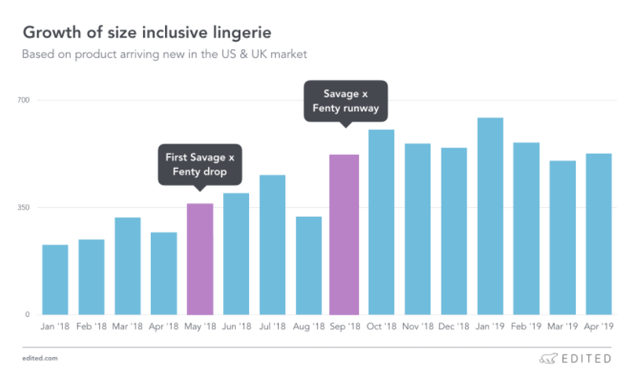
Figure 5: Growth of size-inclusive lingerie (Marci, 2019).

Improving Example: Dolce and Gabbana
Dolce and Gabbana (D&G) is a luxury fashion house established by a Sicilian duo, Domenico Dolce and Stefano Gabbana (Cristoferi, 2019). Throughout the years, Dolce and Gabbana has had a very superficial treatment of diversity. When looking at the brands’ advertisements, we can say that they do include diversity. However, they have previously been accused of insults regarding cultural matters in their ads (Friedman & Wee, 2018).

Their most recent scandal was after the launch of a social media advertisement for its Chinese consumers. The ad featured a Chinese model attempting to eat Italian food with chopsticks. Chinese consumers, who deemed the ad as racist, criticized the campaign. This had a lot of repercussions for the brand given that the ad played up to stereotypes. The Chinese government ordered the brand to cancel their planned fashion show in Shanghai, which was to be held the day after the campaign was launched (Long, 2018).

D&G had the right intentions with trying to use diversity to promote its products, but the ad turned out to be an epic failure. This incident was a clear example of using diversity the wrong way and showed what damages can be done to a brand on account of a marketing campaign that is carried out poorly (Rincon, 2019).

After this particular ad was published, the number of people viewing Dolce and Gabbana ads rocketed. Consequently, the brand saw an increase in its ad awareness score. The score went from +1.1 to +12.1. This means that a lot more people were viewing the ad than the brand was used to. However, contrary to their expectations, this increase was actually based on negative attitudes (Lim, 2018).

Next to the ad awareness score, there was also a change in the brand’s buzz score. This score dropped from +6.5 to -15.0, which is shown in figure 6 below. This score is measured by subtracting the percentage of people who have heard something negative through word-of-mouth, ads, etc. about a certain brand in the past two weeks form the percentage of people who have heard something positive. (Marketing Charts, 2016).
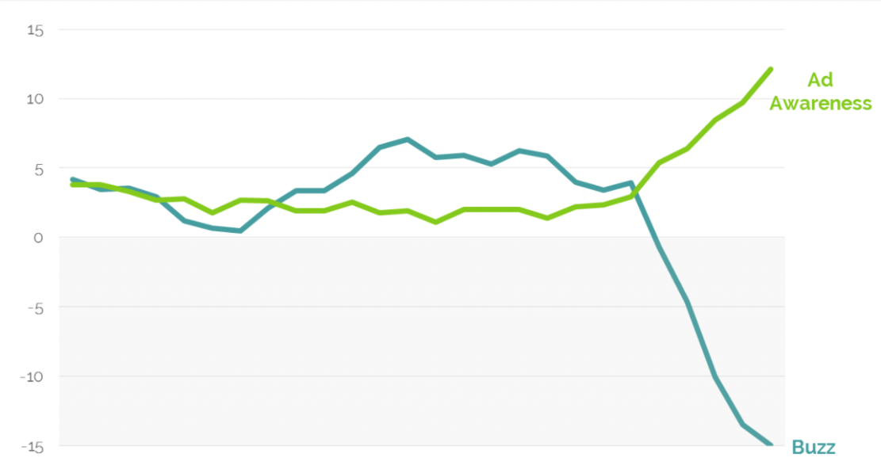
Figure 6: Dolce and Gabbana´s ad awareness & buzz score China incident (Lim, 2018).

Additionally, the brand’s recommended score also plummeted, it fell from +6.0 to -15.3. This implied that consumers were less likely to suggest this brand to others (Lim, 2018).

Overall, apart from some miscalculated steps, the brand is set to emerge stronger from the scandals. In 2019, Dolce and Gabbana launched an ad with plus-sized models, announcing that their collections would be offering bigger sizes, namely up to EU 50 or US 20. Until then, the biggest available size was EU 44 or US 12 (Harper’s Bazaar Singapore, 2019). In December 2020, the brand also shared a beauty ad on their Instagram feed. The ad showcased a diverse cast of homosexual male models wearing makeup. Additionally, they have had appearances of black models in their ads as well. This shows that the brand is ready to enhance diversity and no longer wishes to take part in tokenism.

Negative Example: Victoria’s Secret
Victoria’s Secret is an American retailer in lingerie, clothing, and beauty. The brand’s founder desired to create a store to make men feel more comfortable when shopping for women’s lingerie, which basically means that the brand was created for the pleasure of men and not for women’s empowerment (Segran, 2019).

The company is most known for its annual runway, which features only supermodels (Hanbury, 2020). These shows put an immense pressure upon women to look a particular way and live up to certain beauty expectations because there is no diversity whatsoever. As a consequence, the brand has gotten a great deal of backlash ascribed to the lack of diverse models as they are struggling to remain relevant with the emergence of the body-positivity movement.

According to YouGov, 70 per cent of Victoria’s Secret’s prime demographic, which is consumers between 18 and 24 years old, prefer seeing a real representation of people in ads. Consumers want to feel represented through ads and Victoria’s Secret is failing to do so (George-Parkin, 2018).

The 2018 Victoria’s Secret Fashion Show was actually the most recent one. The casted models amounted to 66, including: 16 black ones, 8 Chinese models and 1 Filipino model. The brand tried to make its show diverse by casting models from different races and ethnicities, but there is still a long way to go. As a consequence, the show was only viewed by 3.3 million people, which was an all-time low. This can be seen in the third figure below (Matera, 2018).

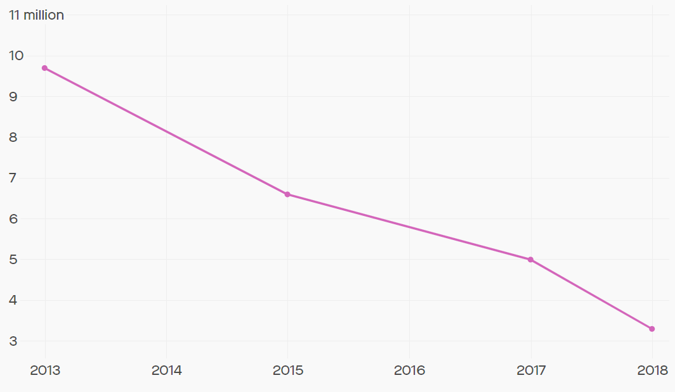
As mentioned before, on figure 7 we see that the show’s viewers fell from what once used to be almost 10 million viewers to 3.3 million viewers in 2018.
Figure 7: Victoria´s Secret fashion show viewers throughout the years (Sangeeta, 2019).

During an interview with Vogue, Ed Razek, who is the former CMO of Victoria’s Secret, shared that the fashion shows are a fantasy and therefore should not include any plus-sized models or transgenders (BBC, 2018) (Phelps, 2018).

In 2019, they announced that the show would be cancelled for that year because they had to figure out the brand’s positioning due to the bad ratings in the previous year given the lack of diversity in the shows. Later on, a new CEO was appointed, namely John Mehas (Flanagan, 2020).

According to Boston University School of Medicine researchers, although the weight of the average American woman has seen an increase over the past 23 years, the brand’s models have become thinner. On figure 8 below, we see that throughout the years, the waist-to-hip ratio (WHR) of the recruited models for ads has overall remained the same and diversity has not been taken into account by the brand (Digravio, 2020).

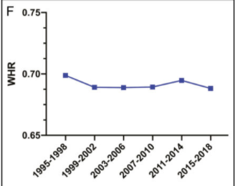
Figure 8: Victoria’s Secret waist-to-hip ratio throughout 1995-2018 (Boston University, 2020).

Surprisingly, the brand decided to turn things around and drastically change its habits. With its ´Body by Victoria´ spring 2020 campaign, the company entered a new era. The advertisement features a diverse cast of models: plus-sized, black, and transgenders (Flanagan, 2020). The brand has made great strides towards featuring more inclusive models in their advertisements.

Changes in Revenue

Increase/Decrease in Sales
Consumers are becoming more aware and are starting to take on a role of an activist. They wish to spend their money on companies where they see their own reflections.
Especially, millennials and the Gen Z generation are really precise in which company they put their money and attention into. Consumers want more socially aware brands and pay will make purchasing decisions based on the brand´s inclusivity of diversity (TechWish, 2021). Therefore, we will look into three brands and how their revenue was affected by their representation of diversity.

Fenty
Fenty creates a perfect opportunity for people to find their matched foundation by offering an extended range for both dark and light shades and slightly undercutting the high-end price point. An example of this is Estée Lauder, which has a range of 42 shades and is priced at $36,35, while Fenty’s foundation costs $35,99. For Estée Lauder, these diverse colours cause for higher prices and something extra, while at Fenty this diversity is a norm (Christiansen, 2021). The shades offered by both companies can be found in figure 9 below.
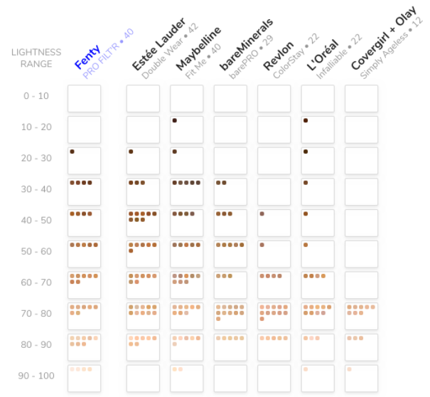

Figure 9: Range of shades of foundation (Christiansen, 2021).

On September 1, 2017, Rihanna posted a video advertisement on her Instagram page, containing a diverse cast of models (Min, 2017). Apart from white women, we also saw women of colour as well as hijab-wearing women, whom we do not see often in other advertisements. Therefore, Fenty Beauty was an immediate success, given they excelled at doing what many other brands have struggled with in the past: representing different types of people. Thanks to their diverse positioning, Fenty generated $100 million in its first 40 days (Christiansen, 2021).

Although surely some of Fenty’s success could be due to Rihanna’s and LVMH´s popularity and power, not every beauty brand with a celebrity face behind it has ever been as successful as Fenty. For instance, Flower Beauty, founded by Drew Barrymore in 2013, only has about 15 shades of foundation in its range and is even priced much cheaper than Fenty, namely around $14. However, people are not as eager to consume these products as their shade of skin tone is not represented by this brand. Barrymore’s advertisements for her brand mainly consist of pictures of herself, we rarely see any other people in her advertisements, while Rihanna opts for diversity when advertising. Whereas Flower Beauty is generating approximately $50 million of revenue per year after almost a decade, Fenty has earned double that revenue in essentially 40 days (Christiansen, 2021).

With an entirely omnichannel marketing strategy, Fenty Beauty went live in 17 countries at once. After this launch, the company revealed they had gotten tremendous consumer and market reactions. They would receive images of queues at retailers and hundreds of people began sharing selfies with the products. The first social media repost of the brand was of a hijab-wearing woman. After that, everything kept going uphill, direct sales had surpassed all of their estimations, leading to a crash of their website because of the purchases (Saputo, 2019).

Savage x Fenty
The lingerie brand is estimated to have an annual revenue of $150 million. Its sales have seen a steady growth.

On average, Savage x Fenty is considered to be more expensive than its competitors. For instance, if we look at figure 10 we see that the average price of a bra is around approximately $43 at Fenty, while at Victoria’s Secret, it is remarkably cheaper, namely around $30 (Marci, 2019).

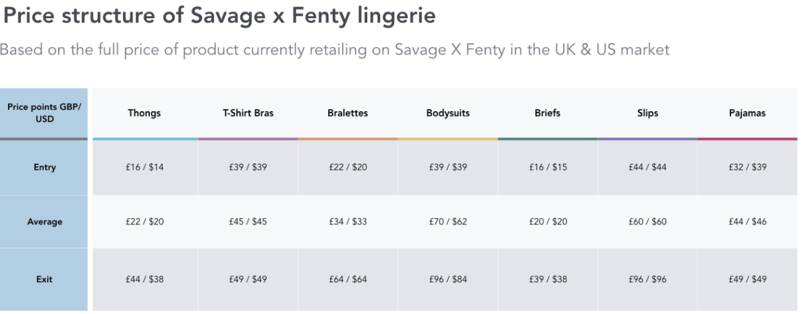
Figure 10: Price structure of Savage x Fenty lingerie (Marci, 2019).

Nevertheless, Fenty’s sales continue to increase whereas those of Victoria’s Secret are declining. This is a result of the brand’s lack of diversity in its advertising and runway shows. What once used to be the U.S. lingerie market leader, is now losing market share to more inclusive brands, such as Fenty (Hanbury, 2018).

Dolce and Gabbana
In 2019, Dolce and Gabbana’s revenue amounted to $1.54 billion, showing a growth of 4.9 per cent compared to the previous year. Regardless of the loss of sales in the Asia-Pacific market due to the Chinese ad mentioned above, the brand still managed to increase its sales in other regions. In America, sales increased from 13 per cent to 16 per cent, other markets were relatively stable, Europe accounted for 23 per cent, Italy for 23 per cent and Japan for 5 per cent (Cristoferi, 2019).

This increase is linked to the company’s launch of its new sizes for plus-sized people. According to the Centers for Disease Control and Prevention (CDC), 42 per cent of U.S. adults were obese in 2019. Meaning that there was a demand for clothes fitting different shapes (Seetharaman, 2020). Many women could not purchase fashion pieces given the unavailability of sizes, therefore, Dolce and Gabbana’s launch for plus-sized consumers serves as an advantage to client and brand.

China Case
In the previous chapter, the China Case was already explained briefly. Here, the financial repercussions will be given.

In the aftermath of the brand’s racist campaign, Chinese e-commerce firms Alibaba, JD, Yoox, etc. had removed Dolce and Gabbana products from their websites leading to a decrease in Dolce and Gabbana’s sales (Long, 2018).

At the time the incident happened, Chinese consumers were responsible for 32 per cent of luxury goods sales around the world, according to the Boston Consulting Group.
By 2024, this number is expected to grow to 40 per cent. If the number reaches that point by then, 75 per cent of the global market’s growth will be driven by the Chinese (Friedman & Wee, 2018). Therefore, it is of importance to Dolce and Gabbana to rectify their actions by 2024, otherwise they could see a serious decline in sales on the Chinese market. That being said, the brand already saw a decrease in sales in 2019 in the Asia-Pacific market as it shrank to 22 per cent from 25 per cent of the total turnover (Cristoferi, 2019).

Victoria’s Secret
In recent years, Victoria’s Secret’s revenues saw a decrease due to the rise of more body-positive brands, one of them being Fenty. On the figure below, figure 11, we see the brand’s revenues throughout the past 10 years. We see that the brand’s sales started declining in the fiscal year of 2016-2017. This was caused by the combination of the former CMO’s allegations of sexual harassment together with the brand’s lack of diversity in ads. (Nazir, 2020).

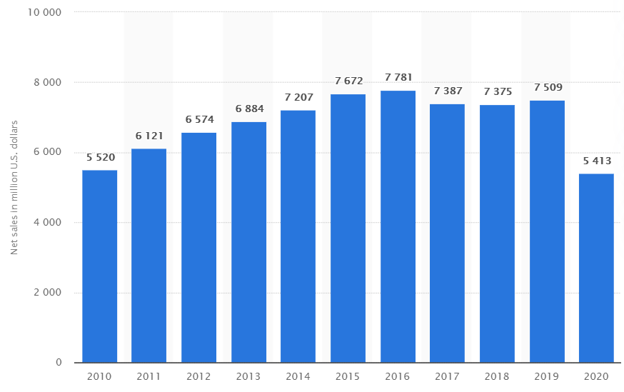
Figure 11: Victoria´s Secret´s net sales in million U.S. dollars from 2010 to 2020 (Sabanoglu, 2021)

In 2018, from September to November 3rd, the brand saw a loss of $42.3 million. Hence the closure of 250 stores in North America, after the stocks dropped 40 per cent (Nazir, 2020).

In the last two years, the brand’s market share fell from 33 per cent to 24 per cent in the United States, which can be directly correlated with the change we have seen in society that celebrates body positivity and inclusion as an essential feature of a brand (Connolly, 2019).

Effects of Diverse Workforces
Aside from including diversity in your advertisements and marketing, there are more things that can help boost revenue and brand perception, such as for example integrating diversity in the workplace. If a company exists predominantly of diverse people, creating diverse advertisements and marketing campaigns could become easier.

Perhaps if workforces were truly diverse, and if diverse people held leadership roles and/or were responsible for marketing, the resulting work would be more inclusive as a matter of course. Companies must intentionally prioritize inclusive communications in the marketing strategy and collaborate with subject matter experts to ensure campaigns are executed with cultural nuance, audience insight and executional excellence (C. Overton, personal communication, January 28, 2021).

Many studies have found that diverse teams are more diverse, productive, innovative, and effective problem-solvers versus monolithic teams (C. Overton, personal communication, January 28, 2021). These are all KPI’s that impact revenue positively. However, diversity is rooted in justice and should not only be valued on its ability to generate profit.

According to a survey conducted by PwC, merely 16 per cent of corporate directors felt their businesses scored ´excellent´ for implementing a diverse workforce. Next, 15 per cent believed their businesses were ´excellent´ in cultivating diverse talent. Lastly, 83 per cent thought the company should do more to support gender and racial diversity (Levine, 2020).

As reported by Harvard Business Review in 2013, a team is more likely to understand a customer’s needs when there is at minimum one team member that shares the customer’s ethnicity (Levine, 2020).
A study performed by the BCG revealed that a company’s earnings are improved by diversity. Companies that had a diverse management team reported to have 19 per cent higher revenue. This is because diverse teams allow the company to find solutions while taking different point of views into account, which makes the solution effective and optimized (Powers, 2018). This can be expressed for advertisements as well, the input of various people with different backgrounds will be more likely to assure diverse advertisements.

Similarly, McKinsey’s report showed that there is a strong correlation between diversity in teams and the brand’s revenue. Diverse businesses tend to earn greater financial outperformances than those who are less diverse (McKinsey, 2020).

On figure 12 below, an analysis can be found where it is shown that companies that find themselves in the best quartile for gender diversity on teams were 25 per cent more likely to gain higher profits than companies in the last quartile (McKinsey, 2020).
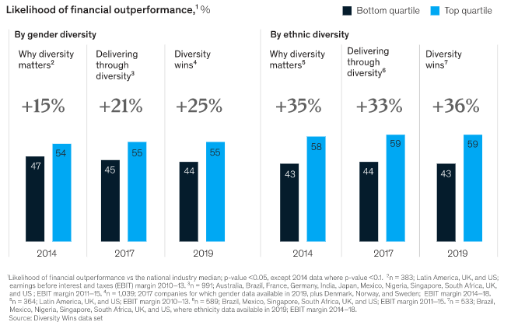

Figure 12: McKinsey´s likelihood of financial outperformance (Dixon-Fyle, Dolan, Hunt, Prince, 2020).

Effects on Brand Perception

Defining Brand Perception
Brand perception is defined as the feelings a consumer has about a certain brand, these of course, can be either positive or negative. When launching a new product, it is important to take customers’ possible feelings into consideration as this will further encourage them to boost the company’s sales. If a customer has negative feelings towards a product, it is likely they will hesitate in purchasing anything from that brand in the future (Brand Master Academy, 2021).

Given that we live in an era where technology is constantly evolving, brand perception is really important since social media has a huge impact on a brand’s image. Consumers communicate to each other via platforms like Instagram, Twitter, Facebook, etc. According to Henning-Tharau these interactions are referred to as electronic word-of-mouth communication (eWOM). This kind of communication has fascinated marketing experts because of its ability to control people’s feelings about brands. It is no longer necessary for people to meet face to face to share their opinions, instead they can do so through social media. Nowadays, consumers tend to browse on the internet for brand reviews before making a purchase (All Answers Ltd, 2018).

According to Yotpo, a positive experience or image with a brand tends to create trust. Sixty percent of a brand’s customers will tell their friends and family about the brand that they are loyal to. 52,3 per cent of customers will join a VIP or loyalty program and 39,4 percent will be likely to spend more on a product even if there were cheaper alternatives elsewhere (Brand Master Academy, 2021). See figure 13 below.
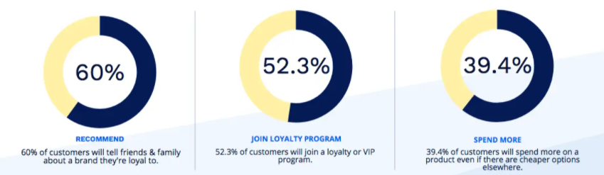

Figure 13: The impact of positive brand perception (Brand Master Academy, 2021).

Fenty
Fenty is considered to be the best social media product launch in history, as it had an astounding engagement rate of 10.41 per cent. Most brands usually have an engagement rate of around one percent. The brand was an immediate success given that people were engaging with the content intensely (Harker, 2020).

Rather than pumping millions of dollars into marketing campaigns when launching new products, Rihanna decided to take a different approach for promoting her products. She invited fans, influencers, makeup artists, etc. to the brand’s launch where she provided samples for these groups of people to try out as well as encouraged them to leave honest reviews on the brand’s social media pages and website. Rihanna filmed the entire evening and used fragments of the night to create an advertisement for the brand. By placing common people in videos, Rihanna shows her customers that diversity and multiculturalism is an absolute must at her company. Customers can relate to the people casted in the advertisements, which creates a positive image for the brand (Harker, 2020).

In September 2017, Fenty’s Instagram account began sharing posts. In just a month it already had 1.6 million followers. In the last week of September alone, it had gained
111 000 followers, that meant an average of 13 000 followers each day. After the brand’s launch the account saw more followers. This increase in followers was a result of positive reviews of fans and influencers (Hudson, 2017). See figure 14.

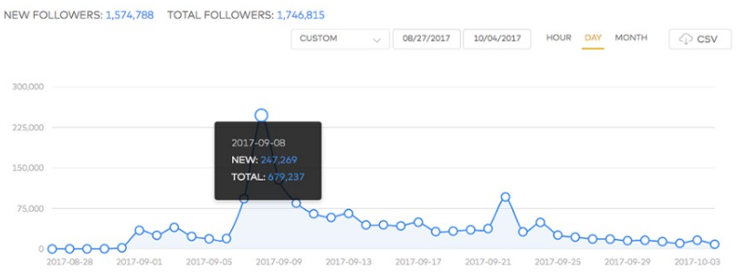
Figure 14: Fenty’s Instagram account engagement (Hudson, 2017)

Dolce and Gabbana
D&G operates in a variety of countries with different marketing strategies aimed at these different markets. However, due to an ad that was misplaced, the brand has faced a failure in brand positioning. In the luxury sector, the cost of breaking customer confidence is the highest. A brand’s value is based largely on its image and reputation. Whenever a brand is put in a bad spot by people, it risks losing its luxe. Dolce and Gabbana experienced this at first hand with their ’Eating with Chopsticks’ advertisement that was discussed earlier. The luxury brand fell 140 places from Asia’s 2019 list of top 1000 brands ranking. They were positioned 360 to 500, which was one of the biggest drops that year. This indicated a change in the brands’ Asian consumers’ attitudes towards Dolce and Gabbana (Parker, 2019).

The brand’s health score collapsed among its Chinese consumers after its ad, which can be seen on the figure below, figure 15. The score fell with 14.1 points, dropping from +3.3 to -11.4 (Ho, 2018).
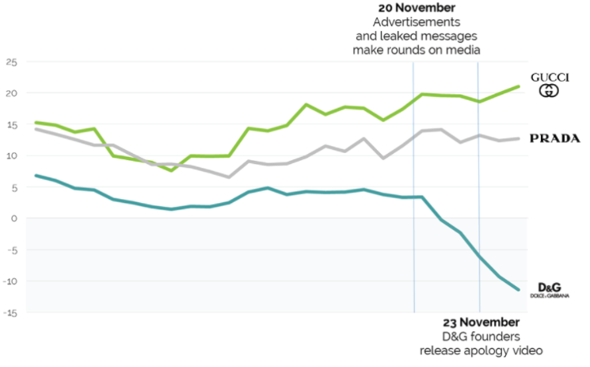
Figure 15: D&G´s brand health score (YouGov, 2018).

They suffered a significant commercial loss as a result of the ad. The consequences included the departures of celebrity ambassadors, the rescheduling of a fashion show, a model strike, and a decrease in sales volume. Even after the brand posted an apology video, they did not see any positive impact on their brand perception (Ho, 2018).

Victoria´s Secret
Victoria´s Secret´s message as a brand is that you have to look unnaturally thin to look good in lingerie, therefore the brand is receiving a lot of backlash and is being named ’outdated’. The women casted in their ads reflect poorly on the brand and create negative body image issues in girls and women (Schnelle, 2018).

The brand’s buzz score has been declining for a couple of years now among U.S. women due to the lack of diversity. This can be seen on figure 16. Women do not feel represented enough by the brand. (Marzilli, 2020).

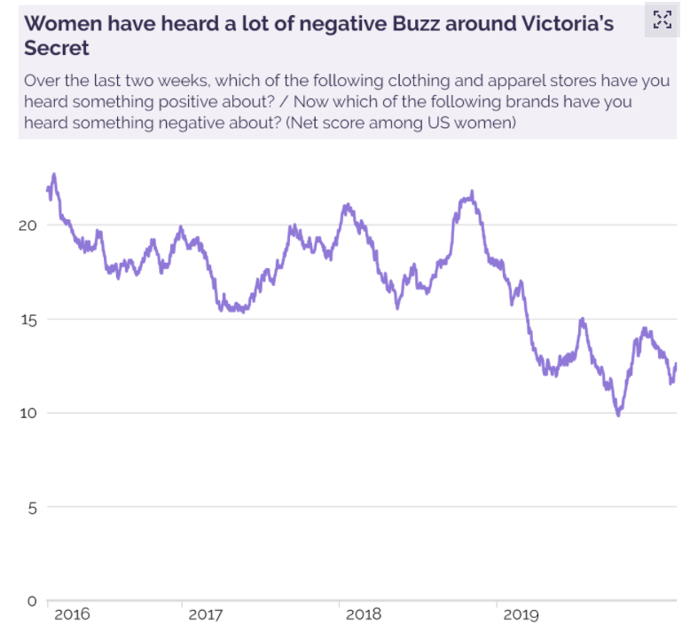

Figure 16: Victoria’s Secret buzz score among U.S. women (YouGov, 2020).

The brand is not as popular as it once used to be. According to YouGov, purchases from American women aged 18 to 34 have declined from 49 per cent in 2016 to 32 per cent as of 2020. Same goes for women aged 35 to 49 (Marzilli, 2020). See figure 17 below.

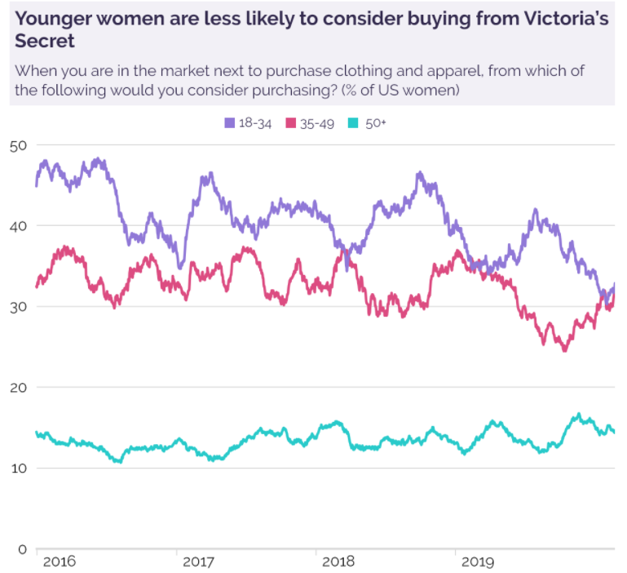

Figure 17: Purchases among different age groups (YouGov, 2020).

However, the brand has been making changes over the past two years towards a more diverse company. New leaders with a fresh outlook were appointed in marketing, brand positioning, internal talent, cost structure and so on. In 2019, a cast of diverse models were appointed for advertisements and marketing campaigns. One example of this change was the announcement on Instagram of newcomer Barbara Palvin, a model that is perceived as ’curvy’. It was pointed out by analysts that the Instagram post was very popular, with 780 000 likes in only two days and it was ranked as the first place among the brand’s 103 Instagram posts from the previous month, generating 4.2 times the average likes. Later in 2019, the brand recruited a 22-year-old transgender model, Valentino Sampaio in an attempt to signal that the brand is indeed listening to its customers (Hanbury, 2020).

Effects of Diverse Workforces
Diversity has become a focus point or priority for 87 per cent of organizations all around the world. Diverse workforces bring many advantages with them. Inclusive businesses are 1.7 times more likely to be leaders of innovation in their industry. Moreover, these organizations are up to 35 per cent more likely to outperform their competition. Additionally, 86 per cent of female millennials stated an employer policy on diversity is of importance to them (Kimberlee, 2019).

Mercer states that the corporate workforce has not seen any progress in diversity. According to their data, a little over 60 per cent of support staff or operations are white. At executive levels, we see that 85 per cent of the positions are also filled by white people. This demonstrates the gap faced by minority groups. See figure 18.
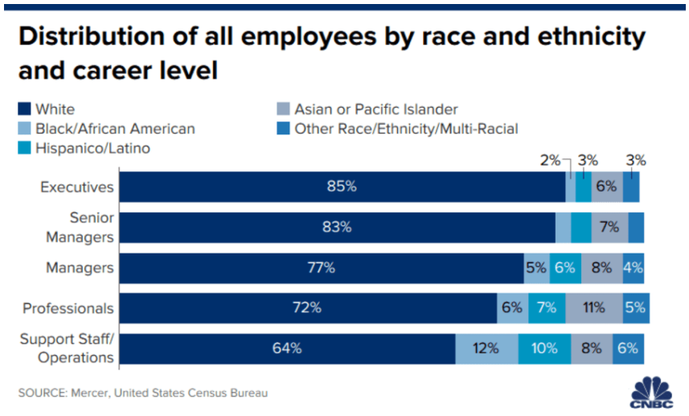

Figure 18: Distribution of all employees by race and ethnicity and career level (Steve, 2020).

A diverse team allows you to gain a better understanding of your customers. For example, your customer service team should be able to relate to customers. The closer you can get to your clients’ level of values and culture, the easier it is for your employees to connect with customers and vice versa. This immediately causes for a good perception of the brand as you create a bond with the customers (Kimberlee, 2019) because as mentioned before, some clients tend to hesitate to purchase something if the brand is not perceived as inclusive. Especially, millennials and Gen Z customers tend to be socially conscious. Consequently, they will prefer spending money at inclusive brands (TechWish, 2021).

Conclusion
This research aimed to identify if representing diversity in advertising and marketing campaigns would result in gains in revenue and brand perception. Based on the data that was found and the given examples we can indeed conclude that the inclusion of diversity has a positive impact on both revenue and perception. This because consumers feel more included and represented. As a consequence, they ought to buy more products and provide more positive reviews to brands. When looking at the brands that were discussed, we could see positive effects in revenue after the implementation of diversity as well as a better brand perception.

Many brands have already shown a great effort of including diversity in not only their advertisements but also in their workforces. This has brought many advantages for them. Generations like millennials and the Gen Z generation are challenging more and more brands to look at societal necessities. The fashion industry has already been singled out for its lack of diversity by consumers, other industries should follow suit.

It is time for change.

Cited Works
A Gender Agenda. (2021). What is gender diversity?. Genderrights.org.au. Retrieved from https://genderrights.org.au/information-hub/what-is-gender-diversity/

All Answers Ltd. (November 2018). An Investigation into the Impact of social media on
https://ukdiss.com/examples/social-media-brand-perception.php?vref=1

Armstrong, M. (2019, September 10). 1 in 8 UK adults have suicidal thoughts due to body image. Statista.com. Retrieved from https://www.statista.com/chart/17972/suicidal-thoughts-due-to-body-image-uk/

Barysevich, A. (2020, July 24). Seven brand health metrics and how to measure them. Search Engine Watch.com. Retrieved from https://www.searchenginewatch.com/2020/07/24/seven-brand-health-metrics-and-how-to-measure-them/

BBC. (2018, November 10). Victoria´s Secret ´sorry´ for transgender model comments. BBC.com. Retrieved from https://www.bbc.com/news/world-us-canada-46163922

Brand Master Academy. (2021). Brand perception: the definitive guide. Brand Master Academy.com. Retrieved from https://brandmasteracademy.com/brand-perception/

Bromwich, J. (2019, June 4). Sephora will shut down for an hour of diversity training tomorrow. NYTimes.com. Retrieved from https://www.nytimes.com/2019/06/04/style/sephora-will-shut-down-for-an-hour-of-diversity-training-tomorrow.html

Cadogan, D. (2020, November 6). Ellie Goldstein is the pioneer for models with Down´s syndrome. DazedDigital.com. Retrieved from https://www.dazeddigital.com/beauty/community/article/51003/1/ellie-goldstein-model-gucci-beauty-downs-syndrome-representation

Cambridge University Press. (1995). Diversity. In Cambridge Dictionary (12th ed.). Retrieved from https://dictionary.cambridge.org/dictionary/english/fashion

Cambridge University Press. (1995). Omnichannel. In Cambridge Dictionary (12th ed.). Retrieved from https://dictionary.cambridge.org/dictionary/english/fashion

Cherry, K. (2020, February 25). What is body positivity?. Very Well Mind.com. Retrieved from https://www.verywellmind.com/what-is-body-positivity-4773402

Christiansen, L. (2021, January 14). How Fenty´s brand positioning generated $100 million in its first 40 days. Jilt.com. Retrieved from https://jilt.com/blog/fenty-brand-positioning/

Connolly, H. (2019, December 3). Lingerie wars: Victoria´s Secret vs. Savage x Fenty. UCLPI Media.com. Retrieved from https://uclpimedia.com/online/lingerie-wars-victorias-secret-vs-savage-x-fenty

Cristoferi, C. (2019, August 27). Dolce & Gabbana sees sales slowdown in China after ad backlash. Reuters.com. Retrieved from https://www.reuters.com/article/us-dolce-gabbana-results/dolce-gabbana-sees-sales-slowdown-in-china-after-ad-backlash-idUSKCN1VH1EV

Danziger, P. (2019, March 3). Luxury brands need more than diversity to prevent more culturally insensitive mistakes. Forbes.com. Retrieved from https://www.forbes.com/sites/pamdanziger/2019/03/03/dolce-and-gabbana-gucci-burberry-caught-being-culturally-insensitive-diversity-isnt-the-fix

David Charles, T. (2020, September). Culture in communication: Dolce & Gabbana´s chopsticks backlash. ResearchGate.net. Retrieved from https://www.researchgate.net/publication/344169174_Culture_in_communication_Dolce_Gabbana's_Chopsticks_Backlash

Davis, J. (2019, June 18). They power: gender and advertising. Ultracreative.com. Retrieved from https://www.ultracreative.com/blog/theypower-gender

Digravio, G. (2020, January 13). Victoria´s Secret fashion show models got thinner and thinner over 23 years. Boston University.com. Retrieved from http://www.bu.edu/articles/2020/victorias-secret-models-thinner-trend/

Disabled World. (2021). Defining disability in diversity in society. Disabled-World.com. Retrieved from https://www.disabled-world.com/disability/diversity.php

Dixon-Fyle, S., Dolan, K., Hunt V., & Prince S. (2020, May 19). Diversity wins: how inclusion matters. McKinsey.com. Retrieved from https://www.mckinsey.com/featured-insights/diversity-and-inclusion/diversity-wins-how-inclusion-matters

El-Bawab, N. (2019, May 10). LVMH launching ´Fenty´, a new fashion house developed by Rihanna. CNBC.com. Retrieved from https://www.cnbc.com/2019/05/10/lvmh-launching-fenty-a-new-fashion-house-developed-by-rihanna.html

Fenty Beauty. (2017). Fenty Beauty.com. Retrieved from https://www.fentybeauty.com/

Flanagan, H. (2020, March 20). Victoria´s Secret launches its most diverse ad campaign featuring transgender and curvy models. People.com. Retrieved from https://people.com/style/victorias-secret-launches-diverse-campaign-with-transgender-curvy-models/

Friedman, F. & Wee, S.L.. (2018, November 23). The crash and burn of Dolce & Gabbana. The New York Times.com. Retrieved from https://www.nytimes.com/2018/11/23/fashion/dolce-gabbana-china-disaster-backlash.html

George-Parkin, H. (2018, November 9). What´s holding Victoria´s Secret back from body diversity on the runway?. Glamour.com. Retrieved from https://www.glamour.com/story/victorias-secret-fashion-show-body-diversity

Hamar, L. C. (2020, June 9). Diversity vs inclusivity: What needs to happen next in the fashion industry. Luxiders.com. Retrieved from Diversity Vs Inclusivity | What Needs to Happen in The Fashion Industry (luxiders.com)

Hanbury, M. (2018, January 22). The CEO behind Victoria´s Secret is slamming Trump while ignoring a huge flaw in his own business. Business Insider.com. Retrieved from https://www.businessinsider.com/victorias-secret-lack-of-diversity-2018-1?r=US&IR=T

Hanbury, M. (2020, January 24). Victoria´s Secret is taking steps to shed its much-criticized image. Here are 4 things that the brand has changed in the past year. BusinessInsider.com. Retrieved from https://www.businessinsider.com/victorias-secret-makes-changes-to-image-2019-8?r=US&IR=T
Hanbury, M. (2020, May 21). The ride and fall of Victoria´s Secret, America´s biggest lingerie retailer. Business Insider.com. Retrieved from https://www.businessinsider.com/victorias-secret-rise-and-fall-history-2019-5?r=US&IR=T

Hargrove, C. (2019, April 12). Thando Hapo is the first albino model to cover Vogue. Refinery29.com. Retrieved from https://www.refinery29.com/en-us/2019/04/229684/vogue-cover-thando-hapo-albino

Harker, L. (2020, October 29). How Fenty Beauty has built brand awareness – and won. Latana.com. Retrieved from https://www.latana.com/post/build-brand-awareness-fenty

Harper´s Bazaar Singapore. (2019, July 10). Dolce & Gabbana extends their size range to include plus-size. Harper´s Bazaar Singapore.com. Retrieved from https://www.harpersbazaar.com.sg/fashion/dolce-gabbana-extending-range-plus-sizes/

Ho, K. (2018, December 6). D&G´s brand health collapses among Chinese consumers after ´racist´ ads. YouGov.com. Retrieved from https://china.yougov.com/en-cn/news/2018/12/06/dgs-brand-health-collapses-among-chinese-consumers/

Holley, P. (2015, January 10). For the first time ever, a Tiffany´s ad features a gay couple. Washingtonpost.com. Retrieved from https://www.washingtonpost.com/news/post-nation/wp/2015/01/10/for-the-first-time-ever-a-tiffanys-ad-features-a-gay-couple/

Kimberlee. (2019, September 10). 7 benefits of diversity in customer service at your company. Harver.com. Retrieved from https://harver.com/blog/diversity-in-customer-service/

Levine, S.R.. (2020, January 15). Diversity confirmed to boost innovation and financial results. Forbes.com. Retrieved from https://www.forbes.com/sites/forbesinsights/2020/01/15/diversity-confirmed-to-boost-innovation-and-financial-results/?sh=6a296b81c4a6

Lim, S. (2018, December 5). Dolce & Gabbana´s branding at all time low in China after racist ad scandal. The Drum.com. Retrieved from https://www.thedrum.com/news/2018/12/05/dolce-gabbanas-branding-all-time-low-china-after-racist-ad-scandal

Long, D. (2018, November 22). Dolce & Gabbana dropped form Alibaba, JD.com, Yoox Net-A-Porter following ´racist´ campaign. The Drum.com. Retrieved from https://www.thedrum.com/news/2018/11/22/dolce-gabbana-dropped-alibaba-jdcom-yoox-net-porter-following-racist-campaign

Lubitz, R. (2017, September 26). Plus-size model Emme first started modeling in 1989. 28 years later, she made her NYFW debut. Mic.com. Retrieved from https://www.mic.com/articles/184733/plus-size-model-emme-first-started-modeling-in-1989-28-years-later-she-made-her-nyfw-debut

Marci, K. (2019, May 2). The Savage x Fenty strategy: how Rihanna is slaying the lingerie game. Edited.com. Retrieved from https://edited.com/resources/how-rihanna-is-slaying-the-lingerie-game/

Marketing Charts. (2016, July 22). These brands are enjoying the best buzz so far this year. Marketing Charts.com. Retrieved from https://www.marketingcharts.com/demographics-and-audiences/hispanic-demographics-and-audiences-69232

Marketing Charts. (2020, March 2). Are advertisers breaking through to multicultural groups?. Marketing Charts.com. Retrieved from https://www.marketingcharts.com/demographics-and-audiences-112119

Marketing Charts. (2019, September 3). Consumers say that diversity in advertising has an impact on them. Marketing Charts.com. Retrieved from https://www.marketingcharts.com/advertising-trends/creative-and-formats-109905

Maryville University. (2021). Guide to diversity and inclusion in modern advertising. Online.maryville.edu. Retrieved from https://online.maryville.edu/online-bachelors-degrees/marketing/guide-to-diversity-and-inclusion-in-modern-advertising/

Marzilli, T. (2020, February 26). Victoria´s Secret brand isn´t going anywhere – but its new owners should act fast. YouGov.com. Retrieved from https://today.yougov.com/topics/consumer/articles-reports/2020/02/26/victorias-secret-brand-isnt-going-anywhere-its-new

Matera, A. (2018, November 8). Victoria´s Secret fashion show 2018: every black model walking this year. Teen Vogue.com. Retrieved from https://www.teenvogue.com/gallery/victorias-secret-fashion-show-black-models

McConnell, K. (2020, June 10). Influential transgender models in fashion. CRFashionbook.com. Retrieved from https://www.crfashionbook.com/fashion/g32784604/transgender-models-tracey-africa-connie-fleming/

Miller, L. (2021, February 17). The time for diversity in advertising is now. Entrepreneur.com. Retrieved from https://www.entrepreneur.com/article/364376#

Min, L. (2017, September 2). Of course, the first ad for Rihanna´s Fenty Beauty is incredible. Cosmopolitan.com. Retrieved from https://www.cosmopolitan.com/style-beauty/beauty/a12161775/rihanna-fenty-beauty-details/

Mindless Mag. (2020, September 3). The fashion industry & diversity: What´s the deal?. Mindless Mag.com. Retrieved from https://mindlessmag.com/2020/09/03/the-fashion-industry-diversity-whats-the-deal/

Morin, A. (2020, June 2020). How to prevent the media from damaging your teen´s body image. Verywellfanily.com. Retrieved from https://www.verywellfamily.com/media-and-teens-body-image-2611245#citation-5

Morrison, A. (2015, September 28). H&M Muslim ad campaign with hijab model signals future diversity in fashion advertisements, analysts say. IBTTimes.com Retrieved from https://www.ibtimes.com/hm-muslim-ad-campaign-hijab-model-signals-future-diversity-fashion-advertisements-2117370

Nazir, S. (2020. June 11). Victoria´s Secret: what went wrong? Retail Gazette.com. Retrieved from https://www.retailgazette.co.uk/blog/2020/06/victorias-secret-what-went-wrong/

Nielsen. (2018, February 15). Black impact: consumer categories where African Americans move markets. Nielsen.com. Retrieved from https://www.nielsen.com/us/en/insights/article/2018/black-impact-consumer-categories-where-african-americans-move-markets/

Nielsen. (2021). Nielsen.com. Retrieved from https://www.nielsen.com/us/en/contact-us/panels/

Okwodu, J. (2019, July 18). The 2010s were a turning point for diversity in fashion. Vogue.com. Retrieved from https://www.vogue.com/article/2010s-diversity-in-fashion-turning-point-timeline

Parker, O. (2019, June 18). Dolce & Gabbana falls 140 places in Asia´s top 1000 brand ranking. Jing Daily.com. Retrieved from https://jingdaily.com/dolce-gabbana-brand-ranking/

Phelps, N. (2018, November 8). ´We´re nobody´s third love, we´re their first love´- the architects of the Victoria´s Secret fashion show are still banking on bombshells. Vogue.com. Retrieved from https://www.vogue.com/article/victorias-secret-ed-razek-monica-mitro-interview.

Powers, A. (2018, June 27). A study finds that diverse companies produce 19% more revenue. Forbes.com. Retrieved from https://www.forbes.com/sites/annapowers/2018/06/27/a-study-finds-that-diverse-companies-produce-19-more-revenue/?sh=55a51d29506f

PwC. (2019). PwC.be. Retrieved from https://www.pwc.be/en/company-information.html

Rincon, F. (2019, October 27). When a diversity and inclusion campaign goes wrong…oh so wrong!. Medium.com. Retrieved from https://medium.com/marketing-in-the-age-of-digital/when-a-diversity-and-inclusion-campaign-goes-wrong-oh-so-wrong-a74b390dcc2d

Sabanoglu, T. (2021, May 12). Victoria´s Secret net sales worldwide from 2010 to 2020. Statista.com. Retrieved from https://www.statista.com/statistics/255806/net-sales-of-victorias-secret-worldwide/

Saputo, S. (2019, June). How Rihanna´s Fenty Beauty delivered ´Beauty for all`- and a wake-up call to the industry. Thinkwithgoogle.com. Retrieved from https://www.thinkwithgoogle.com/future-of-marketing/management-and-culture/diversity-and-inclusion/-fenty-beauty-inclusive-advertising/

Schnelle, R. (2019, March 18). Victoria´s Secret became outdated the minute they enforced negative body image. TheOddyseyOnline.com. Retrieved from https://www.theodysseyonline.com/victories-secret-outdated

Seetharaman, S. (2020, March 24). A closer look at the global plus size clothing market share. Pipe Candy.com. Retrieved from https://blog.pipecandy.com/plus-size-clothing-market-2020/

Segran, E. (2019, July 30). Victoria´s Secret is spiraling down the drain. Here are 3 reasons why. Fast Company.com. Retrieved from https://www.fastcompany.com/90383461/victorias-secret-is-in-decline-here-are-3-reasons-why

Siddique, H. (2019, May 13). One in eight UK adults have suicidal thought over body image-poll. The Guardian.com. Retrieved from https://www.theguardian.com/lifeandstyle/2019/may/13/body-image-survey-one-in-eight-uk-adults-suicidal-thoughts

Stevens Coon, C. (1972). The races of Europe: Praeger; Illustrated edition (14 November 1972).

TechStyle Fashion Group. (2018). TechStyle Fashion Group.com. Retrieved from https://techstylefashiongroup.com/brand/savage-x-fenty/

TechWish. (2021). Diversity matters in building your brand reputation. TechWish.com. Retrieved from https://www.techwish.com/diversity-matters-in-building-your-brand-reputation/#

The Editors of Encyclopedia Britannica. (1768). Charleton S. Coon. In Encyclopedia Britannica (15th ed.). https://www.britannica.com/biography/Carleton-Coon/additional-info#history

The World Bank. (2021). Disability inclusion. The World Bank.com. Retrieved from https://www.worldbank.org/en/topic/disability#1

Thurmond, A. (2015, September 28). This 23-year-old model is the first to wear a hijab in an H&M campaign. Teenvogue.com. Retrieved from https://www.teenvogue.com/story/mariah-idrissi-hijab-model-hm

Walker, T. (2020, September 1). Why diversity in ads is more important than ever for revenue. Aspireiq.com. Retrieved from https://www.aspireiq.com/blog/why-diversity-in-ads-is-more-important-than-ever-for-revenue-2020:/

Wischhover, C. (2018, May 30). The Fenty effect means everyone offers 40 foundation shades now. Racked.com. Retrieved from https://www.racked.com/2018/5/30/17409524/fenty-effect-foundation-40-shades

Wright, G. (2020, October 2017). How Savage x Fenty used social media to solidify itself as a top lingerie retailer. Retailgazette.com. Retrieved from https://www.retailgazette.co.uk/blog/2020/10/savage-x-fenty-lingerie-rihanna-inclusivity-fashion-feature/

Zagarella, C. (2020, October 20). What is considered plus size today?. Bistromd.com. Retrieved from https://www.bistromd.com/womens-health/why-is-size-six-the-new-plus-size#

Carleton Stevens Coon: ´Was an American anthropologist who made contributions to anthropology as well as archaeology.´ (Encyclopedia Britannica, 1768).
Marketing Charts: ´Marketing Charts is a hub of marketing data, graphics, and analyses´ (Marketing Charts, 2021).
PQ Media: ´Delivers intelligent data and analysis to executives at the world´s leading media, entertainment and technology organizations through syndicated market research, custom market intelligence and strategic advisory services.´ (PQ Media, 2021).
ANA: ´The ANA is the U.S. advertising industry´s oldest and largest trade association. It was established to promote cooperative relationships between regional and national advertising industries, manufacturers and dealers, and advertisers and agencies.´ (ANA, 2021).
The Mental Health Foundation: ´A charity whose vision is for a world with good mental health and has a mission to help people understand, protect, and sustain their mental health´ (The Mental Health Foundation, 2021).
Common Sense Media: ´A nonprofit organization dedicated to help kids thrive in a world of media and technology (Common Sense, 2021).
Nielsen: ´An organization that has been helping business understand consumer behaviour´ (Nielsen, 2021).
Horowitz Research: ´A consumer insights and market research agency´ (Horowitz, 2021).
The Clara Lionel Foundation: ´Supports and funds ground-breaking and effective education and emergency response programs around the world´ (Clara Lionel Foundation, 2012).
Ad awareness score: ‘Measures how many consumers have noticed a brand´s advertisements´. (Lim, 2018).
Buzz score: ´Measures whether people have heard anything positive or negative about a brand´(Lim, 2018).
Recommended score: ´Measures whether people would recommend the brand to others´ (Lim, 2018).
Body-positivity movement: ´Refers to the assertion that all people deserve to have a positive body image, regardless of how society and popular culture view ideal shape, size, and appearance´ (Cherry, 2020).
YouGov: ´A market research and data analytics firm´(George-Parkin, 2018).
CMO: Chief Marketing Officer.
Source reference to interview.
Omnichannel: ´A way of selling products that is the same and equally good for the customer whether they are buying from a computer, a mobile phone app, etc., or in a physical shop´. (Cambridge University Press, 1995).
KPI: Key Performance Indicator.
PwC: ´PricewaterhouseCoopers is founded on the principle of creating value through relationships´ (PwC, 2019).
BCG: ´Boston Consulting Group is an organization that partners with leaders in business and society to tackle their most important challenges and capture their greatest opportunities´(Boston Consulting Group, 2013).
McKinsey: McKinsey & Company is the trusted advisor and counselor to many of the world’s most influential businesses and institutions (McKinsey, 1926).
Henning-Thurau: He is the Professor and Chair of Marketing and Media at the University of Münster, Germany (WWU Münster, 2021).
Yotpo: ´An e-commerce marketing platform with advanced solutions for client reviews, etc. (Yotpo, 2021).
Health score: ’A customer’s satisfaction with a brand, it shows how well a brand is doing.
Mercer: ´A human resources consulting company´ (Stevens, 2020).

