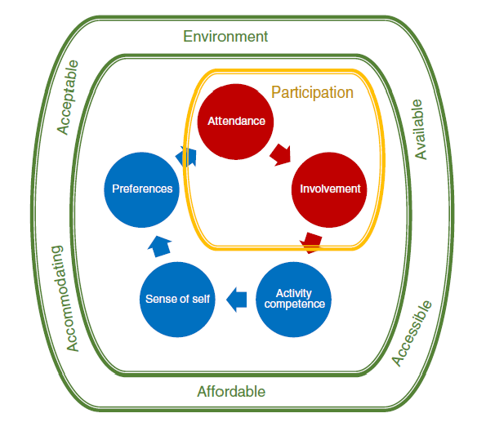
Uit Imms, C., Adair, B., Keen, D., Ullenhag, A., Rosenbaum, P., & Granlund, M. (2016). 'Participation': a systematic review of language, definitions, and constructs used in intervention research with children with disabilities. Dev Med Child Neurol, 58(1), 29-38. doi:10.1111/dmcn.12932

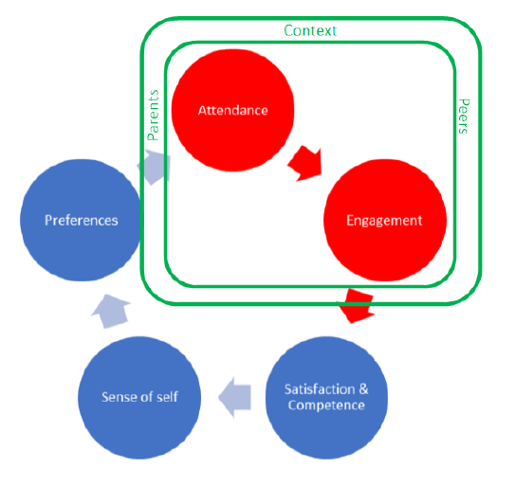
Thematische kaart

