Requirements | 1 Voyage | 1 year (12Voyages)
Amount of Fuel (t)
FPO | 3990 | 47880
Bio diesel | 210 | 2520
Biomass (t)
Bamboo | 9314 | 111768
Canola | 525 | 6299
Farmland (ha)
Bamboo | 261 | 3136
Canola | 66 | 793
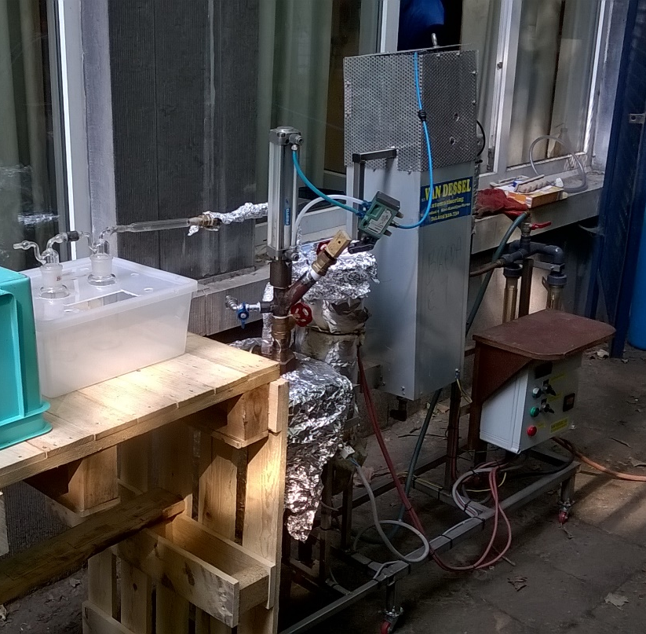
Pyrolyse olie uit bamboe

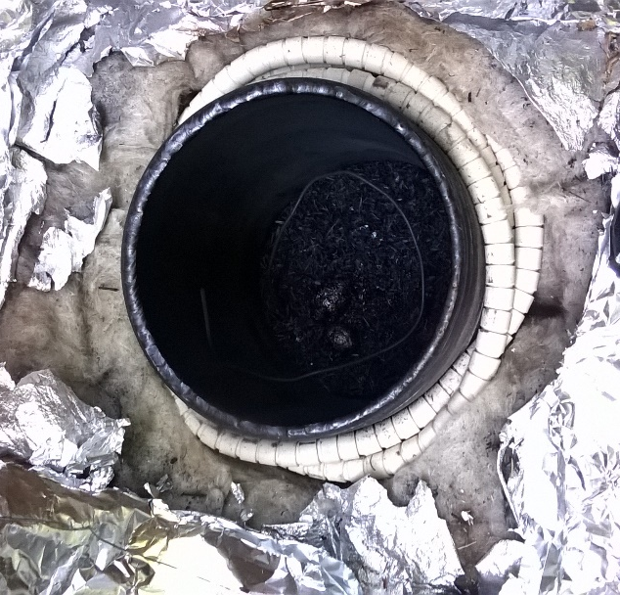

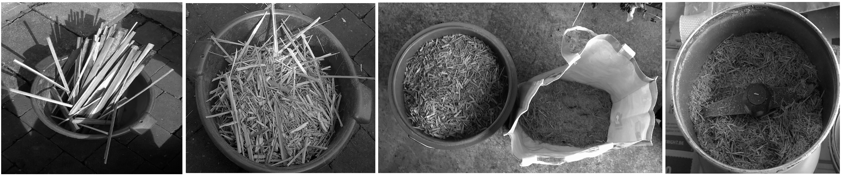
Houtskool residu na bamboe pyrolyse
De Pyrolyse Reactor
Voorbereiding van bamboe

