Academic Year 2015 - 2016

The use of progestins in transgender youth: Clinical and hormonal effects

Lloyd Tack

Promotor: Prof. Dr. Martine Cools

Research report presented in the 4th Master year
for “CLERKSHIP: Research for the Hospital Doctor”
In the program of
Master of Medicine in Medicine

Content
I. Background 1
1. Definitions 1
2. Puberty suppression 1
a) Cyproterone acetate 2
b) Lynestrenol 3
3. Cross-sex hormones 3
a) Estrogens 3
b) Androgens 3
II. Goals of the research 5
III. Material and methods 6
1. General 6
a) Ethics 6
b) Diagnosis 6
2. Part one and two 6
a) FtM transgender adolescents: patients 6
b) MtF transgender adolescents: patients 6
c) Methods 7
3. Part three 10
a) Patients 10
b) Methods 10
IV. Results 12
1. Lynestrenol in Female to Male adolescents 12
a) Patient and treatment characteristics 12
b) Side effects 12
c) Anthropometry 12
d) Biochemical analyses 13
2. Cyproterone acetate in male to female adolescents 19
a) Patients and treatment characteristics 19
b) Side effects 19
c) Anthropometry 19
d) Biochemical analyses 20
3. Monotherapy of progestins on the musculoskeletal system 26
a) Patients and treatment 26
b) Biochemical data (Table 10) 26
c) Anthropometrics and grip strength (Table 11) 26
d) Body composition (Table 12) 27
e) Bone development: DXA results (Table 13) 28
f) Bone development pQCT (Table 14) 30
V. Discussion 32
1. Lynestrenol in Female to Male transgender adolescents 32
a) Patients 32
b) Side effects 32
c) Anthropometrics 32
d) Safety parameters 33
e) Hormones 33
2. Cyproterone acetate in MtF transgender adolescents 35
a) Clinical effects and side effects 35
b) Anthropometrics 35
c) Safety parameters 35
3. Effects of progestins on body composition and muscle and bone development 38
a) Body composition 38
b) Lab results 38
c) Bone (DXA) 39
d) Bone (pQCT) 39
VI. Conclusions 41
VII. Perspectives for further research 42
VIII. Abbreviations 43
IX. References 45

Background

Definitions
Gender dysphoria (GD) is defined as a difference between the experienced or expressed gender and one's natal gender, which causes distress or impairment in important areas of functioning (1). Over the years, a steady increase in the number of adolescents who present with GD has been noted worldwide (2). Prevalence of gender incongruence (identifying more with one's non-natal gender) in men and women is estimated to be respectively 0,7% and 0,6% in the Flemish population (2), which is similar to other populations (4,5).
In an attempt of the American Psychiatric Association to reduce the stigma surrounding people who have GD, the emphasis has increasingly been placed on the distress that people with GD experience in the most recent DSM-5 manual. Whether or not it has succeeded in its goals and if GD should be considered as a mental disorder at all, is still under debate (6–8). The Endocrine Society clinical practice guideline, published in 2009, recommends medical treatment and psychological guidance of children and adolescents with GD (9).

Puberty suppression
Because GD will persist after puberty in only a minority of the children presenting with GD, medical treatment i.e. puberty suppression is best started after the first physical signs of puberty (10,11). At the onset of puberty, the reaction of the adolescent to the first bodily changes, under the form of increasing aversion of their biological sex which will enhance GD, often provides additional diagnostic evidence (12). If GD persists, the adolescent will be eligible for medical treatment aimed at suppressing puberty and/or attenuating its physical symptoms (9,13), a decision which is to be made by an experienced multidisciplinary team, which in our center consists of a child psychologist, a child psychiatrist and a pediatric endocrinologist.
Delaying puberty has long been controversial. The general consensus nowadays tends to be that the advantages of reducing psychological burden, providing time to explore gender identity and decreasing the need for (and extent of) later sex reassignment surgery (SRS) (10) outweigh the disadvantages. A recent, long-term follow-up study revealed that suppression of puberty positively impacts the psychological outcome of transgender individuals (14). However, arguments against puberty suppression include that gender identity is still developing in adolescence and that suppression of endogenous sex hormones may interfere with normal growth, bone maturation and brain development. However with the initiation of cross-sex hormones (CSH), these effects are believed to be (mostly) reversible (15).
In male to female (MtF) and female to male (FtM) transgender individuals who present in childhood and with a confirmed diagnosis of GD in the first months of puberty, gonadotropin releasing hormone analogues (GnRHa) are often the first choice of therapy, in order to avoid the development of advanced secondary sexual characteristics (i.e. beyond Tanner stage G3/B3) and thus prevent the need for mastectomy or laser-assisted hair removal and voice training in respectively FtM and MtF transgender individuals. A disadvantage of GnRHa is the lack of sufficient genital tissue for penile inversion vaginoplasty in MtF transgender individuals (16). However, when secondary sexual characteristics have fully developed, the benefits of using GnRHa instead of cheaper alternatives such as progestins are less clear. GnRHa are probably more effective in suppressing endogenous hormone production but whether this results in significant clinical differences regarding physical changes, side effects and psychological outcome in late adolescence or adulthood has never been investigated.
Progestins that are frequently used in this context are cyproterone acetate (CA) in MtF transgender individuals or lynestrenol (L) in FtM transgender individuals. In Belgium, treatment with CA (Androcur®) and L (Orgametril ®) is respectively 5 and 13 times cheaper than GnRHa - which in addition are not reimbursed for this indication - and have the additional benefit that they can be administered orally instead of intramuscularly. The treatment protocol as applied in our center is represented in Table 1.
Table 1. Treatment protocol of the gender clinic of Ghent University Hospital
Adolescents | Start of puberty (G3/B3) | More advanced pubertal development
FtM transgender individuals | GnRHa: 11,25mg/12 weeks | Lynestrenol: 5mg/day
MtF transgender individuals | GnRHa: 11,25mg/12 weeks | Cyproterone acetate: 50mg/day

Cyproterone acetate
CA has anti-androgenic effects, resulting from its ability to competitively inhibit androgen-binding on the androgen receptor, translocation of the androgen receptor to the nucleus, and inhibition at the transcriptional level (17). Extensive experience has been gained in using CA in adult MtF transgender individuals in combination with estrogens, and in the treatment of hirsutism in (typical) women (18,19). Because of its anti-androgenic properties, CA decreases growth of body hair and to a lesser extent facial hair, and diminishes sexual desire, which is also a cause of distress in natal males with GD (20–22). CA has been reported to be effective in suppressing gonadotropin-independent precocious puberty and central precocious puberty before the introduction of GnRHa (23,24). Elevations of prolactin (PRL) levels and the stimulation of growth of menigiomas and prolactinomas have been reported (25,26).

Lynestrenol
In FtM transgender adolescents, androgenic progestins such as L can be used to reduce the psychological burden of menstruation. L is a prodrug that is converted to norethisterone (27). It is an androgenic, first generation progestin of the 19-nortestosterone steroids family that is commonly used as hormonal replacement therapy in postmenopausal women or to treat endometriosis (28). Older studies have revealed that 19-nortestosterone derivates moderately decrease serum triglyceride levels and deteriorate glucose tolerance in women with pre-existing impaired insulin secretion. In healthy young women however, L does not alter glucose metabolism (29,30). The induction or increase of acne and hirsutism by androgenic progestins results from reductions in estradiol (E2) and sex hormone-binding globulin (SHBG) levels, leading to higher absolute and relative concentrations of endogenous androgens and unbound androgenic progestins (31).

Cross-sex hormones
In line with the Endocrine Society clinical practice guideline, CSH can be initiated from the age of 16 years onwards (9).The strict use of this age criterion is a point of controversy and may be abandoned in a revised version of this guideline, which is currently under preparation.

Estrogens
Although treatment with estrogens in MtF transgender individuals can decrease the production of androgens, combination with CA is more effective in reducing endogenous androgen levels (32). A major concern in treatment with estrogens and especially ethinyl estradiol (EE) is the increased incidence of venous thrombosis (33,34). 17β-estradiol (E) has been proven to be less thrombogenic and is therefore preferred over EE (35,36). A frequent request of MtF transgender adolescents is to have female breast development. To date, little evidence exists on the effect of estrogens on breast development, however in adult MtF, the effect is expected to be rather moderate and possibly more pronounced when treatment is initiated at younger age (37). Initiation of CSH has also been reported to increase bone density and to impact on body composition, causing a more female fat distribution and decreasing muscle mass (18,38).
Benign and malignant hormone-dependent tumors have been reported in a few cases of MtF transgender individuals (32). Few cases of breast and prostate cancer have been published (39–41). However rare, clinicians are generally advised to stay vigilant for such malignancies (42).

Androgens
In FtM transgender adolescents, CSH under the form of testosterone esters (TE) (Sustanon®) are added to the treatment from 16 years onwards if GD persists. After having reached an adult replacement dose, long acting testosterone undecanoate injections (Nebido®) are often considered more convenient.
The effects of TE administration have been well studied in adults. It increases facial and body hair, libido, muscle mass and the oiliness of the skin. It also results in clitoromegaly facilitating later metoidioplasty or phalloplasty, a deeper voice, cessation of menses, redistribution of fat mass and in some cases male pattern balding (9,18,43,44). Although testosterone administration may cause hypercholesterolemia, hypertension and reduced HDL levels, there is no evidence that cardiovascular pathology is increased in FtM (35). Long-term testosterone treatment in adult FtM, has been shown to have positive effects on trabecular bone mineral density (BMD), whilst negatively impacting cortical BMD (45,46). Although rare, induction of hormone-related cancers such as carcinomas of the female genital tract and breasts due to testosterone administration have been reported (42,47). The use of TE in adolescents with GD has not been studied. It is hypothesized that the same bodily changes, side effects and hormonal shifts occur as in adults. It was recently shown that TE from 16 years onwards can only partially reverse the decline in BMD observed during puberty suppression with GnRHa (48,49).
The flowchart of the care plan for GD at Ghent University Hospital is represented in Figure 1.

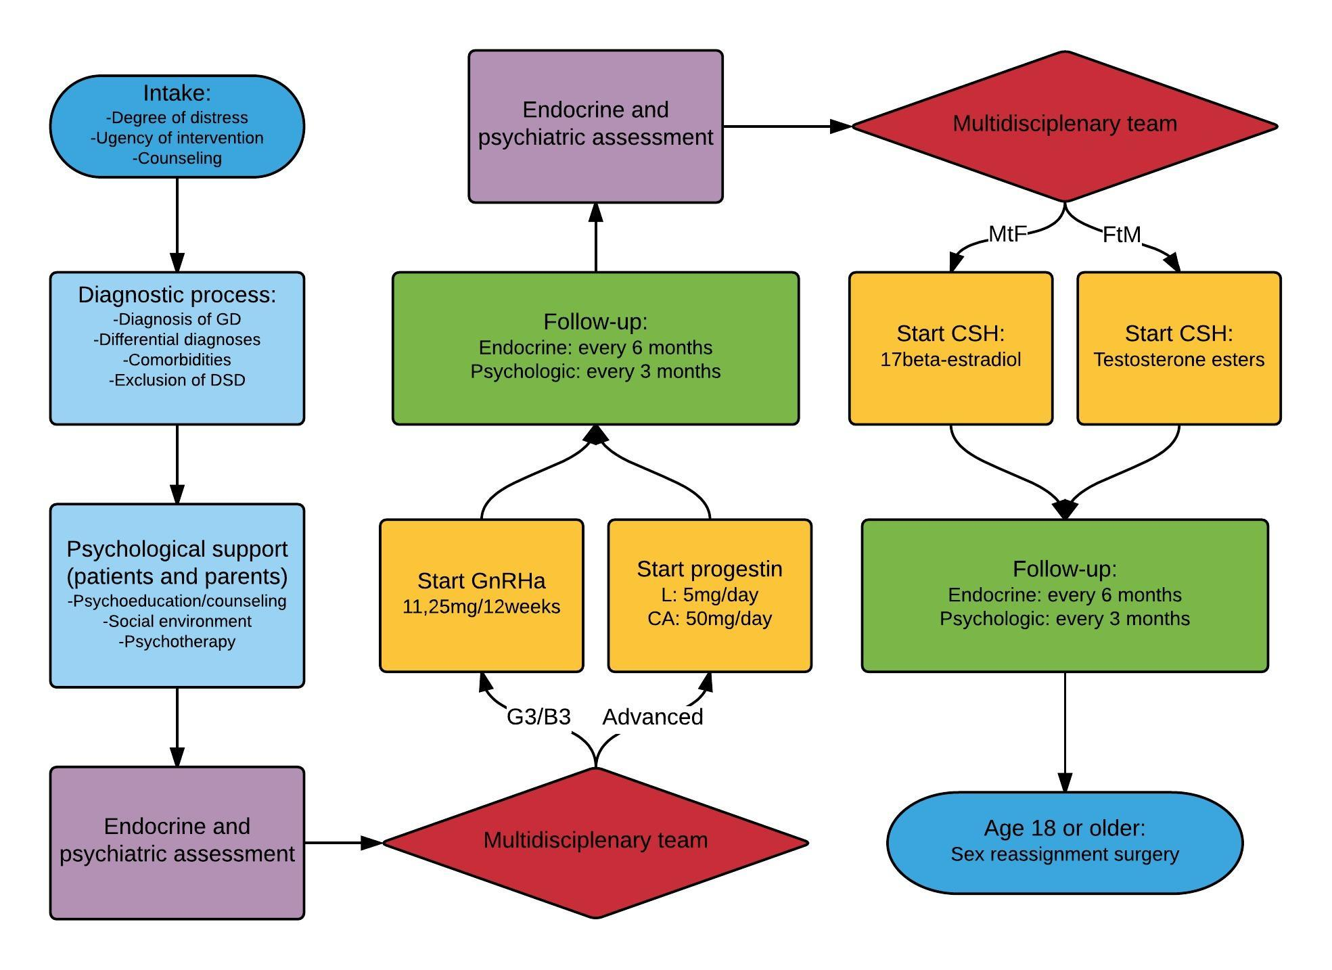
Figure 1. Flowchart of care plan for GD at Ghent University Hospital.

Goals of the research
Since GnRHa are expensive and benefits are less clear in adolescents with already advanced pubertal development, progestins have been postulated as a valuable alternative in countries where endocrine treatment of GD is not reimbursed. However, no studies have been published that investigated the effects of this treatment in adolescents with GD (apart from the already published results of this study (50)). The overall aim of the study was to assess whether or not treatment with progestins is safe and effective in treating adolescents with GD. In addition, we wanted to evaluate the safety and effectiveness of our incremental CSH regimen in transgender youth.

To assess the impact of treatment with CA and L, the study was divided in three parts.
The goal of the first and second part was to retrospectively analyse the impact of consecutive treatment with respectively L and CA in monotherapy and in combination with TE or E on physical characteristics, safety, metabolic parameters and hormone levels in a relatively large cohort of FtM and MtF transgender adolescents and to report side effects that occurred during this treatment.
The goal of the third part was to assess the impact of CA and L on body composition, bone mass accrual and grip strength.
The exact study design is listed in material and methods.

This study contributes greatly to the available knowledge on the possibilities for treating transgender youth. The reported effects of treatment can serve as a guidance for other clinicians who want to implement therapy with progestins in their gender clinic. This will eventually result in more clinical evidence about the safety and effectiveness of this treatment, which hopefully can contribute to reimbursement of endocrine treatment of transgender youth.

Material and methods

General

Ethics
Approval of the ethics committee of Ghent University hospital for the study was obtained (B670201525328).
All individuals who had presented during adolescence with GD at the gender clinic of Ghent University Hospital, were contacted through an opting-out informed consent form sent via mail or regular post. The form explained the goals and design of the study and stated that if the adolescents or their legal guardians wished their data not be included in the study, they had to object via mail or letter. Only one FtM transgender adolescent objected.

Diagnosis
The diagnosis of GD was made by a child psychologist and child psychiatrist and was based on the diagnostic criteria described in the DSM-IV and the International Classification of Diseases (ICD-10) manual (51). The decision to start medical treatment was made by the multidisciplinary child gender team of Ghent University Hospital.

Part one and two

FtM transgender adolescents: patients
Data on 45 FtM transgender adolescents who had received hormonal treatment for a period of at least six months from 2010 until September 2015 were available; two adolescents were excluded: one had committed suicide during the follow-up period and the family was not contacted to obtain informed consent and one did not consent in use of his data for the study. In five of the remaining 43 cases, insufficient laboratory data were available, therefore only anthropometric data were included. In some of the remaining 38, due to the retrospective nature of the study and occasional sample loss, not all parameters were available at each time point.
L monotherapy was administered for at least six months in all included participants followed by combination therapy of L and TE (L+TE) in a subset of them (n=25) for at least 6 months. The others were too young to be eligible for CSH therapy at the time of data analysis. Summary of included adolescents is represented in Figure 2. Criteria to start CSH therapy were based on the Endocrine Society guidelines (9). All adolescents were advised to take vitamin D supplementation and a calcium enriched diet during treatment.

MtF transgender adolescents: patients
Data on 27 transgender adolescents were available; they received hormonal treatment over a period of at least six months, from 2008 until March 2016.
In two of the 27 cases, insufficient laboratory data were available, therefore only anthropometric data were included. In one patient only data of CA monotherapy were available, this treatment was interrupted after one year because the patient did not want to pursue sex reassignment anymore. In some of the remaining 25, due to the retrospective nature of the study and occasional sample loss, not all parameters were available at each time point.
Treatment consisted of CA monotherapy for at least six months in all included participants followed by combination of CA and E (CA+E) in a subset of them (n=16) for at least 6 months. The others were too young to be eligible for CSH therapy at the time of data analysis. Summary of included adolescents is represented in Figure 2. Criteria to start CSH therapy were based on the Endocrine Society guidelines (9). All adolescents were advised to take vitamin D supplementation and a calcium enriched diet during treatment.
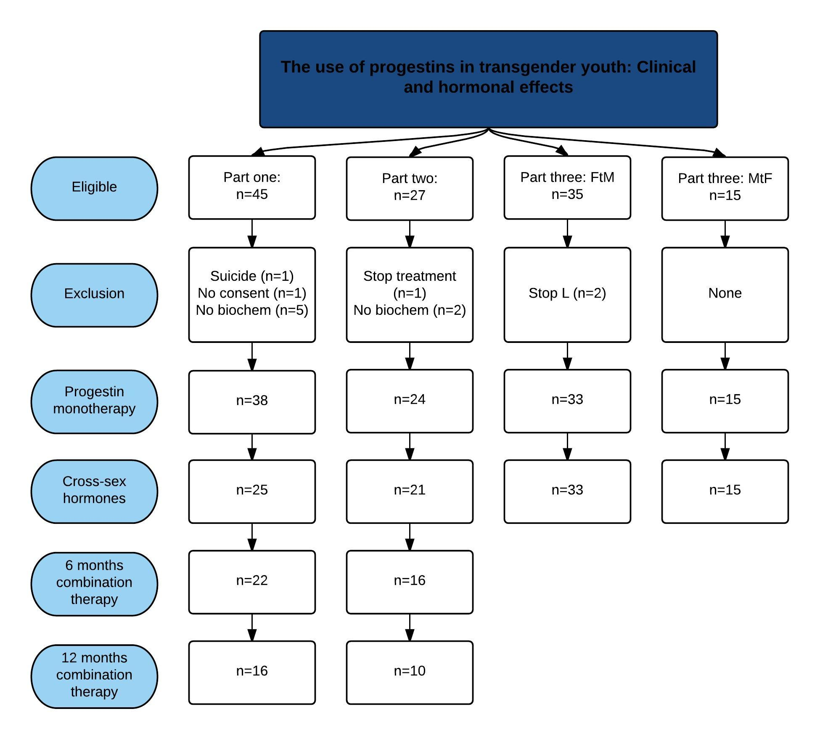
Figure 2. Summary of patients included in each part of the study
FtM: female to male transgender adolescents; MtF: male to female transgender adolescents. Missing biochem: biochemical data was missing, data on anthropometry and (side) effects were still included.

Methods
Intake visits were aimed at excluding a disorder of sex development underlying GD, and at determining the pubertal (Tanner) stage. L (5mg/d) was started in FtM adolescents with Tanner stage B4 and further, CA (50mg/d) in MtF adolescents with Tanner stage G4 or further, who met the criteria as outlined in (9). TE and E were added to the treatment in FtM and MtF transgender adolescents of at least 16 years old who met the criteria as outlined in (9). Doses were gradually increased according to the protocol represented in Table 3. Follow-up visits were scheduled every 6 months. Recorded parameters during each visit are represented in Table 2.

During medical treatment, adolescents were seen every three months by the team child psychologist. In the absence of psychiatric comorbidity, they were evaluated twice by the team child psychiatrist during this phase; once to confirm the diagnosis and exclude comorbidities, and once more at start of CSH. Fertility issues are discussed thoroughly throughout each treatment phase. FtM transgender adolescents were given the chance to undergo ovum pick-up following an ovarian stimulation program before initiation of TE. However, almost all adolescents preferred to start TE without any delay. The same option was given when considering SRS. Alternatively, FtM transgender adolescents were informed that part of their ovaries can be cryopreserved at the time of gonadectomy for eventual later assisted reproduction purposes. In our experience, most FtM transgender adolescents prefer this last option. MtF transgender adolescents are offered to produce a semen sample for cryopreservation before initiation of CA. MtF transgender adolescents can opt to delay this procedure until a later age, however, this requires cessation of treatment for at least three months. Cryopreservation of testicular tissue during orchidectomy is another possibility. Only few adolescents choose to store semen or testicular tissue; those who do, most often store a semen sample before initiation of CA.
Table 2. Summary of recorded parameters during follow-up
 | Parameters
History and life style  Every six months | Family history  Personal medical history  Psychiatric comorbidity  Social situation  (side) effects of treatment
Life style  Every six months | Smoking habits  Alcohol consumption
Physical examination  Every six months | Anthropometry  Blood pressure  Tanner stage  FtM: Acne, hirsutism  MtF: Breast development
Biochemical  Every six months | Complete blood count (hemoglobin/hematocrit)  Electrolytes  Liver enzymes (AST/ALT)  Renal function (serum creatinine, urine sample)  Thyroid function (TSH/fT4)  Luteinizing hormone (LH)  Follicular stimulating hormone (FSH)  Estradiol (E2)  Total and free testosterone (T and fT)  Sex hormone-binding globuline (SHBG)  Cholesterol (total, HDL)

Start of L or CA and start of CSHª | Fasting glucose  Insulin  Lipid metabolism (cholesterol + LDL + triglycerides) Insulin-like growth factor 1 (IGF-1)  Dehydroepiandosterone sulfate (DHEAS)  Δ4-androstenedione  FtM:  Anti-müllerian hormone (AMH)  MtF:  Inhibin B (Inh)  Prolactin (PRL)
a: fasting venous blood sampling was performed between 8 and 9 AM. FtM: female to male transgender adolescents; MtF: male to female transgender adolescents.
Statistical analysis was performed using IBM SPSS software package (version 22). A P-value of less or equal to 0,05 was considered significant. McNemar’s test for comparison of paired data was performed to analyse reported side effects over time. After testing for normality, anthropometric and biochemical data were analysed using a paired Student-T test or a Wilcoxon signed-ranks test as appropriate. For biochemical analyses, all statistical tests were done in comparison with baseline parameters (at start of L/CA or L+TE/CA+E). Eight FtM transgender adolescents were using oral contraceptives (OC) at intake. Data obtained in these patients at intake were excluded from analyses if a Mann-Whitney U-test indicated influence of OC.
Methodological details of biochemical parameters are represented in Table 6 (FtM) and 9 (MtF). The detection limit for LH, E2 and T (RIA) was 0,1 U/L, 25 ng/L and 10 ng/dL respectively. The maximal detection limit for SHBG was 200 nmol/L. In case of values below or above these limits, the limit itself was inputted for statistical analyses.
Table 3. Schedule of increments of CSH administration and vitamin D supplementation.
Cross sex hormones Female to Male transgender adolescents
Schedule 16 year |  |  |  | Schedule 17-19 year
Time | Substance | Dose | DI | Time | Substance | Dose | DI
Start | Sustanon | 50 mg | Every 2w | Start | Sustanon | 100 mg | Every 2w
6m | Sustanon | 75 mg | Every 2w | 6m | Sustanon | 125 mg | Every 2w
12m | Sustanon | 100 mg | Every 2w | 12m | Sustanon | 125 mg | Every 2w
18m | Sustanon | 125 mg | Every 2w | 18m | Sustanon | 125 mg | Every 2w
Cross sex hormones Male to Female transgender adolescents
Time |  | Substance |  | Dose |  | DI
Start |  | 17β-estradiol |  | 0,5 mg |  | Daily
6m |  | 17β-estradiol |  | 0,75 mg |  | Daily
12m |  | 17β-estradiol |  | 1 mg |  | Daily
18m |  | 17β-estradiol |  | 1,5 mg |  | Daily
24m |  | 17β-estradiol |  | 2 mg |  | Daily
+ Vit D 25000 U every 4w oral + calcium intake of 1200 – 1500 mg/day
m: months, w: weeks. DI: dose interval.

Part three

Patients
Biochemical data and data on muscle strength, body composition and bone maturation were available in 50 transgender adolescents (35 FtM, 15 MtF) who used progestins between 2011 and March 2016. Two patients were excluded because they had stopped treatment with L; one because of already very low menstrual frequency and one patient stopped after one day of L because of hot flushes. Both patients did however, start with CSH later.
Of all fifteen MtF adolescents, investigations at both time points (start of CA and start of CA+E) were available. Summary of included adolescents is represented in figure 2.

Methods
Before the initiation of L and CA and at the start of combination therapy with CSH, a fasting venous blood sample was taken (between 8 and 9 AM), a spot urine sample was collected, anthropometric measurements, a DXA and pQCT scan and grip measurement were performed.
Anthropometrics: body weight (without shoes in light indoor clothing), height, hip and waist circumference were measured. A wall-mounted Harpenden stadiometer (Holtain, Ltd, Crymuch, UK) was used to measure height. Waist circumference was measured between the lower rib and the iliac crest at the end of expiration, hip circumference was measured at the widest gluteal circumference.
Biochemical analyses: Serum vitamin D, Type I collagen degradation product (DP1), procollagen type I N-terminal propeptide (P1NP) were determined. Fractional calcium excretion (fCa) was calculated from the calcium and creatinine levels as measured on a urine spot and blood sample.
Grip strength: an adjustable hand-held standard grip device (JAMAR hand dynamometer, Sammons and Preston, Bolingbrook, IL, USA) was used to determine grip strength at both the dominant and non-dominant hand. Grip strength was measured three times at both hands. The highest value was assumed to represent the maximum strength and inputted for analyses.
DXA scan: a Hologic Discovery device (Software Version 11.2.1, Hologic, Inc., Bedford, MA, USA) was used to asses body composition, areal bone mineral content/density (aBMC/aBMD) and projected bone area of the spine, left proximal femur (femoral neck and total hip) and whole body. Z-scores of DXA scan parameters were based on data from the NHANES and BMDCS studies (52,53). Z-scores of BMD were calculated by the software of the Hologic Discovery device, Z-scores of percentage of body fat were calculated manually, based on the data obtained by Hologic from the NHANES study.
pQCT scan: A pQCT device (XCT-2000, Stratec Medizintechnik, Pforzheim, Germany) was used to evaluate both the trabecular and cortical volumetric bone mineral density (vBMD) and bone geometry at the non-dominant metaphysis and midshaft of the radius and left tibia (at respectively 4% and 66%; 4% and 38% of bone length). Muscle and fat areas were measured at the midshaft radius of the non-dominant arm and left tibia (66% and 38% respectively). Z-scores of the radius were calculated by the software of Stratec. Z-scores of the tibia were calculated manually using the formulas published by Roggen et al. (54) based on results of the same pQCT device.

Results

Lynestrenol in Female to Male adolescents
Result of this study have been published in biology of sex differences in February 2016 (50).

Patient and treatment characteristics
Data on educational level, comorbidities, and lifestyle characteristics are represented in Table 4.
Mean age at start of L and L+TE was 15 years 10 months, and 17 years 5 months, respectively. Mean treatment duration for L was 12,6 months and for L+TE 11,4 months. No patients stopped treatment because they no longer wished to pursue gender reassignment. Seven adolescents reported to have a vulnerable social situation, most were raised in a single-parent family. Eleven had a psychiatric comorbidity: autism or autism spectrum disorder (ASD) was documented in three adolescents, attention deficit hyperactivity disorder (ADHD) in three, depression(s) in two, automutilation in two and conduct disorder was documented in one adolescent.

Side effects
Reported side effects are shown in Table 4. Headaches and hot flushes were reported during L monotherapy, fatigue was a complaint during both L and L+TE. One of the four patients with hot flushes stopped treatment because of this side effect. During L, there was a non-significant increase in acne (P = 0,125); however, the prevalence of acne significantly increased in the first six months of L+TE (P = 0,021), requiring treatment with oral retinoic acid in three out of thirteen individuals. Metrorrhagia was mainly reported in the first six months of L but significantly decreased in the next six months (P =0,004). During L+TE, the prevalence of metrorrhagia increased slightly over the course of treatment.
Table 4. Summary of patient characteristics and side effects.
Comorbidity | Education | Side effects
Psychiatric: 11/43 (25.6%)  Social: 7/43 (16,3%)  DSD: 0/43 (0%) | ASO: 9/42 (21,4%)  TSO: 16/42 (38,1%)  BSO: 11/42 (26,2%)  BUSO: 4/42 (9,5%)  KSO: 2/42 (4,8%) | Time | Metrorrhagia | Acne
 |  | L0  L6m  L12m  L+TE0  L+TE6m  L+TE12m | -  19/39 (48,7%)  5/28 (17,9%)  4/25 (16,0%)  5/22 (22,7%)  4/16 (25,0%) | 6/41 (14,6%)  10/39 (25,6%)  8/28 (28,6%)  6/25 (24,0%)  13/22 (59,1%)  6/16 (37,5%)
Smoking | Alcohol | Time | Headache | Hot flushes | fatigue
No: 34/43 (79,1%)  Moderate: 9/43 (20,9%)  High: 0/43 (0%) | No: 24/43 (55,8%)  Yes: 19/43 (44.2%) | L  L+TE | 5/41 (12,1%)  0/25 (0%) | 4/41 (9,8%)  0/25 (0%) | 3/41 (7,3%)  2/25 (8%)
Smoking: Moderate: 1 to 20 cigarettes a day, High: >20 cigarettes a day. ASO: theoretical education, TSO: technical education, BSO: vocational training, BUSO: school for children with learning difficulties, KSO: art school. L: lynestrenol monotherapy; L+TE: lynestrenol and testosterone esters combination therapy.

Anthropometry
Mean height at start of L was 166,9 cm, and at start of L +T, it was 167,6 cm. Weight and body mass index (BMI) significantly increased in the first 6 months of L, which was not significantly different from their age-matched, female peers based on standard deviation (SD) scores (55). L+TE was associated with a significant and continuous weight gain after 6 months and 12 months. This increase in weight and BMI was significantly different from their age-matched, female peers based on SD scores. Evolution of weight and BMI are represented in Table 5 and Figure 3.

Table 5. Summary weight evolution.
 | L: 6 months  (P-value) | L: 12 months  (P-value) | L: L+TE  (P-value) | L+TE: 6 months  (P-value) | L+TE: 12 months  (P-value)
Weight | +1,79 kg  (0,004) | +2,02 kg  (0,007) | +1,23 kg  (0,052) | +2,58 kg  (0,023) | +5,09 kg  (0,001)
SD | +0,114  (0,120) | -0,014  (0,911) | -0,050  (0,715) | +0,300  (0,016) | +0,357  (0,001)
BMI | +0,44 kg/m²  (0,031) | +0,50 kg/m²  (0,193) | +0,04 kg/m²  (0,326) | +1,24 kg/m²  (0,003) | +1,92 kg/m²  (0,004)
SD | +0,141  (0,098) | +0,053  (0,719) | +0,067  (0,681) | +0,400  (0,011) | +0,480  (0,004)
L: 6 months: mean difference after 6 months of L (compared with start of L); L: 12 months: mean difference after 12 months of L (compared with start of L); L: L+TE: mean difference during entire monotherapy with L; L+TE: 6 months: mean difference after 6 months of L+TE (compared with start of L+TE); L+TE: 12 months: mean difference after 12 months of L+TE (compared with start of L+TE); P-value: result of statistical tests; Weight: difference expressed in kg; BMI: difference in kg/m². SD: standard deviation in comparison with Flemish peers (55); L: lynestrenol monotherapy; L+TE: lynestrenol and testosterone esters combination therapy.

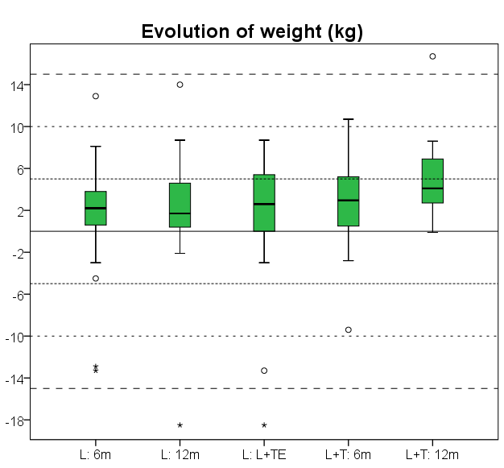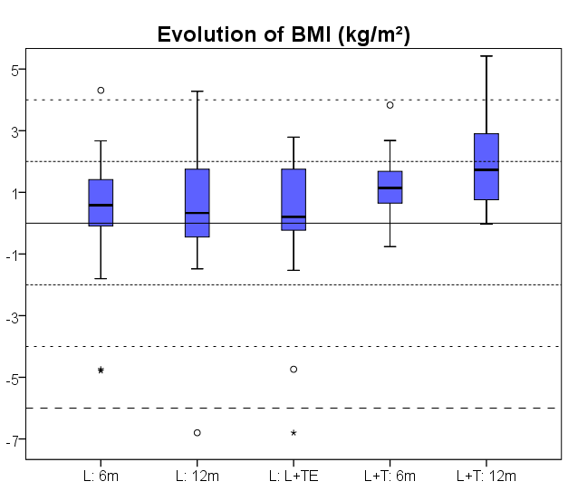
Figure 3. Box-and-whisker plots of evolution of weight and BMI. L: 6 months: weight/BMI evolution after 6 months of L (compared with start of L); L: 12 months: weight/BMI evolution after 12 months of L (compared with start of L); L: L+TE: weight/BMI evolution after entire monotherapy with L; L+TE: 6 months: weight/BMI evolution after 6 months of L+TE (compared with start of L+TE); L+TE: 12 months: weight/BMI evolution after 12 months of L+TE (compared with start of L+TE). L: lynestrenol monotherapy; L+TE: lynestrenol and testosterone esters combination therapy. Area between horizontal lines represent 5kg or 2kg/m².

Biochemical analyses

Safety and metabolic parameters
Mean hemoglobin (Hb) and hematocrit (Hct) levels increased significantly in the first 6 months of L and of L+TE but remained constant in the next 6 months. None of the individual Hb values rose above the upper adult male reference (Fig. 4a, b).
Only alanine amino transferase (ALT) but not aspartate amino transferase (AST) showed a statistically significant, although not clinically relevant rise after 12 months of L. In one patient, ALT levels transiently increased above the upper male reference to 57 U/L after 12 months of L but normalized after the start of L+TE. Both ALT and AST further increased under L+TE treatment but remained well within the male reference range. None of the patients reached the threshold of three times the upper reference limit which we considered the cut-off to stop treatment (Fig. 4c, d). Creatinine significantly increased during the first 6 months of L and during the first 6 months of L+TE but remained constant in the following 6 months (Fig. 4g).
Total cholesterol and triglyceride levels did not change during treatment; however, mean HDL decreased significantly and mean low-density lipoprotein (LDL) levels increased significantly in the first 6 months of L. During L+TE, mean LDL levels did not change significantly (Fig. 4e, f).
No significant changes in hemoglobin A1c (HbA1c), glucose levels, insulin levels, or homeostasis model assessment (HOMA) index were noticed during either L or L+TE.

Hormone levels
Although no significant changes in mean TSH levels were observed, fT4 levels increased significantly both in the first and second half year of L. In the first 6 months of L+TE, there was a decrease in TSH accompanied with a significant decrease in fT4 in the first and next 6 months of treatment. However, in all patients, serum levels for both TSH and fT4 remained well within the reference range (Table 6).
The eight patients who were using OC before L was started were excluded for baseline analysis of LH, FSH, E2 and SHBG. Mean AMH, T, and fT levels were not different in OC users as compared to non-OC users and were included in baseline analyses. Mean SHBG, LH, but not FSH levels decreased sharply during the first 6 months of L, whereas only LH decreased further in the next 6 months (Fig. 4h). Only after L+TE, LH and FSH were both fully suppressed (Fig. 4i). L caused a significant decrease in mean E2 levels at 6 months with no significant changes anymore thereafter (Fig. 4j). Mean Anti-Müllerian Hormone (AMH) levels did not change during the course of treatment. The significant decrease in T levels in the first 6 months of L was accompanied by a non-significant increase in fT. Both T and fT did not change in the next 6 months. As expected, mean T increased significantly in the first months of L+TE, already at the lowest dose (50 mg/2 weeks) and further increased in the next months to reach T values well within the male reference range. This was accompanied by a similar increase in fT levels. For fT, some patients exceeded the male upper reference of 25 ng/dL, due to blood sampling close to the last TE injection (Table 6 and Fig. 4k, l).

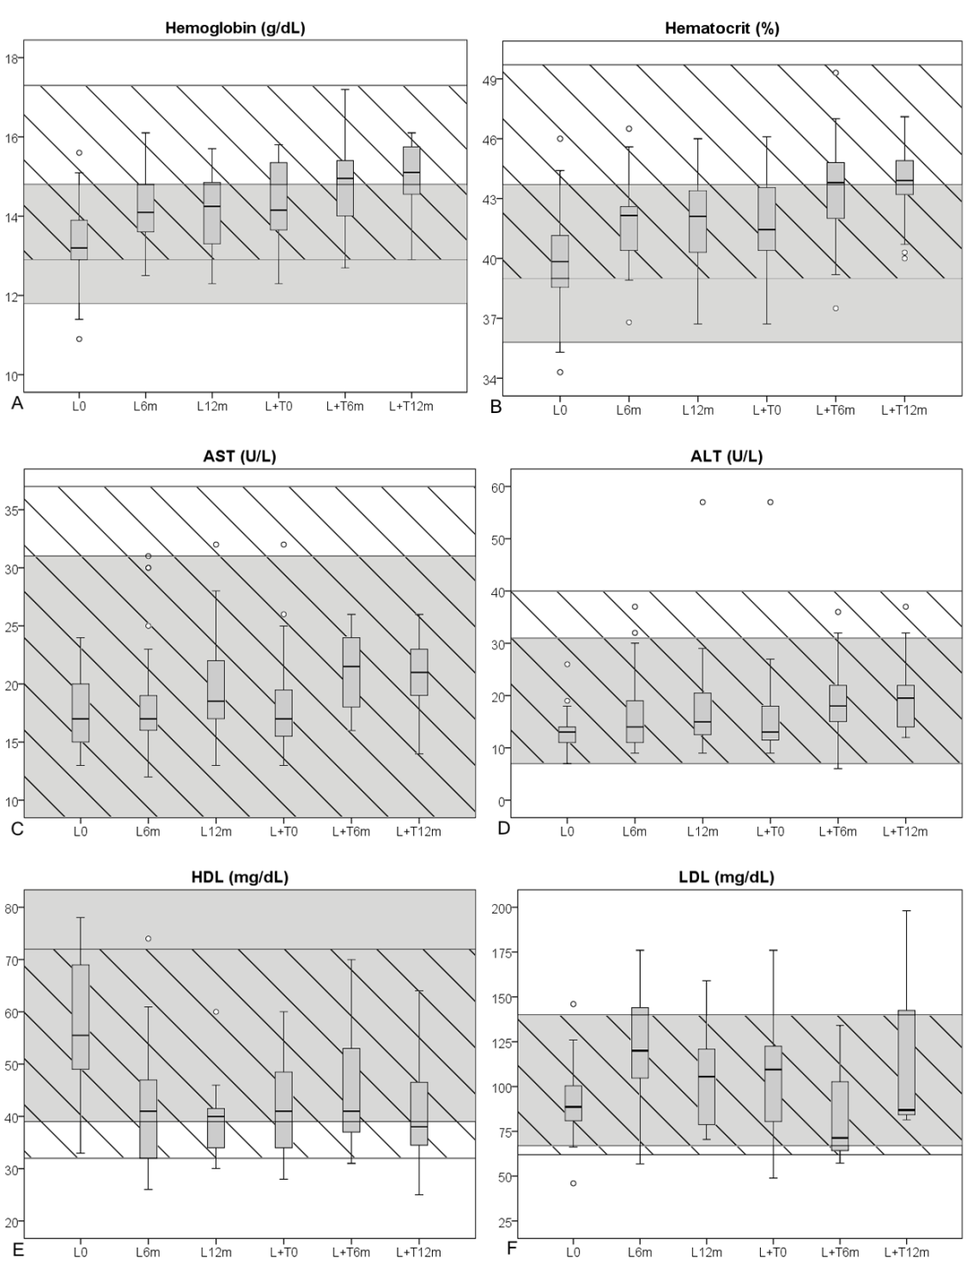
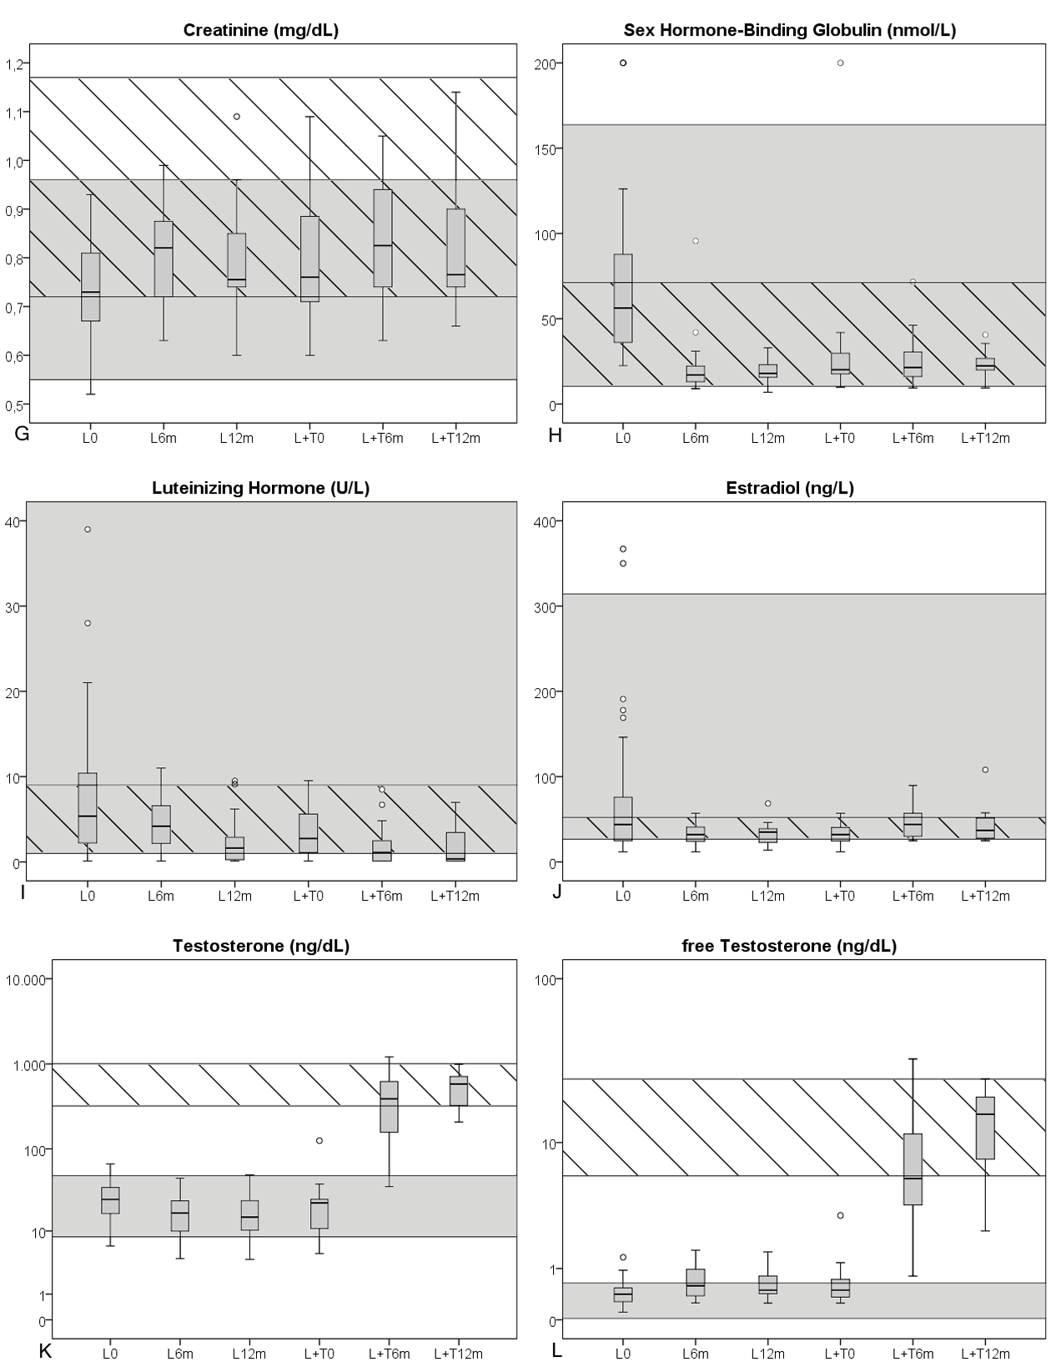
Figure 4. Box-and-whisker plots of biochemical parameters. L0: baseline values; L6m: after six months of L; L12m: after 12m of L; L+T0: before start of L+T; L+T6m: after 6 months of L+T; L+T12m: after 12 months of L+T. Grey zones: female reference range, hatched zones: male reference range. A: hemoglobin (g/dL, multiply by 10 for SI units: g/L); B: hematocrit (%, multiply by 0,01 for SI units: proportion of 1,0); C: AST (U/L, multiply by 0,0167 for SI units: µkat/L); D: ALT (U/L, multiply by 0,0167 for SI units: µkat/L); E: HDL (mg/dL, multiply by 0,0259 for SI units: mmol/L); F: LDL (mg/dL, multiply by 0,0259 for SI units: mmol/L); G: creatinine (mg/dL, multiply by 88,4 for SI units: µmol/L); H: Sex Hormone-Binding Globulin (nmol/L); I: Luteinizing Hormone (U/L); J: Estradiol (ng/L, multiply by 3,671 for SI units: pmol/L); K: Testosterone (ng/dL, multiply by 0,0347 for SI units: nmol/L); L: free Testosterone (ng/dL, multiply by 34,7 for SI units: pmol/L). L: lynestrenol monotherapy; L+T: lynestrenol and testosterone esters combination therapy. AST/ALT: Aspartate/Alanine Amino Transferase; HDL/LDL: High/Low Density Lipoprotein.

Table 6. Summary of analysis of biochemical data.
Test  Method of measurement | L0 | L6m | P (L0-6m) | L12m | P (L0-12m) | L+TE0 | L+TE6m | P (L+TE0-6m) | L+TE12m | P (L+TE0-12m)
Hemoglobin (g/L)  Spectrophotometry (Sysmex XE-5000) | 133,7 | 142,4 | <0,001 | 141,4 | 0,001 | 143,3 | 148,5 | <0,001 | 149,7 | <0,001
 | Reference (g/L): M<18y: 130-160, M>18y: 129-173, F<18y: 120-160, F>18y: 118-148
Hematocrit  DC impendance (Sysmex XE-5000) | 0,400 | 0,417 | <0,001 | 0,418 | 0,003 | 0,419 | 0,435 | 0,002 | 0,438 | <0,001
 | Reference (proportion of 1,0): M<18y: 0.37-0.49, M>18y: 0.39-0.497, F<18y: 0.36-0.46, F>18y: 0.358-0.437
Creatinine (µmol/L)  Rate-blanked Jaffé kinetic assay (Roche Diagnostics c701 (a+b)) | 65,416 | 71,604 | <0,001 | 70,72 | <0,001 | 69,836 | 73,372 | 0,052 | 72,488 | 0,045
 | Reference (µmol/L): M/F: 11-13y: 46.852-69.836, M/F: 13-15y: 50.388-76.908, M>15y: 63.648-103.428, F>15y: 48.62-84.864
Aspartate Amino Transferase (µkat/L)  UV-kinetic (IFCC) method without pyridoxal phosphate (Roche Diagnostics Cobas c701) | 0,30 | 0,31 | 0,903 | 0,33 | 0,091 | 0,31 | 0,35 | 0,031 | 0,35 | 0,003
 | Reference (µkat/L): M: 0-0.62, F:0-0.52
Alanine Amino Transferase (µkat/L)  UV-kinetic (IFCC) method without pyridoxal phosphate (Roche Diagnostics Cobas c701) | 0,22 | 0,27 | 0,121 | 0,31 | 0,012 | 0,28 | 0,31 | 0,079 | 0,34 | 0,045
 | Reference (µkat/L): M: 0.12-0.67, F: 0.12-0.52
Triglycerides (mmol/L)  Enzymatic colorimetric method (GPO-PAP and CHOD-PAP, Roche Diagnostics c701 (a+b)) | 0,838 | 0,870 | 0,31 | 0,661 | 0,128 | 0,651 | 0,934 | 0,18 | 1,394 | 0,18
 | Reference (mmol/L): M 10-15y: 0.362-1,413, M 15-20y: 0.418-1,672, F 10-15y: 0.418-1.48; F 15-20y: 0.441-1,492
Total cholesterol (mmol/L)  Enzymatic colorimetric method (GPO-PAP and CHOD-PAP, Roche Diagnostics c701 (a+b)) | 4,153 | 4,348 | 0,182 | 4,237 | 0,218 | 4,212 | 4,099 | 0,504 | 4,450 | 0,11
 | Reference (mmol/L): M 10-15y: 3.082-5.232, M 15-20y: 2.927-5.102, F 10-15y: 3.212-5.206, F 15-20y: 3.108-5.258
High Density Lipoprotein (mmol/L)  Enzymatic colorimetric method (Roche Diagnostics c701 (a+b)) | 1,481 | 1,096 | <0,001 | 1,017 | 0,002 | 1,098 | 1,194 | 0,419 | 1,085 | 0,77
 | Reference (mmol/L): M: 0.829-1.865, F: 1.010-2.486
Low Density Lipoprotein (mmol/L)  Calculated | 2,379 | 3,057 | 0,001 | 2,750 | 0,043 | 2,794 | 2,267 | NA | 3,163 | 0,09
 | Reference (mmol/L): M<20y: 1.606-3.626, F<20y: 1.735-3.626
Hemoglobin A1c  Ion-exchange chromatography (Tosoh HLV-723 G8) | 0,052 | 0,051 | 0,228 | 0,052 | 0,34 | 0,051 | 0,052 | 0,102 | 0,051 | 0,317
 | Reference (Proportion of 1.0): M/F: 0.04-0.055
Homeostasis Model Assessment insulin resistance  Calculated | 2,99 | 3,11 | 0,122 | 2,43 | 0,396 | 2,45 | 4,84 | NA | 7,44 | 0,185
 | Reference: M during puberty: <5.22, F during puberty: <3.82 or M/F: <4.39 ^{(55, 56)}
Thyroid Stimulating Hormone (mIU/L)  Electro-chemoluminescence assay (Roche Diagnostics E170 Modular) | 2,07 | 2,06 | 0,757 | 2,1 | 0,257 | 2,25 | 1,83 | 0,013 | 2,22 | 0,271
 | Reference (mIU/L): M/F 11-20y: 0,51-4,3
Free Thyroxin (pmol/L)  Electro-chemoluminescence assay (Roche Diagnostics E170 Modular) | 15,959 | 17,375 | 0,006 | 19,820 | <0,001 | 18,275 | 16,216 | 0,001 | 14,543 | 0,003
 | Reference (pmol/L): M/F 12-20 y: 12.613-20.978
Lutheinizing Hormone (IU/L)  Electro-chemoluminescence assay (Roche Diagnostics E170 Modular) | 7,56 | 4,63 | 0,065 | 2,58 | 0,042 | 3,41 | 1,93 | 0,004 | 1,68 | 0,028
 | Reference (IU/L): M: 1-9 U/L, F: 1-96U/L (cycle dependant)
Follicular Stimulating Hormone (IU/L)  Electro-chemoluminescence assay (Roche Diagnostics E170 Modular) | 5,15 | 5,18 | 0,785 | 4,36 | 0,623 | 4,96 | 2,95 | 0,001 | 2,56 | 0,019
 | Reference (IU/L): M: 1-12 U/L, F: 2-22U/L (cycle dependant)
Sex Hormone-Binding Globulin (nmol/L)  Electro-chemoluminescence assay (Roche Diagnostics E170 Modular) | 77,14 | 20,88 | <0,001 | 19,15 | 0,001 | 30,34 | 25,27 | 0,279 | 23,51 | 0,279
 | Reference (nmol/L): M<70y: 11,6-71,2, F<50y: 10,5-163,7
Estradiol (pmol/L)  Electro-chemoluminescence assay (Roche Diagnostics E170 Modular) | 277,564 | 119,895 | 0,002 | 120,225 | 0,122 | 117,802 | 175,841 | 0,107 | 156,348 | 0,701
 | Reference (pmol/L): M: 99.484-191.626, F: 98.016-1152.694 (cycle dependant)
Testosterone (nmol/L)  liquid chromatography tandem mass spectrometry (LC/MSMS) | 0,950 | 0,667 | 0,002 | 0,663 | 0,687 | 0,844 | 15,559 | <0,001 | 19,532 | 0,001
 | Reference (nmol/L): M: 11.139-34.874, F<50y: 0.291-1.669
Free Testosterone (pmol/L)  Calculated | 15,962 | 24,290 | 0,209 | 21,861 | 0,138 | 25,678 | 295,297 | 0,005 | 472,614 | 0,008
 | Reference (pmol/L): M: 208.2-867.5, F: 0.694-22.208
Anti-Müllerian Hormone (pmol/L)  Enzyme linked immunosorbent assay (Beckman Coulter Company) until 2/2015, thereafter Electro-chemoluminescence assay (Roche Diagnostics E170 Modular) | 33,214 | 25,714 | 0,066 | 24,000 | 0,423 | 24,357 | 28,429 | 0,18 | 27,072 | 0,575
 | Reference (pmol/L): M 6-20y 11.429-1028.578 (Tanner), F 8-20y: 4.7143-60.143
First column: biochemical parameters in SI units; L0: mean values before initiation of L; L6m: mean values after six months of L; P(L0-6m): P-values for comparison of baseline parameters with values after six months of L; L12m: mean values after twelve months of L; P(L0-12m): P-values for comparison of baseline parameters with values after twelve months of L; L+TE0: mean values before initiation of L+TE; L+TE6m: mean values after six months of L+TE; P(L+TE0-6m): P-values for comparison of baseline parameters with values after six months of L+TE; L+TE12m: mean values after twelve months of L+TE; P(L+TE0-12m): P-values for comparison of baseline parameters with values after twelve months of L+TE. NA: not available due to insufficient data. L: lynestrenol monotherapy; L+TE: lynestrenol and testosterone esters combination therapy. M: male reference, F: female reference. Y: years old. Cycle dependant: different reference ranges according to different stages of menstrual cycle (maximum upper and lower limit of all cycle stages are represented), Tanner: different reference ranges according to different Tanner stages (maximum upper and lower limit of all Tanner stages are represented).

Cyproterone acetate in male to female adolescents

Patients and treatment characteristics
Data on educational level, comorbidities, and lifestyle characteristics are represented in Table 7.
Mean age at start of CA and CA+E was 16 years 6 months, and 17 years 7 months, respectively. Mean treatment duration for CA was 11 months and for CA+E 12 months. One patient stopped treatment with CA after 12 months because he no longer wished to pursue gender reassignment. His data were therefore only included for the analyses of CA in monotherapy. Six adolescents had a psychiatric comorbidity: ASD was documented in four adolescents, associated with automutilation in one. Depression(s) was found in two (one also had ASD) and ADHD was diagnosed in one adolescent. Six adolescents had vulnerable social situation, such as being raised in a single-parent family, residency in foster care or institution, parental alcohol abuse or having a severely handicapped brother to look after.
As compared to the general male Flemish population, a considerably higher number of MtF transgender adolescents attended vocational training (mostly hairdressing) or art school. Reported side effects and patient characteristics are shown in Table 7.

Side effects
Over half of the adolescents reported a decreased frequency of facial shaving already during CA. Two adolescents underwent laser treatment to remove facial hair (one during CA, one during CA+E). Breast development was noticed during CA in 28% of the patients, reaching Tanner B2-3. During CA+E, 82,4% reached Tanner B3-4, however with objectively small and subjectively unsatisfactory breast volume in most cases. Breast tenderness, increased emotionality and hunger were most frequently reported during CA+E; fatigue was prevalent during CA. Hot flushes were reported by some during both treatment phases.
Table 7. Summary of patient characteristics and side effects
Comorbidity | Education | Side effects
Psychiatric: 6/27 (22,2%)  Social: 6/27 (22,2%)  DSD: 0/27 (0%) | ASO: 4/27 (14,8%)  TSO: 8/27 (29,6%)  BSO: 10/27 (37,0%)  BUSO: 1/27 (3,7%)  KSO: 4/27 (14,8%) | Side effect | CA | CA+E
 |  | Breast tenderness  Emotionality  Hunger  Fatigue  Flushes | 2/25 (8%)  2/25 (8%)  0/25 (0%)  8/25 (32%)  1/25 (4%) | 8/17 (47,1%)  4/17 (23,5%)  4/17 (23,5%)  2/17 (11,8%)  2/17 (11,8%)
Smoking | Alcohol | Effect | CA | CA+E
No: 20/27 (74,1%)  Yes: 7/27 (25,9%)  High: 2/27 (7,4%) | No: 16/27 (59,3%)  Yes: 11/27 (40,7%)  High: 3/27 (11,1%) | Decreased shaving need | 14/25 (56,0%) | 10/17 (58,8%)
 |  | Breast development | B2: 3/25 (12,0%)  B3: 4/25 (16,0) | B3: 13/17 (76,5%)  B4: 1/17 (5,9%)
Smoking: Yes: any amount of cigarettes on regular bases; High: >20 cigarettes a day. Alcohol: Yes: any amount; High: >21 consumptions a week. ASO: theoretical education, TSO: technical education, BSO: vocational training, BUSO: school for children with learning difficulties, KSO: art school. CA: cyproterone acetate monotherapy; CA+E: Cyproterone acetate and 17β-estradiol combination therapy.

Anthropometry
Mean height at start of CA and CA+E were 174,6 cm and 175,6 cm respectively. No clinically important changes in body weight and BMI were noted over the course of treatment. In comparison with their age-matched male peers, based on SD scores (55), weight gain was significantly less during treatment with CA. However, after adjusting for height (BMI), the difference was not significant. Weight, height and BMI are represented in Table 8 and Figure 5.
Table 8. Summary of anthropometric data
Treatment phase | Weight |  | Height |  | BMI
 | kg | SD | cm | SD | kg/m² | SD
CA: 6 months  (P-value) | -0,02  (0,989) | -0,200  (0,039) | +0,4  (0,017) | -0,138  (<0,001) | -0,15  (0,958) | -0,128  (0,217)
CA: 12 months  (P-value) | +1,58  (0,478) | -0,300  (0,076) | +1,1  (0,036) | -0,330  (0,006) | +0,29  (0,680) | -0,190  (0,304)
CA: CA+E  (P-value) | +1,21  (0,525) | -0,311  (0,018) | +1,0  (0,013) | -0,338  (0,004) | +0,18  (0,663) | -0,172  (0,205)
CA+E: 6 months  (P-value) | +0,45  (0,513) | -0,053  (0,443) | +0,2  (0,034) | -0,046  (0,053) | +0,12  (0,423) | -0,076  (0,342)
CA+E: 12 months  (P-value) | +2,27  (0,050) | +0,037  (0,757) | +0,3  (0,122) | -0,128  (0,012) | +0,63  (0,028) | -0,014  (0,766)
CA: 6 months: mean difference after 6 months of CA (compared with start of CA); CA: 12 months: mean difference after 12 months of CA (compared with start of CA); CA: CA+E: mean difference during entire monotherapy with CA; CA+E: 6 months: mean difference after 6 months of CA+E (compared with start of CA+E); CA+E: 12 months: mean difference after 12 months of CA+E (compared with start of CA+E); P-value: result of statistical tests; Weight: difference expressed in kg; Height expressed in cm; BMI: difference in kg/m². SD: standard deviation in comparison with Flemish peers (55); CA: cyproterone acetate monotherapy; CA+E: cyproterone acetate and 17β-estradiol combination therapy.

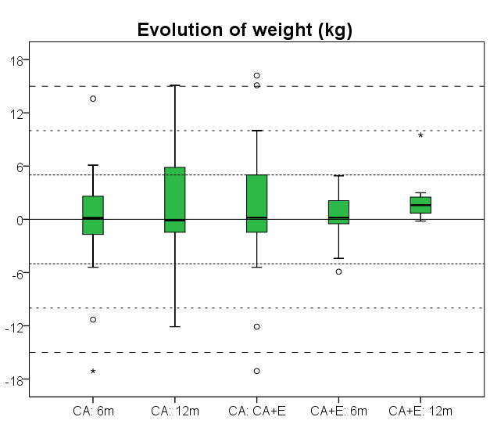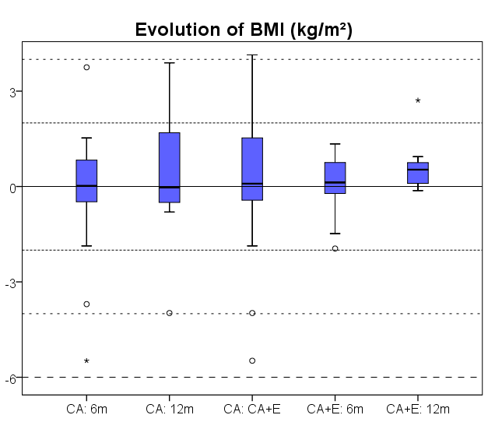
Figure 5. Box-and-whisker plots of evolution of weight and BMI. CA: 6 months: weight/BMI evolution after 6 months of CA (compared with start of CA); CA: 12 months: weight/BMI evolution after 12 months of CA (compared with start of CA); CA: CA+E: weight/BMI evolution after entire monotherapy with CA; CA+E: 6 months: weight/BMI evolution after 6 months of CA+E (compared with start of CA+E); CA+E: 12 months: weight/BMI evolution after 12 months of CA+E (compared with start of CA+E). CA: cyproterone acetate monotherapy; CA+E: cyproterone acetate and 17β-estradiol combination therapy. Horizontal lines represent 5kg or 2kg/m².

Biochemical analyses

Safety and metabolic parameters
Mean Hb and Hct levels decreased progressively and significantly during CA and remained constant during CA+E (Fig. 6a, b). Creatinine levels showed a non-significant decreasing trend during CA, and stabilised during CA+E (Fig. 6c). There were no significant changes in AST and ALT levels. Transient elevations of liver enzymes were seen in four adolescents. None of the patients reached the threshold of three times the upper reference limit which we considered the cut-off to stop treatment (Fig. 6e, f).
Total cholesterol, triglyceride and HDL decreased during CA, but increased again after addition of E. LDL remained fairly stable over the course of treatment (Fig. 6d). No significant changes were noticed in parameters assessing insulin sensitivity: HbA1c, glucose levels, insulin levels, or homeostasis model assessment (HOMA) index did not change during either CA or CA+E treatment (data not shown).

Hormone levels
fT4 levels slightly increased during CA, with stable TSH levels. In contrast, after addition of E, TSH levels significantly increased with stable fT4 levels. These changes were not considered clinically relevant (Table 9). Z-scores of IGF-1 remained constant over the entire course of treatment (data not shown).
Gonadotropin levels non-significantly increased during CA and decreased during CA+E (Fig. 6g). E2 levels were mostly below the detection limit of 25ng/L, at baseline and during CA, but also after 12months of CA+E. Therefore, we were unable to quantify the “real” changes in E2 levels (Fig. 6i). Total and free T levels significantly and progressively decreased over the course of treatment. Levels dropped below the male reference range, but did not reach the female reference range (Fig. 6k, l). Inhibin B levels decreased significantly under CA, but restored during CA+E (Table 9). Significant increments in PRL levels were noted during CA (Fig. 6j) but none of the adolescents experienced galactorrhea. SHBG, Androstenedione and DHEAS levels reached a nadir under CA and partially restored after addition of E (Table 9).
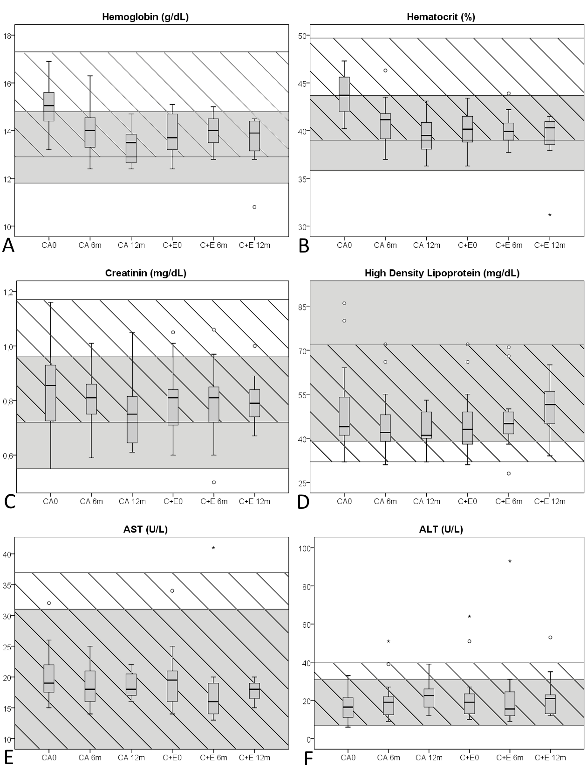
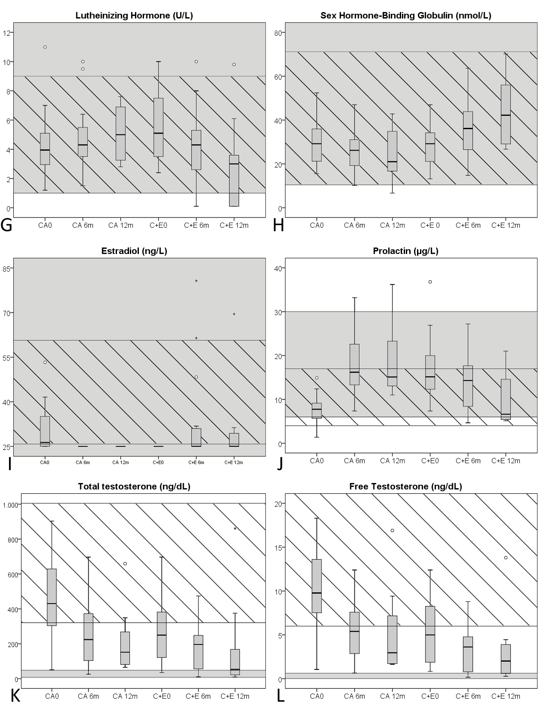
Figure 6. Box-and-whisker plots of biochemical parameters. CA0: baseline values; CA6m: after six months of CA; CA 12m: after 12m of CA; C+E0: before start of C+E; C+E 6m: after 6 months of C+E; C+E 12m: after 12 months of C+E. Grey zones: female reference range, hatched zones: male reference range. A: hemoglobin (g/dL, multiply by 10 for SI units: g/L); B: hematocrit (%, multiply by 0,01 for SI units: proportion of 1,0); C: creatinine (mg/dL, multiply by 88,4 for SI units: µmol/L); D: HDL (mg/dL, multiply by 0,0259 for SI units: mmol/L); E: AST (U/L, multiply by 0,0167 for SI units: µkat/L); F: ALT (U/L, multiply by 0,0167 for SI units: µkat/L); G: Luteinizing Hormone (U/L); H: Sex Hormone-Binding Globulin (nmol/L); I: Estradiol (ng/L, multiply by 3,671 for SI units: pmol/L); J: Prolactin (µg/L, multiply by 43,478 for SI units: pmol/L); K: Testosterone (ng/dL, multiply by 0,0347 for SI units: nmol/L); L: free Testosterone (ng/dL, multiply by 34,7 for SI units: pmol/L). CA: Cyproterone acetate monotherapy; C+E: cyproterone acetate and 17β-estradiol combination therapy. AST/ALT: Aspartate/Alanine Amino Transferase; HDL: High Density Lipoprotein.

Table 9. Summary of analysis of biochemical data.
Test  Method of measurement | CA0 | CA6m | P (CA0-6m) | CA12m | P (CA0-12m) | CA+E0 | CA+E6m | P (CA+E0-6m) | CA+E12m | P (CA+E0-12m)
Hemoglobin (g/L)  Spectrophotometry (Sysmex XE-5000) | 150,2 | 139,8 | <0,001 | 133,9 | 0,003 | 137,9 | 139,5 | 0,670 | 134,7 | 1,000
 | Reference (g/L): M<18y: 130-160, M>18y: 129-173, F<18y: 120-160, F>18y: 118-148
Hematocrit  DC impendance (Sysmex XE-5000) | 0,438 | 0,408 | <0,001 | 0,395 | 0,002 | 0,402 | 0,401 | 0,359 | 0,390 | 0,735
 | Reference (proportion of 1,0): M<18y: 0.37-0.49, M>18y: 0.39-0.497, F<18y: 0.36-0.46, F>18y: 0.358-0.437
Creatinine (µmol/L)  Rate-blanked Jaffé kinetic assay (Roche Diagnostics c701 (a+b)) | 73,779 | 70,861 | 0,145 | 66,698 | 0,709 | 69,712 | 69,111 | 0,355 | 70,914 | 0,919
 | Reference (µmol/L): M/F: 11-13y: 46.852-69.836, M/F: 13-15y: 50.388-76.908, M>15y: 63.648-103.428, F>15y: 48.62-84.864
Aspartate Amino Transferase (µkat/L)  UV-kinetic (IFCC) method without pyridoxal phosphate (Roche Diagnostics Cobas c701) | 0,34 | 0,31 | 0,175 | 0,31 | 0,498 | 0,32 | 0,30 | 0,758 | 0,30 | 1,000
 | Reference (µkat/L): M: 0-0.62, F:0-0.52
Alanine Amino Transferase (µkat/L)  UV-kinetic (IFCC) method without pyridoxal phosphate (Roche Diagnostics Cobas c701) | 0,28 | 0,33 | 0,134 | 0,38 | 0,311 | 0,37 | 0,37 | 0,614 | 0,39 | 0,237
 | Reference (µkat/L): M: 0.12-0.67, F: 0.12-0.52
Triglycerides (mmol/L)  Enzymatic colorimetric method (GPO-PAP and CHOD-PAP, Roche Diagnostics c701 (a+b)) | 0,930 | 0,764 | 0,333 | 0,766 | 0,046 | 0,644 | 0,928 | 0,179 | 0,827 | 0,536
 | Reference (mmol/L): M 10-15y: 0.362-1,413, M 15-20y: 0.418-1,672, F 10-15y: 0.418-1.48; F 15-20y: 0.441-1,492
Total cholesterol (mmol/L)  Enzymatic colorimetric method (GPO-PAP and CHOD-PAP, Roche Diagnostics c701 (a+b)) | 3,764 | 3,664 | 0,349 | 3,605 | 0,244 | 3,570 | 3,737 | 0,281 | 3,509 | 0,710
 | Reference (mmol/L): M 10-15y: 3.082-5.232, M 15-20y: 2.927-5.102, F 10-15y: 3.212-5.206, F 15-20y: 3.108-5.258
High Density Lipoprotein (mmol/L)  Enzymatic colorimetric method (Roche Diagnostics c701 (a+b)) | 1,278 | 1,172 | 0,091 | 1,105 | 0,219 | 1,163 | 1,224 | 0,954 | 1,308 | 0,095
 | Reference (mmol/L): M: 0.829-1.865, F: 1.010-2.486
Low Density Lipoprotein (mmol/L)  Calculated | 2,099 | 2,039 | 0,766 | 2,361 | 0,788 | 2,118 | 1,741 | 0,571 | 2,152 | 0,552
 | Reference (mmol/L): M<20y: 1.606-3.626, F<20y: 1.735-3.626
Thyroid Stimulating Hormone (mIU/L)  Electro-chemoluminescence assay (Roche Diagnostics E170 Modular) | 2,2036 | 2,1945 | 0,546 | 2,1743 | 0,917 | 2,3944 | 1,7436 | 0,05 | 1,9875 | 0,637
 | Reference (mIU/L): M/F 11-20y: 0,51-4,3
Free Thyroxin (pmol/L)  Electro-chemoluminescence assay (Roche Diagnostics E170 Modular) | 16,786 | 18,018 | 0,031 | 18,501 | 0,167 | 18,472 | 18,447 | 0,668 | 18,501 | 0,822
 | Reference (pmol/L): M/F 12-20 y: 12.613-20.978
Lutheinizing Hormone (IU/L)  Electro-chemoluminescence assay (Roche Diagnostics E170 Modular) | 4,17 | 4,64 | 0,123 | 5,07 | 0,168 | 5,54 | 4,02 | 0,077 | 3,00 | 0,053
 | Reference (IU/L): M: 1-9 U/L, F: 1-96U/L (cycle dependant)
Follicular Stimulating Hormone (IU/L)  Electro-chemoluminescence assay (Roche Diagnostics E170 Modular) | 4,19 | 3,32 | 0,005 | 5,45 | 0,373 | 5,19 | 3,97 | 0,187 | 2,68 | 0,102
 | Reference (IU/L): M: 1-12 U/L, F: 2-22U/L (cycle dependant)

Sex Hormone-Binding Globulin (nmol/L)  Electro-chemoluminescence assay (Roche Diagnostics E170 Modular) | 30,13 | 25,82 | 0,074 | 23,90 | 0,802 | 28,36 | 37,07 | 0,081 | 43,94 | 0,151
 | Reference (nmol/L): M<70y: 11,6-71,2, F<50y: 10,5-163,7
Estradiol (pmol/L)  Electro-chemoluminescence assay (Roche Diagnostics E170 Modular) | 113,685 | 91,775 | 0,005 | 91,775 | 0,317 | 91,775 | 121,208 | 0,012 | 114,984 | 0,068
 | Reference (pmol/L): M: 99.484-191.626, F: 98.016-1152.694 (cycle dependant)
Testosterone (nmol/L)  liquid chromatography tandem mass spectrometry (LC/MSMS) | 15,821 | 8,696 | <0,001 | 7,348 | 0,022 | 9,582 | 6,857 | 0,008 | 5,951 | 0,074
 | Reference (nmol/L): M: 11.139-34.874, F<50y: 0.291-1.669
Free Testosterone (pmol/L)  Calculated | 339,824 | 186,058 | 0,002 | 183,174 | 0,889 | 184,528 | 116,117 | 0,004 | 117,546 | 0,208
 | Reference (pmol/L): M: 208.2-867.5, F: 0.694-22.208
Inhibin B (ng/L)  Enzyme Immunoassay (Wallac Victor 2, Perkin Elmer) | 205,3 | 197,0 | 0,173 | 112,0 | 0,028 | 152,8 | 201,1 | 0,096 | 117,4ª | 0,242
 | Reference (ng/L): M: 67-323 (Tanner IV-V), F: <15-205 (Tanner IV-V)
Prolactin (pmol/L)  Siemens immulite | 334,0 | 777,2 | <0,001 | 838,5 | 0,012 | 726,0 | 634,0 | 0,917 | 458,7 | 0,043
 | Reference (pmol/L): M: 173,9-739,1, F: 260,9-695,6
DHEAS (µmol/L)  Electro-chemoluminescence assay (Roche Diagnostics E170 Modular) | 0,803 | 0,791 | 0,954 | 0,653 | 0,002 | 0,709 | 0,740 | 0,268 | 0,659 | 0,322
 | Reference (µmol/L): M: 0,183-1,279, F: 0,169-0,957
∆4 androstenedione (nmol/L)  liquid chromatography tandem mass spectrometry (LC/MSMS) | 6,099 | 2,338 | <0,001 | 2,325 | 0,008 | 2,574 | 2,802 | 0,139 | 4,224^{b} | 0,18
 | Reference (nmol/L): M 14-18y: 0,628-4,118, M 18-40y: 1,152-4,677, F 14-18y: 1,222-7,399, F 18-40y: 0,907-7,469
First column: biochemical parameters in SI units; CA0: mean values before initiation of CA; CA6m: mean values after six months of CA; P(CA0-6m): P-values for comparison of baseline parameters with values after six months of CA; CA12m: mean values after twelve months of CA; P(CA0-12m): P-values for comparison of baseline parameters with values after twelve months of CA; CA+E0: mean values before initiation of CA+E; CA+E6m: mean values after six months of CA+E; P(CA+E0-6m): P-values of comparison of baseline parameters with values after six months of CA+E; CA+E12m: mean values after twelve months of CA+E; P(CA+E0-12m): P-values for comparison of baseline parameters with values after twelve months of CA+E. CA: cyproterone acetate monotherapy; CA+E: cyproterone acetate and 17β-estradiol combination therapy. M: male reference, F: female reference. Y: years old. Cycle dependant: different reference ranges according to different stages of menstrual cycle (maximum upper and lower limit of all cycle stages are represented), Tanner: different reference ranges according to different Tanner stages (maximum upper and lower limit of all Tanner stages are represented). a: In all patients who had continued CA+E for 12 months, inhibin B levels had increased as compared to start of CA+E. Absolute values of Inhibin B at CA+E12m were lower as compared to baseline due to the fact that only a subgroup of individuals who had measurements at baseline and 6 months had continued treatment for 12 months, making direct comparison difficult. b: Similar to the phenomenon described in a, mean ∆4 androstenedione levels decreased after 12 months of CA+E as compared to baseline.

Monotherapy of progestins on the musculoskeletal system

Patients and treatment
Investigations were performed in 48 adolescents before initiation of progestin monotherapy and before association of the progestin with CSH. Thirty-three FtM transgender adolescents received L; fifteen MtF transgender adolescents were given CA. Mean treatment duration with progestins was 11,5 months.

Biochemical data (Table 10)
P1NP, a marker for bone formation, decreased significantly in both the L and CA groups. DP1, a marker for bone degradation, did not change in both groups. Due to supplementation and dietary advice, mean vitamin D levels increased in both groups. However, fCa increased only in the L group, whereas it decreased significantly in the CA group.
Table 10. Biochemical parameters
Biochemical
Parameter | Mean before L | Mean before CSH | P (L) | Mean before CA | Mean before CSH | P (CA)
Vitamin D (ng/mL) | 17,73 | 23,18 | 0,002 | 18,05 | 24,79 | 0,039
DP1 (ng/mL) | 0,741 | 0,770 | 0,578 | 1,120 | 0,966 | 0,176
P1NP (µg/L) | 163,46 | 137,19 | 0,047 | 297,32 | 133,88 | 0,005
fCa (%) | 0,297 | 0,316 | 0,054 | 0,351 | 0,334 | 0,012
Mean before L/CA: baseline; Mean before CSH: mean levels before start CSH; P (L/CA): results of statistical tests; DP1: Type I collagen degradation product (Electro-chemoluminescence assay); P1NP: procollagen type I N-terminal propeptide (Electro-chemoluminescence assay); fCA: fractional calcium excretion (calculated); L: lynestrenol; CA: cyproterone acetate.

Anthropometrics and grip strength (Table 11)
Taking L, FtM transgender adolescents grew an average of 0,9 cm and gained 2,2 kg during the study period, which is not significantly different from age-matched female peers. Both waist and hip circumference increased significantly, leading to a constant waist/hip ratio (Fig. 7). An increase in grip strength was noted in the dominant and non-dominant hand (Fig. 7). MtF transgender adolescents treated with CA grew on average 0,8 cm, and gained approximately 1,5 kg, which is significantly less than their age-matched male peers. Their waist circumference significantly decreased, whilst hip circumference remained constant, leading to a significantly decreased waist/hip ratio (Fig. 7). These adolescents had a stable grip strength (Fig. 7).
Table 11. Anthropometrics & grip strength
Anthropometrics & Grip strength
Parameter | Mean before L | Mean before CSH | P (L) | Mean before CA | Mean before CSH | P (CA)
Grip dom (kg) | 29,0 | 32,2 | <0,001 | 34,0 | 34,9 | 0,678
Grip non-dom (kg) | 25,5 | 29,3 | <0,001 | 29,4 | 30,9 | 0,302
Length (cm) | 165,6 | 166,5 | <0,001 | 174,3 | 175,1 | 0,055
Weight (kg) | 62,97 | 65,18 | 0,007 | 70,67 | 72,23 | 0,457
Waist Circumf (cm) | 75,33 | 77,73 | 0,031 | 82,71 | 76,54 | 0,028
Hip Circumf (cm) | 97,97 | 100,51 | 0,045 | 94,40 | 94,71 | 0,903
W/H ratio | 0,776 | 0,773 | 0,485 | 0,878 | 0,805 | 0,005
Mean before L/CA: baseline; Mean before CSH: mean levels before start CSH; P (L/CA): results of statistical tests; Grip dom: grip strength of the dominant hand (expressed in kilograms); Grip non-dom: grip strength of the non-dominant hand (expressed in kilograms); circumf: circumference; W/H ratio: waist/hip ratio; L: lynestrenol; CA: cyproterone acetate.
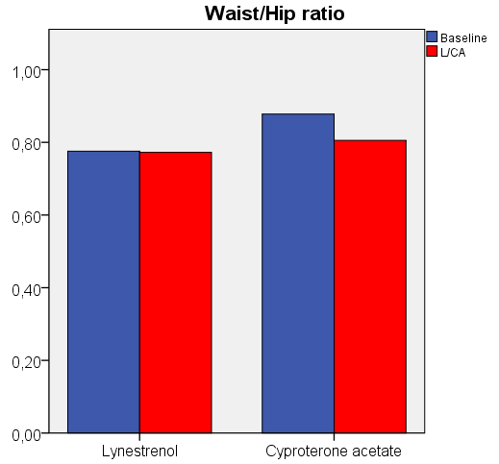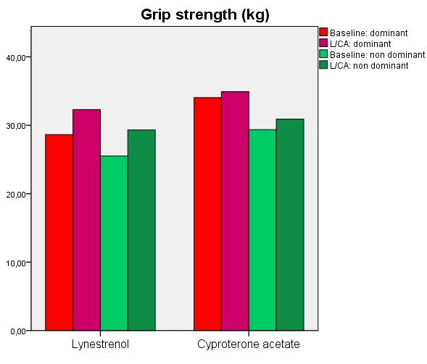
Figure 7. Bar plots of evolution of waist/hip ratio (left) and grip strength (right). Baseline: before initiation of progestin; L/CA: before start of CSH; dominant: grip strength of the dominant hand; non dominant: grip strength of the non-dominant hand.

Body composition (Table 12)
Lean mass significantly increased and fat mass remained constant in FtM transgender adolescents, leading to an increased total body mass and slightly decreased body fat percentage. This is significantly different from their age-matched female peers, as calculated from population-based Z-scores. Muscle area significantly increased at the non-dominant forearm and left lower leg (radius 66%, tibia 38%), this increase was significantly higher than what was observed in age-matched peers of the same natal sex, based on Z-scores. Fat area and muscle density at the forearm and lower leg remained constant.
MtF transgender adolescents treated with CA showed an increase in fat mass and a decrease in lean mass. This led to a stable total body weight. However, the percentage of body fat significantly increased. This increase was significantly greater than what has been observed in their age-matched male peers, based on Z-scores. At the forearm and lower leg (radius 66%, tibia 38%), muscle area and density respectively significantly and non-significantly decreased, whereas fat area significantly increased. Based on Z-scores these changes are significantly different from their age-matched peers of the same sex.
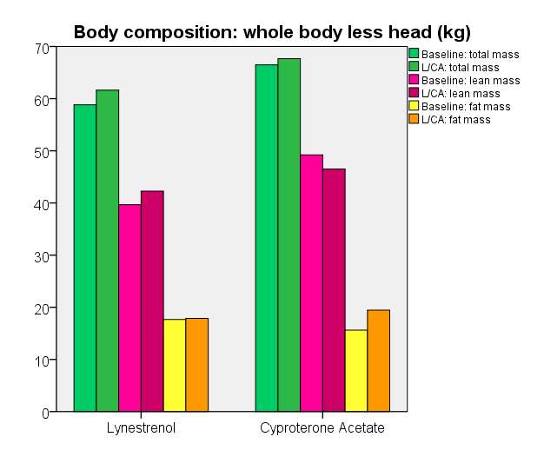
Figure 8. Bar plots of evolution in body composition. Baseline: before initiation of progestin; L/CA: before start of CSH.
Table 12. Summary of changes in body composition.
Body composition (DXA results)
Location | Mean before L | Mean before CSH | P (L) | Mean before CA | Mean before CSH | P (CA)
Subtotal fat mass (g) | 17487,24 | 17507,51 | 0,765 | 15618,76 | 19441,94 | 0,017
%Fat (%) | 28,95 | 27,67 | 0,062 | 22,72 | 27,54 | 0,001
Z-scores: %fat | -0,140 | -0,405 | 0,010 | 0,421 | 0,977 | 0,001
Lean mass (g) | 39672,39 | 42264,60 | <0,001 | 49213,69 | 46523,78 | 0,003
Total mass (g) | 58542,94 | 61108,77 | 0,006 | 66476,65 | 67668,93 | 0,583
pQCT: Radius 66%
Location | Mean before L | Mean before CSH | P (L) | Mean before CA | Mean before CSH | P (CA)
Muscle density | 78,31 | 78,41 | 0,735 | 78,33 | 76,88 | 0,055
Muscle area | 2463,72 | 2720,68 | <0,001 | 3346,21 | 3067,64 | 0,019
Z-scores: Muscle area | -0,762 | 0,031 | <0,001 | -0,664 | -1,327 | 0,001
Fat area | 1512,31 | 1525,98 | 0,845 | 1190,70 | 1535,09 | 0,013
Z-scores: Fat area | 0,541 | 0,424 | 0,447 | 0,564 | 1,391 | 0,033
pQCT: Tibia 38%
Location | Mean before L | Mean before CSH | P (L) | Mean before CA | Mean before CSH | P (CA)
Muscle density | 78,11 | 78,30 | 0,797 | 76,95 | 76,39 | 0,480
Muscle area | 3307,29 | 3398,98 | 0,002 | 4204,18 | 3827,83 | 0,315
Fat area | 2907,83 | 2913,01 | 0,586 | 2081,31 | 2597,79 | 0,027
Mean before L/CA: baseline; Mean before CSH: mean levels before start CSH; P (L/CA): results of statistical tests; Subtotal: whole body without the head. Mean M: mean values before start of progestin; Mean C: mean levels before start CSH; L: lynestrenol; CA: cyproterone acetate.

Bone development: DXA results (Table 13)

FtM adolescents
FtM adolescents had a significant increase of the aBMC at the total hip, whilst bone area remained constant. This led to a significant increase in absolute values and z-scores of aBMD. At the femoral neck, representing mainly cortical bone, Z-scores of aBMD did not change.
At the lumbar spine, representing mostly trabecular bone, aBMC increased and bone area did not change, leading to an increased aBMD. aBMD Z-scores did not change, pointing at an evolution similar to age-matched female peers.
For whole body, only values less head are reported. Areal BMC and bone area significantly increased; aBMD only slightly and non-significantly increased.

MtF adolescents
In MtF adolescents taking CA, DXA scans of the hip revealed an increase in bone area and decrease in aBMC, leading to a decreased aBMD, which was significant at the femoral neck. Compared with their age-matched male peers, Z-scores of the total hip and femoral neck significantly decreased.
At the lumbar spine, Bone area and aBMC both increased with as a consequence, a fairly stable aBMD. This resulted in significantly decreased Z-scores.
Whole body less head DXA scan revealed an increase in bone area and aBMC; aBMD did not change. However, this resulted in significantly decreased Z-scores.
Of note, Z-scores of aBMD at all sites were already negative at baseline in all adolescents and most pronounced in the MtF transgender adolescents.
Table 13. Summary of results: DXA scans.
DXA Hip
Location | Mean before L | Mean before CSH | P (L) | Mean before CA | Mean before CSH | P (CA)
Total hip Area | 34,127 | 34,036 | 0,525 | 39,390 | 39,500 | 0,724
aBMC | 31,491 | 31,908 | 0,025 | 37,127 | 36,593 | 0,219
aBMD | 0,923 | 0,937 | 0,003 | 0,943 | 0,928 | 0,086
Z-scores: BMD | -0,197 | -0,069 | 0,001 | -0,567 | -0,787 | 0,031
Femoral neck Area | 5,035 | 5,103 | 0,152 | 5,480 | 5,556 | 0,087
aBMC | 4,109 | 4,188 | 0,046 | 4,691 | 4,664 | 0,665
aBMD | 0,814 | 0,819 | 0,381 | 0,858 | 0,841 | 0,049
Z-scores: BMD | -0,266 | -0,244 | 0,598 | -0,487 | -0,760 | 0,012
DXA Lumbar spine
Location | Mean before L | Mean before CSH | P (L) | Mean before CA | Mean before CSH | P (CA)
Total Area | 56,473 | 56,789 | 0,254 | 58,099 | 59,474 | 0,001
aBMC | 53,443 | 54,435 | 0,022 | 52,478 | 54,305 | 0,011
aBMD | 0,943 | 0,956 | 0,007 | 0,901 | 0,912 | 0,345
Z-score: BMD | -0,377 | -0,381 | 0,968 | -0,457 | -0,864 | 0,015
DXA Whole body
Location | Mean before L | Mean before CSH | P (L) | Mean before CA | Mean before CSH | P (CA)
Whole body Area | 1943,62 | 1972,39 | 0,001 | 2113,26 | 2177,54 | 0,003
aBMC | 1975,40 | 2030,72 | <0,001 | 2139,26 | 2218,93 | 0,002
aBMD | 1,014 | 1,028 | <0,001 | 1,006 | 1,016 | 0,190
Z-score: BMD | -0,813 | -0,813 | 1,000 | -1,280 | -1,587 | 0,017
Subtotal Area | 1720,82 | 1750,24 | <0,001 | 1868,12 | 1932,37 | 0,003
aBMC | 1479,00 | 1514,81 | 0,001 | 1644,19 | 1703,20 | 0,006
aBMD | 0,856 | 0,862 | 0,102 | 0,875 | 0,878 | 0,631
Mean before L/CA: baseline; Mean before CSH: mean levels before start CSH; P (L/CA): results of statistical tests, aBMC: areal bone mineral content, aBMD: areal bone mineral density; Subtotal: whole body less head; L: lynestrenol; CA: cyproterone acetate.
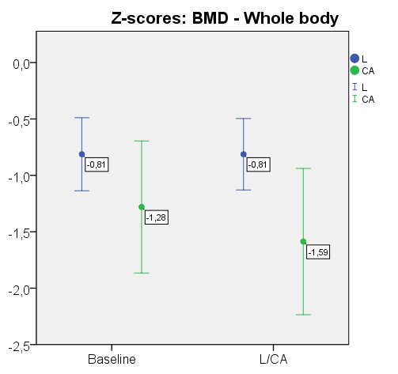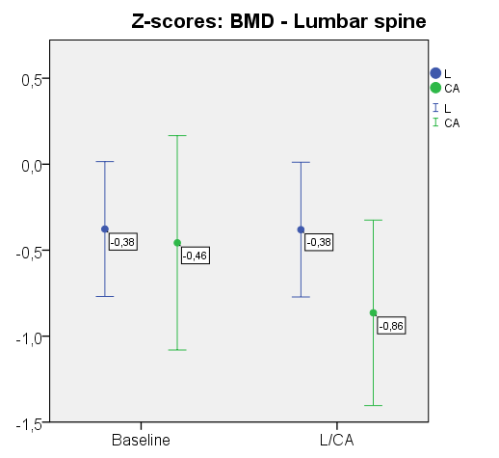

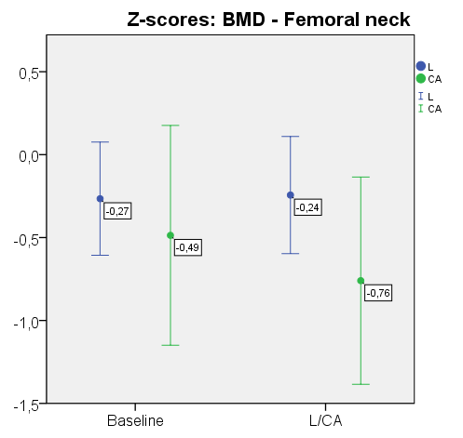
Figure 9. Evolution of Z-scores: BMD of whole body (upper left), lumbar spine (right), and femoral neck (lower left). Baseline: before initiation of progestin; L/CA: before start of CSH

Bone development pQCT (Table 14)
In FtM adolescents, both trabecular and cortical bone parameters (area, vBMC, vBMD) at the radius and the tibia increased during the study period, to the same extent as in age-matched control girls.
Z-scores of the strength strain index were unaltered at the midshaft radius.
In contrast, in MtF adolescents taking CA, trabecular vBMD decreased at the metaphysis of the radius and tibia, Z-scores only significantly decreased at the radius.
Significant increases of the cortical vBMC and vBMD were noted at both midshaft tibia and radius.
Z-scores of the strength strain index at the midshaft radius decreased significantly.
Table 14. Summary of results: pQCT scans.
Bone - Radius 4%
Total
Location | Mean before L | Mean before CSH | P (L) | Mean before CA | Mean before CSH | P (CA)
Area | 332,76 | 338,90 | 0,809 | 365,15 | 362,38 | 0,784
vBMC | 105,56 | 109,12 | 0,011* | 114,55 | 116,09 | 0,375
vBMD | 321,40 | 323,63 | 0,205 | 318,47 | 322,99 | 0,558
Z-scores: vBMD | -0,572 | -0,697 | 0,436 | -0,817 | -1,075 | 0,023*
Trabecular
Location | Mean before L | Mean before CSH | P (L) | Mean before CA | Mean before CSH | P (CA)
Area | 150,59 | 152,69 | 0,845 | 164,19 | 162,96 | 0,788
vBMC | 27,87 | 28,83 | 0,266 | 33,26 | 31,83 | 0,264
vBMD | 187,06 | 189,66 | 0,126 | 203,89 | 195,80 | 0,016*
Z-scores: vBMD | -0,038 | -0,062 | 0,626 | -0,317 | -0,667 | 0,046*

Bone - Tibia 4%
Total
Location | Mean before L |  | Mean before CSH |  | P (L) |  | Mean before CA |  | Mean before CSH |  | P (CA)
Area | 978,67 |  | 991,91 |  | 0,710 |  | 1024,67 |  | 981,96 |  | 0,280
vBMC | 297,09 |  | 304,76 |  | 0,013* |  | 328,56 |  | 317,43 |  | 0,507
vBMD | 303,21 |  | 307,36 |  | 0,152 |  | 320,22 |  | 324,29 |  | 0,555
Z-scores: vBMD | -0,970 |  | -0,920 |  | <0,001* |  | -0,605 |  | -0,571 |  | 0,003*
Trabecular
Location | Mean before L |  | Mean before CSH |  | P (L) |  | Mean before CA |  | Mean before CSH |  | P (CA)
Area | 444,33 |  | 449,78 |  | 0,619 |  | 460,98 |  | 441,79 |  | 0,281
vBMC | 98,07 |  | 101,76 |  | 0,063 |  | 114,20 |  | 104,29 |  | 0,861
vBMD | 219,91 |  | 225,86 |  | 0,003* |  | 243,29 |  | 235,33 |  | 0,561
Z-scores: vBMD | -0,078 |  | -0,008 |  | 0,198 |  | 0,065 |  | -0,377 |  | 0,267
Bone - Radius 66%
Total
Location | Mean before L |  | Mean before CSH |  | P (L) |  | Mean before CA |  | Mean before CSH |  | P (CA)
Area | 142,85 |  | 141,77 |  | 0,943 |  | 178,20 |  | 156,86 |  | 0,551
vBMC | 97,78 |  | 98,32 |  | 0,399 |  | 106,92 |  | 109,04 |  | 0,307
vBMD | 685,35 |  | 695,45 |  | 0,287 |  | 656,99 |  | 703,77 |  | 0,158
Cortex
Location | Mean before L |  | Mean before CSH |  | P (L) |  | Mean before CA |  | Mean before CSH |  | P (CA)
Area | 72,59 |  | 73,14 |  | 0,257 |  | 73,05 |  | 82,34 |  | 0,038*
vBMC | 80,89 |  | 82,39 |  | 0,018* |  | 79,64 |  | 91,78 |  | 0,016*
vBMD | 1115,51 |  | 1125,68 |  | 0,127 |  | 1007,90 |  | 1113,59 |  | 0,011*
Z-scores: vBMD | 0,255 |  | 0,128 |  | 0,542 |  | 0,583 |  | 0,858 |  | 0,098
Cortical thickness | 2,021 |  | 2,054 |  | 0,221 |  | 1,969 |  | 2,220 |  | 0,221
Circumference: periost | 42,408 |  | 42,212 |  | 0,969 |  | 46,511 |  | 44,290 |  | 0,510
Endost | 29,709 |  | 29,305 |  | 0,644 |  | 34,138 |  | 30,341 |  | 0,551
Bone strength
Location | Mean before L |  | Mean before CSH |  | P (L) |  | Mean before CA |  | Mean before CSH |  | P (CA)
Z-scores: SSI | 0,645 |  | 0,659 |  | 0,522 |  | -0,150 |  | -0,483 |  | 0,002*
Bone - Tibia 38%
Total
Location |  | Mean before L |  | Mean before CSH |  | P (L) |  | Mean before CA |  | Mean before CSH |  | P (CA)
Area |  | 394,77 |  | 397,48 |  | 0,383 |  | 473,62 |  | 446,04 |  | 0,650
vBMC |  | 327,12 |  | 332,80 |  | 0,002* |  | 347,56 |  | 359,61 |  | 0,012*
vBMD |  | 825,80 |  | 838,17 |  | 0,102 |  | 787,18 |  | 812,54 |  | 0,861
Cortex
Location |  | Mean before L |  | Mean before CSH |  | P (L) |  | Mean before CA |  | Mean before CSH |  | P (CA)
Area |  | 254,98 |  | 259,75 |  | 0,002* |  | 268,10 |  | 282,77 |  | 0,724
vBMC |  | 295,99 |  | 301,18 |  | 0,018 |  | 298,91 |  | 321,28 |  | 0,028*
vBMD |  | 1160,49 |  | 1161,62 |  | 0,643 |  | 1094,96 |  | 1135,10 |  | 0,013*
Z-scores: vBMD |  | 0,787 |  | 0,488 |  | <0,001* |  | 0,622 |  | 0,581 |  | 0,870
Cortical thickness |  | 4,530 |  | 4,629 |  | 0,055 |  | 4,637 |  | 4,764 |  | 0,421
Circumference: periost |  | 70,473 |  | 70,540 |  | 0,705 |  | 76,304 |  | 74,722 |  | 0,650
Z-scores: Periost cir |  | -0,014 |  | -0,132 |  | 0,230 |  | -1,577 |  | -2,046 |  | 0,102
Endost |  | 42,011 |  | 41,453 |  | 0,210 |  | 47,168 |  | 44,786 |  | 0,463
Z-scores: Endost cir |  | -0,229 |  | -0,346 |  | 0,163 |  | -1,033 |  | -0,653 |  | 0,211
Mean before L/CA: baseline; Mean before CSH: mean levels before start CSH; P (L/CA): results of statistical tests; vBMC: volumetric bone mineral content; vBMD: volumetric bone mineral density; cir: circumference; SSI: strength strain index; L: lynestrenol; CA: cyproterone acetate; *: statistical significant result.

Discussion
Having periods is a major psychological burden for FtM late pubertal adolescents, whereas hair growth and sexual arousal are experienced as very stressful by MtF transgender adolescents. In Belgium, as in many other countries where GnRHa are not reimbursed for the treatment of transgender adolescents, androgenic and anti-androgenic progestins may be a valuable alternative to alleviate these complaints, especially in late pubertal adolescents who already have advanced secondary sexual characteristics. However, no data exist to date on their efficacy in reducing the above mentioned symptoms, nor on their ability to interfere with other puberty-related physical characteristics, their side effects and potential capacity to modify physical appearance, body composition, bone development and biochemical parameters towards the desired sex. In order to investigate these questions, we undertook three studies, as described above. In addition, we retrospectively studied the effects and safety of CSH in FtM and MtF transgender adolescents in the first months of their use.

Lynestrenol in Female to Male transgender adolescents

Patients
Our study population did not differ from the adolescent Belgian population in terms of educational level, smoking habits, and alcohol consumption (56–58).

Side effects
The most frequently reported side effects were metrorrhagia (almost 50 % after 6 months of L) and acne (almost 60 % after 6 months of L+TE but also prevalent during L). In many but not all cases, metrorrhagia was limited and could be controlled by doubling the L dose during 10 days; metrorrhagia tends to be less prevalent with longer treatment duration. An increase in acne in women during androgenic progestin or androgen administration is a well-known phenomenon (18,44,51,59,60). However, adolescents are particularly vulnerable for this side effect. In 3/13 (23.1 %) of adolescents with acne during L+TE, vitamin A analogs were required. Combining L+TE with vitamin A analogs did not lead to exacerbation of liver enzymes or important changes in other safety parameters.

Anthropometrics
Since according to our protocol, L is started in late puberty (B4 and later), it does not interfere with residual growth. L in monotherapy did not lead to unphysiological weight gain, whereas L+TE was associated with a significant increase in weight and BMI. This is most likely due to changes in lean body mass, as is seen in athletes who use androgenic anabolic steroids and will be discussed further in part three of this study (59).

Safety parameters
Analysis of safety parameters was mostly reassuring, and no patients had to stop treatment because of an adverse safety profile. Throughout treatment, Hb, Hct, and creatinine shifted into, but did not exceed, the male reference range. Indeed, androgens are known to stimulate erythropoiesis, renal erythropoietin production (60,61), and muscle mass (62). Similarly, liver enzymes increased during L+TE but remained well within the male reference range in all patients. Although rare, androgens may cause severe liver disease (59,63–67), therefore monitoring of liver enzymes during treatment is advised. Consistent with other studies (29,30,60), no changes in HbA1c, insulin, glucose, or HOMA index were found during the entire course of treatment. Importantly, our treatment regimen resulted in a more unfavourable lipid profile. Similar findings have been reported, mostly in adults (68,69). However, there are currently no data available on the metabolic profile and cardiovascular risk in older adult transmen who changed their gender during adolescence (49); this finding merits attention, and further research in transgender adults focusing on early determinants of cardiovascular disease such as adiponectin or carotid artery intima media thickness is warranted.

Hormones
The expected hormonal changes of L were already obvious after 6 months of monotherapy: T had decreased by almost 30 % whereas E2 had decreased by almost 60 %. The overall decrease in the estrogenic to androgenic ratio is a common property of all androgenic progestins (31,68,70). Similarly, cross-sex hormone therapy resulted in mean T levels within the male reference range already after 6 months and with the lowest doses of 50 mg TE per 2 weeks only. The non-significant rise in E2 levels during L+TE likely represents the effect of aromatisation of the injected TE. LH, but not FSH, was only partially suppressed by L monotherapy. Complete suppression of both gonadotropins was achieved during L+TE. The impact of sex steroids on thyroid function is poorly understood and various studies have yielded conflicting data (71,72). Overall, changes in TSH and fT4 were small in our study and did not result in clinical or biochemical hypo- or hyperthyroidism. Therefore, we did not consider them as clinically relevant. Whether or not long-term androgen exposure in natal women alters the ovarian follicle reserve, limiting the possibilities for successful ovarian cryopreservation and subsequent in vitro follicle maturation, is currently debated. In primates, androgen administration has been shown to stimulate early follicular growth, after which further follicular development is stopped due to suppression of gonadotropin secretion, resulting in an ovarian morphology similar to polycystic ovary (PCO) syndrome in combination with increased AMH levels (73–76). Similar PCO-like changes have been observed in ovaries of transmen after salpingo-oophorectomy; however, this was not confirmed in a more recent study (77–80). In contrast with the study of Caanen et al. (81) where AMH levels were strongly reduced using a combination of T, an aromatase inhibitor, and a GnRHa to treat GD in adult natal women, AMH levels did not significantly change in our patients. Further clinical and pathological studies are needed to examine the impact of androgen treatment on AMH levels and ovarian morphology and follicle reserve in natal women with GD.

Our study has the typical limitations of a retrospective analysis, such as a number of missing data and the impossibility to draw causal relationships. Reported side effects were limited to those recorded in the patient’s files and can therefore be an underestimation. Strengths of our study are the relatively large and homogenous patient population and the fact that this is a single center study where all patients received the same treatment regimen and follow-up schedule according to a strict protocol. It is, to our knowledge, the first report on the effects of L/progesteron treatment in FtM transgender adolescents and one of the few studies reporting on CSH treatment in GD adolescents.

Cyproterone acetate in MtF transgender adolescents
Compared with other adolescents in Belgium, a similar prevalence of smoking and alcohol consumption was seen (57,58). As for educational level, a remarkably higher proportion of transgender adolescents attended art school and vocational training compared with the general Flemish school population (56).

Clinical effects and side effects
Over half of the adolescents reported a decreased shaving frequency during CA. After initiation of CA+E, the need for shaving decreased further. Four patients reported that they no longer needed to shave, two others had laser treatment to eliminate facial hair growth. Surprisingly, breast development initiated during CA in 28%; after addition of E, 82,4% reached Tanner stage B3-4, which in all but one case coincided with tenderness of nipples/breasts. It has been hypothesized that breast growth is more pronounced when CSH are given earlier in life (37,82). Unfortunately, breast volume was not objectively measured in our study, however, in most MtF adolescents, breast growth was limited or at best moderate in some. In line with this, many adolescents indicated a desire for later breast augmentation surgery. During CA, fatigue was the most reported side effect, whilst during CA+E increased hunger, emotionality and tenderness of nipples/breasts were often reported. None of our patients had a venous thrombosis event during treatment.

Anthropometrics
Androgen deprivation therapy in adult males has been associated with an increase in weight and BMI, and a decrease in lean body mass (83). In adult transgenders, CA+E similarly increases weight and body fat (18,38). Even though, based on these studies a pronounced weight gain was expected, changes in weight and BMI over the entire study were very small and clinically irrelevant. Since people with GD are more prone to body dissatisfaction (84), we cannot exclude the possibility that the status quo in BMI resulted from changes in diet and physical exercise of the adolescents to prevent weight gain and conform more to the female ideals (85).

Safety parameters
None of the patients had to stop treatment because of adverse events. CA induced a decrease in Hb and Hct levels, which stabilized during CA+E. However, estrogens have been shown to be the cause of lower Hb levels in women, through vasodilatation of the microvasculature in the kidney, leading to higher Hct levels in the juxtaglomerular apparatus through the Fåhraeus effect, and thus lowering the Hct setpoint for erythropoiesis (86,87). Creatinine did not significantly change during treatment. The slight decrease at start of CA, is possibly related to a decrease in muscle mass due to CA, as was shown in our third study (62). CA in healthy men does not negatively influence renal function, whereas estrogens have even been shown to have a renoprotective effect (88–90).
Transient ALT and AST elevations were noticed sporadically, in line with other reports (18,91). High doses of CA, as used in androgen deprivation therapy, have been associated with severe liver dysfunction (92). Thus, monitoring of liver function during treatment is important.
No changes were seen in HbA1c and fasting glucose levels during CA and CA+E. However, in adults, this treatment has been shown to increase fasting insulin and to reduce insulin sensitivity (93). Unfortunately, fasting insulin levels were often missing in our retrospective study, making it impossible to draw solid conclusions.
Interestingly, no persistent changes in cholesterol and triglyceride levels were seen. Other studies on the use of CA in combination with EE in adult MtF transgender individuals and women with and without PCOS, have revealed increases in total cholesterol and HDL levels and decreases in LDL, resulting in a more favourable lipid profile (93–95). However, a decreased lipid metabolism (including HDL) has been reported by Wierckx et al. (96) in adult MtF transgender adults. The absence of significant alterations in lipid profiles in our study can be the result of the young age of participants, since hypercholesterolaemia generally develops during and after early adulthood (97).
In contrast to what we observed in FtM adolescents who started CSH therapy, hormone levels continued to change after the first six months of CA+E. This might indicate that the initial dose of 0,5 mg E is too low to have a direct desirable effect on hormone levels.
CA decreased adrenal androgen production. Of note, CA has been associated in other studies with suppression of adrenal, including glucocorticoid function and reduction of adrenal weight (98–100). Unfortunately, we did not measure cortisol levels nor performed ACTH-stimulation tests, preventing us to draw any conclusions regarding this issue. However, we believe that further studies are needed to assess whether CA can cause clinically relevant glucocorticoid suppression.
As expected, endogenous gonadal hormones decreased during CA and even further during CA+E. E2 levels increased in some patients after addition of E to the treatment, however, in many adolescents, E2 levels remained under the detection limit, especially in the first six months (thus with the lowest E dose of 0.5 mg). More precise methods to measure E2, such as liquid chromatography tandem mass spectrometry are necessary to document these subtle changes, especially in the lower ranges. Only small, non-significant changes in SHBG levels were seen. Gonadotropin levels were not significantly influenced by CA but decreased during CA+E, which is similar to other studies (101,102). The lowering of Inhibin B during treatment suggests (partial) suppression of spermatogenesis, however, no semen samples were analysed to confirm this hypothesis. CA is well-known to increase prolactin secretion, however, this does not (often) seem to result in clinically relevant effects such as galactorrhea (103).
This study has the typical limitations of a retrospective analysis: a number of missing data, the impossibility to draw causal relationships and reported side effects were limited to those recorded in the patient’s files and can therefore be an underestimation. However, the strengths are the relatively large and homogenous patient population and the fact that this is a single center study where all patients received the same treatment regimen and follow-up schedule according to a strict protocol. It is, to our knowledge, the first report on the effects of CA treatment in MtF transgender adolescents and one of the few studies reporting on CSH treatment in GD adolescents.

Effects of progestins on body composition and muscle and bone development
A major concern with GnRHa is that it negatively impacts bone development in a period in life during which bone mass accrual takes place (48). In the two previous studies, we have shown that progestins do not suppress gonadotropins and endogenous sex steroid production completely. Therefore, we hypothesized that their impact on bone accrual is less pronounced as compared to GnRHa. In addition, we investigated whether pro- and anti-androgenic progestins caused body composition changes towards the desired sex. This is the first study that evaluates the effects of progestins in monotherapy on body composition and bone development in transgender adolescents.

Body composition
Under L, lean mass and grip strength significantly increased. Similar effects on lean body mass have been reported in adult FtM transgenders using androgens and in athletes who use anabolic steroids (46,59,104). Also grip strength has been reported to increase in adult FtM transgenders and even in women who have increased androgen levels due to polycystic ovaries (46,105). Unfortunately, no controls or reference values are available to exclude aging as the cause of increased grip strength, but the fact that muscle area as measured by pQCT of the radius increased significantly more than in age-matched, female peers provides indirect evidence for an - at least partial - L induced effect. Taken together, the above findings suggest that L has a (weak) androgenic effect on lean body mass and body musculature.
Opposite changes were obvious in MtF adolescents, i.e. lean body mass decreased and fat mass increased. Adult MtF transgenders using CA+E have a lower lean mass and higher fat mass than male controls (106). Similar changes have been observed in men treated for prostate cancer with GnRHa or after bilateral orchidectomy (107). In our study, grip strength did not diminish (yet), but muscle area at the radius and tibia did. Prospective studies of longer duration and inclusion of controls are needed to clarify whether prolonged treatment would result in more pronounced effects or whether our findings are indeed of clinical relevance due to the fact that body musculature in adolescents is normally increasing at this age. Interestingly, waist/hip ratio significantly increased, due to a decreased waist circumference, indicating a more female fat distribution in CA users (108).
Of note, all body composition changes in both patient groups occurred in less than one year of treatment.

Lab results
P1NP and DP1 levels normally decline after Tanner B3/G3, similar to what has been observed here. Thererfore, these parameters were not helpful in documenting eventual treatment-induced changes in bone-turnover (109,110).

Bone (DXA)
FtM transgender adolescents had similar increases in aBMD at all sites as their age-matched female peers, indicating that, in contrast to GnRH, L for approximately 12 months does not negatively impact on bone mass accrual. Many studies have evaluated the effects of progestin only contraceptives, mostly depot medroxyprogesterone acetate on bone development. These studies revealed that depot medroxyprogesterone acetate can have a negative impact on BMD in adults, but this effect is thought to be reversible after cessation (111,112). On the other hand, depot medroxyprogesterone acetate and progestin only pills protect BMD during lactation, which is considered to be a hypoestrogenic period (113,114).
Areal BMD at all sites did not increase in MtF transgender adolescents, in contrast to their age-matched male peers. In comparison with GnRHa, Z-scores of our adolescents treated with CA, decreased more at the lumbar spine, whilst similar results were seen at the femoral neck (48). Of note, average treatment duration in our study was approximately four months shorter. Therefore, our results suggest that CA has a similar or even more negative impact on bone mass accrual than GnRHa. However, it cannot be excluded that differences in bone mass accrual compared to typical male adolescents results from lifestyle differences, e.g. less physical activity, rather than from a CA (or GnRHa) induced effect. A prospective study, controlling for this variable may shed more light on this important issue.

Bone (pQCT)
In line with the DXA results, total, trabecular and cortical vBMD increased at all sites in FtM transgender adolescents. No major changes were seen in cortical thickness. These results were all similar to their female peers, again indicating a normal bone development.
In MtF transgender adolescents, CA had a negative effect on the vBMD of the metaphysis (trabecular bone) of the radius and tibia, whereas cortical bone was not affected and showed a similar evolution as their male peers. There was a decrease in both the endostal and periostal circumference, which can be the result of decreasing androgen (and estrogen) levels by CA (115–119).

Importantly, strength strain index increased at both radius (66%) and tibia (38%) in both patient groups. However, in MtF adolescents this increase was smaller than in age-matched male peers, in line with the above findings that CA during adolescence negatively influences bone development.
Overall, based on the results of DXA and pQCT scans, L does not seem to negatively impact bone mass accrual. In contrast, CA did negatively impact bone mass accrual, similar to GnRHa and may warrant special attention during follow-up in prevention of osteoporosis in later life.

Strengths of this prospective study are the large cohort of investigated adolescents and the combination of DXA and pQCT technology, allowing a more detailed view on the effects of the progestins on trabecular and cortical bone, areal and volumetric BMD and body composition at the same time. However, at the time of analysis many adolescents were not yet eligible for CSH and thus had not had their follow-up exam yet. Repeated analysis at a later time is therefore indicated for more robust evidence on the effects of the progestins, especially in MtF adolescents.

Conclusions
This study shows that treatment of FtM adolescents with L effectively and significantly decreases the overall estrogenic to androgenic ratio within 6 months and that it can be used as a safe and cheap alternative to GnRHa to reduce the physical signs of female puberty and alleviate psychological burden. However, a daily dose of 5mg induced amenorrhea in only 50% of participants. Doubling the dose to 10mg daily, may be needed. From our data, L induces changes towards the desired sex, such as an increase in lean body mass and musculature and a stable waist/hip ratio within one year of treatment. Bone mass accrual during L, was similar to their female peers, indicating that L, unlike GnRHa, does not negatively impact bone mass accrual. Since L does not fully suppress gonadotropins or endogenous estrogens, it will, in contrast to GnRHa, most likely not prevent the development of secondary sex characteristics in early adolescents. Therefore, L is specifically indicated in adolescents with advanced pubertal development, especially in situations where GnRHa are not reimbursed, while they are awaiting eligibility for CSH treatment.
Although CA does not fully suppress androgen levels, it effectively reduces some of the effects of endogenous sex steroids, such as growth of body hair and sexual arousal. Other secondary sexual characteristics, e.g. voice timbre do not alter. Limited breast development is noticed only in a minority of MtF under CA. A more feminine body composition can be attained with CA. Bone mass accrual seems to be negatively affected in the same extent or even more than with GnRHa, although the effect of lifestyle variables is currently unclear. These findings underscore the importance of adequate vitamin D and calcium intake as well as weight bearing exercise in all adolescents and especially in MtF transgender adolescents. Compared to GnRHa, suppression of endogenous testosterone and gonadotropins is less effective and CA can most likely not prevent the development of secondary sexual characteristics. Therefore, as L, it is specifically indicated in adolescents with already advanced pubertal development, in a setting where GnRHa are not reimbursed while awaiting eligibility for CSH treatment.

Overall, the use of L and CA seems to be safe, both with regard to physical side effects and biochemical changes. After start of CSH therapy, physical and biochemical characteristics of the desired sex appear rapidly, especially in FtM adolescents.

Perspectives for further research
Few studies have been performed that evaluate the effects of treatment in transgender adolescents. Since an increasing number of individuals present at young age, treatment is often initiated from early puberty onwards. This will facilitate and also necessitate studies of very long follow-up to assess the long term effects of treatment, e.g. with regard to metabolic outcome. At this time, no major adverse events have been recorded in adolescents, but side effects occurring in later adulthood - such as tumors or cardiovascular disease - might be the cause of premature death or iatrogenic loss of quality of life. Cross-sectional and, even better, long-term prospective studies would also be able to diminish biases and provide more solid evidence than individually reported events. Studies assessing cardiovascular outcome after at least ten years of treatment or longer may be more informative regarding safety of treatment.
We have concluded that treatment with progestins is safe and effective in adolescents with advanced pubertal development, which justifies setting up randomised trials comparing progestins with GnRHa in adolescents (with advanced pubertal development) with regard to physical and biochemical changes as well as psychological outcome. This type of study will allow to determine the exact place of progestins for the treatment of transgender adolescents, and might even allow progestins to become the first choice of treatment, which will reduce the total cost of treatment for society or the adolescents.
The effect of any treatment (progestins or GnRHa) on bone mass development in transgender adolescents remains a matter of concern, especially in MtF. More, longer and also more detailed studies, assessing the possible effects of life style and reversibility of changes after addition of CSH to the therapy are needed here.

In conclusion, this study is just the tip of the iceberg of studies needed to fully understand the effects of treatment of GD. Many studies are conceivable, studying a multitude of different aspects of GD as a perhaps peculiar gender identity or clinically entity which needs pharmacological support.

Abbreviations
Abbreviation | Meaning
aBMC | areal Bone Mineral Content
aBMD | areal Bone Mineral Density
ALT | Alanine aminotransferase
AMH | Anti-Müllerian Hormone
AST | Aspartate aminotransferase
CA+E | Cyproterone Acetate and 17β-estradiol (combination therapy)
CA | Cyproterone Acetate
CSH | Cross-Sex Hormones
D4 | Δ4 Androstenedione
DHEAS | Dehydroepiandosterone Sulfate
DP1 | Type I collagen Degradation Product
DXA | Dual X-ray Absorptiometry
E | 17β-Estradiol
E2 | Estradiol
EE | Ethinyl Estradiol
fCA | fractional Calcium excretion
FSH | Follicular Stimulating Hormone
fT | free Testosterone
fT4 | free Thyroxine
FtM | Female to Male
GD | Gender Dysphoria
GnRHa | Gonadotropin Releasing Hormone analogues
Hb | Hemoglobin
HbA1c | Hemoglobin A1c
Hct | Hematocrit
HDL | High Density Lipoprotein
HOMA | Homeostasis Model Assessment
IGF-1 | Insuline-like Growth Factor-1
Inh | Inhibin B
L | Lynestrenol (monotherapy)
L+TE | Lynestrenol and Testosterone esters (combination therapy)
LDL | Low Density Lipoprotein
LH | Luteinizing Hormone
MtF | Male to Female
OC | Oral Contraceptives
P1NP | Procollagen type I N-terminal Propeptide
PCO | Polycyclic Ovary
pQCT | peripheral Quantitative Computerized Tomography
PRL | Prolactin
SD | Standard Deviation
SHBG | Sex hormone-binding Globulin
SRS | Sex Reassignment Surgery
T | Testosterone
TE | Testosterone Esters
TSH | Thyroid-Stimulating Hormone
vBMC | volumetric Bone Mineral Content
vBMD | volumetric Bone Mineral Density

References
1. F. Beek T, Cohen-Kettenis PT, Kreukels BPC. Gender incongruence/gender dysphoria and its classification history. Int Rev Psychiatry. 2016;28(1):5–12.
2. Bonifacio HJ, Rosenthal SM. Gender Variance and Dysphoria in Children and Adolescents. Pediatr Clin North Am. Elsevier Inc; 2015;62(4):1001–16.
3. Van Caenegem E, Wierckx K, Elaut E, Buysse A, Dewaele A, Van Nieuwerburgh F, et al. Prevalence of Gender Nonconformity in Flanders, Belgium. Arch Sex Behav. Springer US; 2015;44(5):1281–7.
4. Conron KJ, Scott G, Stowell GS, Landers SJ. Transgender Health in Massachusetts: Results From a Household Probability Sample of Adults. Am J Public Health. 2012;102(1):118–22.
5. Kuyper L, Wijsen C. Gender identities and gender dysphoria in the Netherlands. Arch Sex Behav. 2014;43:377–85.
6. Davy Z. The DSM-5 and the Politics of Diagnosing Transpeople. Arch Sex Behav. 2015;44(5):1165–76.
7. Bartlett N, Vasey P, Bukowski W. Is gender identity disorder in children a mental disorder? Sex Roles. 2000;43(2):753–85.
8. Cohen-Kettenis PT, Pfäfflin F. The DSM diagnostic criteria for gender identity disorder in adolescents and adults. Arch Sex Behav. 2010;39:499–513.
9. Hembree WC, Cohen-Kettenis P, Delemarre-Van De Waal HA, Gooren LJ, Meyer WJ, Spack NP, et al. Endocrine Treatment of Transsexual Persons:An Endocrine Society Clinical Practice Guideline. J Clin Endocrinol Metab. 2009;94(9):3132–54.
10. Kreukels BPC, Cohen-Kettenis PT. Puberty suppression in gender identity disorder: the Amsterdam experience. Nat Rev Endocrinol. 2011;7(8):466–72.
11. Wallien MSC, Cohen-Kettenis PT. Psychosexual outcome of gender-dysphoric children. J Am Acad Child Adolesc Psychiatry. 2008;47(12):1413–23.
12. Cohen-Kettenis PT, van Goozen SH. Pubertal delay as an aid in diagnosis and treatment of a transsexual adolescent. Eur Child Adolesc Psychiatry. 1998;7(4):246–8.
13. Hembree WC. Management of juvenile gender dysphoria. Curr Opin Endocrinol Diabetes Obes. 2013;20(6):559–64.
14. de Vries ALC, McGuire JK, Steensma TD, Wagenaar ECF, Doreleijers TAH, Cohen-Kettenis PT. Young adult psychological outcome after puberty suppression and gender reassignment. Pediatrics. 2014;134(4):696–704.
15. Cohen-Kettenis PT, Delemarre-van de Waal HA, Gooren LJG. The Treatment of Adolescent Transsexuals: Changing Insights. J Sex Med. 2008;5(8):1892–7.
16. Khatchadourian K, Amed S, Metzger DL. Clinical Management of Youth with Gender Dysphoria in Vancouver. J Pediatr. Elsevier Ltd; 2014;164(4):906–11.
17. Schröder FH. Cyproterone acetate--mechanism of action and clinical effectiveness in prostate cancer treatment. Cancer. 1993;72(12 Suppl):3810–5.
18. Wierckx K, Van Caenegem E, Schreiner T, Haraldsen I, Fisher A, Toye K, et al. Cross-Sex Hormone Therapy in Trans Persons Is Safe and Effective at Short-Time Follow-Up: Results from the European Network for the Investigation of Gender Incongruence. J Sex Med. 2014;11:1999–2011.
19. Hawryluk EB, English JC. Female Adolescent Hair Disorders. J Pediatr Adolesc Gynecol. Elsevier Inc; 2009;22(4):271–81.
20. Giltay EJ, Gooren LJG. Effects of Sex Steroid Deprivation / Administration on Hair Growth and Skin Sebum Production in Transsexual. 2014;85(8).
21. Cooper AJ, Ismail AA, Phanjoo AL, Love DL. Antiandrogen (cyproterone acetate) therapy in deviant hypersexuality. Br J Psychiatry. 1972;120(554):59–63.
22. Davies TS. Cyproterone Acetate for Male Hypersexuality. J Int Med Res. 1974;2(159).
23. Almeida MQ, Brito VN, Lins TSS, Guerra-Junior G, de Castro M, Antonini SR, et al. Long-term treatment of familial male-limited precocious puberty (testotoxicosis) with cyproterone acetate or ketoconazole. Clin Endocrinol (Oxf). 2008;69(1):93–8.
24. Werder E, Murset G, Zachmann M. Treatment of precocious puberty with cyproterone acetate. Pediatr Res. 1974;8:248–56.
25. Goncalves AMG, Page P, Domigo V, Meder J-F, Oppenheim C. Abrupt Regression of a Meningioma after Discontinuation of Cyproterone Treatment. Am J Neuroradiol. 2010;31(8):1504–5.
26. García-Malpartida K, Martín-Gorgojo A, Rocha M, Gómez-Balaguer M, Hernández-Mijares A. Prolactinoma induced by estrogen and cyproterone acetate in a male-to-female transsexual. Fertil Steril. 2010;94(3):1097.e13–1097.e15.
27. Schindler AE, Campagnoli C, Druckmann R, Huber J, Pasqualini JR, Schweppe KW, et al. Classification and pharmacology of progestins. Maturitas. 2003;46:7–16.
28. Schindler AE. The “newer” progestogens and postmenopausal hormone therapy (HRT). J Steroid Biochem Mol Biol. Elsevier Ltd; 2014;142:48–51.
29. Beck P. Effect of progestins on glucose and lipid metabolism. Ann N Y Acad Sci. 1977;286:434–45.
30. Beck P. Contraceptive steroids: modification of carbohydrate and lipid metabolism. Metabolism. 1973;22(6):841–55.
31. Darney PD. The androgenicity of progestins. Am J Med. 1995 Jan 16;98(1A):104S – 110S.
32. Gooren L. Hormone treatment of the adult transsexual patient. Horm Res. 2005;64(SUPPL. 2):31–6.
33. Asscheman H, T’sjoen G, Lemaire a, Mas M, Meriggiola MC, Mueller a, et al. Venous thrombo-embolism as a complication of cross-sex hormone treatment of male-to-female transsexual subjects: a review. Andrologia. 2013;1–5.
34. HC K, E K, RM S, P S. Response of blood coagulation parameters to elevated endogenous 17 beta-estradiol levels induced by human menopausal gonadotropins. Am J Obstet Gynecol. 140(7):807–10.
35. Gooren LJ, Wierckx K, Giltay EJ. Cardiovascular disease in transsexual persons treated with cross-sex hormones: reversal of the traditional sex difference in cardiovascular disease pattern. Eur J Endocrinol. 2014;170(6):809–19.
36. Toorians a WFT, Thomassen MCLGD, Zweegman S, Magdeleyns EJP, Tans G, Gooren LJG, et al. Venous thrombosis and changes of hemostatic variables during cross-sex hormone treatment in transsexual people. J Clin Endocrinol Metab. 2003;88(12):5723–9.
37. Wierckx KMD, Gooren LMDP, T’Sjoen GMDP. Clinical Review: Breast Development in Trans Women Receiving Cross-Sex Hormones. [Article]. J Sex Med May. 2014;11:1240–7.
38. Van Caenegem E, Wierckx K, Taes Y, Schreiner T, Vandewalle S, Toye K, et al. Preservation of volumetric bone density and geometry in trans women during cross-sex hormonal therapy: a prospective observational study. Osteoporos Int. 2015;26(1):35–47.
39. Pritchard TJ. Breast Cancer in a Male-to-Female Transsexual. JAMA. American Medical Association; 1988 Apr 15;259(15):2278.
40. Sattari M. Breast Cancer in Male-to-Female Transgender Patients: A Case for Caution. Clin Breast Cancer. Elsevier Inc; 2015;15(1):e67–9.
41. Miksad RA, Bubley G, Church P, Sanda M, Rofsky N, Kaplan I, et al. Prostate cancer in a transgender woman 41 years after initiation of feminization. J Am Med Assoc. 2006;296(19):2316–7.
42. Mueller A, Gooren L. Hormone-related tumors in transsexuals receiving treatment with cross-sex hormones. Eur J Endocrinol. 2008;159(3):197–202.
43. Gooren LJ, Ph D. Care of Transsexual Persons. 2011;1251–7.
44. Wierckx K, Van de Peer F, Verhaeghe E, Dedecker D, Van Caenegem E, Toye K, et al. Short- and Long-Term Clinical Skin Effects of Testosterone Treatment in Trans Men. J Sex Med. 2014;11(1):222–9.
45. Van Caenegem E, Wierckx K, Taes Y, Dedecker D, Van De Peer F, Toye K, et al. Bone mass, bone geometry, and body composition in female-to-male transsexual persons after long-term cross-sex hormonal therapy. J Clin Endocrinol Metab. 2012;97(7):2503–11.
46. Van Caenegem E, Wierckx K, Taes Y, Schreiner T, Vandewalle S, Toye K, et al. Body composition, bone turnover, and bone mass in trans men during testosterone treatment: 1-year follow-up data from a prospective case-controlled study (ENIGI). Eur J Endocrinol. 2014;172(2):163–71.
47. Gooren LJ. Management of female-to-male transgender persons. Curr Opin Endocrinol Diabetes Obes. 2014;21(3):233–8.
48. Klink D, Caris M, Heijboer A, van Trotsenburg M, Rotteveel J. Bone Mass in Young Adulthood Following Gonadotropin-Releasing Hormone Analog Treatment and Cross-Sex Hormone Treatment in Adolescents With Gender Dysphoria. J Clin Endocrinol Metab. 2015;100(2):E270–5.
49. Cohen-Kettenis PT, Klink D. Adolescents with gender dysphoria. Best Pract Res Clin Endocrinol Metab. Elsevier Ltd; 2015;29(3):485–95.
50. Tack LJW, Craen M, Dhondt K, Vanden Bossche H, Laridaen J, Cools M. Consecutive lynestrenol and cross-sex hormone treatment in biological female adolescents with gender dysphoria: a retrospective analysis. Biol Sex Differ. Biology of Sex Differences; 2016;7(1):14.
51. Cools M, Craen M, T’Sjoen G. The endocrine treatment of transsexual adolescents. Tijdschr van Belgische Kinderarts. 2010;12(1):28–33.
52. Kelly TL, Wilson KE, Heymsfield SB. Dual energy X-ray absorptiometry body composition reference values from NHANES. PLoS One. 2009;4(9):2–9.
53. Kalkwarf HJ, Zemel BS, Gilsanz V, Lappe JM, Horlick M, Oberfield S, et al. The bone mineral density in childhood study: Bone mineral content and density according to age, sex, and race. J Clin Endocrinol Metab. 2007;92(6):2087–99.
54. Roggen I, Roelants M, Sioen I, Vandewalle S, De Henauw S, Goemaere S, et al. Pediatric reference values for tibial trabecular bone mineral density and bone geometry parameters using peripheral quantitative computed tomography. - PubMed - NCBI. Calcif Tissue Int. 2015;96(6):527–33.
55. Roelants M, Hauspie R, Hoppenbrouwers K. References for growth and pubertal development from birth to 21 years in Flanders, Belgium. Ann Hum Biol. Jan;36(6):680–94.
56. Scheys M. Vlaams onderwijs in cijfers 2013-2014. In: Departement Onderwijs en Vorming. [Internet]. [cited 2016 Mar 17]. Available from: http://www.onderwijs.vlaanderen.be/onderwijsstatistieken
57. Paulus D, Saint-Remy A, Jeanjean M. Smoking during adolescence: Association with other cardiovascular risk factors in Belgian adolescents. 2000;
58. Challier B, Chau N, Prédine R, Choquet M, Legras B, Predine R, et al. Associations of family environment and individual factors with tobacco, alcohol, and illicit drug use in adolescents. Eur J Epidemiol. 2000;16(1):33–42.
59. Hartgens F, Kuipers H. Effects of androgenic-anabolic steroids in athletes. Sport Med. 2004;34(8):513–54.
60. Al-Imari L, Wolfman WL. The safety of testosterone therapy in women. J Obstet Gynaecol Canada JOGC = J d’obstétrique gynécologie du Canada JOGC. 2012 Sep;34(9):859–65.
61. Berns JS, Rudnick MR, Cohen RM. A controlled trial of recombinant human erythropoietin and nandrolone decanoate in the treatment of anemia in patients on chronic hemodialysis. Clin Nephrol. 1992 May;37(5):264–7.
62. Baxmann AC, Ahmed MS, Marques NC, Menon VB, Pereira AB, Kirsztajn GM, et al. Influence of muscle mass and physical activity on serum and urinary creatinine and serum cystatin C. Clin J Am Soc Nephrol. 2008;3(2):348–54.
63. Ishak KG. Hepatic lesions caused by anabolic and contraceptive steroids. Semin Liver Dis. 1981 May;1(2):116–28.
64. Søe KL, Søe M, Gluud C. Liver pathology associated with the use of anabolic-androgenic steroids. Liver. 1992 Apr;12(2):73–9.
65. Freed DL, Banks a J, Longson D, Burley DM. Anabolic steroids in athelics: crossover double-blind trial on weightlifters. Br Med J. 1975;2(May):471–3.
66. Lenders JW, Demacker PN, Vos JA, Jansen PL, Hoitsma AJ, van ’t Laar A, et al. Deleterious effects of anabolic steroids on serum lipoproteins, blood pressure, and liver function in amateur body builders. Int J Sports Med. 1988 Feb;9(1):19–23.
67. Alén M. Androgenic steroid effects on liver and red cells. Br J Sports Med. 1985 Mar;19(1):15–20.
68. Ruokonen a, Käär K. Effects of desogestrel, levonorgestrel and lynestrenol on serum sex hormone binding globulin, cortisol binding globulin, ceruloplasmin and HDL-cholesterol. Eur J Obstet Gynecol Reprod Biol. 1985;20(1):13–8.
69. Goh HH, Loke DF, Ratnam SS. The impact of long-term testosterone replacement therapy on lipid and lipoprotein profiles in women. Maturitas. 1995;21(1):65–70.
70. Gooren LJ, Kreukels B, Lapauw B, Giltay EJ. (Patho)physiology of cross-sex hormone administration to transsexual people: the potential impact of male-female genetic differences. Andrologia. 2015;47(1):5–19.
71. FORTUNATO RS, MARASSI MP, CHAVES EA, NASCIMENTO JHM, ROSENTHAL D, CARVALHO DP. Chronic Administration of Anabolic Androgenic Steroid Alters Murine Thyroid Function. Med Sci Sport Exerc. 2006;38(2):256–61.
72. Daly RC, Su TP, Schmidt PJ, Pagliaro M, Pickar D, Rubinow DR. Neuroendocrine and behavioral effects of high-dose anabolic steroid administration in male normal volunteers. Psychoneuroendocrinology. 2003;28:317–31.
73. Vendola K a., Zhou J, Adesanya OO, Weil SJ, Bondy C a. Androgens stimulate early stages of follicular growth in the primate ovary. J Clin Invest. 1998;101(12):2622–9.
74. Jamil AS, Alalaf SK, Al-Tawil NG, Al-Shawaf T. Comparison of clinical and hormonal characteristics among four phenotypes of polycystic ovary syndrome based on the Rotterdam criteria. Arch Gynecol Obstet. Springer Berlin Heidelberg; 2015;293(2):447–56.
75. Pinola P, Morin-Papunen LC, Bloigu a, Puukka K, Ruokonen a, Järvelin M-R, et al. Anti-Müllerian hormone: correlation with testosterone and oligo- or amenorrhoea in female adolescence in a population-based cohort study. Hum Reprod. 2014;0(0):1–9.
76. Sopher AB, Grigoriev G, Laura D, Cameo T, Lerner JP, Chang RJ, et al. Anti-Mullerian hormone may be a useful adjunct in the diagnosis of polycystic ovary syndrome in nonobese adolescents. J Pediatr Endocrinol Metab. 2014;27(11-12):1175–9.
77. Ikeda K, Baba T, Noguchi H, Nagasawa K, Endo T, Kiya T, et al. Excessive androgen exposure in female-to-male transsexual persons of reproductive age induces hyperplasia of the ovarian cortex and stroma but not polycystic ovary morphology. Hum Reprod. 2013;28(2):453–61.
78. Grynberg M, Fanchin R, Dubost G, Colau J-C, Brémont-Weil C, Frydman R, et al. Histology of genital tract and breast tissue after long-term testosterone administration in a female-to-male transsexual population. Reprod Biomed Online. 2010;20(4):553–8.
79. Futterweit W, Deligdisch L. Histopathological effects of exogenously administered testosterone in 19 female to male transsexuals. J Clin Endocrinol Metab. 1986 Jan;62(1):16–21.
80. Spinder T, Spijkstra JJ, Gooren LJ, Hompes PG, van Kessel H. Effects of long-term testosterone administration on gonadotropin secretion in agonadal female to male transsexuals compared with hypogonadal and normal women. J Clin Endocrinol Metab. 1989 Jan;68(1):200–7.
81. Caanen MR, Soleman RS, Kuijper EAM, Kreukels BPC, De Roo C, Tilleman K, et al. Antimüllerian hormone levels decrease in female-to-male transsexuals using testosterone as cross-sex therapy. Fertil Steril. 2015;103(5):1340–5.
82. Wallace PM, Rasmussen S. Analysis of Adulterated Silicone: Implications for Health Promotion. Int J Transgenderism. Taylor & Francis Group; 2010 Oct 12;12(3):167–75.
83. Haseen F, Murray LJ, Cardwell CR, O’Sullivan JM, Cantwell MM. The effect of androgen deprivation therapy on body composition in men with prostate cancer: systematic review and meta-analysis. J Cancer Surviv. 2010;4(2):128–39.
84. van de Grift TC, Cohen-Kettenis PT, Steensma TD, De Cuypere G, Richter-Appelt H, Haraldsen IRH, et al. Body Satisfaction and Physical Appearance in Gender Dysphoria. Arch Sex Behav. Springer US; 2015;
85. Jones BA, Haycraft E, Murjan S, Arcelus J. Body dissatisfaction and disordered eating in trans people: A systematic review of the literature. Int Rev Psychiatry. 2016 Feb;28(1):81–94.
86. Strum SE, McDermed JE, Scholz MC, Johnson H, Tisman G. Anaemia associated with androgen deprivation in patients with prostate cancer receiving combined hormone blockade. Br J Urol. 1997;79:933–41.
87. Murphy WG. The sex difference in haemoglobin levels in adults - Mechanisms, causes, and consequences. Blood Rev. Elsevier Ltd; 2014;28(2):41–7.
88. Strutz F, Müller G a. The impact of gender on the progression of chronic renal disease. Nephron. 1995;69(4):371–9.
89. Mankhey RW. 17 -Estradiol replacement improves renal function and pathology associated with diabetic nephropathy. AJP Ren Physiol. 2004;288(2):F399–405.
90. Morse HC, Leach DR, Rowley MJ, Heller CG. Effect of cyproterone acetate on sperm concentration, seminal fluid volume, testicular cytology and levels of plasma and urinary ICSH, FSH and testosterone in normal men. J Reprod Fertil. 1973;32(3):365–78.
91. van Kesteren PJ, Asscheman H, Megens J a, Gooren LJ. Mortality and morbidity in transsexual subjects treated with cross-sex hormones. Clin Endocrinol (Oxf). 1997;47(3):337–42.
92. Bessone F, Lucena MI, Roma MG, Stephens C, Medina-Cáliz I, Frider B, et al. Cyproterone acetate induces a wide spectrum of acute liver damage including corticosteroid-responsive hepatitis: report of 22 cases. Liver Int. 2015;(April 2015):n/a – n/a.
93. Elbers JMH, Giltay EJ, Teerlink T, Scheffer PG, Asscheman H, Seidell JC, et al. Effects of sex steroids on components of the insulin resistance syndrome in transsexual subjects. Clin Endocrinol (Oxf). 2003;58(5):562–71.
94. Falsetti L, Pasinetti E. Effects of long-term administration of an oral contraceptive containing ethinylestradiol and cyproterone acetate on lipid metabolism in women with polycystic ovary syndrome. Acta Obstet Gynecol Scand. Taylor & Francis; 2009 Aug 3;
95. Wynn V, Godsland IF, Seed M, Jacobs HS. Paradoxical effects of the anti-androgen cyproterone acetate on lipid and lipoprotein metabolism. Clin Endocrinol (Oxf). 1986 Feb;24(2):183–91.
96. Wierckx K, Elaut E, Van Hoorde B, Heylens G, De Cuypere G, Monstrey S, et al. Sexual desire in trans persons: associations with sex reassignment treatment. J Sex Med. 2014;11(1):107–18.
97. Gostynski M, Gutzwiller F, Kuulasmaa K, Döring A, Ferrario M, Grafnetter D, et al. Analysis of the relationship between total cholesterol, age, body mass index among males and females in the WHO MONICA Project. Int J Obes Relat Metab Disord. 2004;28(8):1082–90.
98. Stahnke N, Ilicki A, Willig RP. Effect of Cyproterone Acetate (Ca) on Growth and Endocrine Function in Precocious Puberty. Acta Paediatr. 1979;68(s277):32–40.
99. Hague WM, Munro DS, Sawers RS, Duncan SL, Honour JW. Long-term effects of cyproterone acetate on the pituitary adrenal axis in adult women. Br J Obstet Gynaecol. 1982 Dec;89(12):981–4.
100. Neri RO, Monahan MD, Meyer JG, Afonso BA, Tabachnick IA. Biological studies on an anti-androgen (SH 714). Eur J Pharmacol. 1967 Sep;1(5):438–44.
101. Bisschop PH, Toorians AW, Endert E, Wiersinga WM, Gooren LJ, Fliers E. The effects of sex-steroid administration on the pituitary-thyroid axis in transsexuals. Eur J Endocrinol. 2006;155(1):11–6.
102. Rost A, Schmidt-Gollwitzer M, Hantelmann W, Brosig W. Cyproterone acetate, testosterone, LH, FSH, and prolactin levels in plasma after intramuscular application of cyproterone acetate in patients with prostatic cancer. Prostate. 1981 Jan;2(3):315–22.
103. Holub G, Lunglmayr G, Spona J. Effect of cyproterone/acetate (SH-714) on plasma prolactin in patients with prostatic cancer. Urol Res. 1981 Jan;9(5):245–7.
104. Mueller A, Haeberle L, Zollver H, Claassen T, Kronawitter D, Oppelt PG, et al. Effects of Intramuscular Testosterone Undecanoate on Body Composition and Bone Mineral Density in Female-to-Male Transsexuals. J Sex Med. 2010;7(9):3190–8.
105. Kogure GS, Silva RC, Picchi Ramos FK, Miranda-Furtado CL, Lara LADS, Ferriani RA, et al. Women with polycystic ovary syndrome have greater muscle strength irrespective of body composition. Gynecol Endocrinol. 2014;3590:1–6.
106. Lapauw B, Taes Y, Simoens S, Van Caenegem E, Weyers S, Goemaere S, et al. Body composition, volumetric and areal bone parameters in male-to-female transsexual persons. Bone. Elsevier Inc.; 2008;43(6):1016–21.
107. Choi SM, Kam SC. Metabolic effects of androgen deprivation therapy. Korean J Urol. 2015;56(1):12–8.
108. Fredriks AM, van Buuren S, Fekkes M, Verloove-Vanhorick SP, Wit JM. Are age references for waist circumference, hip circumference and waist-hip ratio in Dutch children useful in clinical practice? Eur J Pediatr. 2005 Apr;164(4):216–22.
109. Bayer M. Reference values of osteocalcin and procollagen type I N-propeptide plasma levels in a healthy Central European population aged 0-18 years. Osteoporos Int. 2014;25(2):729–36.
110. Rauchenzauner M, Schmid A, Heinz-Erian P, Kapelari K, Falkensammer G, Griesmacher A, et al. Sex- and age-specific reference curves for serum markers of bone turnover in healthy children from 2 months to 18 years. J Clin Endocrinol Metab. 2007;92(2):443–9.
111. Paiva LC, Pinto-Neto AM, Faundes A. Bone density among long-term users of medroxyprogesterone acetate as a contraceptive. Contraception. 1998;58(6):351–5.
112. Rosenberg L, Zhang Y, Constant D, Cooper D, Kalla AA, Micklesfield L, et al. Bone status after cessation of use of injectable progestin contraceptives. Contraception. 2007;76(6):425–31.
113. Costa ML, Cecatti JG, Krupa FG, Rehder PM, Sousa MH, Costa-Paiva L. Progestin-only contraception prevents bone loss in postpartum breastfeeding women. Contraception. Elsevier Inc.; 2012;85(4):374–80.
114. Curtis KM, Martins SL. Progestogen-only contraception and bone mineral density: a systematic review. Contraception. 2006;73(5):470–87.
115. Vanderschueren D, Vandenput L, Boonen S, Lindberg MK, Bouillon R, Ohlsson C. Androgens and bone. Endocr Rev. 2004 Jun;25(3):389–425.
116. Bouillon R, Bex M, Vanderschueren D, Boonen S. Estrogens are essential for male pubertal periosteal bone expansion. J Clin Endocrinol Metab. 2004;89(12):6025–9.
117. Taes Y, Lapauw B, Vandewalle S, Zmierczak H, Goemaere S, Vanderschueren D, et al. Estrogen-specific action on bone geometry and volumetric bone density: Longitudinal observations in an adult with complete androgen insensitivity. Bone. Elsevier Inc.; 2009;45(2):392–7.
118. Lorentzon M, Swanson C, Andersson N, Mellström D, Ohlsson C. Free testosterone is a positive, whereas free estradiol is a negative, predictor of cortical bone size in young Swedish men: The GOOD study. J Bone Miner Res. 2005;20(8):1334–41.
119. Lapauw BM, Taes Y, Bogaert V, Vanbillemont G, Goemaere S, Zmierczak H-G, et al. Serum estradiol is associated with volumetric BMD and modulates the impact of physical activity on bone size at the age of peak bone mass: a study in healthy male siblings. J Bone Miner Res. 2009;24(6):1075–85.

