

THE EFFECTIVENESS OF THE TYP10 PROGRAM FOR FOURTH-GRADE CHILDREN WITH AND WITHOUT NEURODEVELOPMENTAL DISORDERS IN MAINSTREAM EDUCATION IN FLANDERS (BELGIUM)
Bauwens Delphine 02006044
Callewaert Christel 02003340
Maes Sara 02004156

Promotor: Prof. Lynn Bar-On
Copromotoren: Grietje Dewitte en Ruth Houben

Masterproef voorgelegd voor het behalen van de graad master
in de Revalidatiewetenschappen en Kinesitherapie

Academiejaar: 2025 – 2026


Acknowledgements

We would like to express our sincere gratitude to all those who contributed to the completion of this master’s thesis.
First and foremost, we would like to thank our supervisor, Lynn Bar-On, for her continuous guidance, valuable advice, and constructive feedback throughout this research process. We could always rely on her support, and we greatly appreciated the pleasant collaboration throughout this project.
We are also deeply grateful to Ruth Houben, Marian Peeters, and Heidi Ernots from Typ10 for introducing us to this master’s thesis topic. We greatly appreciate the excellent collaboration, their critical feedback, and their ongoing support and guidance throughout the project.
Thanks to Grietje Dewitte for her assistance in the evaluation of the SOS-2-VL texts, and to Henny van der Meijden for her expert insights into typing and writing, which were highly valuable for this study.
We would also like to thank teachers Ann Machiels and Lore Ebens for allowing their pupils to participate in our research and for facilitating the data collection process.
We are very grateful to all the pupils who took part in this study, as well as to their parents for granting permission for participation. Without their cooperation, this research would not have been possible.
Finally, we would like to thank Stedelijke Basisschool Vliermaalroot and Vrije Basisschool De Bladwijzer for giving us the opportunity to conduct our research within their schools.

Delphine, Christel and Sara
Master’s thesis students
TABLE OF CONTENTS

1 Abstract 4
1.1 English 4
1.2 Dutch 5
2 List of figures 6
3 List of abbreviations 7
4 Introduction 8
5 Research questions and hypotheses 9
6 Method 10
6.1 Participants 10
6.2 Procedure 11
6.2.1 Intervention: The Typ10 program 11
6.2.2 Assessments 12
6.2.3 Practice time 14
7 DATA analysis 14
7.1 Participant characteristics 14
7.2 Subgroups 14
7.3 Statistical analysis 15
7.4 Typing behaviour 16
7.5 Participant perceptions and experiences 16
8 Results 17
8.1 Statistical analysis 17
8.1.1 Typing behaviour 17
8.1.2 Individual evolution 18
8.1.3 Evolution of the typing measures 19
8.1.4 Group differences in evolution of the typing measures 20
8.1.5 Association between SOS-2-VL score and the typing measures 21
8.1.6 Association between typing performance and total practice time 21
8.1.7 Additional exploratory data analysis 21
8.1.8 Participant perceptions and experiences 22
8.1.9 Power analysis 22
9 Discussion 23
10 Conclusion 24
Reference list 25
Appendix 34

Abstract

English

Background: Handwriting remains the primary method of written communication in primary education, yet it poses challenges for many children, particularly those with (suspected) neurodevelopmental disorders (NDDs). Typing has been proposed as a complementary modality that may reduce motor demands and cognitive load. However, typing is not an intuitive skill and requires structured instruction to achieve fluency and accuracy. Evidence on the effectiveness of structured typing programs in heterogeneous classroom settings remains limited.

Objectives: This study aimed to examine the development of typing speed and typing accuracy following a structured Typ10 touch-typing program, to explore differences in typing performance between children with and without (suspected) NDDs, and to investigate the associations between handwriting quality and speed, practice time at the Typ10 program and typing performance. In addition, participants’ experiences with the Typ10 program were explored using two self-report questionnaires (“Typ10: “What do you think?”), assessing perceived motivation, use of strategies, practice conditions, and overall experiences.
Study Design: A quasi-experimental longitudinal pre-post feasibility study was conducted, with four assessment time points.
Methods: 35 fourth-grade children (M age = 9.2, SD = 0.41, 20 females, 15 males) participated in a structured Typ10 touch-typing program. Typing speed and accuracy were measured at four time points: T0, four weeks before the start of the lessons; T1, the week before the lessons started; T2, immediately after the lessons; and T3, eight weeks after the lessons ended. Handwriting performance was assessed at one time point using the ‘Systematische Opsporing Schrijfproblemen’ (SOS-2-VL), a systematic screening tool for writing difficulties. Linear mixed models were used to examine changes over time and group differences between the (suspected) NDD group (n = 19) and the no-NDD group (n = 16), as well as between participants scoring below the 15th percentile on the SOS-2-VL (n = 21) and those scoring above the 15th percentile (n = 14). Correlation analyses explored associations between handwriting performance, practice time, and typing outcomes.
Results: Typing speed increased significantly over time (p < 0.001), with the largest improvement observed immediately after the intervention period. Typing accuracy showed a gradual increase (p = 0.010), with significant improvements between baseline and later time points. Children with (suspected) NDDs started with lower typing speed but showed clear improvements, although their progress was significantly smaller (p = 0.043) compared to children without NDDs. No significant group differences were found for typing accuracy. A weak but significant association was found between typing speed and accuracy (p < 0.001), suggesting partially independent development of both skills. No significant associations were found between SOS-2-VL scores and typing performance or improvement over time. Similarly, total practice time was not significantly related to typing outcomes. Questionnaire findings revealed favourable reception of the Typ10 program, evidenced by self-reported typing gains and high perceived competence, whilst moderate evaluation pressure and limited intrinsic motivation for autonomous practice point to constraints on long-term engagement.
Conclusion: Structured Typ10 touch-typing instruction leads to substantial improvements in typing speed and gradual improvements in accuracy in primary school children. Improvements in typing performance were found in both children with and without suspected NDDs and were not related to the children's handwriting performance or amount of practice. These findings support the use of structured typing programs such as Typ10 in diverse classroom settings, including for children with (suspected) NDDs.
Keywords: Typing intervention, primary school students, neurodevelopmental disorders, typing performance, longitudinal study

Dutch

Achtergrond: Handschrift blijft de primaire vorm van schriftelijke communicatie in het basisonderwijs, maar vormt voor veel kinderen een uitdaging, in het bijzonder voor kinderen met (vermoedelijke) neurologische ontwikkelingsstoornissen (NOS). Typen wordt voorgesteld als een aanvullende modaliteit die de motorische en cognitieve belasting kan verminderen. Typen is echter geen intuïtieve vaardigheid en vereist gestructureerde instructie om vloeiendheid en nauwkeurigheid te bereiken. Het bewijs voor de effectiviteit van gestructureerde typeprogramma’s in heterogene klascontexten blijft beperkt.
Doelstellingen: Deze studie had als doel de ontwikkeling van typesnelheid en typenauwkeurigheid na een gestructureerd Typ10 programma te onderzoeken, verschillen in typeprestaties tussen kinderen met en zonder (vermoedelijke) NOS te verkennen, en de associaties tussen handschriftprestaties, oefentijd op het Typ10 programma en typeprestaties te onderzoeken. Daarnaast werden de ervaringen van de deelnemers met het Typ10 programma onderzocht aan de hand van twee zelfrapportagevragenlijsten (“Typ10: “Wat denk jij?”), waarin ervaren motivatie, gebruik van strategieën, oefenomstandigheden en algemene ervaringen werden bevraagd.
Onderzoeksdesign: Er werd een quasi-experimenteel longitudinaal pre-post haalbaarheidsonderzoek uitgevoerd, met vier meetmomenten (T0–T3).
Methode: Vijfendertig leerlingen uit het vierde leerjaar (gemiddelde leeftijd = 9.2 jaar, SD = 0.41; 20 meisjes, 15 jongens) namen deel aan een gestructureerd Typ10 typeprogramma. Typesnelheid en typenauwkeurigheid werden gemeten op vier tijdstippen: T0, vier weken vóór de start van de lessen; T1, de week vóór de start van de lessen; T2, onmiddellijk na de lessen; en T3, acht weken na afloop van de lessen. Handschriftprestaties werden op één tijdstip geëvalueerd met de ‘Systematische Opsporing Schrijfproblemen’ (SOS-2-VL), een screeningsinstrument voor schrijfproblemen. Linear mixed models werden gebruikt om veranderingen over tijd en groepsverschillen tussen de groep met een (vermoedelijke) NOS (n = 19) en de groep zonder NOS (n = 16) te onderzoeken, evenals tussen deelnemers die onder het 15de percentiel scoorden op de SOS-2-VL (n = 21) en deelnemers die boven het 15de percentiel scoorden (n = 14). Correlatieanalyses onderzochten associaties tussen handschriftprestaties, oefentijd en typeprestaties.
Resultaten: De typesnelheid nam significant toe over tijd (p < 0.001), waarbij de grootste verbetering werd vastgesteld onmiddellijk na de interventieperiode. De typenauwkeurigheid vertoonde een geleidelijke toename (p = 0.010), met significante verbeteringen tussen de baseline en latere meetmomenten. Kinderen met een (vermoedelijke) NOS startten met een lagere typesnelheid, maar vertoonden duidelijke verbeteringen, hoewel hun vooruitgang significant kleiner was (p = 0.043) dan die van kinderen zonder NOS. Er werden geen significante groepsverschillen gevonden voor typenauwkeurigheid. Er werd een zwakke maar significante associatie gevonden tussen typesnelheid en typenauwkeurigheid (p < 0.001), wat wijst op een gedeeltelijk onafhankelijke ontwikkeling van beide vaardigheden. Er werden geen significante associaties gevonden tussen SOS-2-VL-scores en typeprestaties of verbetering over tijd. Ook was de totale oefentijd niet significant gerelateerd aan de type-uitkomsten. Uit de vragenlijstbevindingen blijkt dat het Typ10 programma positief werd ontvangen, met zelfgerapporteerde verbeteringen in typevaardigheid en een hoge ervaren competentie, terwijl matige evaluatiedruk en beperkte intrinsieke motivatie voor zelfstandig oefenen wijzen op beperkingen in de langetermijnbetrokkenheid.
Conclusie: Gestructureerde Typ10 lessen leidt tot substantiële verbeteringen in typesnelheid en geleidelijke verbeteringen in typenauwkeurigheid bij kinderen uit het basisonderwijs. Verbeteringen in typeprestaties werden gevonden bij zowel kinderen met als zonder een vermoedelijke NOS en waren niet gerelateerd aan handschriftprestaties of hoeveel ze hebben geoefend. Deze bevindingen ondersteunen het gebruik van gestructureerde typeprogramma’s zoals Typ10 in diverse klascontexten, inclusief voor kinderen met een (vermoedelijke) NOS.

Trefwoorden: typelessen, leerlingen basisschool, neurobiologische ontwikkelingsstoornissen, typeprestatie, longitudinaal onderzoek

List of figures

- Overview of the study timeline. The figure shows the four measurement time points and the data collected at each moment in the study.
- Example of a Typ10 exercise used during the touch-typing lessons to practice finger placement and letter recognition.
- Number of participants who used the finger in the testmoment (left), and mean number of fingers used for typing (right).
- Evolution of typing speed.
- Evolution of typing accuracy.
- Association between typing speed and typing accuracy.
- Association of the evolution of the typing measures.
- Evolution of typing speed (blue) with mean typing speed (green).
- Evolution of typing accuracy (blue) with mean typing accuracy (green).
- Mean typing speed between the groups.
- Mean typing accuracy between the groups.
- Correlation of the typing measures at all time points.

List of abbreviations

ADHD | Attention Deficit Hyperactivity Disorder
ADHD-I | Attention Deficit Hyperactivity Disorder, Inattentive Type
ASD | Autism Spectrum Disorder
BHK | Beknopte beoordelingsmethode voor Kinderhandschriften
BPM | Beats Per Minute
DCD | Developmental Coordination Disorder
EMMeans | Estimated marginal means
f | Cohen’s f effect size (ANOVA)
F | F-statistic (ANOVA / regression)
ICC | Intraclass correlation coefficient
ID | Identifier
IMI | Intrinsieke Motivatie Inventaris
IQ | Intelligence Quotient
L IF | Left index finger
L MF | Left middle finger
L P | Left pink
L RF | Left ring finger
L TH | Left thumb
LMMs | Linear mixed models
M | Mean
Med | Median
N | Population size
n | Sample size
NDDs | Neuro-developmental disorders
NOS | Neurobiologische ontwikkelingsstoornissen
p | p-value
Pc | Percentile
r | Spearman’s rank-order correlations coefficient
R IF | Right index finger
R MF | Right index finger
R P | Right pink
R RF | Right ring finger
R TH | Right thumb
REML | Restricted maximum likelihood
SD | Standard deviation
SOS-2-VL | Systematische Opsporing Schrijfproblemen, Vlaamse herziene versie
Tx | Test moment x
U | Mann-Whitney U test
z | z-statistic (z-test)
χ² | Chi-Square statistic

Introduction

Handwriting remains a fundamental component of primary school education and one of the primary modes of written communication in the classroom. Writing, however, is a highly demanding and complex activity that requires the integration of fine motor coordination, visual–motor integration, sustained attention, working memory and higher-order cognitive planning (Alstad et al., 2015; Dionne et al., 2022). Successful written production depends not only on language skills, but also on efficient transcription processes that allow children to translate ideas into written text fluently and accurately. When transcription skills are not sufficiently automatized, cognitive resources are diverted away from higher-level processes such as idea generation, text organization and revision (Connelly et al., 2006; Van Weerdenburg et al., 2018).
Neurodevelopmental disorders (NDDs) comprise a heterogeneous group of conditions affecting cognitive, motor, attentional, learning and linguistic functioning. These include, among others, developmental coordination disorder (DCD), specific learning disorders, attention deficit hyperactivity disorder (ADHD), autism spectrum disorder (ASD) and language disorders. Children with such profiles frequently experience writing difficulties, including reduced handwriting fluency, lower legibility and slower transcription speed. Consequently, they may demonstrate lower academic performance and decreased motivation for written tasks (Alstad et al., 2015; Dionne et al., 2022). Because handwriting places high demands on fine motor control, motor memory and visual–motor integration, these children may experience disproportionate cognitive load during written production, which can negatively affect both performance and engagement.
Mainstream primary school classrooms are characterized by heterogeneous student populations, including children with diverse writing abilities and with or without (suspected) NDDs. Inclusive education policies increasingly emphasize participation and accessibility for all learners within the same classroom context. However, when handwriting remains the primary mode of written expression, children with motor or transcription difficulties may be systematically disadvantaged. This creates a clear educational challenge: how can written production be supported in a way that promotes accessibility while maintaining educational standards?
A potential complementary modality is typing. In primary education, handwriting is traditionally taught through explicit and structured instruction, whereas typing skills are often assumed to develop implicitly through exposure to digital devices. However, research consistently shows that typing is not an intuitive skill and requires systematic instruction to achieve fluency and automaticity (Alstad et al., 2015; Freeman et al., 2005). Without explicit teaching, children tend to rely on inefficient strategies such as visually searching for keys or using only a few fingers, which hinders automatization and increases cognitive load (Yechiam et al., 2003).
Typing depends strongly on bilateral coordination, spatial knowledge of keyboard layout, sequential motor planning and proprioceptive feedback. While handwriting plays a crucial role in early literacy development, typing becomes increasingly relevant in upper elementary grades, particularly for extended text production (Alstad et al., 2015; Connelly et al., 2006). When typing is sufficiently automatized, it can reduce motor constraints and free cognitive resources for higher‑order writing processes (Berninger et al., 2002, as cited in Connelly et al., 2006; Van Weerdenburg et al., 2018). Conversely, insufficient typing fluency may increase cognitive load if attention is diverted to key location and finger movement (Sweller, 1988, as cited in Connelly et al., 2006).
Touch typing, characterized by memorized key locations and no visual search, has been associated with improved typing speed and accuracy (Freeman et al., 2005; Pisha, 1993, as cited in Donica et al., 2018). According to motor learning theories, skill acquisition progresses from cognitively demanding stages toward automatic performance through structured practice and feedback (Schmidt & Lee, 2011, as cited in Donica et al., 2018; Zwicker & Harris, 2009). Structured keyboarding programs that teach touch typing have been shown to enhance transcription fluency and reduce cognitive load, particularly for children who require extended practice to achieve motor automaticity, including those with neurodevelopmental and learning disorders (Donica et al., 2018; Van Weerdenburg et al., 2018; Barnett & Stuart, 2024). The fourth year of primary school is a common starting point for touch-typing instruction, as children aged 9–10 years old typically demonstrate more refined fine-motor control (Case-Smith, 2005), stronger executive functions (Best & Miller, 2010) and sufficient reading and spelling proficiency to benefit from the motor patterns involved in touch typing (Berninger & Amtmann, 2003; Graham et al., 2018).
Typ10 is a Flemish touch‑typing program designed to help fourth year primary school children with and without NDDs develop efficient ten‑finger typing skills. The program combines an online platform with a workbook and uses a structured, multisensory approach involving mnemonics, color‑coding and gamified exercises to support automatization of keyboard use. By improving typing fluency, Typ10 aims to reduce the cognitive load associated with handwriting and written school tasks. Teachers and parents can monitor progress through detailed error and speed analyses. Although the program was primarily developed for children with learning disorders, in Flanders, the program is currently mainly used in mainstream education for children with neurotypical development.
A recent scoping review (Bailey et al., 2025) showed that common transcription instruction for children with autism rarely includes learning to type, leaving evidence‑based guidelines largely absent despite the motor challenges many of these children face. The limited studies that do exist suggest that typing can support more efficient written output than handwriting, particularly for children with co‑occurring conditions such as DCD, ADHD, or dysgraphia.
At the same time, literature increasingly highlights the educational importance of digital literacy and keyboarding skills for all children (Van der Meijden. (2023). Typ jij blind?). Although growing evidence points to the potential benefits of structured keyboarding instruction (Malpique et al. (2023)), interventional research on typing instruction in mainstream primary education remains scarce. Many studies rely on neurotypical samples or observational designs, limiting conclusions about the effectiveness of specific typing programs for heterogeneous classroom populations (Jiménez et al., 2016; Jung et al., 2021). Given the cognitive demands of handwriting and the heterogeneity of mainstream classrooms, there is a need to explore structured typing instruction as a potentially inclusive educational intervention. However, evidence regarding the effectiveness of specific typing programs in improving typing performance and supporting diverse learners in Flemish primary education is currently lacking. Moreover, no quantitative study has yet evaluated the effectiveness of the Typ10 program within Flemish primary education or examined potential differences in outcomes between children with and without NDDs. This gap highlights the need for controlled feasibility research in authentic classroom settings.
The primary aim of this pilot feasibility study was to evaluate the effectiveness of the Typ10 touch-typing program in improving typing performance, including typing speed and typing accuracy, in fourth-grade children within mainstream education in Flanders, both with and without (suspected) NDDs. More specifically, the study examined the evolution of typing performance over time, group differences between children with and without (suspected) NDDs, and the relationships between typing performance, handwriting performance via ‘Systematische Opsporing Schrijfproblemen’ (SOS-2-VL), practice time, and typing speed and accuracy. In addition, the study explored whether SOS-2-VL classification was associated with NDD status. Finally, the study aimed to examine motivation, frustration, typing strategies, and short-term retention of typing skills following the Typ10 touch-typing program.

Research questions and hypotheses

- How do typing speed and typing accuracy evolve over time during a period of no intervention, a period of using the Typ10 program and a retention period?
It is hypothesized that both typing speed and typing accuracy will increase following the Typ10 intervention, reflecting increased typing proficiency following participation in the Typ10 program.
- Is there a difference in the evolution of typing speed and typing accuracy between participants with and without a (suspected) NDD?
It is hypothesized that the evolution of typing speed and typing accuracy will differ between participants with and without a (suspected) NDD, with children without NDD demonstrating greater improvements over time.
- Is there an association between the score on the SOS-2-VL and typing speed and typing accuracy at baseline and at the retention measurement?
It is hypothesized that higher SOS-2-VL percentile scores will be positively associated with better typing performance, such that higher scores will correlate with higher typing speed and greater typing accuracy at both baseline and retention measurement.
- Is increased practice time associated with improved typing speed and typing accuracy after the intervention?
It is hypothesized that increased practice time will be positively associated with improvements in typing speed and typing accuracy, indicating that greater exposure to the Typ10 program leads to better typing performance and increased typing automaticity.

Method

This study employed a quasi-experimental longitudinal pre-post feasibility design.

Participants

The target population consisted of children in the fourth grade (aged 8 - 11 years) attending mainstream primary education in Flanders, Belgium.

Participants were recruited from two mainstream primary schools in the Limburg region of Belgium. Both schools were familiar with the Typ10 program and were contacted to participate directly by the Typ10 organization.
During the first week of September 2025, all eligible fourth-grade pupils received an information package containing:
- a parental information letter describing the study aims and procedures;
- an informed consent form for parents;
- an age-appropriate information letter for children.

The study was conducted in accordance with the ethical guidelines of the Faculty of Psychology and Educational Sciences (add the ethical approval number). Signed parental consent forms had to be returned by 22 September 2025. These forms were also used to identify children who did not meet inclusion criteria (Table 1). Children whose parents did not provide consent were not excluded from receiving the typing program, but their data was omitted from the study analyses.
Children and parents were informed that participation could be discontinued at any time without negative consequences.

Table 1
Inclusion and exclusion criteria
Inclusion criteria | Exclusion criteria
The child was enrolled in the fourth grade of mainstream education | The child had previously completed a full Typ10 typing program (either privately or at school)
The child had successfully completed the third grade

Children who did not meet the inclusion criteria would have continued to participate in classroom activities as part of the regular curriculum; however, all participants in the present study met the predefined eligibility criteria. One eligible participant did not take part in the study due to lack of parental consent.

Procedure
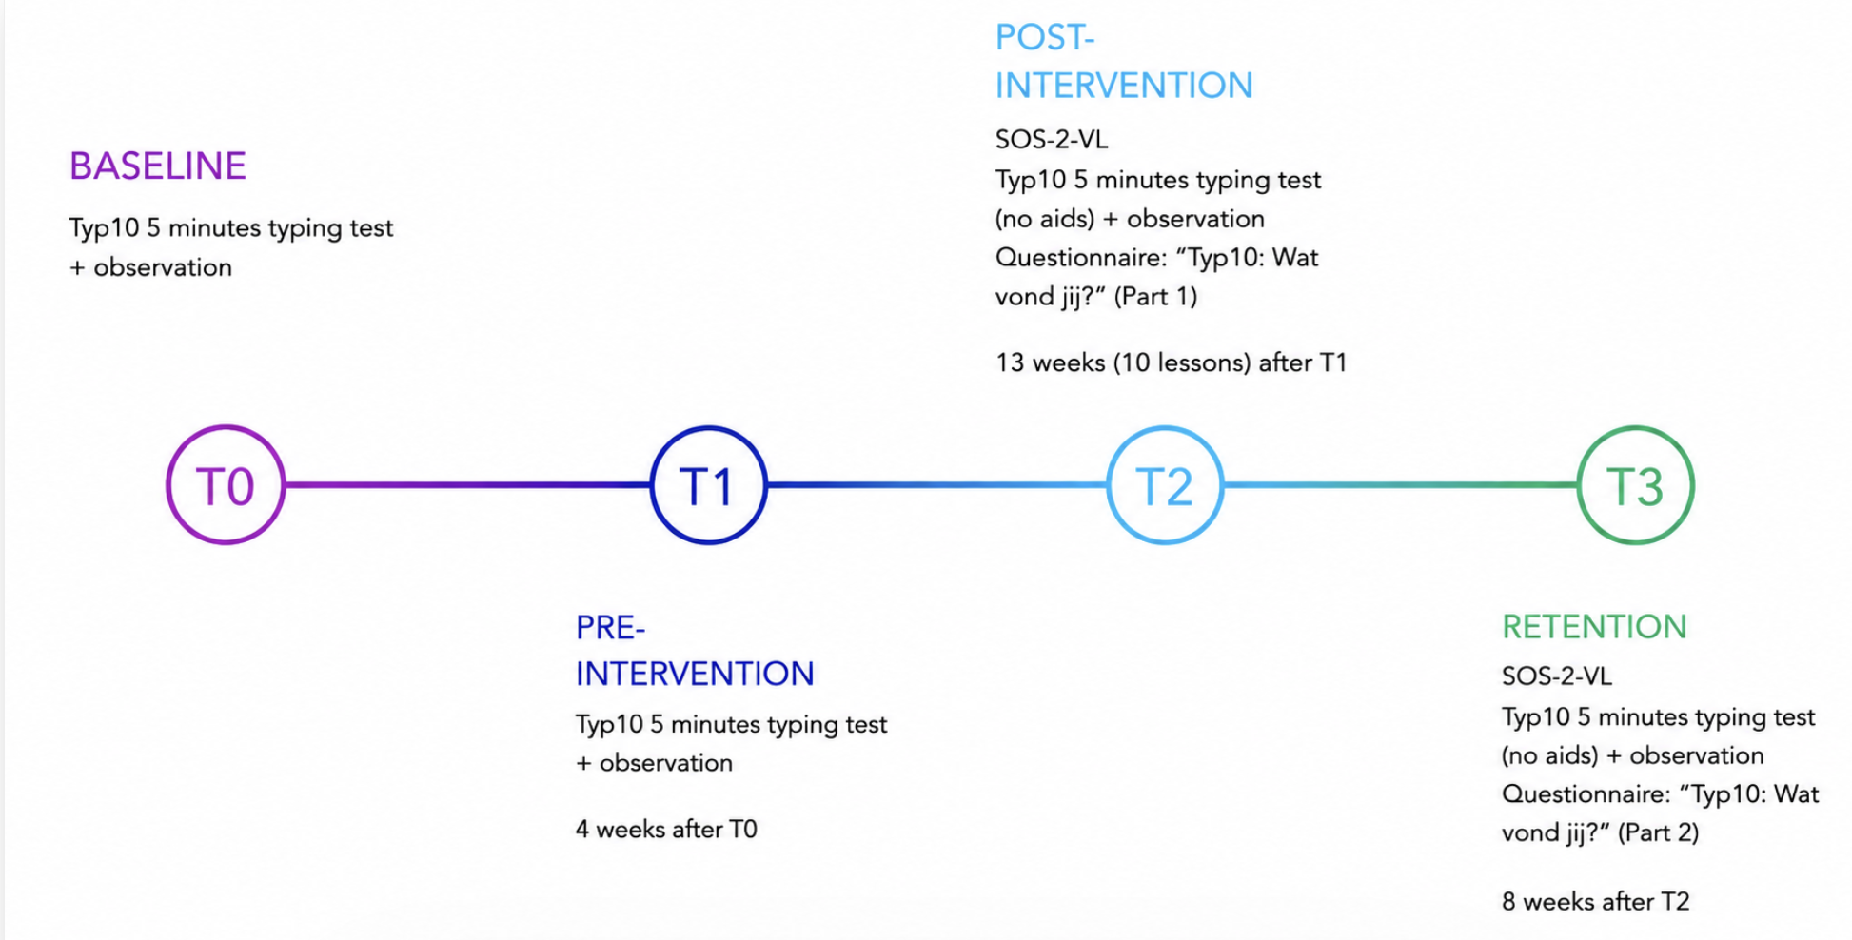Figure 1: Overview of the study timeline. The figure shows the four measurement time points and the data collected at each time point in the study.

Data collection took place at four assessment time points: baseline (T0), pre-intervention (T1), post-intervention (T2), and retention (T3). At T0 and T1, participants completed the Typ10 five-minute typing test while being observed by two master’s thesis students and an additional observer. At SBS Vliermaalroot, this observer was the classroom teacher, whereas at De Bladwijzer, observations were supported by a Typ10 instructor. Assessments were conducted in small groups of six participants, while the remaining children completed regular classroom tasks. At SBS Vliermaalroot, assessments took place within the classroom setting, whereas at De Bladwijzer, participants completed the typing test in a hallway adjacent to the classroom.
Between T1 and T2, participants received ten typing lessons of approximately 60 minutes during regular school hours, delivered by a certified Typ10 instructor. Participants were additionally encouraged to practice typing at home or at school several times per week using the Typ10 program.
At T2, participants first completed the SOS-2-VL collectively in the classroom setting. Afterwards, participants completed the first questionnaire (“Typ10: What did you think?”) while other children were taking the typing test. Questions regarding the questionnaire could be addressed afterwards. At SBS Vliermaalroot, the classroom teacher additionally reviewed the questionnaire collectively with the class to ensure comprehension.
At T3, participants completed the Typ10 five-minute typing test for the final time. The second questionnaire was administered following the same procedure as at T2.

Intervention: The Typ10 program
The intervention consisted of the Typ10 program (https://typ10.com/nl/home-page), a Dutch-language typing program developed in Flanders. It was originally designed to teach touch-typing to primary school children with NDDs, based on principles of motor learning (Zwicker & Harris, 2009; Typ10, n.d.). Currently the program is implemented among children both with and without NDDs in Belgium and the Netherlands. The program is typically integrated into classroom practice through a combination of an online platform, a digital textbook and accompanying instructional materials. Typ10 is structured as a sequence of ten lessons, in which learners progressively acquire touch-typing skills using all ten fingers.

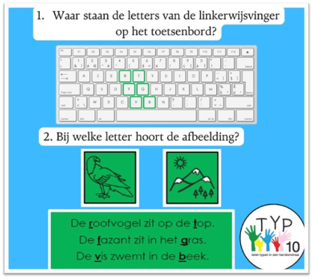
Typ10 combines structured instruction with gamified learning elements to enhance engagement and retention. The instructional approach is based on a systematic learning trajectory in which letters are linked to specific words and embedded in mnemonics. For example, the Dutch mnemonic “De Roofvogel zit op de Top, de Fazant zit in het Gras en de Vis zwemt in de Beek” supports the recall of letter placement on the keyboard. Each finger is associated with a specific mnemonic phrase and a corresponding colour, facilitating both cognitive and motor learning. This system can be reinforced through additional aids during the learning process, such as color-coded stickers applied to keyboards (e.g., the left index finger is associated with the colour green, which is shared with the right index finger).
Figure 2: Example of a Typ10 exercise used during the touch-typing lessons to practice finger placement and letter recognition.

The program further includes interactive games that incorporate previously learned letters and are adapted to the learner’s progression. In addition, structured exercises are complemented by a reward system in which performance is reinforced through trophies or diamonds. A diamond is awarded when 97% of their exercise was correct, after which the task is marked as completed and cannot be repeated. In cases where more errors occur, learners receive a trophy (gold, silver or bronze) based on their performance and are given the opportunity to repeat the exercise.
Typ10 also provides a progress-tracking feature accessible to both teachers and parents, offering detailed insights into typing speed and recurring error patterns. This allows for targeted guidance and individualized support for learners who require additional assistance. The program is accessible online and supplemented by a digital textbook containing exercises, mnemonics, colour associations and word-to-letter mappings, enabling practice in both school and home environments. Additionally, some learners use specialized keyboards with larger, thicker keys, which provide enhanced tactile feedback and support key recognition and spatial orientation.

Assessments

SOS-2-VL
Handwriting quality and speed were assessed using the ‘Systematische Opsporing Schrijfproblemen’ (SOS-2-VL). This is a standardized Flemish screening instrument for handwriting difficulties. The SOS-2-VL demonstrates good psychometric properties. Intra-rater reliability was reported as r = 0.88 for handwriting quality and r = 1.00 for handwriting speed, while interrater reliability was r = 0.77 for quality and r = 1.00 for speed. Test–retest reliability was r = 0.69 for handwriting quality and r = 0.66 for handwriting speed. Concurrent validity with the BHK showed strong correlations for handwriting quality (r = 0.88, p < 0.001) and handwriting speed (r = 0.80, p < 0.001). In special education, a Pearson correlation of r = 0.70 (p < 0.001) with the BHK was reported. Additionally, readability demonstrated excellent reliability, with an ICC = 0.97.
During this assessment, participants were instructed to copy a standardized text for five minutes. Handwriting quality was evaluated based on the first five lines of the copied text, using seven predefined criteria: letter formation, fluency of writing, transitions between letters, average letter size, consistency in letter size, spacing between words and alignment on the writing line. Each criterion was scored on a scale from 0 to 2, depending on the number of lines (within the first five lines) in which the error occurred. Writing speed was determined by counting the total number of letters produced within the given time frame.
Scoring was conducted by trained master’s thesis researchers. All three researchers independently scored each assessment, after which scores were compared and discussed. In cases of discrepancies, efforts were made to reach consensus. If consensus could not be achieved, an experienced physiotherapist was consulted to make the final decision. Raw scores were subsequently converted into percentile scores based on Flemish normative data (SOS-2-VL, 2014).

Typ10 typing test
For the typing assessment, the Typ10 program was used, which includes a built-in test typically administered after completion of the course. This standard test has a duration of seven minutes and uses a standardised text. In the present study, the test duration was reduced to five minutes to ensure comparability with the SOS-2-VL. Additionally, a text based on the ‘Beknopte beoordelingsmethode voor Kinderhandschriften’ (BHK) (appendix 2) was used, as this method has been validated for comparability with the SOS-2-VL text (Van Waelvelde et al., 2012). The use of the BHK text also minimized repetition bias, as participants had already been exposed to the SOS-2-VL text during the handwriting assessment.
Typing performance was evaluated using the Typ10 test, focusing on two primary outcome variables (= typing measures): typing speed, expressed in beats per minute (BPM) and typing accuracy, expressed as the percentage of correctly typed characters. During the assessment, participants were presented with the text on their laptop screen and were instructed to transcribe it. The test started automatically upon pressing the first key.
The assessment was conducted in the classroom in small groups of six participants at a time, while the remaining pupils engaged in independent tasks provided by the teacher. An external keyboard was used, incorporating the Typ10 color-coding system and thicker keys to enhance tactile feedback compared to standard laptop keyboards. The use of the backspace key was disabled; when an incorrect letter was entered, participants were required to continue typing the subsequent characters. Clear instructions were provided by the assessors (master's thesis students), emphasizing that errors were acceptable and that typing should continue without interruption. After five minutes, the test ended automatically and the results were subsequently analysed and summarized by the software.

Observation form
During each Typ10 typing test, trained observers completed a structured observation form (appendix 3) for each child. The recorded variables included the number of fingers used, identification of the specific fingers involved and the frequency of looking at the keyboard, which was categorized as “constant,” “frequent,” “occasional,” or “never,” as well as the opportunity to add additional remarks.
The observation team consisted of two master’s thesis students and one Typ10 teacher, all of whom were trained on how to complete the observation form. During the five-minute typing test, each observer was assigned two participants and was responsible for completing the observation form for both. As a result, each observer had approximately 2.5 minutes per child to conduct the observations.

“Typ10: Wat denk jij?” questionnaire (part 1 & part 2)
To gain an understanding of the feasibility of the Typ10 program, a custom-designed, Dutch-language, child-friendly, “What do you think?” questionnaire was developed to assess the use of additional Typ10 aids, as well as the self-perceived levels of motivation and frustration of the participants during both the typing lessons and the assessments. The questionnaire was developed based on the standard Typ10 questionnaire and the Intrinsic Motivation Inventory (IMI), which served as the primary sources of inspiration for the item construction.
The questionnaire was administered in a classroom setting, with all items read aloud to ensure that each student completed every question. Any questions raised by the participants were addressed collectively in order to maintain consistency in clarification. Furthermore, it was explicitly emphasized that participants should respond based on their own opinions and experiences, without being influenced by their classmates’ answers.
Part 1 of the questionnaire (appendix 4) was designed to capture the experiences of the children during the lessons and practice sessions. It examined the extent to which rewards within the Typ10 program motivated them to engage in practice, how they perceived the various support tools available during these sessions and their overall attitudes and feelings toward typing. These aspects were assessed by a series of statements, for which the children were asked to indicate their level of agreement by circling a number on a five-point Likert scale, ranging from 1 (not true/not enjoyable) to 5 (true/enjoyable).
Part 2 of the questionnaire (appendix 5) focused on the perceptions of the children eight weeks after completing the lessons. It aimed to assess the extent to which they could recall the instructional content, the degree to which they were still able to apply the acquired knowledge, their current typing skills and attitudes, and their motivation to continue practicing. Similar to the first part, responses were measured by statements rated on a five-point Likert scale, with the children indicating their answers by circling a number from 1 to 5.

Practice time
Practice time was obtained via the Typ10 program, which automatically records the duration of each exercise session. For each participant, total practice time was calculated by summing all recorded sessions across both the intervention and retention periods. It should be noted that the recorded durations reflect the time during which exercises were open and may not fully correspond to active engagement. Participants were encouraged by their teacher to practise typing at home and were permitted to do so as much as they wished throughout the entire testing period from T1 to T3.

DATA analysis

Participant characteristics

Table 2 summarizes the baseline characteristics of the study sample (N = 35). Participants had a mean age of 9.2 years (SD = 0.41). The sample was predominantly female (57%) and largely right-handed (94%). Regarding neurodevelopmental diagnostic status, 26% of the participants had a formal diagnosis of an NDD, while an additional 29% were suspected of having an NDD.

Table 2
Participant Characteristics (N = 35)
Variable | n (%) / M (SD)
Age, years | 9,2 (0,41)
Female | 20 (57%)
Right-handed  Diagnosed NDD | 33 (94%)  9 (26%)
Suspected NDD | 10 (29%)
M = mean; SD = standard deviation.

Subgroups

Participants were categorized into subgroups based on handwriting performance and (suspected) NDD. Specifically, groups were defined as: (1) participants scoring below the 15th percentile on the SOS-2-VL, (2) participants scoring above the 15th percentile, and (3) participants with a diagnosed or suspected NDD. As shown in Table 3, 60% of the sample (n = 21) scored below the 15th percentile, whereas 40% (n = 14) scored above this threshold, indicating that most participants demonstrated lower handwriting performance relative to normative expectations.

Table 3
Percentile scores SOS-2-VL (N = 35)
Variable | n (%)
Pc <15 | 21 (60%)
Pc >15  (Suspected) NDD | 14 (40%)  19 (54%)

Table 4 provides an overview of both confirmed and suspected diagnoses reported within the participant group. The left column summarises the formally established diagnoses. The right column presents the suspected (unconfirmed) diagnoses based on available information and observations. Together, this table illustrates the heterogeneity and frequent comorbidity of neurodevelopmental and learning-related difficulties within the sample.

Table 4
Confirmed and suspected (unconfirmed) diagnoses (N = 19)
Confirmed diagnoses | Suspected (unconfirmed) diagnoses
Dysphasia AND ADHD (n = 1)
Low IQ (n = 1) | Reading difficulties (n = 1)
Dysphasia (n = 1) | Mathematical difficulties (n = 1)
ADHD + Nonverbal learning disorder (NLD) (n = 1) | ASD (n = 1)
Dyslexia (n = 1) | ADHD + ASD (n = 1)
ADHD + ASD (n = 1) | ADHD-I (n = 1)
Low IQ + DCD + visuospatial weaknesses (n = 1) | DCD (n = 1)
ADHD (n = 2) | Dysphasia (n = 1)
 | Dyslexia or dyscalculia (n = 2)
 | Difficulties in attention, planning, concentration and organisation (n = 1)
IQ = intelligence quotient, ADHD = Attention Deficit Hyperactivity Disorder, ADHD-I = Attention Deficit Hyperactivity Disorder, Inattentive Type, ASD = Autism Spectrum Disorder, DCD = Developmental Coordination Disorder.

Statistical analysis

All data were compiled and organized in a Microsoft 365 Excel spreadsheet prior to analysis. Statistical analyses were conducted using IBM SPSS Statistics (version 31). The significance level was set at α = 0.05.
Given the longitudinal design of the study, with repeated measurements nested within participants, linear mixed models (LMMs) were used to account for the dependency of observations within individuals.
Typing speed and typing accuracy were analysed as dependent variables in separate models. Time point (T0-T3) was included as a fixed effect in all models. For analyses examining group differences, group (participants with versus without a [suspected] NDD) and the interaction between time point and group were included as fixed effects.
A random intercept for participant (ID) was included to account for individual variability. Models were estimated using restricted maximum likelihood (REML) and degrees of freedom were approximated using the Satterthwaite method. Post-hoc analyses were conducted using estimated marginal means (EMMeans) with Bonferroni correction.
To examine associations between variables, correlation analyses were conducted. As assumptions of normality were not met for all variables, Spearman rank-order correlations were used where appropriate to assess relationships between SOS-2-VL scores, typing performance, total practice time (defined as the sum of all recorded practice sessions on the Typ10 program), and the relationship between typing speed and typing accuracy.
Associations between SOS-2-VL percentile scores and typing performance were examined at baseline (T0) and retention (T3), whereas associations between total practice time and typing performance were examined at T2 and T3. Correlations between typing speed and typing accuracy were explored across all available observations using scatterplots and Spearman correlation analyses.
To investigate whether improvement in typing performance differed between children with low and typical SOS-2-VL scores, difference scores (T3-T0) were calculated for typing speed and typing accuracy, and Mann–Whitney U tests were conducted to compare improvements between groups. In addition, an exploratory chi-square test of independence was conducted to examine the association between SOS-2-VL classification and NDD status. Where appropriate, effect sizes were estimated using Phi or Cramer’s V.
A post-hoc power analysis was conducted using G*Power to estimate the statistical power of the primary longitudinal analyses examining changes in typing performance over time and group differences. This analysis was based on a medium effect size (f = 0.25), the study sample size, and design parameters.

Typing behaviour

To analyse the typing behaviour data collected using the observation forms, descriptive statistics were used to summarize the number of participants using each finger across the four assessment time points. In addition, a line graph was constructed to depict the mean number of fingers used during typing at each measurement occasion. Individual trajectories in typing speed and typing accuracy across time were visualized using spaghetti plots. Group means and corresponding 95% confidence intervals were superimposed to facilitate interpretation of overall trends and within-subject variability.

Participant perceptions and experiences

All collected questionnaire data were entered and processed in Microsoft Excel. For each questionnaire item, means and medians were calculated to summarize the central tendency of the responses. Part 1 and Part 2 of the “Typ10: Wat denk jij?” questionnaire were analysed and reported separately.

Results

Statistical analysis

Typing behaviour

Observation forms
Figure 3 illustrate the distribution of the number of fingers used for typing across the four measurement moments (T0-T3).
At T0, the median number of fingers used is low (2 fingers), with a relatively large standard deviation, indicating substantial variability among participants. Overall, this suggests that most participants initially used only a limited number of fingers when typing.
At T1, median remains around 2 fingers with a standard comparable to that observed at T0, indicating a similar distribution to the measurement at T0.
At T2, there is a clear upward shift in the distribution. The median increases to approximately 9 fingers, while the standard deviation becomes narrower, indicating that most participants used a greater number of fingers with reduced variability.
At T3, the median remains high (9 fingers) accompanied by a small standard deviation. This indicates a consistent use of many fingers across participants and suggests maintenance of the improvement observed at T2.
Figure 3 also presents the number of participants who used each finger during typing across the four measurement moments. At T0, the index fingers were used by the largest number of participants, followed by the middle fingers, while the ring fingers, little fingers and thumbs were used by fewer participants. At T1, a similar distribution was observed, with only small fluctuations across fingers. At T2, the number of participants using each finger increased and the distribution became more even across both hands. At T3, the number of participants using each finger remained comparable to T2, with only minor changes across fingers.

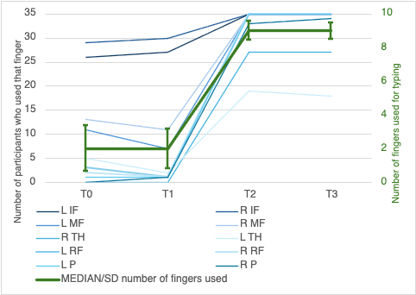
L IF = left index finger, R IF = right index finger, L MF = left middle finger, R MF = right middle finger, L TH = left thumb, R TH = right thumb, L RF = left ring finger, R RF = right ring finger, L P = left pink, R P = right pink.
Figure 3: Number of participants who used the finger in the testmoment (left), and mean number of fingers used for typing (right).

During T0 and T1, more than 90% of the participants continuously looked at the keyboard, while the remaining participants looked at it frequently. At T2 and T3, none of the participants continuously looked at the keyboard.
At T2, participants either looked at the keyboard frequently (9%), occasionally (20%), or not at all (71%). By T3, the majority of participants no longer relied on visual guidance, with 73.5% reporting that they never looked at the keyboard and 20.5% doing so only occasionally. Only two participants continued to depend on visual input, one looking continuously and another frequently, both of whom had a suspected NDD. Overall, these findings indicate that there was little to no meaningful difference between T2 and T3.

Individual evolution
Overall, most participants demonstrated improvements between T0 and T3 in typing speed (Figure 4). Typing accuracy appears mostly static for most participants (Figure 5). During the retention period, accuracy levels were maintained, while typing speed continued to increase.

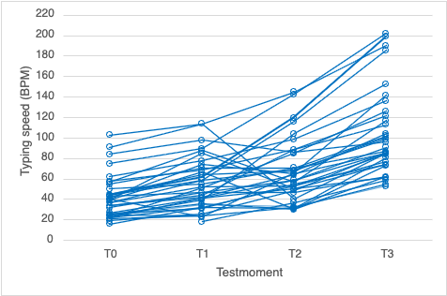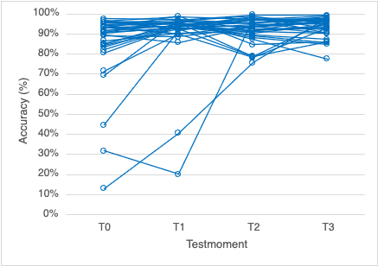
Figure 4: Evolution of typing speed. | Figure 5: Evolution of typing accuracy.

Figure 6 illustrates that at T0 and T1, some participants demonstrated typing accuracy below 50%, these outliers were left out of figure 6. Following the intervention (T2) and after the retention period (T3), all participants showed improvements in both typing accuracy and speed. The trendlines show a slight upward trend.
Figure 7 shows that after the intervention period (T2 and trendline T2-T1), variability in individual outcomes was observed, with some participants showing lower typing speed and accuracy, while others demonstrated clear improvements in typing speed. It is important to note that the main difference between the final two measurement moments (T2 and T3) and the initial assessments (T0 and T1) is that participants were instructed not to look at the keyboard during the final two sessions. The plotted trajectories indicate that, between T2 and T3, several participants showed an increase in typing speed without a substantial decrease in accuracy, and in some cases even an improvement in accuracy. The trendline from T3 to T2 is almost parallel to the horizontal line.

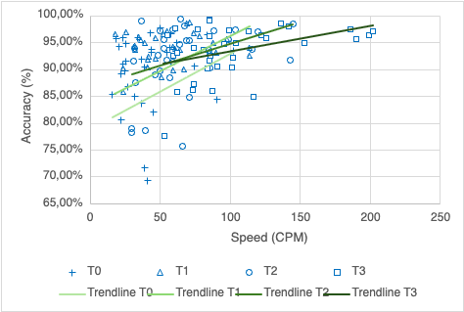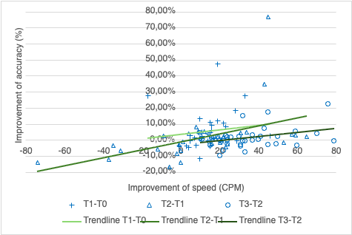
Figure 6: Association between typing speed and typing accuracy. | Figure 7: Association of the evolution of the typing measures.

Evolution of the typing measures

Typing speed
A linear mixed model revealed a significant effect of time on typing speed, F(3, 100.10) = 60.27, p < 0.001. Estimated marginal means showed a clear and progressive increase in typing speed across the four time points (Figure 8), rising from 40.81 (SD = 21.27) at T0 to 55.11 (SD = 25.61) at T1, 68.80 (SD = 30.77) at T2, and 105.17 (SD = 41.23) at T3. Bonferroni-adjusted pairwise comparisons indicated that all time points differed significantly from one another (all p < 0.05), reflecting a consistent improvement over time. Notably, the largest increase was observed between T2 and T3.
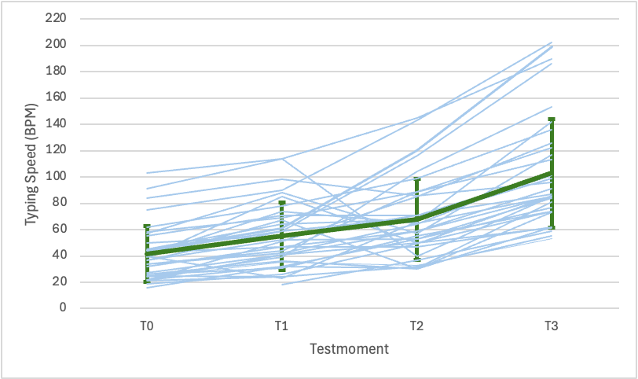
Figure 8: Evolution of typing speed (blue) with mean typing speed (green).

Typing accuracy
A linear mixed model revealed a significant effect of time on typing accuracy, F(3, 100.83) = 4.02, p = 0.010. Estimated marginal means indicated a gradual increase in accuracy across the four time points (Figure 9), rising from M = 84.71, SD = 18.96 at T0 to M = 90.26, SD = 15.43 at T1, M = 92.04, SD = 6.33 at T2, and M = 93.41, SD = 4.92 at T3. Post-hoc comparisons showed that typing accuracy at T2 and T3 was significantly higher than at T0, whereas differences between consecutive time points were not significant, suggesting an initial improvement followed by stabilization of performance. Typing accuracy continued to increase across these time points.

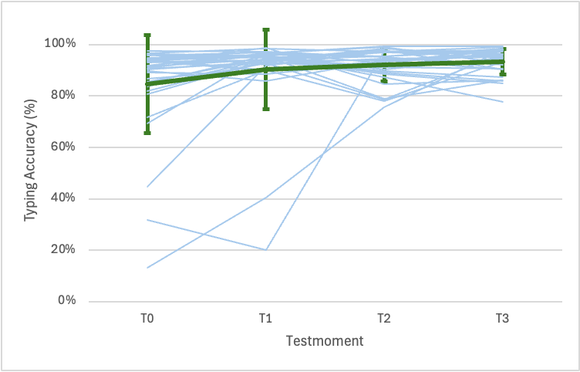
Figure 9: Evolution of typing accuracy (blue) with mean typing accuracy (green).

Group differences in evolution of the typing measures

Typing speed
A linear mixed model revealed a significant effect of time, F(3, 32.64) = 83.19, p < 0.001 and a significant main effect of group, F(1, 33.04) = 16.87, p < 0.001.
Importantly, a significant interaction between time and group was found, F(3, 32.56) = 3.03, p = 0.043, indicating that the evolution of typing speed differed between the groups.
Inspection of the estimated marginal means (Figure 10) showed that both groups improved across all time points. However, participants without NDD consistently outperformed those with NDDs at each measurement occasion. Moreover, the increase in typing speed was steeper for participants without NDDs, resulting in increasing differences between the groups over time.

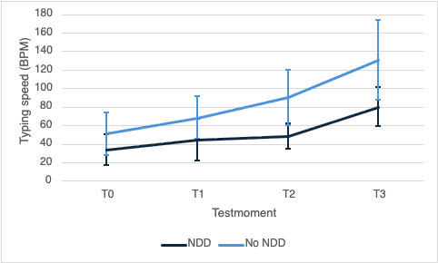
Figure 10: Evolution of typing speed (blue) with mean typing speed (green).

Typing accuracy
A linear mixed model revealed a significant effect of time, F(3, 32.54) = 3.16, p = 0.038, indicating that typing accuracy improved across the different time points.
No significant main effect of group was found, F(1, 33.08) = 0.98, p = 0.329, suggesting that there was no overall difference in typing accuracy between participants with and without NDD.
Additionally, the interaction between time and group was not significant, F(3, 32.54) = 2.55, p = 0.073, indicating that both groups followed a similar developmental trajectory over time.
Both groups showed an increase in typing accuracy, with a comparable pattern of initial improvement followed by stabilization (Figure 11).

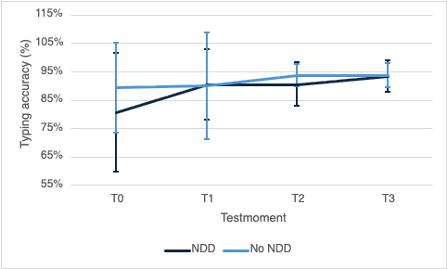
Figure 11: Mean typing accuracy between the groups.

Association between SOS-2-VL score and the typing measures

Correlation at T0
Spearman’s rank correlation analyses were conducted to examine the association between SOS-2-VL percentile scores and typing speed at T0. In addition, the relationship between SOS-2-VL speed scores and typing speed at T0 was assessed.
No significant correlations were observed between SOS-2-VL scores and typing speed (r = −0.024, p = 0.891), nor between SOS-2-VL scores and typing accuracy (r = −0.262, p = 0.135). Furthermore, no significant association was found between SOS-2-VL speed scores and typing speed at T0 (r = 0.280, p = 0.109). These findings indicate that, prior to the typing intervention, typing performance was not significantly associated with performance on the SOS-2-VL.

Correlations at T3
At T3, SOS-2-VL scores were not significantly associated with typing speed (r = −0.090, p = 0.609) or typing accuracy (r = 0.127, p = 0.467). Similarly, SOS-2-VL speed scores were not significantly correlated with typing speed at T3 (r = 0.114, p = 0.516).

Association between typing performance and total practice time
Spearman correlation analyses were conducted to examine the association between total practice time and typing performance at T2 and T3. No significant correlations were found between practice time and typing accuracy at T2 (r = 0.250, p = .154) or T3 (r = 0.086, p = 0.622). Similarly, no significant correlations were found between practice time and typing speed at T2 (r = 0.060, p = 0.735) or T3 (r = 0.011, p = 0.949).

Additional exploratory data analysis

Correlation of the typing measures at all time points
A scatterplot (Figure 12) suggested a weak positive association between typing speed and typing accuracy, which was confirmed by a significant Spearman correlation, r = 0.374, p < 0.001 (N = 138). Although the relationship was statistically significant, the strength of the association was modest.

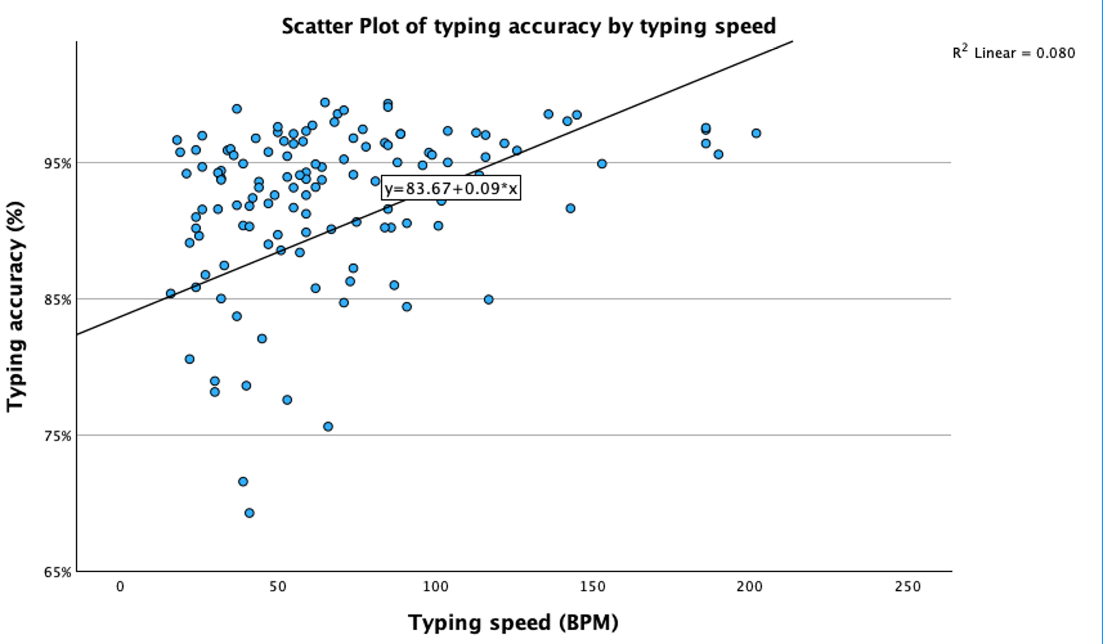

Figure 12: Correlation of the typing measures at all time points.

Association between SOS-2-VL score and improvement in typing measures
A Mann–Whitney U test was conducted to examine whether improvements in typing speed and typing accuracy from T0 to T3 differed between children with low and typical SOS-2-VL scores. Difference scores were calculated by subtracting baseline (T0) scores from post-intervention follow-up (T3) scores. No significant difference was found in improvement in typing speed, U = 133.50, Z = -0.23, p = 0.820. Similarly, no significant difference was found in improvement in typing accuracy, U = 99.00, Z = -1.44, p = 0.151.

Association between SOS-2-VL score and NDD
A chi-square test of independence showed no significant association between SOS-2-VL classification and NDD status, χ²(1) = 3.24, p = 0.072.

Participant perceptions and experiences

“Typ 10: “Wat denk jij?” questionnaire part 1
The reported scores reflect participants’ self-evaluations on questionnaire items regarding their experiences with the Typ10 lessons. A large majority indicated favourable practice conditions, with 97% reporting the opportunity to practice at home and 86% indicating access to a quiet environment.
Overall, participants rated the Typ10 program positively. Self-reported scores on items related to lesson experience and practice were consistently high, with mean scores above 3.5 and median values of at least 4. Only the item concerning the usefulness of movement during lessons received a somewhat lower, yet still moderately positive, evaluation (M = 3.1).
High levels of motivation and engagement were also reflected in the self-reported scores. Gamification elements were particularly well received (M = 4.4, Med = 5). Although slightly lower, participants’ anticipation of practice remained positive (M = 3.4).
Regarding support tools, participants’ responses indicated moderate to frequent use of learned strategies, with the highest-rated item reaching a mean of 3.9. Online tools such as coloured letter markings (86%) and finger rhymes (77%) were most reported as being used, whereas other tools were used less frequently. Additionally, 43% of participants reported using a separate keyboard at home.
Participants’ self-reported attitudes towards typing were largely positive. High scores were observed for perceived value of typing instruction, satisfaction with performance, and motivation to improve (means ranging from 4.03 to 4.7). Low scores on the statement that typing is boring (M = 2.2) and relatively low nervousness (M = 2.6) suggest a generally positive and comfortable learning experience. However, self-reported pressure during evaluations was moderately elevated (M = 3.2), indicating a potential area for improvement. Moderate levels of frustration when errors occurred were also reported (M = 2.9).

“Typ 10: “Wat denk jij?” questionnaire part 2
The questionnaire data further indicate that participants perceived themselves as retaining the lesson content well. Self-reported scores showed strong recall, with median values of 4 to 5 across most items. Knowledge of correct typing posture was rated particularly high (M = 4.7), whereas recall of specific mnemonic strategies, such as rhymes (M = 3.3) and visual associations (M = 3.9), was somewhat lower but still positive.
Despite this reported retention, participants indicated limited continued use of instructional supports (M = 1.5), suggesting that these tools were no longer actively applied. Nevertheless, self-reported improvements in typing competence were substantial, including increased ability to type without looking at the keyboard (M = 4.6) and the ability to correct errors while typing (M = 4.5).
Regarding skills and affective experiences, participants reported moderate levels of pressure during evaluations (M = 3.2), while nervousness and boredom remained relatively low. Motivation to practice was rated more neutrally (M = 3.0), and some degree of perceived obligation was reported (M = 3.6).
In contrast, self-reported satisfaction and perceived competence were high. Participants indicated that they found it easier to use their computer at school during the lessons after the intervention (M = 4.4), experienced greater enjoyment when working on a computer (M = 4.0), and felt confident in their typing abilities. Ratings for self-perceived competence, ease, and relaxation during typing were consistently above 4. A Spearman correlation analysis showed a positive association between improvements in typing performance and self-perceived performance, but this was not significant (r = 0.13, p = 0.473).
Finally, self-reported motivation appeared to be moderately maintained over time, with mean scores of at least 3.5. However, motivation for independent practice at home was comparatively lower (M = 3.2).

Power analysis
A post-hoc power analysis for the within-subjects effect indicated that the study had high statistical power (1 - β = 0.95) to detect medium-sized effects (f = 0.25), suggesting that the study was well powered to detect changes in typing speed over time across the full sample.

Discussion

The present study examined the development of typing speed and typing accuracy following structured typing instruction, as well as potential differences between children with and without a (suspected) NDD.
Typing speed increased substantially over time, with the largest improvement occurring between T2 and T3. Improvements in typing performance were already observed between T0 and T1, despite the absence of structured typing instruction during this period. This may reflect familiarization with the typing test and keyboard layout, typing activities outside the intervention, or natural developmental progression over the four-week interval. However, the larger improvements observed following the intervention support the added value of structured touch-typing instruction. Continued practice after the first ten lessons further enhanced speed, likely reflecting increasing automatization of typing skills. This aligns with previous research showing that typing is not an intuitive skill but requires structured instruction and practice to achieve fluency (Freeman et al., 2005; Yechiam et al., 2003). Children with a (suspected) NDD started at a lower typing speed and, although they improved over time, their progress was somewhat smaller compared to children without NDD, resulting in a larger gap at T3.
Typing accuracy showed a more gradual pattern. Post-hoc comparisons indicated that accuracy at T2 and T3 was significantly higher than at T0, while no differences were found between consecutive time points, suggesting cumulative rather than stepwise improvement. This pattern can be understood considering the study design: T0 and T1 were pre-intervention measurements, whereas from T2 onwards participants had received instruction and were required to type without visual guidance. Despite this increase in task difficulty, accuracy continued to improve, indicating that participants were able to maintain and further improve their performance under more demanding conditions. This is consistent with findings that touch typing, once automatized, supports efficient and accurate performance without reliance on visual input (Freeman et al., 2005). The findings from the questionnaires suggest that the Typ10 program was positively received by the participants, with self-reported improvements in typing skills and high perceived competence. Gamification elements within the Typ10 program appeared to be particularly motivating for participants. Motivation for independent practice was somewhat lower, possibly reflecting the compulsory nature of the lessons and indicating challenges in maintaining engagement outside the structured learning context. A weak but significant positive association was found between typing speed and typing accuracy, suggesting that faster typists tended to be slightly more accurate. However, the modest strength of this relationship indicates that both skills develop largely independently, reflecting partially distinct components of transcription processes.
No significant associations were found between total practice time and typing performance at either T2 or T3. This suggests that the amount of practice alone may not be sufficient to explain improvements in typing skills. It is possible that the quality of practice, rather than its quantity, plays a more important role in skill acquisition. Additionally, the measurement of practice time may not have accurately reflected actual engagement, as recorded time on the Typ10 program did not necessarily correspond to active practice.
No significant associations were found between SOS-2-VL scores and typing performance or improvement. In addition, SOS classification was not significantly related to NDD status, although children with lower SOS scores appeared somewhat more frequently in the NDD group.
Together, these findings suggest that typing performance relies more on task-specific motor learning than on general motor coordination abilities. However, dichotomizing SOS scores may have reduced variability and sensitivity to detect more subtle associations.
Although children with NDDs are often reported to experience difficulties in handwriting and transcription (Alstad et al., 2015; Dionne et al., 2022), the present findings indicate that structured typing instruction can support comparable development in typing accuracy and meaningful improvements in typing speed across groups.
The observed pattern of strong improvements in speed and stabilization of accuracy is consistent with Motor Learning Theory, which describes a progression from cognitively demanding performance toward automatization through practice (Schmidt & Lee, 2011; Zwicker & Harris, 2009). As skills become more automated, cognitive resources can be allocated to higher-order processes, allowing performance to be maintained even under increased task demands (Connelly et al., 2006; Van Weerdenburg et al., 2018).
Importantly, these findings emphasize that typing skills do not develop automatically through exposure to digital devices but require explicit instruction and sustained practice. The ability of participants to maintain accuracy without visual guidance further supports the effectiveness of structured touch-typing instruction, highlighting the potential of Typ10 in heterogeneous classroom settings.
In addition to these findings, several strengths of this study should also be acknowledged. First, the study was conducted in ecologically valid school settings across two different primary schools with a heterogeneous study population, enhancing the practical relevance and generalizability of the findings. Second, the longitudinal design with four assessment time points, including a retention measurement, allowed for the examination of both immediate learning effects and short-term retention of typing skills. Furthermore, the inclusion of children both with and without (suspected) NDDs increased the relevance of the findings for heterogeneous classroom settings. Another strength was the combination of objective typing measures, observational data and self-report questionnaires, which provided a more comprehensive understanding of typing development and participants’ experiences with the Typ10 program. Finally, this feasibility study contributes to a still limited body of research on structured touch-typing instruction in Flanders and the Netherlands and may serve as a valuable starting point for future research in this field.
Despite these strengths, several limitations should be considered when interpreting the findings. First, the study did not assess long-term retention beyond eight weeks, limiting conclusions about sustained learning effects. Second, the sample size was relatively small, which may have reduced the ability to detect smaller effects. Third, children with suspected and formally diagnosed NDDs were grouped together, which may have obscured potential differences within this group. The classification of suspected NDDs was based on information provided by teachers, rather than formal clinical diagnoses, which may have introduced some uncertainty in group assignment. Additionally, practice time was not standardized or accurately measurable, as usage data from the Typ10 program did not necessarily reflect actual engagement. Furthermore, some children experienced difficulties in understanding how to correctly use the typing program during the test, which may have led to an underestimation of actual typing accuracy.
Another limitation concerns the observational measures used during the typing sessions. Certain variables, such as the extent to which participants looked at their fingers (e.g., constantly, often, occasionally, or never), were based on subjective judgments. As a result, these observations may be prone to observer bias and limited reliability, which could have introduced measurement error.
An additional limitation of this study is that the intervention was conducted across two different schools, where the typing lessons were given by different teachers. Although the same program (Typ10) was used, potential differences in teaching style, classroom environment and implementation fidelity may have influenced the outcomes.
Although the study demonstrated high statistical power to detect medium-sized effects, smaller effects may still have gone undetected. Furthermore, power estimates are based on assumed effect sizes and should be interpreted with caution in mixed-model designs.
Future research should aim to include larger samples, distinguish between formally diagnosed and suspected NDDs and incorporate longer follow-up periods to better assess retention of typing skills. Furthermore, implementing standardized practice conditions and using more objective measurement methods, such as video recordings or standardized observation protocols, would allow for a more precise and reliable evaluation of the relationship between practice and performance. In addition, future work should remain attentive to minimising evaluation-related pressure on children and to fostering sustained motivation for independent practice at home.

Conclusion

In conclusion, the present study shows that structured touch-typing instruction can support the development of typing skills in primary school children. Both typing speed and typing accuracy improved over time, with children both with and without (suspected) NDDs showing clear progress throughout the Typ10 program. Although children with (suspected) NDDs generally typed more slowly, they also benefited from the instruction. The findings further suggest that typing development may rely more on task-specific learning and structured instruction than on general motor coordination abilities or the amount of practice alone. Overall, these results highlight the potential of structured typing programmes such as Typ10 to support the development of transcription skills in heterogeneous classroom settings.

Reference list

Alstad, Z., Barnett, A., Connelly, V., Berninger, V., & Sanders, E. (2015). Modes of Alphabet Letter Production during Middle Childhood and Adolescence: Interrelationships with Each Other and Other Writing Skills. Journal Of Writing Research, 6(3), 199–231. https://doi.org/10.17239/jowr-2015.06.03.1
Bailey, B., Philpott-Robinson, K., & Ray, K.. A scoping review of transcription instruction involving children with autism. J. Res. Read., 2026;49(1):e70016. https://doi-org.libugent.idm.oclc.org/10.1111/1467-9817.70016
Berninger, V.W. & Amtmann, Dagmar. (2003). Preventing written expression disabilities through early and continuing assessment and intervention for handwriting and/or spelling problems: Research into practise. Handbook of learning disabilities. 345-363.
Best, J. R., & Miller, P. H. (2010). A developmental perspective on executive function. Child Development, 81(6), 1641–1660. https://doi.org/10.1111/j.1467-8624.2010.01499.x
Case‑Smith, J. (2005). Occupational therapy for children (5th ed.). Mosby/Elsevier.
Connelly, V., Gee, D., & Walsh, E. (2006). A comparison of keyboarded and handwritten compositions and the relationship with transcription speed. British Journal Of Educational Psychology, 77(2), 479–492. https://doi.org/10.1348/000709906x116768
Dionne, E., Bolduc, M. È., Majnemer, A., Beauchamp, M. H., & Brossard-Racine, M. (2022). Academic Challenges in Developmental Coordination Disorder: A Systematic Review and Meta-Analysis. Physical & Occupational Therapy In Pediatrics, 43(1), 34–57. https://doi.org/10.1080/01942638.2022.2073801
Donica, D. K., Giroux, P., & Faust, A. (2018). Keyboarding instruction: Comparison of techniques for improved keyboarding skills in elementary students. Journal Of Occupational Therapy Schools & Early Intervention, 11(4), 396–410. https://doi.org/10.1080/19411243.2018.1512067
Freeman, A., MacKinnon, J. R., Miller, L. T., & Université Laval. (2005). Keyboarding for Students with Handwriting Problems. In Physical & Occupational Therapy in Pediatrics (Vols. 1–2) [Journal-article]. https://doi.org/10.1080/J006v25n01_08
Graham, S., Berninger, V. W., Abbott, R. D., Abbott, S. P., & Whitaker, D. (2018). Role of handwriting and keyboarding in writing development. Journal of Educational Psychology, 110(5), 664–679. https://doi.org/10.1037/edu0000229
Jiménez, J. E., Marco, I., Suárez, N., & González, D. (2016). Internal Structure and Development of Keyboard Skills in Spanish-Speaking Primary-School Children With and Without LD in Writing. Journal Of Learning Disabilities, 50(5), 522–533. https://doi.org/10.1177/0022219416633864
Jung, S., Moeller, K., Klein, E., & Heller, J. (2021). Mode effect: An issue of perspective? Writing mode differences in a spelling assessment in German children with and without developmental dyslexia. Dyslexia, 27(3), 373–410. https://doi.org/10.1002/dys.1675
Malpique, A. A., Valcan, D., Pino-Pasternak, D., Ledger, S., & Kelso-Marsh, B. (2023). Shaping young children’s handwriting and keyboarding performance: Individual and contextual-level factors. Issues in Educational Research, 33(4), 1441–1460. https://www.iier.org.au/iier33/malpique.pdf
SOS-2-VL: systematische opsporing schrijfproblemen : handleiding. (2014).
Stuart, N. & Barnett, A. L. (2024). Writing Quality Scale (WQS) Administration and scoring guide. Oxford,
England: Oxford Brookes University. doi: 10.24384/sq3r-1m26
Typ10. (n.d.). https://typ10.com/nl/home-page
Van der Meijden, H. (2023). Typ jij blind? Aan de slag in het basisonderwijs. Boom.
Van Waelvelde, H., Hellinckx, T., Peersman, W., & Smits-Engelsman, B. C. M. (2012). SOS: A Screening Instrument to Identify Children with Handwriting Impairments. Physical & Occupational Therapy in Pediatrics, 32(3), 306–319. https://doi.org/10.3109/01942638.2012.678971
Van Weerdenburg, M., Tesselhof, M., & Van Der Meijden, H. (2018). Touch‐typing for better spelling and narrative‐writing skills on the computer. Journal Of Computer Assisted Learning, 35(1), 143–152. https://doi.org/10.1111/jcal.12323
Yechiam, E., Erev, I., Yehene, V., & Gopher, D. (2003). Melioration and the Transition from Touch-Typing Training to Everyday Use. Human Factors The Journal Of The Human Factors And Ergonomics Society, 45(4), 671–684. https://doi.org/10.1518/hfes.45.4.671.27085
Zwicker, J. G., & Harris, S. R. (2009). A Reflection on Motor Learning Theory in Pediatric Occupational Therapy Practice. Canadian Journal Of Occupational Therapy, 76(1), 29–37. https://doi.org/10.1177/000841740907600108

Populariserende samenvatting
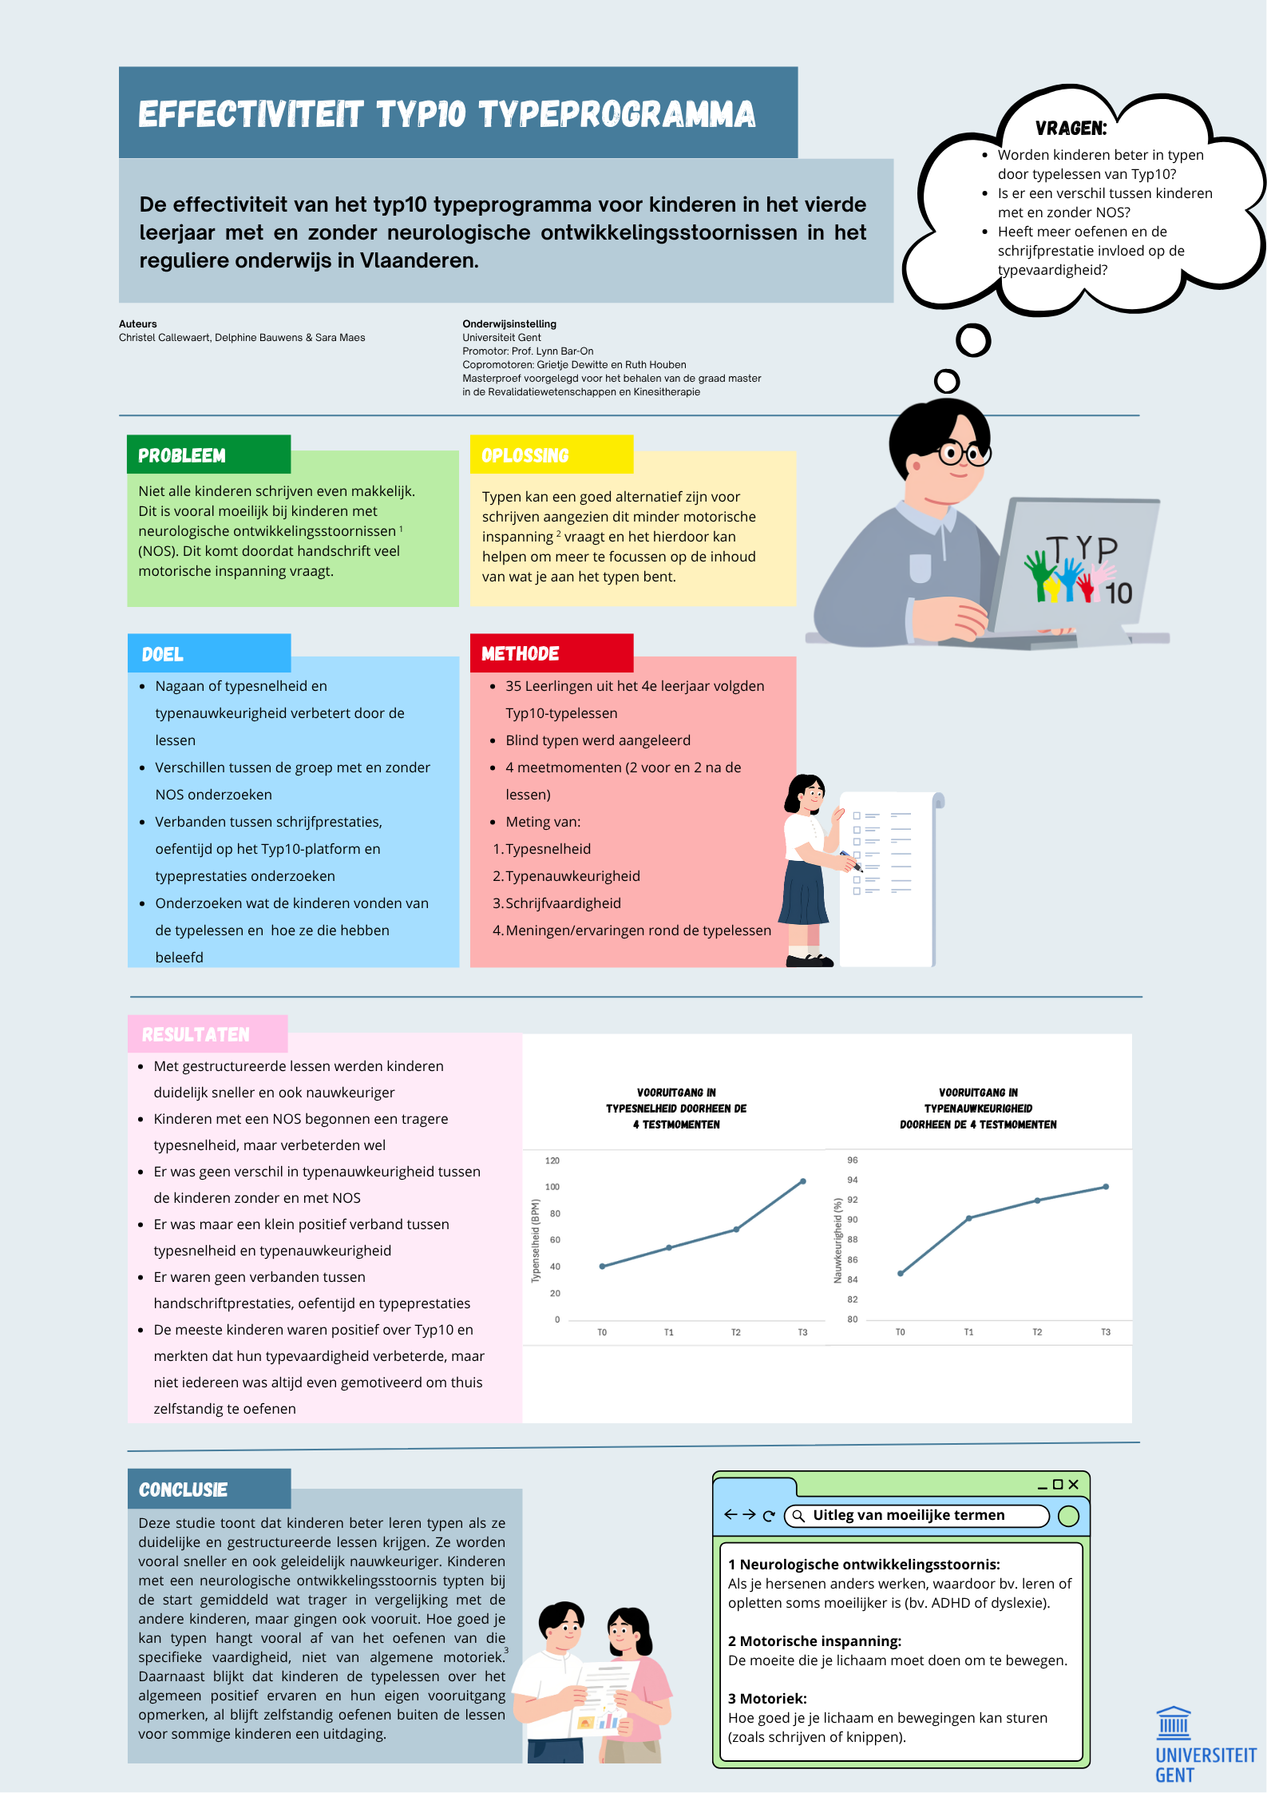

BEWIJS VAN INDIENING bij het ethisch comité
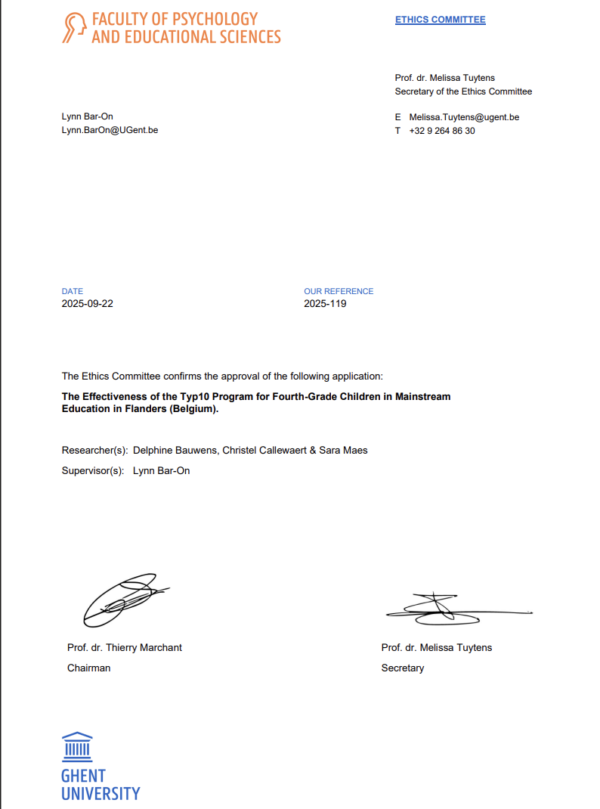

Checklist transparant generatief AI-gebruik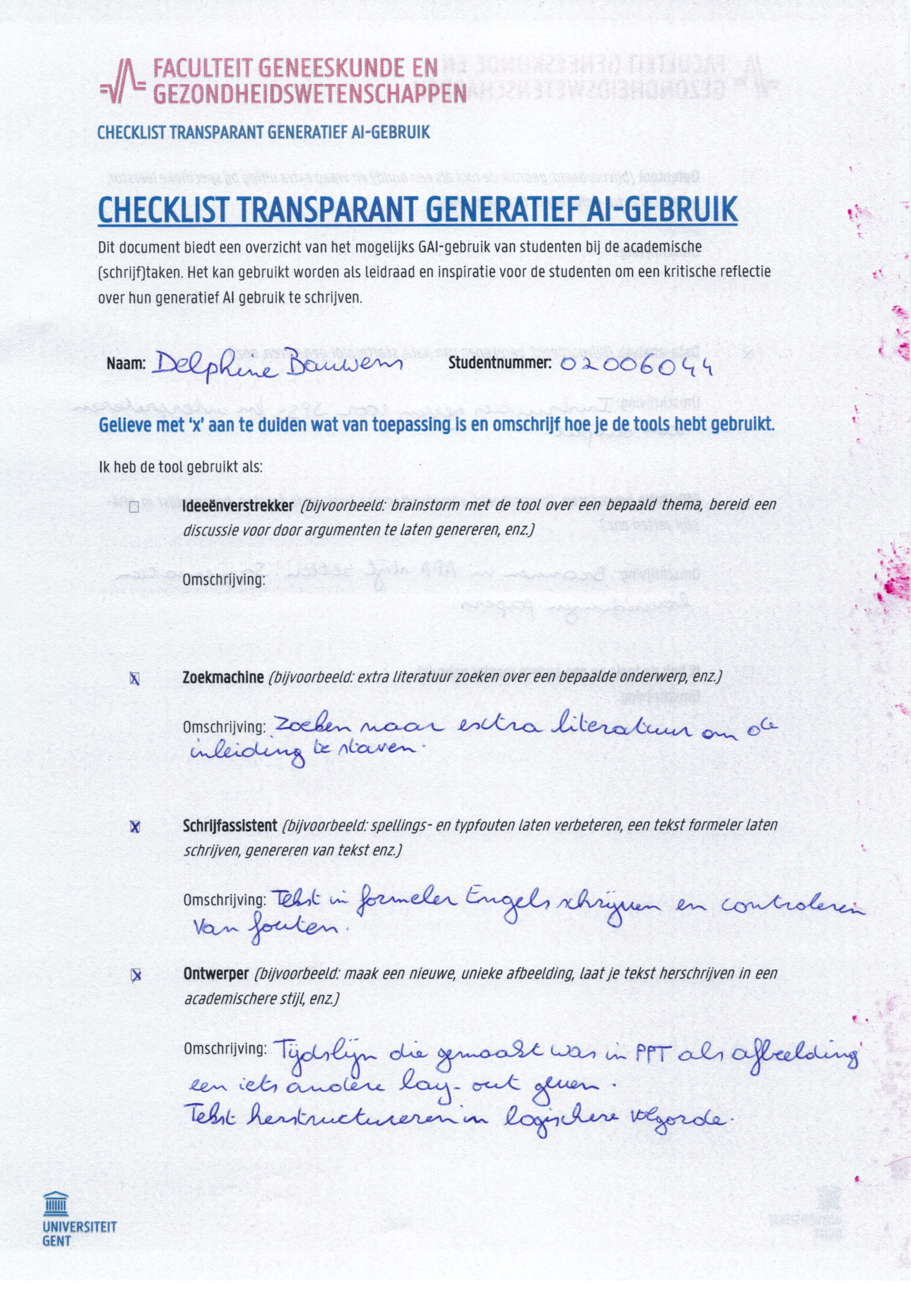
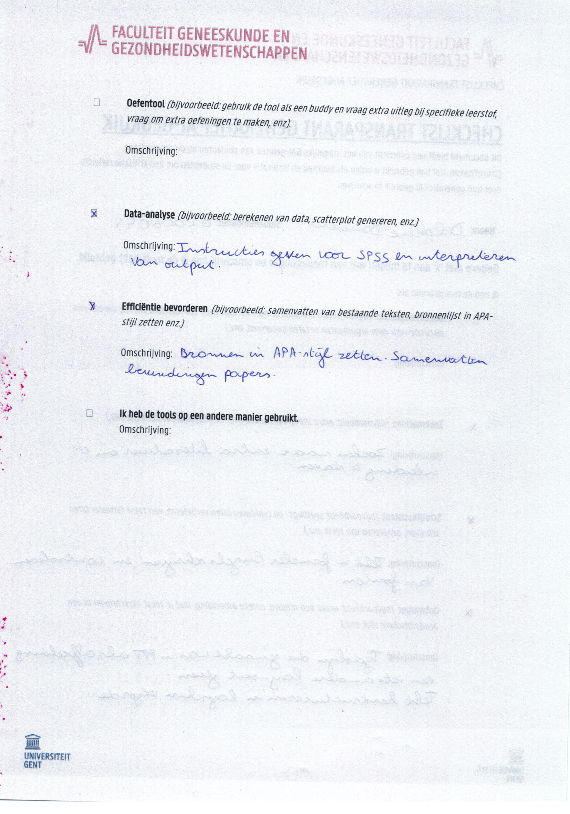

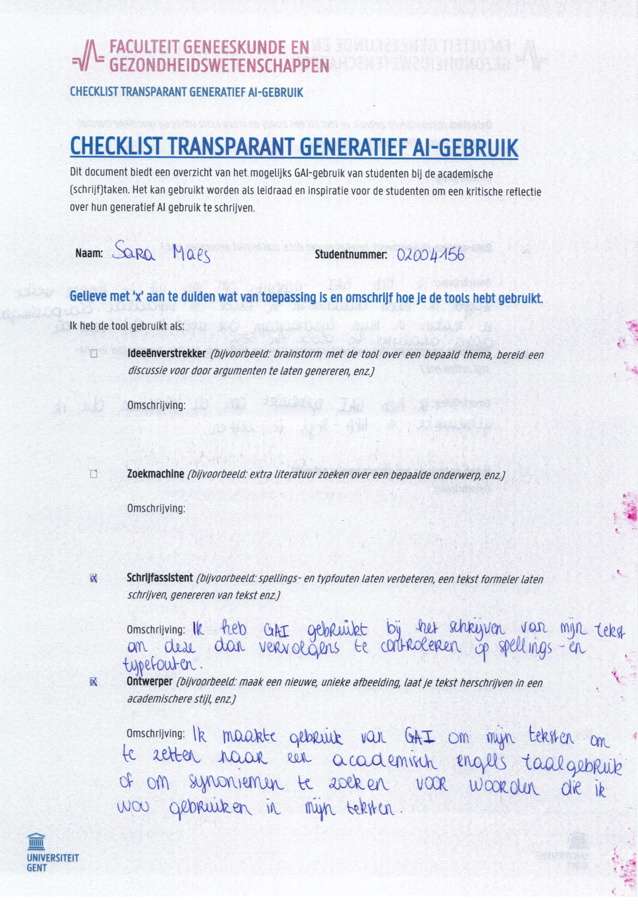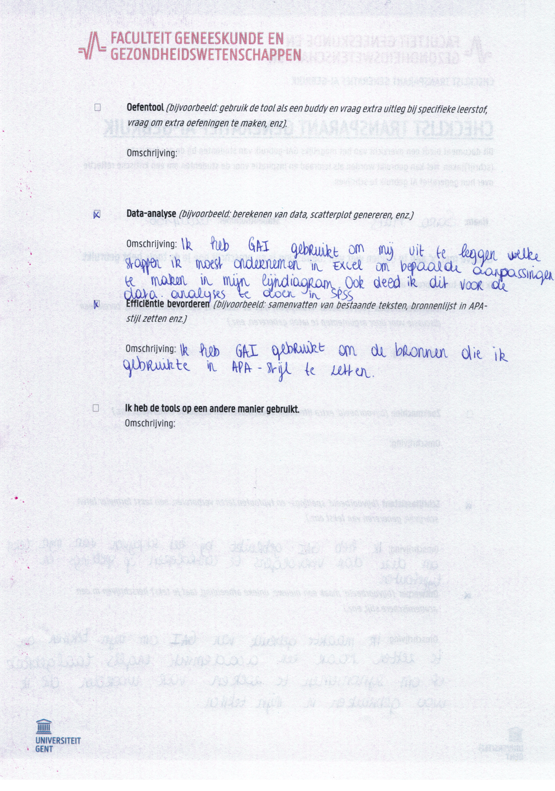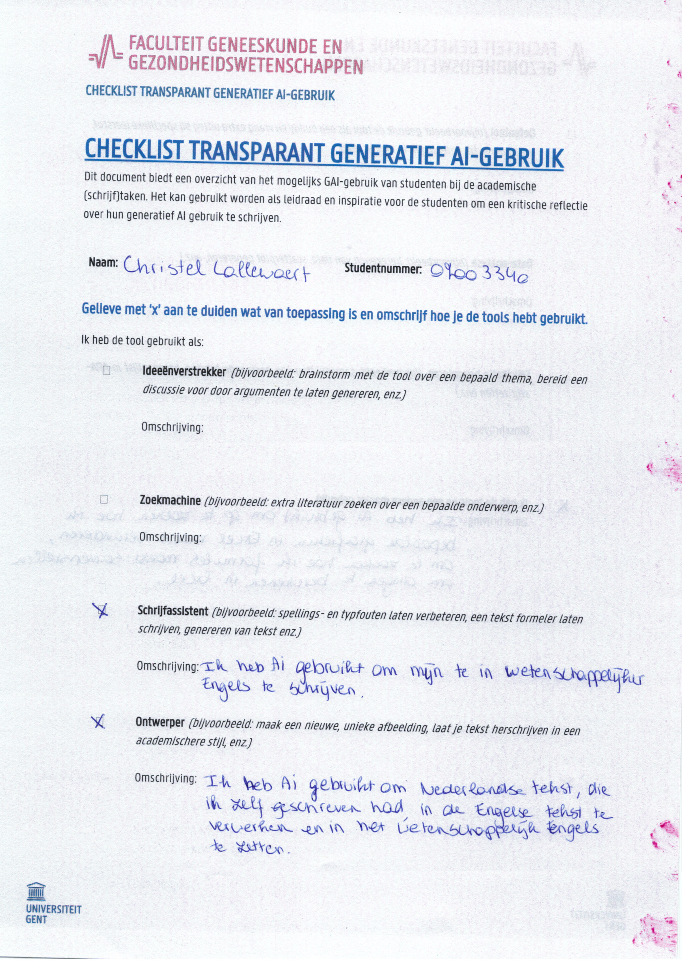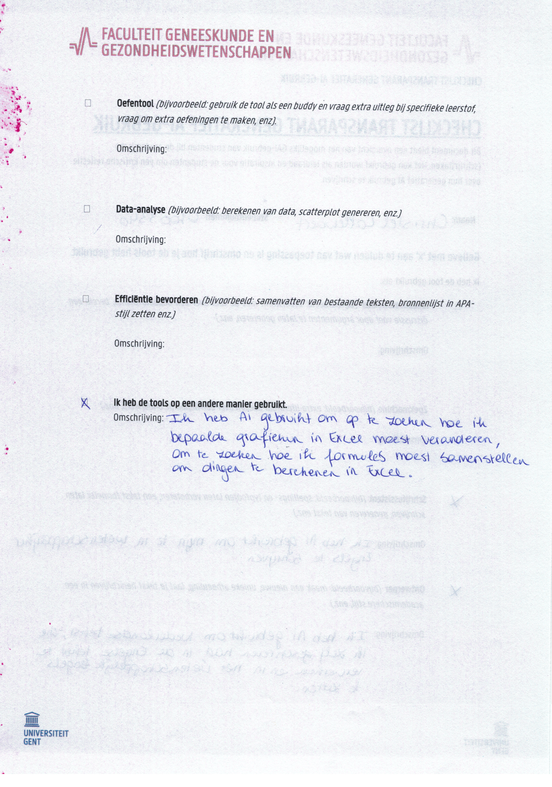

Appendix

- SOS-2-VL-text

jos is in de wei
hij eet koek
mus is er ook
zij zit op een muur
en is heel blij

Mus vliegt naar het hek, ze fluit een vrolijk lied.
Jos loopt naar het musje toe. Wat een mooi liedje is dat!
Dan ziet Jos een poes hoog in de boom.

Ben je daarom zo blij Mus, omdat poes bang in de boom zit? Poes schreeuwt: “miauw,
miauw...” wel 10 keer achter elkaar. Jos rent naar poes toe en wil haar helpen. Maar het
vogeltje wordt nu boos. Poes zat mij achterna en nu is ze bang. Laat haar daar maar
lekker zitten want ik heb geen medelijden met haar. Maar Jos gaat poes wel helpen.

Nu is het vogeltje heel erg boos en ze krijgen ruzie. Jos klimt in de boom en bevrijdt
het poesje dat angstig op een boomtak zit te kijken. Het musje is verstandig en vliegt
nu gauw de boom weer in. Poes heeft geleerd van de achtervolging en zal nooit meer
in een boom klimmen. Jos ruikt iets vies. Hij kijkt naar zijn schoenen en ziet dat hij in
een koeienvlaai heeft gestapt. “Hoe krijg ik die schoon?” vraagt Jos zich af. Hij trekt
een bosje droog gras uit de grond en begint zijn schoen schoon te wrijven. Maar echt
schoon worden die niet.

Nu ziet hij ook dat zijn broek gescheurd is. Dat zal zijn moeder niet leuk vinden. Maar ze is erg
Creatief en kan de broek nog wel maken op de naaimachine. Hij kijkt om zich heen en ziet dat
het poesje is verdwenen. Het vogeltje fluit weer een vrolijk wijsje. “Ben je niet meer boos op mij?”
vraagt Jos. Ik kon dat zielig poesje toch niet in de boom laten verhongeren?

Het musje vergeeft Jos en slaat zijn vleugels uit. Jos gaat op een sukkeldrafje naar huis. Onderweg
moet hij een drukke verkeersweg oversteken. Hij gaat bij een zebrapad stil staan en wacht tot de grote
vrachtwagen, die hij in de verte ziet aankomen, langs is gekomen. Dan kijkt hij nog een keer naar links,
naar rechts en nogmaals naar links en steekt over. Thuis aangekomen is zijn moeder gelukkig niet boos
over de scheur in zijn broek. Ze maakt lekkere chocolademelk voor hem en Jos typt het hele verhaal
in een Word-document op de computer. Later wil hij journalist worden en daarom wil hij journalistiek
gaan studeren.

- BHK-text

jan is bij oom
hij eet ijs
oom zit op een bank
wie zijn er nog meer
suus en zus

Zus kruipt op de grond, maar Suus springt rond.
Suus heeft haar ijsje al op. Wat smaakt dat lekker.
Mmm! Dat is nog eens smullen.

Dan schreeuwt Jan: ‘’O, kijk eens oom. Daar varen schepen, . . . wel drie achter
elkaar.’’ Jan holt naar de kant van het water. Suus draaft met
hem mee en buigt zich over de kademuur om beter te kunnen kijken.
Zus waggelt hen achterna. Oom houdt een oogje in het zeil.

In de haven drijft allerlei rommel: kisten, kratten, planken, een grote
plastic zak, een boomtak met bladeren en zelfs . . . een kapotte matras!
Een grijs-witte meeuw scheert over hen heen.

De kinderen zwaaien met hun zakdoek naar het voorste schip. Tot hun
verrukking laat de boot zijn stoomfluit horen. ‘’Hij zegt ook dag’’,
lacht Suus en danst van plezier.

Maar dan klapt oom in zijn handen. Hij roept: ‘’We moeten naar huis, hoor!’’
Jan en Suus zijn gehoorzaam, ze komen direkt. Zus stribbelt echter tegen
en begint te zeuren. Oom glimlacht en zegt: ‘’Je bent een kleine schavuit.’’
Met een reuzenzwaai tilt hij haar op zijn schouders. ‘’Kom jongens,
niet treuzelen, in galop naar huis, anders wordt tante ongerust.’’

De kinderen lopen op een sukkeldrafje met oom mee langs enorme pakhuizen, kantoren,
opslagplaatsen met containers, parkeerterreinen vol met vrachtwagen. Oom puft ervan.
‘’Ik word oud, mijn gewrichten kraken helemaal’’. ‘’Daar ligt die mammoettanker nog’’, wijst
Suus. Ze is trots op dat moeilijke woord. ‘’Gaan we weer met de metro?‘’, vraagt Jan. Oom
grinnikt bevestigend, hij grabbelt naar zijn portemonnee en vist alvast tussen munten en
verkreukelde briefjes het kaartje tevoorschijn. Daar zijn ze al bij het metrostation. ‘’Goed
uitkijken hoor’’, zegt oom, ‘’en op de zebra oversteken’’.

SchrijvenNL.nl / QuickScan-Handschrift / Overschrijftekst uit Beknopte Beoordelingsmethode voor Kinderhandschriften (BHK) / 01-2023

- Observation form

Nummer: | School:
 | Omcirkel wat past:
Frequentie dat het kind naar het toetsenbord kijk. | Constant – vaak – af en toe - nooit
Het aantal vingers dat het kind gebruikt tijdens het typen.
Welke vingers worden gebruikt? | Kruis aan wat past:
 | Links | Rechts
Wijsvinger
Middelvinger
Duim
Ringvinger
Pink

Extra observaties:
___________________________________________________________________________________________________________________________________________________________________________________________________________________________________________________

Bedankt voor het invullen!
Sara, Delphine, Christel en team Typ10

- “Typ10: What did you think?” (part 1)

Super gedaan!
Jullie hebben nu alle typlessen van Typ10 gevolgd én heel wat testen gemaakt. Goed gewerkt en bedankt voor jullie inzet!
We zijn benieuwd wat jullie vonden van de lessen. Daarom willen we jullie graag een paar vragen stellen.
Op de volgende pagina’s vinden jullie zinnen over de lessen en het typen. Lees elke zin goed en duid aan of je het ermee eens bent of niet.
Kies wat het beste past bij hoe jij je voelt.

Ervaring met de lessen en het oefenen |  |  | Omcirkel wat past:
 |  | Niet leuk |  |  |  |  |  |  |  |  | Leuk
Hoe vond je de Typ10 lessen? |  | 1 |  | 2 |  | 3 |  |  | 4 |  | 5
Hoe vond je het oefenen op Typ10 Online? |  | 1 |  | 2 |  | 3 |  |  | 4 |  | 5
Hoe vond je de invuloefeningen in het online werkboek? |  | 1 |  | 2 |  | 3 |  |  | 4 |  | 5
Hoe vond je het leren van de versjes? |  | 1 |  | 2 |  | 3 |  |  | 4 |  | 5
Hoe vond je de beweegspelletjes? |  | 1 |  | 2 |  | 3 |  |  | 4 |  | 5
Hoe vond je het oefenen van verhaaltjes zonder scherm? |  | 1 |  | 2 |  | 3 |  |  | 4 |  | 5
 |  | Niet waar |  |  |  |  |  |  |  | Waar
Ik kon mij genoeg focussen tijdens de Typ10 lessen op school. |  | 1 |  |  | 2 | 3 |  | 4 |  | 5
Ik keek uit naar de lessen Typ10 op school. |  | 1 |  |  | 2 | 3 |  | 4 |  | 5
Door af en toe te bewegen in de les, lukte het mij beter om de opdrachten te maken. |  | 1 |  |  | 2 | 3 |  | 4 |  | 5
De beweegspelletjes tijdens de lessen, hielpen mij om de nieuwe informatie van de les te onthouden. |  | 1 |  |  | 2 | 3 |  | 4 |  | 5
Het verhaaltje dat tijdens de les werd voorgelezen, hielp mij om de letters te koppelen aan de afbeeldingen. |  | 1 |  |  | 2 | 3 |  | 4 |  | 5
Het oefenen van de verhaaltjes zonder scherm vond ik fijn omdat ik me zo geen zorgen hoefde te maken of het goed of fout was. |  | 1 |  |  | 2 | 3 |  | 4 |  | 5
De invulschema’s in het online werkboek hielpen mij om de nieuwe informatie uit de les beter te onthouden en te herhalen. |  | 1 |  |  | 2 | 3 |  | 4 |  | 5
Motivatie en beloning |  | Omcirkel wat past:
 |  | Niet leuk |  |  |  |  |  |  |  | Leuk
Wat vond je ervan dat je na het Online oefenen een beker of diamant kon winnen? |  | 1 |  |  | 2 | 3 |  | 4 |  | 5
 |  | Niet waar |  |  |  |  |  |  |  | Waar
Het kunnen winnen van een beker of diamant motiveerde mij om extra te oefenen. |  | 1 |  |  | 2 | 3 |  | 4 |  | 5
Ik voelde mij verplicht om te oefenen. |  | 1 |  |  | 2 | 3 |  | 4 |  | 5
Ik keek er naar uit om te oefenen. |  | 1 |  |  | 2 | 3 |  | 4 |  | 5
Ik ben trots als ik foutloos kan typen. |  | 1 |  |  | 2 | 3 |  | 4 |  | 5
Ik vind het fijn om te zien hoeveel ik al geleerd heb. |  | 1 |  |  | 2 | 3 |  | 4 |  | 5
Ik was gemotiveerd om thuis te oefenen. |  | 1 |  |  | 2 | 3 |  | 4 |  | 5
Gebruik van algemene hulpmiddelen tijdens het oefenen |  | Omcirkel wat past:
 |  | Niet waar |  |  |  |  |  |  |  | Waar
Ik kan nu de toetsen makkelijker blind vinden door de hulpmiddelen die mij hielpen onthouden waar de letters staan op het toetsenbord. |  | 1 |  |  | 2 | 3 |  | 4 |  | 5
Als ik een letter even niet weet te vinden, denk ik terug aan één van de hulpmiddelen die ik leerde. |  | 1 |  |  | 2 | 3 |  | 4 |  | 5
Ik vind het nuttig dat er kleuren gebruikt worden, zodat ik weet welke vinger ik het best gebruik voor het typen van de letters. |  | 1 |  |  | 2 | 3 |  | 4 |  | 5
Ik vind het nuttig dat er afbeeldingen gebruikt worden, zodat ik weet welke letter waar staat op het toetsenbord. |  | 1 |  |  | 2 | 3 |  | 4 |  | 5
Ik vind het nuttig dat er woorden gebruikt worden, zodat ik weet welke letter waar staat op het toetsenbord. |  | 1 |  |  | 2 | 3 |  | 4 |  | 5
Ik vind het nuttig dat er versjes gebruikt worden, zodat ik de plaats van de letters ten opzichte van elkaar beter kan onthouden. |  | 1 |  |  | 2 | 3 |  | 4 |  | 5
Wanneer ik letters moet overtypen, denk ik vaak aan de gekoppelde woorden van die letter om te weten waar ik deze terugvind op het toetsenbord. |  | 1 |  |  | 2 | 3 |  | 4 |  | 5
Wanneer ik letters moet overtypen, denk ik vaak aan de gekoppelde woorden van die letter om te weten waar ik deze terugvind op het toetsenbord. |  | 1 |  |  | 2 | 3 |  | 4 |  | 5
Gebruik van (online) hulpmiddelen tijdens het oefenen |  | Omcirkel wat past:
Ik gebruikte de groen/rode lettermarkeringen tijdens het oefenen op Typ10 Online. |  | Ja |  |  |  |  | Nee
Ik gebruikte de zwart/witte lettermarkeringen tijdens het oefenen op Typ10 Online. |  | Ja |  |  |  |  | Nee
Ik gebruikte een los toetsenbord tijdens het oefenen thuis. |  | Ja |  |  |  |  | Nee
Ik gebruikte muziek/ritme tijdens het oefenen op Typ10 Online. |  | Ja |  |  |  |  | Nee
Ik gebruikte de kleuren op het toetsenbord op het scherm tijdens het oefenen op Typ10 Online. |  | Ja |  |  |  |  | Nee
Ik gebruikte de afbeeldingen op het toetsenbord op het scherm tijdens het oefenen op Typ10 Online. |  | Ja |  |  |  |  | Nee
Ik kan de versjes van de verschillende vingers opnoemen. |  | Ja |  |  |  |  | Nee
Thuis oefenen |  | Omcirkel wat past:
Ik had de mogelijkheid om thuis te oefenen. |  | Ja |  |  |  |  | Nee
Ik kan thuis oefenen in een rustige omgeving. |  | Ja |  |  |  |  | Nee
Gevoelens en houding t.o.v. typen |  | Omcirkel wat past:
 |  | Niet waar |  |  |  |  |  |  |  | Waar
Ik voel mij ontspannen tijdens het typen. |  | 1 |  |  | 2 | 3 |  | 4 |  | 5
Ik voel mij zenuwachtig tijdens het typen. |  | 1 |  |  | 2 | 3 |  | 4 |  | 5
Ik ervaarde druk tijdens de evaluaties. |  | 1 |  |  | 2 | 3 |  | 4 |  | 5
Ik vind typen saai. |  | 1 |  |  | 2 | 3 |  | 4 |  | 5
Ik vind typen makkelijk. |  | 1 |  |  | 2 | 3 |  | 4 |  | 5
Ik word wel eens boos of gefrustreerd als het foutloos typen niet lukt. |  | 1 |  |  | 2 | 3 |  | 4 |  | 5
Ik vind het goed dat we leren typen op school. |  | 1 |  |  | 2 | 3 |  | 4 |  | 5
Ik ben tevreden over de typetest die ik aflegde. |  | 1 |  |  | 2 | 3 |  | 4 |  | 5
Ik wil graag beter worden in typen. |  | 1 |  |  | 2 | 3 |  | 4 |  | 5

Extra opmerking:
____________________________________________________________________________________________________________________________________________________________________________________________________________________________________________________________________________________________________________________________________
Bedankt voor het invullen!
Sara, Delphine, Christel en team Typ10

- “Typ10: What did you think?” (part 2)

Dankjewel!
Je hebt net de allerlaatste testen gedaan voor ons onderzoek. Goed gedaan!
We hebben nog een paar laatste vraagjes voor jou. Deze gaan over wat jij vindt van het typen en van de lessen.
Lees elke zin goed en duid aan of je het ermee eens bent of niet.
Kies wat het beste past bij hoe jij je voelt.

Herinnering aan de lesinhoud | Omcirkel wat past:
 | Niet waar |  |  |  | Waar
Ik weet nog goed hoe de beginhouding op het toetsenbord bij het typen moet zijn. | 1 | 2 | 3 | 4 | 5
Ik herinner mij welke vingers ik voor welke letters moet gebruiken. | 1 | 2 | 3 | 4 | 5
Ik kan de versjes opzeggen die helpen om letters te onthouden. | 1 | 2 | 3 | 4 | 5
Ik weet welke kleuren bij welke vingers horen. | 1 | 2 | 3 | 4 | 5
Ik weet welke afbeeldingen horen bij welke letters. | 1 | 2 | 3 | 4 | 5
Toepassen van kennis | Omcirkel wat past:
 | Niet waar |  |  |  | Waar
Als ik een typefout maak, weet ik hoe ik die moet verbeteren. | 1 | 2 | 3 | 4 | 5
Ik gebruik nog steeds hulpmiddelen uit de lessen (zoals woorden, kleuren of versjes). | 1 | 2 | 3 | 4 | 5
Ik kan makkelijker blind typen dan voor de Typ10 lessen. | 1 | 2 | 3 | 4 | 5
Vaardigheden en gevoelens t.o.v. typen | Omcirkel wat past:
 | Niet waar |  |  |  | Waar
Nu ik Typ10 gevolgd heb, werk ik op school gemakkelijker met het toetsenbord dan vóór de typlessen van Typ10. | 1 | 2 | 3 | 4 | 5
Nu ik Typ10 gevolgd heb, vind ik het werken op de computer leuker dan vóór de typlessen van Typ10. | 1 | 2 | 3 | 4 | 5
Ik vind van mezelf dat ik nu goed kan blind typen. | 1 | 2 | 3 | 4 | 5
Ik vind typen makkelijk. | 1 | 2 | 3 | 4 | 5
Ik vind het goed dat we leren typen op school. | 1 | 2 | 3 | 4 | 5
Ik voel mij ontspannen tijdens het typen. | 1 | 2 | 3 | 4 | 5
Ik voel mij zenuwachtig tijdens het typen. | 1 | 2 | 3 | 4 | 5
Ik vind typen saai. | 1 | 2 | 3 | 4 | 5
Ik voelde mij verplicht om te oefenen. | 1 | 2 | 3 | 4 | 5
Ik keek er naar uit om te oefenen. | 1 | 2 | 3 | 4 | 5
Ik ben tevreden over de typetest die ik aflegde. | 1 | 2 | 3 | 4 | 5
Ik ervaarde druk tijdens de evaluaties. | 1 | 2 | 3 | 4 | 5
Behoud van motivatie | Omcirkel wat past:
 | Niet waar |  |  |  | Waar
Ik merk dat ik vaker met tien vingers typ, zelfs buiten het oefenen. | 1 | 2 | 3 | 4 | 5
Ik wil mijn typevaardigheden blijven verbeteren. | 1 | 2 | 3 | 4 | 5
Ik had de mogelijkheid om thuis te oefenen. | 1 | 2 | 3 | 4 | 5
Ik kon thuis oefenen in een rustige omgeving. | 1 | 2 | 3 | 4 | 5
Ik was gemotiveerd om thuis te oefenen. | 1 | 2 | 3 | 4 | 5
Ik vond het leuk om na de typlessen nog zelf verder te oefenen. | 1 | 2 | 3 | 4 | 5

Extra opmerking:
____________________________________________________________________________________________________________________________________________________________________________________________________________________________________________________________________________________________________________________________________

