Anatomical variability in lower limb arteries
A systematic review

Laura van der Tol
Student number: 02104066

Emma Deceuninck
Student number: 02010227
Supervisor(s): Prof. Dr. Isabelle Van Herzeele, Prof. Dr. Emmanuel Audenaert, Marlies Verleyen

A dissertation submitted to Ghent University in partial fulfilment of the requirements for the degree of Master of Medicine in Medicine
Academic year: 2024 – 2025

Acknowledgements
This thesis has been completed as part of the program of the Master of Medicine at Ghent University. We would like to thank everyone who supported us during this process.
Writing a thesis is a long and challenging process, but also deeply rewarding once the final product is completed. It has been a demanding journey, and we could not have done it without each other. This teamwork made the entire process of completing our master’s thesis both enjoyable and fulfilling. Our collaboration and communication worked seamlessly, which contributed greatly to this project.
We would like to express our sincere gratitude to our promoter, Prof. Dr. Isabelle Van Herzeele, for her valuable guidance, continuous support, and constructive feedback throughout the course of this thesis. Her expertise and encouragement have been a great source of inspiration.

We are also deeply thankful to our supervisor, Dr. Marlies Verleyen, for her constant availability, helpful insights, and exceptionally prompt responses to our questions. Her support greatly facilitated the progress of this work.

Finally, we would like to thank our family and friends for their unwavering encouragement, patience, and understanding during this journey. Their support has been essential and deeply appreciated.

Community outreach
There are two types of blood vessels in the human body: veins and arteries. By definition, veins transport deoxygenated blood, whereas arteries carry oxygenated blood. This thesis focuses on arteries and the anatomical variations that may exist, in the arteries of the lower limb, from the pelvic region to the feet. Branching pattern, diameters and tortuosity of the arteries were analyzed. Tortuosity refers to the abnormal twisting or irregular course of an artery. This literature review aims to compile all available information regarding the anatomy of the arteries of the lower limb using different databases. Special attention was given to information regarding gender differences and the possible influence of ethnicity. Several articles categorize the existing variations in arteries into different classification systems. Because of these different classifications, an extensive and sometimes confusing array of systems has emerged over time. Reaching a consensus on this matter therefore appears to be essential. In most studies, the anatomy of men has been studied more often than women, but sometimes the gender has not been reported which makes it unclear what the true anatomical differences between the sexes are. Therefore, most classification systems of peripheral arteries in the lower limbs are primarily based on anatomy of men. The same is true for ethnicity. Why is the anatomical variability in lower limb arteries important? Because the variability in branching pattern, diameters and tortuosity may be important in decision-making how to treat the patient and what devices to use to obtain good results. Therefore, standardizing classification systems and establishing consistent methods for measuring diameters and tortuosity could lead to improved reporting, more relevant guidelines, resulting in fewer complications and better patient outcomes. This review highlights the need for clear and uniform classifications that are based on anatomy of women and men, with mandatory reporting of the study population’s ethnicity.

Table of contents
Abstract 1
Abbreviations 3
Introduction 4
Embryology of the lower extremities 7
Anatomy of the lower extremities 8
Methods 11
Protocol 11
Search strategy 11
In- and exclusion criteria 12
Screening and selection 13
Risk of bias and quality assessment 14
Data extraction 15
Results 16
Risk of bias and quality assessment 16
Main findings 18
Branching pattern 20
Diameter 36
Tortuosity 37
Velocity 38
Discussion 38
Branching pattern 39
Diameter 42
Tortuosity 44
Limitations and future directions 44
Conclusion 46
References 47
Supplementaries I
1. Table of 56 included articles I
2. Final selection articles II
3. Checklist used for assessment of risk of bias III
3A. JBI Critical Appraisal Checklist for analytical cross-sectional studies III
3B. JBI Critical Appraisal Checklist for systematic reviews and research syntheses V
4. JBI quality assessment for cross-sectional studies VIII
5. JBI quality assessment for systematic reviews VIII
6. Results VIII
6A. branching pattern of the deep femoral artery (DFA): Variations in branching patterns of the lateral circumflex femoral artery (LCFA) and the medial circumflex femoral artery (MCFA) according to Siddharth et al.⁵⁴. VIII
6B. branching pattern of the popliteal artery: A new variant branching pattern ‘IID’ introduced by Mavili et al.⁶⁷. X
6C. branching pattern of the genicular arteries X
6D. Velocity XIII

Abstract
Introduction: Arterial anatomy of the lower limbs shows considerable variability, which can be described across four domains: branching pattern, diameter, blood flow velocity, and tortuosity. Understanding these variations is crucial for optimizing the treatment of vascular diseases and for minimizing complications during surgical and endovascular procedures.

Method: A systematic literature search was conducted in PubMed, Embase, and Web of Science between 6 April 2024 and 11 February 2025 to identify studies describing the anatomy of the lower-extremity arteries. The protocol was prospectively registered in PROSPERO (CRD42024605174). Two reviewers (E.D. and L.V.) independently screened all records and assessed eligibility. Studies were included if they involved healthy humans, participant age >18 years, had a sample size of ≥ ten, were available in full text in English, and reported anatomical characteristics of the lower-limb arteries, including branching patterns, diameter, flow velocity, or tortuosity. Eligible study designs comprised cohort studies, randomized controlled trials, systematic reviews, and meta-analyses. Risk of bias and methodological quality were evaluated using the Joanna Briggs Institute (JBI) checklists for analytical cross-sectional studies and for systematic reviews, resulting in the following categories: high-, moderate-, or low-quality.

Results: A total of 56 studies were included, comprising 52 cross-sectional studies and four systematic reviews. Most studies focused on the branching patterns of the lower extremity arteries. For nearly all arteries, multiple classification systems were identified. One classification was described for the iliac artery, while the deep femoral artery showed the greatest variation, with four different classification systems reported. The popliteal artery was the only artery for which one classification clearly predominated over all others. Three variant classifications were reported for the dorsalis pedis artery. In contrast, substantially less information was available regarding arterial diameter and tortuosity.

Conclusion: Current research mainly focuses on the morphological aspects of the lower extremity arteries, while diameter and tortuosity remain largely underreported. Moreover, there are numerous classification systems for arterial branching patterns, but no standardized definition for these. Similarly, no standardized definitions exist for arterial diameter or tortuosity. This lack of uniformity makes it difficult to compare findings across studies. A consensus on the classification of branching patterns, as well as on definitions of diameter and tortuosity, is therefore essential. Establishing such standardization would facilitate comparison between studies and help bridge the gap between anatomists and surgeons.

Introductie: Anatomie van de arteriën van het onderste lidmaat toont een aannemelijke variabiliteit, deze kan worden beschreven op basis van 4 domeinen: vertakkingspatroon, diameter, snelheid van bloedstroom en tortuositeit. Kennis hieromtrent is essentieel om de behandeling van vasculaire aandoeningen te optimaliseren en de kans op complicaties tijdens chirurgie en endovasculaire ingrepen te verkleinen.

Methode: Er werd een literatuurstudie uitgevoerd in PubMed, Embase en Web of Science tussen 6 april 2024 en 11 februari 2025 om studies te identificeren die de anatomie van de arteriële structuren van de onderste extremiteit beschreven. Het protocol werd geregistreerd in PROSPERO (CRD42024605174). Twee onafhankelijke reviewers (E.D. en L.V.) screenden alle records en beoordeelden de geschiktheid. Studies werden geïncludeerd wanneer zij een gezonde populatie bevatten, een leeftijd >18 jaar hadden, een steekproefgrootte van ≥ tien rapporteerden, volledig beschikbaar waren in het Engels en anatomische kenmerken van de arterieën van de onderste extremiteit beschreven, waaronder vertakkingspatronen, diameter, stroomsnelheid of tortuositeit. Toelaatbare studiedesigns omvatten cohortonderzoeken, randomized controlled trials, systematische reviews en meta-analyses. Het risico op bias en de methodologische kwaliteit werden beoordeeld met behulp van de Joanna Briggs Institute (JBI) checklists voor analytische cross-sectionele studies en voor systematische reviews, hetgeen resulteerde in een classificatie op basis van hoge, matige of lage kwaliteit.

Resultaten: In totaal werden 56 studies geïncludeerd, waaronder 52 cross-sectionele studies en vier systematische reviews. Van de cross-sectionele studies werden 14 artikels als hoge kwaliteit beoordeeld, 20 als matige kwaliteit en 18 als lage kwaliteit, terwijl alle review artikels (n=4) als hoge kwaliteit werden beoordeeld. De meeste studies richtten zich op de vertakkingspatronen van de arterieën van de onderste extremiteit. Voor quasi alle arterieën werden meerdere classificatiesystemen geïdentificeerd. Voor de arteria iliaca werd één classificatie beschreven, terwijl de arteria profunda femoris de grootste variabiliteit vertoonde met vier verschillende classificatiesystemen. De arteria poplitea was de enige arterie waarvoor duidelijk één classificatiesysteem geopteerd werd. Voor de arteria dorsalis pedis werden drie classificaties gerapporteerd. Daarentegen was er aanzienlijk minder informatie beschikbaar over arteriële diameter en tortuositeit.

Conclusie: Huidig onderzoek richt zich voornamelijk op de morfologische kenmerken van de arteriën in het onderste lidmaat, terwijl diameter en tortuositeit grotendeels onderbelicht blijven. Hoewel er talloze classificaties zijn om arteriële vertakkingspatronen te beschrijven, ontbreekt een gestandaardiseerde definitie. Ook voor arteriële diameter en tortuositeit zijn tot op heden geen uniforme definities geformuleerd. Het gebrek aan uniformiteit bemoeilijkt het vergelijken van resultaten tussen verschillende studies. Een consensus over de classificatie van vertakkingspatronen en over definities van diameter en tortuositeit is essentieel. Het vastleggen van dergelijke standaardisatie zou de vergelijkbaarheid tussen studies verbeteren en de kloof tussen anatomisten en chirurgen verkleinen.

Abbreviations

AA | Arcuate artery | IIA | Internal iliac artery
AL | Axial line | ILGA | Inferior lateral genicular artery
ATA | Anterior tibial artery | IMGA | Inferior medial genicular artery
CBCT | Cone beam computed tomography | IVUS | Intravascular ultrasound
(C)FA | (common) femoral artery | MGA | Medial genicular artery
CIA | Common iliac artery | MPA | Medial plantar artery
CTA | Computed tomography angiography | MRA | Magnetic resonance angiography
DB-MPA | Deep branch medial plantar artery | MTA | Medial tarsal artery
DCIA | Deep circumflex iliac artery | LTA | Lateral tarsal artery
DFA | Deep femoral artery | PA | Popliteal artery
DGA | Descending genicular artery | PTA | Posterior tibial artery
DPA | Dorsal pedis artery | PR | Peroneal artery = fibular artery
DSA | Digital substraction angiography | TPT | Tibioperoneal trunk
DUS | Duplex ultrasound scan | SB-MPA | Superficial branch medial plantar artery
EIA | External iliac artery | SFA | Superficial femoral artery
EIV | External iliac vein | SLGA | Superior lateral genicular artery
FDMA | First dorsal metatarsal artery | SMGA | Superior medial genicular artery
GA | Genicular artery

Introduction
The heart circulates approximately four to five liters of blood throughout the body every minute. This blood is transported by the vascular system which comprises two primary types of blood vessels: arteries and veins. Arteries are characterized by a thicker vascular wall than veins and possess a higher density of smooth muscle fibers¹. This enhances their elasticity and contractility allowing them to transport and deliver oxygenated blood from the heart to the organs and tissues throughout the body¹. Because of their crucial function in the human body, arteries are still a significant area of research within the medical and biological sciences. An important part of the research conducted deals with the variability of arteries in the lower limb. Especially, the knowledge of the anatomical variations in arteries is important for anyone in the medical and biological sciences treating patients with vascular disease (e.g. angiology, vascular surgery, interventional cardiology, interventional radiology). The knowledge of these variations is important in the diagnosis as well as the treatment of vascular disease. Vascular disease can be suspected based on anamnesis and clinical examination (including ankle-arm index, 6-minute walk test) but formal diagnosis of any vascular disease will require non-invasive (e.g. Duplex Ultrasound (DUS), Computed Tomography Angiography (CTA), or Magnetic Resonance Angiography (MRA)) and sometimes invasive imaging (e.g. Digital Subtraction Angiography (DSA), Intravascular Ultrasound (IVUS))^{2.} Awareness of the variability of arteries is fundamental to optimally prepare for surgical and endovascular interventions and to minimize complications and overall increase the success rate of surgical or vascular treatment³. When anatomical variability is present, there is a greater risk of iatrogenic trauma which may lead to complications such as bleeding, dissection, ischemic complications and amputation^{4,5}. Before performing any invasive procedure, it is vital to define the vascular variability of the arteries to avoid unexpected iatrogenic injuries⁶.

When addressing variability in the lower extremity arteries, Lorbeer et al.⁷ distinguished four distinct domains: the branching pattern of arteries, the diameter of arteries, the velocity of blood in arteries and tortuosity of the arteries. The primary focus is the branching patterns of arteries, which represent the most documented topic in the existing literature. The anatomical description of arteries of the lower extremity in anatomy books does not accurately reflect the anatomical reality or variability observed in clinical practice. Adachi⁸ was one of the first to describe anatomical variations in branching pattern of the arteries in ‘das Arteriensysteem der Japanner. Since then, the branching pattern has been largely investigated using dissection of cadavers, CTA or DSA. This led to numerous classifications of the different arteries of the lower limb such as the classification by Kim et al.⁹ regarding the variations of the popliteal artery.

The subsequent domain of investigation has studied the arterial diameter. The diameter of arteries is dynamic, depending on the regulation of vascular tone, which is influenced by the release of vasodilatory or vasoconstrictive factors. Endothelial cells, which are derived from the vascular endothelium, the innermost lining of the blood vessel wall, play a crucial role in this regulation. Adverse changes in normal endothelial function, thereby influencing vascular diameter, can be an early predictor of various pathologies, such as atherosclerosis and other cardiovascular diseases¹⁰. The diameter of arteries can be measured using non-invasive methods such as Doppler ultrasound, duplex sonography, CTA or MRA. Some studies use dissection of cadavers however, postmortem vessel contraction necessitates a cautious interpretation of these findings^{1,11}.

A third area of focus is the velocity of blood flow within arterial vessels. The blood volume flow and velocity often decrease in patients with peripheral arterial disease². Various techniques can be used to measure velocity, including Doppler ultrasound and Doppler waveform analysis; the ankle-arm index, which reflects the waveform generated by heart contractions; pulsatility index plethysmography; which detects significant changes in blood flow segmental pressure measurement, which reveals reduced blood pressure but not its exact location measurement methods are qualitative and provide only indirect information about the quantitative blood flow. However, MRA provides a more reliable method to determine the velocity of blood flow in the lower extremities ².

The final domain of investigation pertains to arterial tortuosity. Tortuosity is a common vascular anomaly that has been observed in numerous vascular regions. This term is used to describe the tortuous deformation of blood vessels, manifesting in various forms (e.g. curving, twisting, looping and kinking), depending on the vessel’s location or the underlying predisposing factors. This anomaly may disrupt the local hemodynamic conditions, leading to phenomena such as flow separation, recirculation, and diminished oscillatory wall shear stress, all of which have been well-established as factors contributing to the initiation and progression of atherosclerosis¹². The association between the degree of tortuosity and the magnitude of flow disturbance is yet to be systematically studied ¹². MRI can be utilized for the visualization of tortuosity ¹³.

In addition to the areas discussed above, ethnicity and gender also have a significant influence on the arterial variability within the human body. Difference in anatomical vasculature among ethnic groups becomes evident when examining the incidence of certain cardiovascular diseases across these populations. For example, the incidence of stroke is higher in black people than in white people, the incidence of intracerebral hemorrhage and subarachnoid hemorrhage is higher among Hispanics than non-Hispanic whites¹⁴. However, because anatomical variations mainly have been investigated in Western populations, there is a lack of scientific knowledge in minorities e.g. Asians¹⁵. Because of this lack of information about certain ethnicities, ethnic minorities (e.g. African Americans and Hispanic Americans), are less likely to receive evidence-based medical and invasive treatment compared to the Western population¹⁶. Furthermore, disparities are intensified by lower socioeconomic status, as minorities are likely to hold lower-paying jobs and face higher unemployment rates. They often have reduced access to health information and health insurance, contributing to lower health literacy within these populations and, therefore, decreased awareness ¹⁷.

A few articles have specifically studied the difference in the lower limb arteries of men and women¹⁵. Men generally have greater height, body mass, and a solider skeletal framework compared to women. The arterial system of both sexes functions similarly in circulating blood throughout the body, but it differs in structural and viscoelastic properties. These structural and mechanical variations influence pulsatile pressure and flow waveforms, leading to sex-specific differences in hemodynamic patterns¹⁸. Sex differences in vascular phenotypes emerge in childhood and follow distinct trajectories influenced by sex-specific genetics, differential responses to risk exposures, and hormonal fluctuations throughout life¹⁹. However, centuries of excluding women in studies have led to inadequate knowledge of treatment of diseases affecting women²⁰.

This study aims to provide an overview of the existing literature of the arterial system of the lower extremities in the human body, describing branching patterns, diameter, velocity and tortuosity of these arteries. Moreover, the objective is to identify the gaps in the existing literature and to propose methodological approaches to address these deficiencies. Finally, this study has studied the possible arterial differences based on gender and ethnicity.

Embryology of the lower extremities
Before discussing the branching pattern, diameter, velocity or tortuosity of the lower limb arteries, a thorough understanding of the embryological development of the lower limb arteries and the typical course they follow in adults is needed (figure 1).

When an embryo is nine mm the development of the arteries starts in the lower extremity²¹. The vessels of the lower extremity originate from two primitive vessels that supply the lower extremity: the sciatic artery or axial artery, from the umbilical artery; and the femoral artery (FA), from the external iliac artery (EIA)^{1,21}. The sciatic artery supplies the majority of the developing limb bud²¹. When the embryo reaches 14mm the femoral artery (8 weeks) anastomoses with the sciatic artery. The new artery formed by this anastomosis will be the main supplier of the lower extremity at the level of the adductor canal^{2,21}. The popliteal (PA) and peroneal artery (PR) consist of the primitive middle and distal part of the sciatic artery¹. The proximal part of the sciatic artery will regress but a part of the proximal sciatic artery remains and becomes the inferior gluteal artery^{2,21}. The anterior tibial artery (ATA) originates from the PA and the posterior tibial artery (PTA) is formed by the PA and the early distal femoral artery²¹. At the 12th week of the pregnancy the arterial anatomy of the lower limb is completed²¹.

A | B | C
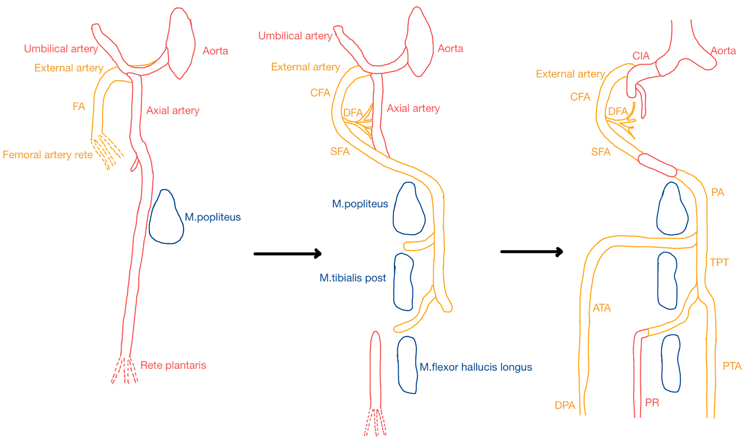
Figure 1
Embryological development of vascular anatomy of the lower limb. A: The axial artery is the first artery in the lower extremity. B: The common femoral artery (CFA) with superficial femoral artery (SFA) and deep femoral artery (DFA) forms later during embryological development and joins the axial artery at the level of the ramus communicant superior and becomes the major source of blood flow to the lower extremity. The middle part of the axial artery regresses. C: The remnant of the axial artery is the sciatic artery. The common iliac artery (CIA) splits off the aorta. The popliteal artery (PA) develops. Thereafter, the anterior tibial artery (ATA) (with dorsalis pedis artery (DPA)) and posterior tibial artery (PTA) form through vasculogenesis. The distal peroneal artery (PR) is a remnant of the original axial artery²¹.

Anatomy of the lower extremities
The common iliac arteries (CIA) are the two terminal branches of the abdominal aorta which supply the pelvis and the lower extremities²². The branches of the CIA are less well-documented in literature. The larger branches of the CIA contribute to the vascularization of the Psoas muscle and the ureter²². The course of each CIA starts right after the termination of the aorta, between the 3rd or 4th lumbar vertebra^{22,23}. Afterwards, the CIA divides into the EIA and the internal iliac artery (IIA)²².

The EIA distributes blood to the peripheral vasculature and represents the larger terminal branch of the CIA²³. It courses anterior-inferiorly within the iliac fossa and exits the pelvis by passing posterior to the inguinal ligament. Upon crossing the mid-inguinal point, the EIA continues as the FA⁵. The IIA supplies blood to the visceral and parietal regions of the pelvis²³. This research does not address the IIA, as its vascular supply is primarily confined to the pelvis. Instead, the focus of this study is specifically directed toward the lower extremities.

The FA, also known as the common femoral artery (CFA), bifurcates at the level of the thigh into the deep femoral artery (DFA) and the superficial femoral artery (SFA). The SFA follows a helical course along the limb as it progresses through the adductor canal¹³. As the FA approaches the popliteal fossa, it becomes the PA¹⁰. The DFA originates approximately in the femoral triangle, below the inguinal ligament and can arise from the lateral, medial or dorsal regions of the FA²⁴. It courses deep between the adductor longus and pectineus muscles²⁴. The DFA is the principal branch of the FA and serves as the primary arterial supply to the thigh adductors, flexors and extensors^{6,24}. The DFA plays a crucial compensatory role in facilitating collateral blood flow between the lower pelvis and the infrapopliteal circulation²⁴. The classification of Lippert and Pabst describes the different patterns and frequency of anatomical variations of the DFA and its branches²⁵. Anatomical variations in DFA are of significant interest to surgeons and interventional radiologists because the artery is readily accessible through catheterization, making it a preferred option for a variety of arterial investigations²⁴.

The SFA leaves the adductor canal, also known as Hunter’s canal. Once it crosses the hiatus adductor it becomes the PA^{26,27}. The PA is often located proximally behind the posterior horn of the lateral meniscus at the level of the knee joint line⁴. The PA has an oblique course, this means that the artery goes downward and outward⁴. The PA is an artery that supplies the knee, the bottom of the lower limb, and the foot²⁸. A lot of variable branching patterns have been described in the literature, but the pattern by Kim et al. is mostly used⁹.

When the PA crosses the popliteal fossa it gives rise to five branches, from top to bottom: bilateral, superior medial genicular artery (SMGA) and the superior lateral genicular artery (SLGA), unilateral, middle genicular artery (MGA), bilateral, inferior medial genicular artery (IMGA) and inferior lateral genicular artery (ILGA)²⁹. These five arteries anastomose with each other and form the genicular anastomosis, which helps to provide the knee joint and the surrounding tissues³⁰. The SMGA and SLGA supply the superior medial and superior lateral parts of the knee joint³¹. The MGA provides the cruciate ligaments and synovium³¹. The IMGA and ILGA supply the inferior knee joint³¹.

After the PA crosses the popliteal fossa at the level of the distal border of the popliteus muscle it comes to an end and divides into branches^{4,32}. A first branch is the ATA, this artery splits off from the popliteal artery at the distal border of the popliteus muscle³. The second and third branches form the tibioperoneal trunk (TPT) and bifurcate into the PTA (the second branch) and the PR (the third branch), also called the fibular branch^{3,27}. These arteries stay in the posterior chamber²⁸.

The ATA goes from the posterior chamber, the part of the bottom of the lower limb located on the backside that contains the flexor muscles, to the anterior chamber, the part of the bottom of the lower limb located on the frontside that contains the extensor muscles²⁸. The ATA reaches this anterior chamber by passing through the two heads of the posterior tibial muscle, going through the oval opening at the upper part of the interosseous membrane between the tibia and fibula^{28,33}. In the anterior chamber the ATA passes medial from the head of the fibula and runs vertically down between the extensors of the bottom part of the lower limb and over the interosseous membrane³³. Once the ATA reaches the ankle it passes through the inferior extensor retinaculum and becomes the dorsalis pedis artery (DPA) (cfr infra)³³.

The PTA stays in the posterior chamber and runs vertically along the tibial posterior muscle on the bottom part of the lower limb³⁴. At the height of the medial ankle it goes through the tarsal tunnel together with the posterior tibial vein and the tibial nerve³⁴. The tarsal tunnel is a tunnel formed by the tendons of the flexor hallucis longus muscle and the flexor digitorum longus muscle wherethrough neurovascular structures pass (cfr. supra)³⁴. After passing through the tarsal tunnel the PTA bifurcates into the medial plantar artery and the lateral plantar artery³⁴. These terminal arteries of the PTA supply the muscles of the foot³⁴.

The DPA is the continuation of the ATA at the anterior part of the ankle joint³⁵. The DPA follows the dorsum of the foot and along its course it gives off a few branches (from top to bottom): the lateral tarsal artery, the medial tarsal artery and the arcuate pedis artery³⁶. At the proximal part of the first metatarsal space, it bifurcates into two terminal branches: the first dorsal metatarsal artery and the deep plantar artery³⁵. The deep plantar artery passes between the two heads of the 1st interosseus muscle and completes the plantar arterial arch³⁶. The DPA supplies the dorsum of the foot³⁵.
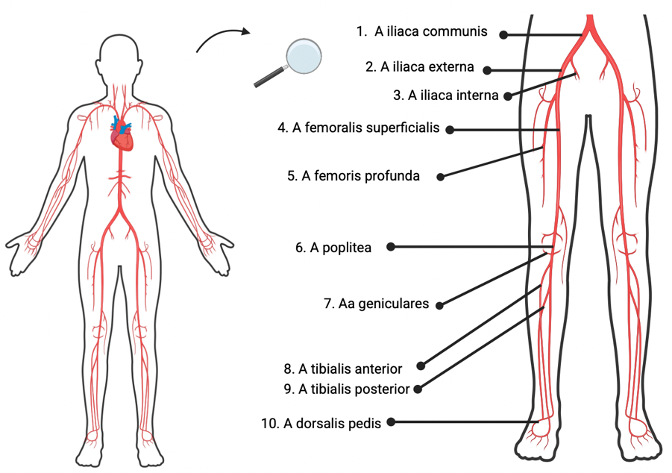
Figure 2
The vascular anatomy of the lower limb starting from the common iliac artery. (Created in https://BioRender.com)

Methods

Protocol
The original protocol was registered and approved on the International Prospective Register of Systematic Reviews (PROSPERO), which can be accessed online (https://www.crd.york.ac.uk/prospero/) with protocol code CRD42024605174. This systematic review was performed in conformity with the Preferred Reporting Items for Systematic reviews and Meta-Analyses (PRISMA) guidelines.

Search strategy
Between 6th April 2024 and 11th February 2025, a comprehensive search was conducted in PubMed, Web of Science and Embase databases for studies investigating anatomical variability of the human lower limb arteries. Both researchers (E.D. and L.V) screened the articles in PubMed, Web of Science and Embase. To identify additional relevant articles, the authors conducted an extensive examination of the references cited in the included publications. The search was performed using the following terms represented in Table 1. No date restrictions were applied to ensure a comprehensive overview of the existing literature.

Table 1
Search strings in the different databases used for the selection of the articles included in this systematic review on anatomical variability of lower limb arteries.
Database | Search terms | n
Pubmed | ("biological variation, population"[MeSH Terms] OR "variability"[Title/Abstract] OR "branching pattern"[Title/Abstract] OR "tortuosity"[Title/Abstract] OR "diversity"[Title/Abstract]) AND ("Lower Extremity"[MeSH Terms] OR "lower limb’’ [Title/Abstract] OR "Femoral Artery"[Title/Abstract] OR "Iliac Artery"[Title/Abstract] OR "sciatic artery"[Title/Abstract] OR "popliteal artery"[Title/Abstract] OR "tibial artery"[Title/Abstract] OR "fibular artery"[Title/Abstract] OR "dorsalis pedis artery"[Title/Abstract]) AND ("Arteries"[MeSH Terms] OR "vascular"[Title/Abstract] OR ("Arteries"[MeSH Terms] OR "Tibial Arteries"[MeSH Terms] OR "Femoral Artery"[MeSH Terms] OR "Iliac Artery"[MeSH Terms] OR "vascular"[Title/Abstract])) | 692
Embase | ('lower limb'/exp OR 'lower limb' OR 'knee':ab,ti OR 'hip':ab,ti OR foot:ab,ti OR 'leg':ab,ti) AND ('artery':ab,ti OR 'popliteal artery':ab,ti OR 'femoral artery':ab,ti OR 'tibial artery':ab,ti OR 'superior gluteal artery':ab,ti OR 'deep femoral artery':ab,ti OR 'inferior gluteal artery':ab,ti OR 'sciatic artery':ab,ti OR 'dorsalis pedis artery':ab,ti OR 'radiographic anatomy':ab,ti OR 'anatomy':ab,ti OR 'vascular anatomy':ab,ti) AND ('varietas':ab,ti OR 'variability':ab,ti OR 'biological variation':ab,ti OR 'diversity':ab,ti OR 'dysmorphism':ab,ti OR 'arterial variation':ab,ti OR 'tortuosity':ab,ti OR 'branching pattern':ab,ti) | 1168
Web of science | ((AB=lower limb) OR (AB=knee) OR (AB=hip) OR (AB=leg)) AND ((AB=artery) OR (AB=popliteal artery) OR (AB=femoral artery) OR (AB=tibial artery) OR (AB=superior gluteal artery) OR (AB=inferior gluteal artery) OR (AB=dorsalis pedis artery) OR (AB=deep femoral artery) OR (AB=sciatic artery) OR (AB=radiographic anatomy) OR (AB=anatomy) OR (AB=vascular anatomy)) AND ((AB=varietas) OR (AB=arterial variation) OR (AB=variability) OR (AB=dysmorphism) OR (AB=tortuosity) OR (AB=branching pattern) OR (AB=diversity)) | 715

In- and exclusion criteria
The inclusion criteria were defined based on the PICOS framework: cohort studies, randomized controlled trials (RCTs), systematic reviews and meta-analyses about healthy humans from the age of 18 years and up were included. Only studies with full-text availability in English were included. Studies from which the cohort consisted of animals or children (<18 years) were excluded. Studies with a sample size less than ten were excluded. Articles containing extractable data about upper limb arteries, urological veins and arteries were excluded. Furthermore, articles about lower limb arteries that were affected by atherosclerosis or had been subjected to flap-related surgical interventions were excluded as well. Case reports were also excluded. An overview of the more detailed in- and exclusion criteria can be found in Table 2.

Table 2
Inclusion and exclusion criteria for selecting studies within the scope of this systematic review on anatomical variability of lower limb arteries.
Inclusion criteria | Exclusion criteria
Healthy humans | Known diseased humans  Animal studies
Age >18 years | Age < 18 years
Study design  - Cohort study  - Randomized controlled trial  - Systematic review  - Meta-analysis | Study design  - Case report
Full text available | No full text available
Language: English | In another language than English
Studie size >= 10 cases | Studie size < 10 cases
Subject of article: (branching pattern OR diameter OR velocity OR tortuosity) AND lower limb artery | Subject of article: atherosclerosis, flap reconstruction surgery, urological arteries, veins, arteries of upper body

Screening and selection
Articles qualified for inclusion were analyzed independently by the two authors (E.D., L.V.). Relevant articles (cfr. supra) were first evaluated by screening the title and abstract. These articles were all first assembled in Excel according to title, author, artery type, focus of the article, population size, ethnicity and study design. When a disagreement occurred, this was discussed between the two authors, if necessary, with the supervisor (M.V.) to reach a consensus. Afterwards articles with extractable data about branching pattern of the artery, diameter of the artery, tortuosity and velocity were included and uploaded to Rayyan (https://www.rayyan.ai/) (https://pubmed.ncbi.nlm.nih.gov/27919275/). This resulted in 207 articles in Rayyan. The full text of the articles in Rayyan was thoroughly reviewed. Finally, 33 articles relevant to this topic met the inclusion criteria (figure 3). The references of these were screened, this led to the inclusion of 23 additional articles (supplementary 1, 2).

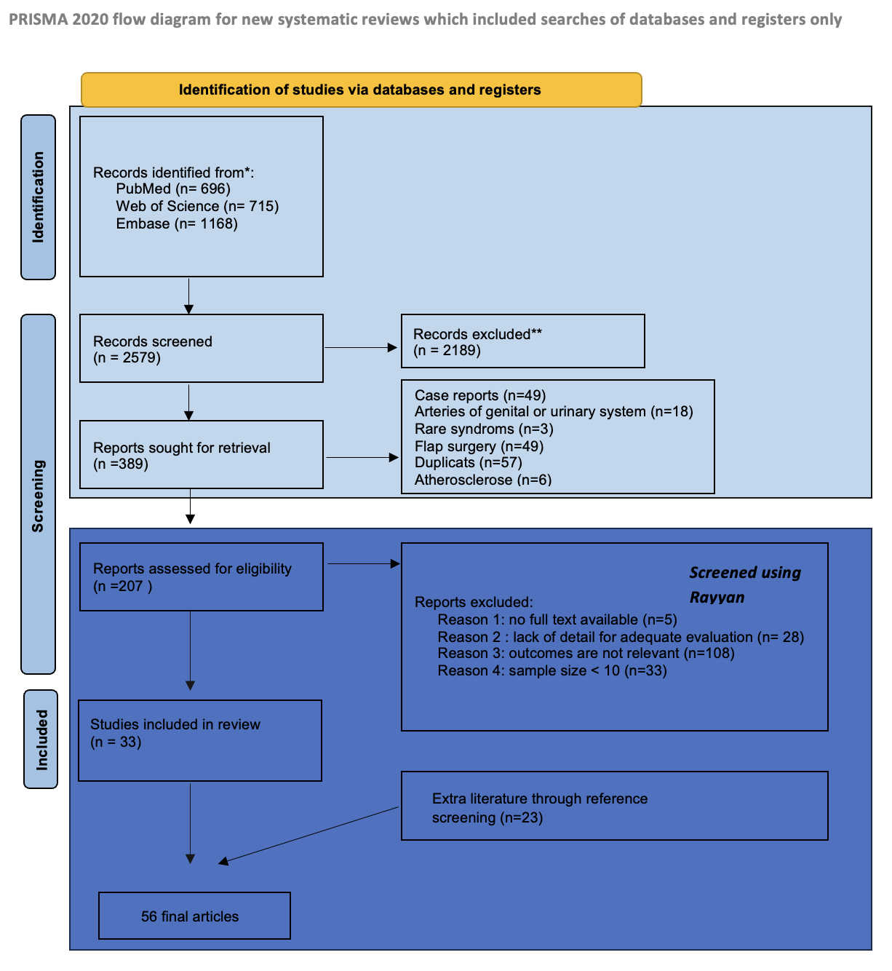
Figure 3
PRISMA-flowchart illustrating the screening and selection process for the articles included in this systematic review on anatomical variability of lower limb arteries.

Risk of bias and quality assessment
Evaluation of the included studies’ quality and risk of bias were conducted with the following bias tools. For retrospective, cross-sectional observational studies the ‘Joanna Briggs Institute (JBI) checklist for analytical cross-sectional studies’ was used (https://jbi.global/critical-appraisal-tools) (supplementary 3A)³⁷⁻⁴¹. Initially, the articles were assessed using eight predefined questions addressing the following domains: inclusion criteria, study population, exposure, confounding factors, methods to control confounding, publication bias, outcomes and statistical analysis. Response options included yes, no, unclear, or not applicable. As the JBI does not provide a scoring system for study inclusion or exclusion, a pragmatic scoring approach was adopted based on the method used by George et al⁴¹. Studies scoring below 50% were excluded; those scoring between 50% and 70% were subject to further evaluation, and studies scoring above 70% were included. In practice, this system was applied as follows: for cross-sectional studies (JBI checklist with 8 items), a score of less than four out of eight led to exclusion, a score between four and six prompted further information gathering, and a score above six resulted in inclusion (supplementary 4). For systematic reviews the ‘JBI checklist for systematic reviews’ (https://jbi.global/critical-appraisal-tools) was used (supplementary 3B)³⁷⁻⁴¹. Subsequently, eleven questions were used to evaluate each systematic review. The checklist addressed the following domains: review question, inclusion criteria, sources and resources, criteria for appraising studies, critical appraisal conducted by two or more reviewers, methods to minimize errors in data extraction, publication bias, and recommendations for future research. Response options included yes, no, unclear, or not applicable. For systematic reviews (JBI checklist with 11 items) the method as outlined by George et al.⁴¹ was applied. Studies scoring less than six out of 11 were excluded, scores between six and eight required additional information, and scores above eight were included. Through consensus, the authors established the following decision thresholds: more than seven ‘yes’ responses indicated inclusion, seven ‘yes’ responses required additional clarification, and fewer than seven ‘yes’ responses resulted in exclusion (supplementary 5). The authors (E.D., L.V.) independently assessed all articles using the JBI checklist. In case of any discrepancies, they discussed the differences until a consensus was reached.

Data extraction
These articles were all assembled in Excel according to title, author, artery, focus of the article, population size, ethnicity, age of study population and study design.

After screening the articles in Rayyan, relevant information from the 56 selected studies was extracted and organized into Excel files. The extracted data was used to generate pie charts that visually represent key findings.

Results

Risk of bias and quality assessment
In this study, 52 retrospective, cross-sectional observational studies were evaluated with the JBI checklist. Based on the quality assessment, 14 cross-sectional studies were identified as high quality, 20 studies were evaluated as being of moderate quality, and 18 studies were evaluated as low quality. Four systematic reviews were evaluated with the JBI checklist (table 3). All four were evaluated as high quality (table 4).

Table 3
Summary of the quality assessment for all included observational studies (n = 52).
Ref | Title aricle | Author | Quality assesment
1 | Evaluation of Lower Limb Arteriovenous Diameters in Indoor Soccer Athletes: Arterial Doppler Ultrasound Study | Mateus | High
2 | Magnetic resonance imaging measurement of blood volume flow in peripheral arteries in healthy subjects | Klein | High
12 | Tortuosity of the superficial femoral artery and its influence on blood flow patterns and risk of atherosclerosis | Li | High
13 | Curvature and tortuosity of the superficial femoral artery: a possible risk factor for peripheral arterial disease | Wood | High
15 | Iliofemoral anatomy among Asians: implications for transcatheter aortic valve implantation | Chiam | High
23 | Mechanical, structural, and morphological differences in the iliac arteries | Kazim | High
28 | Variations in terminal branches of the popliteal artery: cadaveric study | Olewnik | High
30 | Collateral circulation of the femoral and genicular systems in human lower limbs is highly uncommon | Jethwa | High
33 | Morphometic and morhological evaluation of anterior tibial artery | Çandir | High
34 | Anatomical study of the distal course of the posterior tibial artery: A cadaver study | Karip | High
35 | Anatomical variation of the Dorsalis pedis artery in a South African population - A Cadaveric Study | Ntuli | High
36 | anatomy of the dorsalis pedis artery | Luckrajh | High
50 | Popliteal Artery Branching Variations: A Study on Multidetector CT Angiography | Oner | High
72 | Variability of lower limb artery systolic–diastolic velocities in futsal athletes and non-athletes: Evaluation by arterial doppler ultrasound | Duarte-Mendes | High
3 | Anatomical variations of the popliteal artery and its tibial branches: analysis in 1242 extremities | Kil | Moderate
4 | Popliteal artery: Anatomical study and review of the literature | Aragones | Moderate
5 | A cadaveric study of variations of external iliac artery and its implication in trauma and radiology | Nayak | Moderate
6 | Origin of profunda femoris artery and its circumflex femoral branches: anatomical variations and clinical significance | Nasr | Moderate
7 | Reference values of vessel diameters, stenosis prevalence, and arterial variations of the lower limb arteries in a male population sample using contrast-enhanced MR angiography | Lorbeer | Moderate
9 | Surgical significance of popliteal arterial | Kim | Moderate
22 | Anatomical study of the common iliac arteries | Panagouli | Moderate
25 | Anatomical variants of the profunda femoris artery: An angiographic study | Massoud | Moderate
29 | A Cadaveric Study of the Branching Pattern and Diameter of the Genicular Arteries: A Focus on the Middle Genicular Artery | Shahid | Moderate
31 | Classification of Genicular Artery Anatomic Variants Using Intraoperative Cone-Beam Computed Tomography | Callese | Moderate
44 | Patterns of the Circumflex Femoral Arteries Revisited | Vazquez | Moderate
42 | Distinct intergender difference in the femoral artery ramification patterns found in the Turkish population: angiographic study | Basar | Moderate
45 | A morphological study of the medial and lateral femoral circumflex arteries: a proposed new classification | Labetowicz | Moderate
46 | Deep femoral artery: A new point of view based on cadaveric study | Claassen | Moderate
49 | Variations in the popliteal artery branching in 342 patients studied with peripheral CT angiography using 64-MDCT | Calisir | Moderate
48 | Variation in branching pattern of the popliteal artery | Bardsley | Moderate
51 | Prevalence and surgical significance of a high-origin anterior tibial artery | Tindall | Moderate
52 | A morphological study of dorsalis pedis artery and its clinical correlation | Kulkarni | Moderate
53 | Variations of branching pattern of the dorsalis pedis artery: A cadaveric study | Patel | Moderate
73 | Anatomical study of the descending genicular artery and implications for image-guided interventions for knee pain | Fonkoue | Moderate
47 | A study of the arterial variations in the limbs, with special reference to symmetry of vascualr patterns | Keen | Low
54 | Variational Anatomy of the Deep Femoral Artery | Siddharth | Low
55 | Branching pattern of the femoral artery at the femoral triangle: a cadaver study | Samara-wickrama | Low
56 | Variations in the origins of the profunda femoris, medial and lateral femoral circumflex arteries: a cadaver study in the Indian population | Prakash | Low
57 | A Study Of Variations In The Origin Of Profunda Femoris Artery And Its Circumflex Branches. | Dixit | Low
58 | The Origin of Profunda Femoris Artery in Thais | Siriporn | Low
59 | Cadaveric Study of Profunda Femoris Artery with Some Unique Variations | Rajani | Low
60 | Anatomical Variations of the Profunda Femoris Artery and Its Branches: A Cadaveric Study in South Indian Population | Manjappa | Low
61 | A Study of Branching Pattern of Femoral Artery in Femoral Triangle in Cadavers | Kulkarni | Low
62 | Anatomical variations of profunda femoris artery | Sabnis | Low
63 | Cadaveric study: morphological study of branches of femoral artery in front of thigh | Suthar | Low
64 | Popliteal artery branching patterns -- an angiographic study | Day | Low
65 | Branching patterns of the popliteal artery and its clinical importance | Ozgur | Low
67 | Popliteal artery branching patterns detected by digital subtraction angiographym | Mavili | Low
68 | Anatomic study of infrapopliteal vessels | Lappas | Low
74 | Anatomical variants of the lateral femoral circumflex artery: an angiographic study | Fukuda | Low
75 | Variations in the origin, course and branching pattern of dorsalis pedis artery with clinical significance | Hemamalini | Low
77 | Anatomical Variability of Descending Genicular Artery | García-Pumarino | Low

Table 4
Summary of the quality assessment for all included systematic reviews (n = 4). The last column, “Articles included in this review”, lists the articles that were included in both the respective systematic reviews and the present study, along with their quality assessment: green = high quality, orange = moderate quality, and red = low quality.
Ref | Title | Author | Quality assesment | Articles included in the review
66 | The evidence-based surgical anatomy of the popliteal artery and the variations in its branching patterns | Tomaszewski | High | ^{3,9,48,49,51, 47,64,65,67,68}
32 | Variations in anatomy of the popliteal artery and its side branches | Kropman | High | ^{3,9,48}
24 | Variations in the origin of the deep femoral artery: A meta-analysis | Tomaszewski | High | 6,25,  54,55,56,57,58,59,60,61,62,63
76 | Descending genicular artery. Branching patterns and measuring parameters: A systematic review and meta-analysis of several anatomical studies | Ziegler | High | 77

Main findings
The key findings of the final 56 selected articles are visually represented with pie charts, illustrating the focus of the study, the methods used for artery evaluation, and the type of artery discussed in the articles (figure 4).

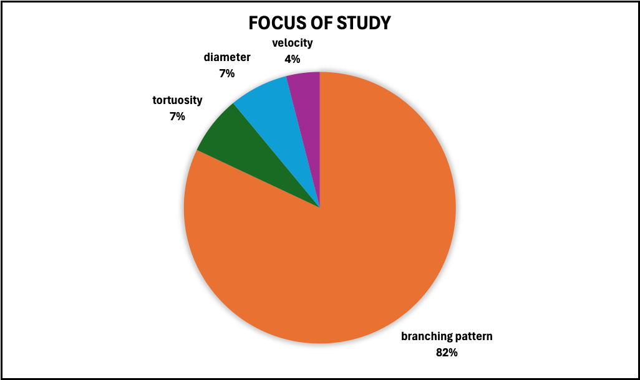

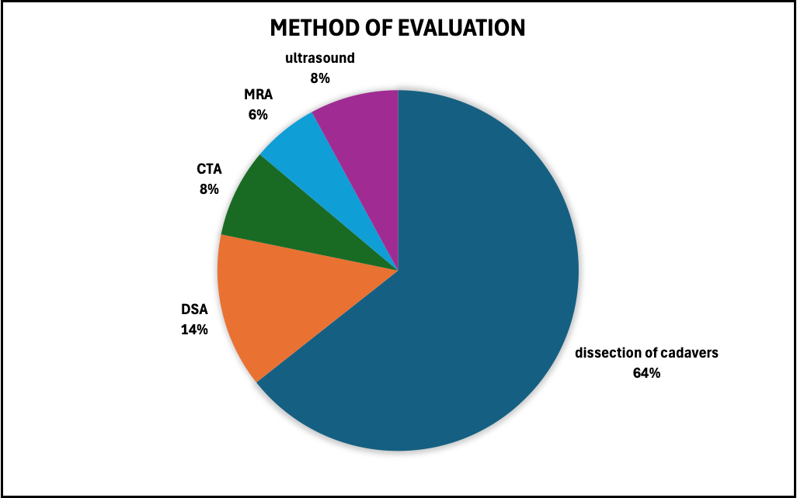
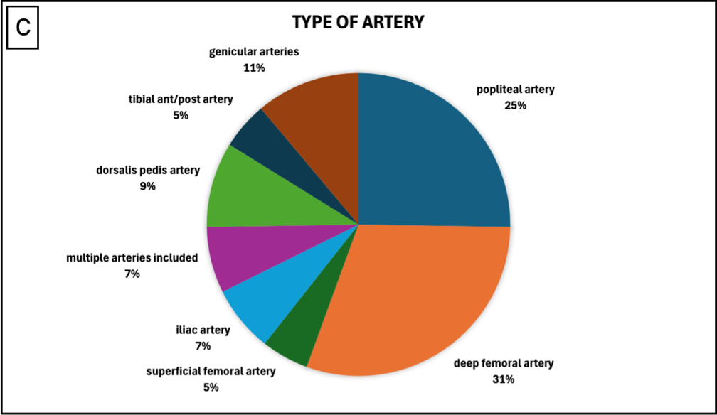
Figure 4
Pie charts with results of the 56 included articles in this study 4A: Main focus of each of the 56 included articles, 4B: Methods of classification used in the 52 included cross-sectional studies and 4C: Types of arteries examined in the 56 selected articles.

Of the 56 articles included in this study, 46 focused on the branching patterns of the arteries in the lower limb. Therefor this topic represents the primary focus of this review. Fewer studies addressed arterial diameter (four articles), tortuosity (four articles) and velocity (two articles).
The included articles investigated these four domains using various research methods, which can be categorized into two main groups. The first group comprised studies conducted on deceased individuals, and the second group on living subjects. Studies involving deceased individuals were conducted using anatomical dissection methods. The majority of the studies included in this review (34 articles) were performed through cadaveric dissection. The second group, consisting of studies on living subjects, can be divided into invasive and non-invasive imaging methods. The invasive technique, namely DSA, was employed in seven studies. Among the non-invasive methods, CTA was used in four studies, duplex ultrasound in four as well and MR(A) in three studies. Among the individual arteries discussed, the deep femoral artery (17 articles) and the popliteal artery (14 articles) were the most frequently examined. The different arteries will be discussed in the results according to each research domain.

The following observations were identified in the 52 observational studies:

The men-to-women distribution was described in 30 studies. In 17 studies, no gender-related differences were reported, while in five studies the study population consisted exclusively of men.

Most studies did not report the ethnic background of the included study population (n = 36), while 16 studies did. Most study populations were Caucasian (n = 7), a small proportion were Asian (n = 3), and a few studies included a mixed population consisting of Caucasian, Asian, African, and Middle Eastern participants (n = 3). Some articles reported the age of the participants (n=26), while others didn’t (n=16). The age range, varied between 18 to 103 years.

Only studies rated as high or moderate quality were included in the results (cfr. infra), as low-quality studies often lacked sufficient methodological quality to allow reliable interpretation of their findings (table 3).

Branching pattern

Common iliac artery (CIA), external iliac artery (EIA)
Nayak et al.⁵ aimed to describe the morphology and variations of the EIA in human cadaveric pelvises, based on 48 EIA obtained from 48 pelvic halves. Variations related to morphology and branching pattern were observed in 41.7% of the cases. Variations were grouped into 3 categories. Category 1: morphological variations (19%) including curved, tortuosity, looped, twisted, S-shaped. Category 2: branching pattern variations (13%) including variation in the origin of the obturator artery from EIA and duplication of the deep circumflex iliac artery (DCIA). Category 3: variant relation of the EIA with the external iliac vein (EIV), including superficial or medial courses. The mean length of EIA was 100mm on the right, 99mm on the left side⁵. Panagouli et al.²² examined if any significant correlations exist between length of CIA and sex in a Greek population (n=76). Mean length of the CIA measured 61.2mm on the left side and 60.3mm on the right side, on both sides vessels in men were slightly longer than in women, but no statistically significant difference was found²².

Deep femoral artery (DFA)
Massoud et al.²⁵ did a study in which they subdivided 94 examined DSAs and Basar et al.⁴² examined 600 DSAs (300 men and 300 women). All the variant branching patterns found for the DFA were classified into eight categories, formulated by Lippert and Pabst in 1985^{25,42,43} (figure 5) (table 5).

Pattern a | Pattern b | Pattern c
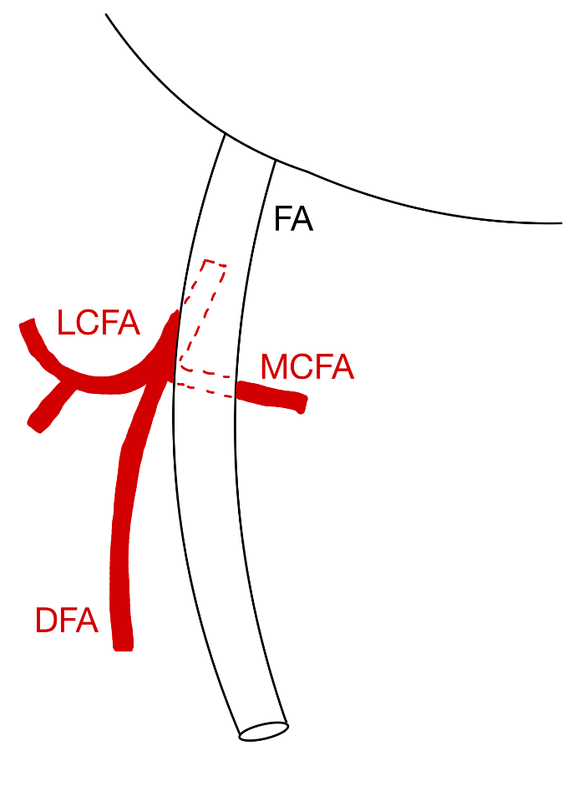 | 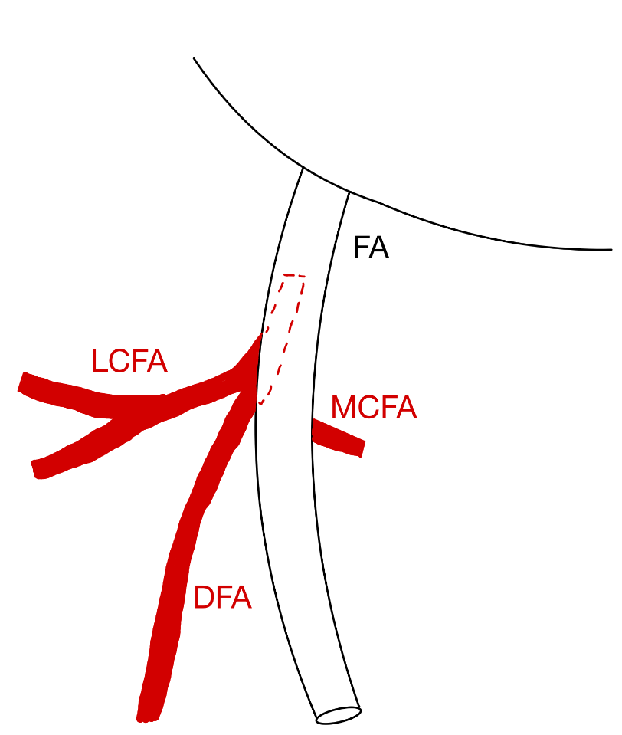 | 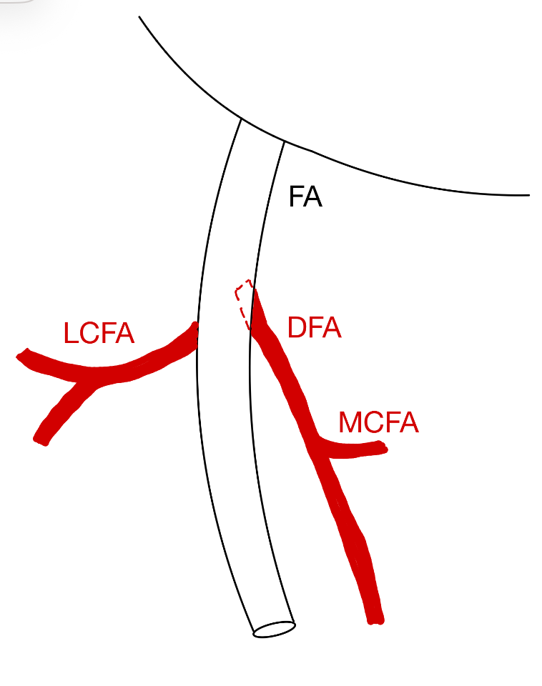
DFA, MCFA and LCFA all originate from one common trunk splitting off from FA. | LCFA and DFA originate from one trunk and MCFA splits off from FA. | MCFA and DFA originate from one trunk and LCFA splits off from FA.
Pattern d | Pattern e | Pattern f
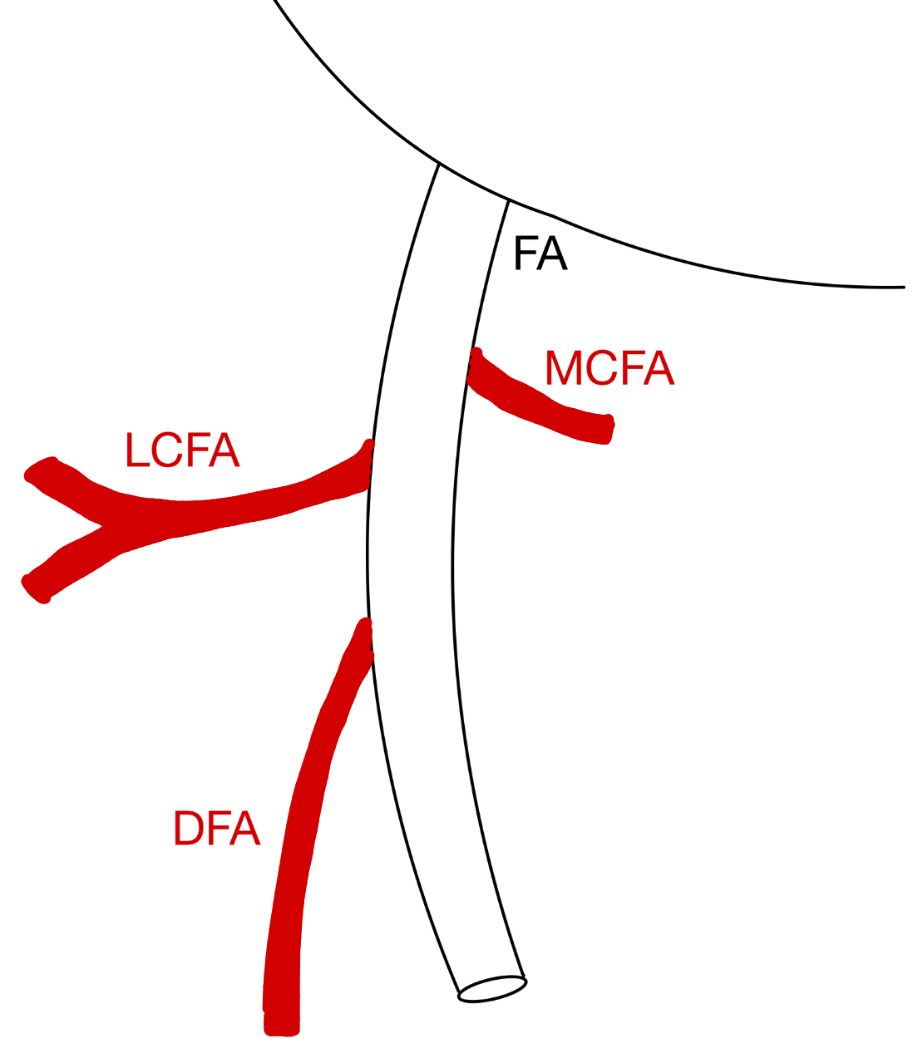 | 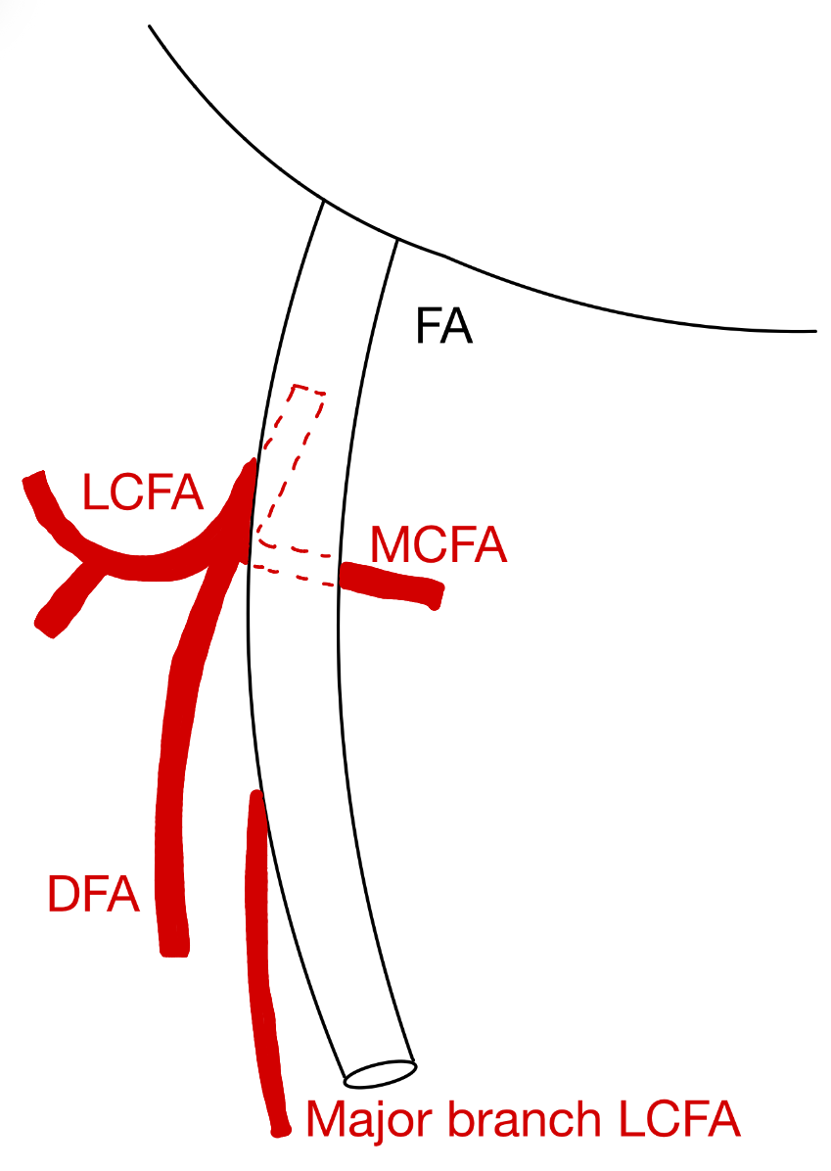 | 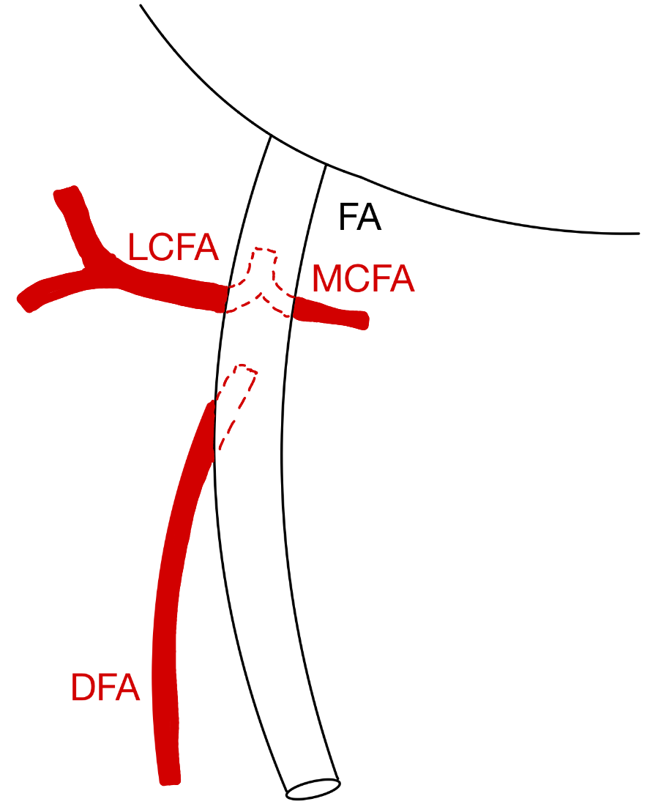
Three arteries split off separately from FA. | DFA, MCFA and LCFA all originate from one common trunk splitting off from FA, LCFA gives off a major branch below. | MCFA and LCFA originate from one trunk originating from FA and DFA splits off alone.
Pattern g | Pattern h
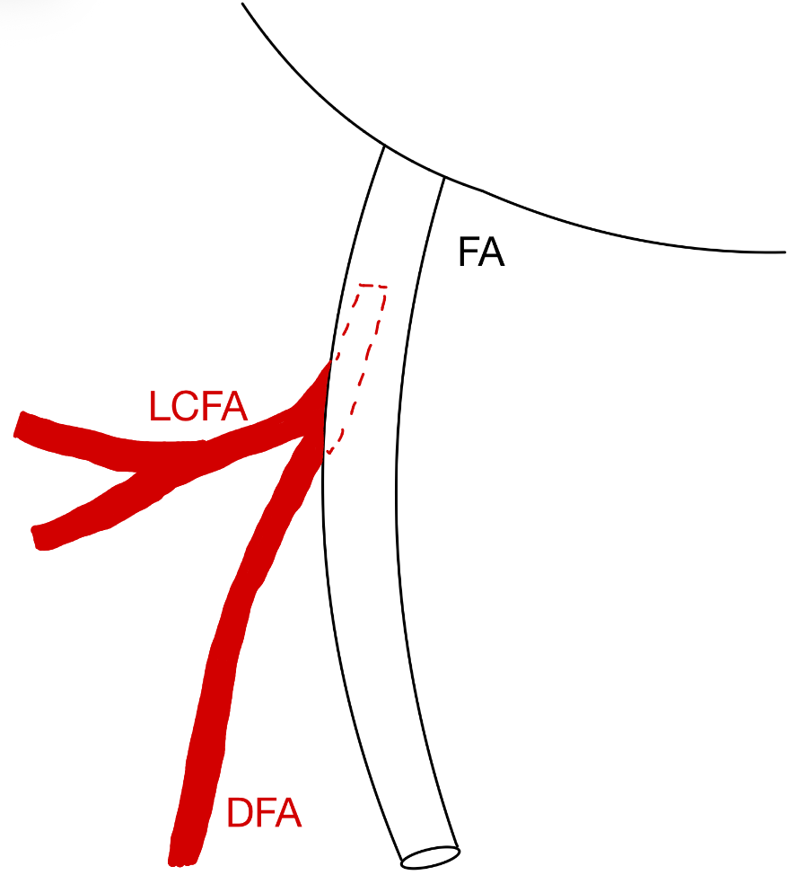 | 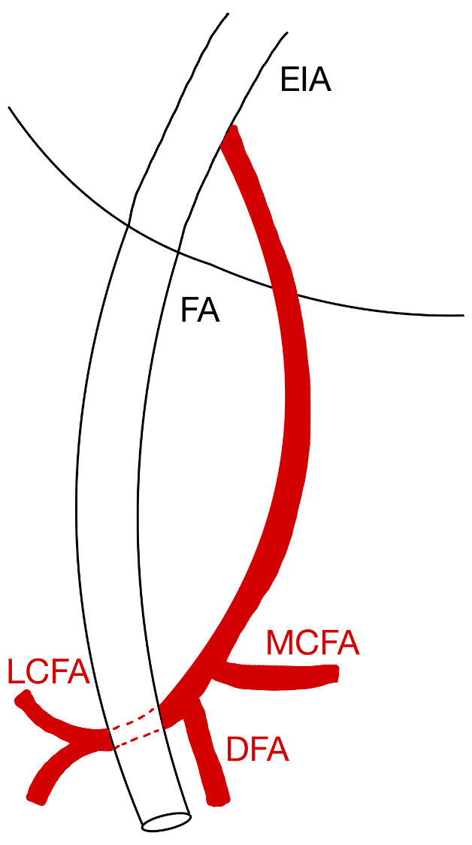
No MCFA. | DFA splits off from EIA.
Figure 5
Variant branching patterns of the lateral circumflex artery (LCFA), the medial circumflex artery (MCFA) and the deep femoral artery (DFA) according to the eight categories of Lippert and Pabst^{25,43}.

Table 5
Comparison of the distribution (%) of the deep femoral artery (DFA) branching patterns (a–h) as classified by Lippert et al. (26), based on data from three studies: Lippert et al.⁴³ (n = 100), Massoud et al.²⁵ (n = 94), and Basar et al.⁴² (n = 600).
Pattern | Lippert^{25,43}  n = 100 DSA | Massoud²⁵  n = 94 DSA | Basar⁴²  n = 600 DSA
a | 58% | 81% | 63.2%
b | 18% | 6.4% | 15%
c | 15% | 2.8% | 14.4%
d | 4% | 5.9% | 3.6%
e | 3% | 0 | 2.2%
f | 1% | 0.7% | 0.6%
g | <1% | 3.2% | 0.5%
h | <1% | 0 | 0.3%

Vazquez et al.⁴⁴ wanted to simplify this classification. They proposed three categories and five subcategories based on the dissection of 211 cadavers (105 men and 116 women). This study considered the DFA as a subsidiary artery and the LCFA and the MCFA as branches of the DFA or the FA (figure 6). In 0.2% a non-specified pattern was seen: the LCFA arose from the inferior epigastric artery ⁴⁴.
Pattern I: Both circumflex arteries splitt of from DFA (79%).
Ia | Ib |  | IC
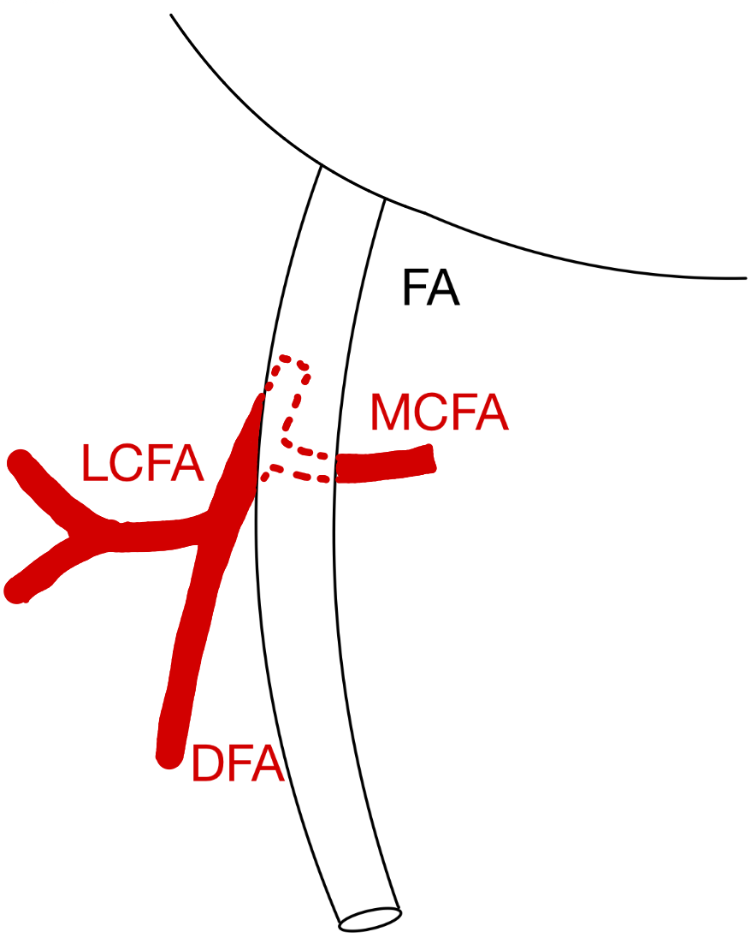 | 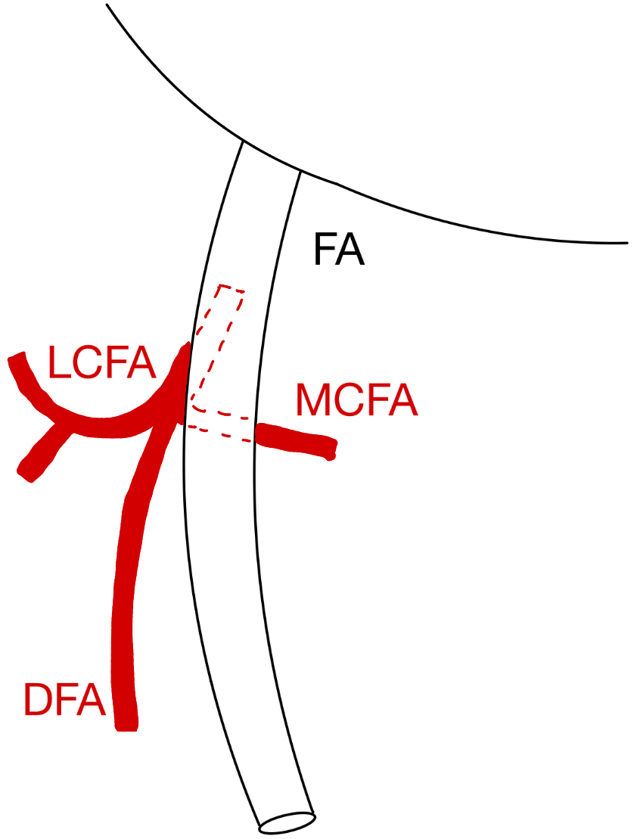 |  | 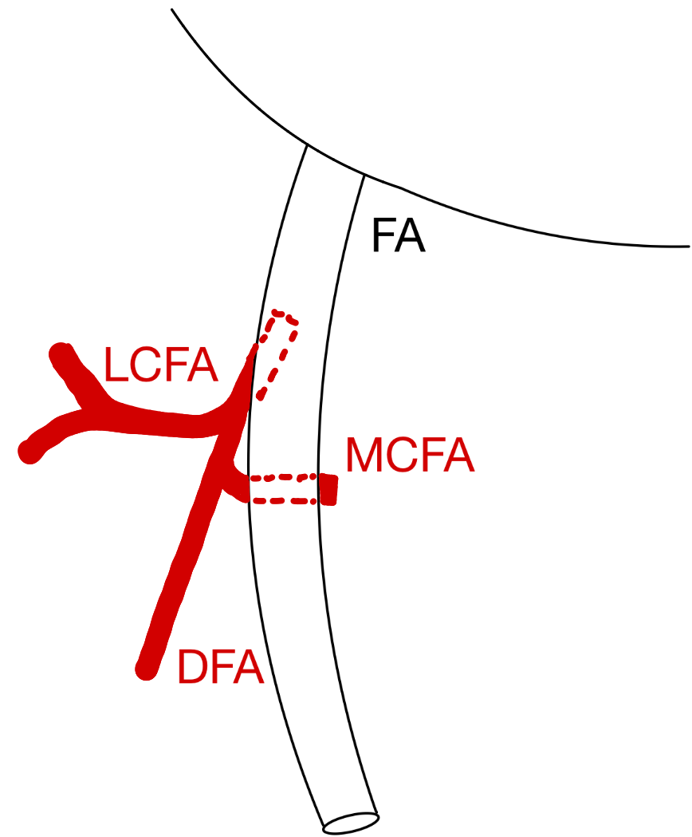
MCFA splits off DFA above LCFA (53.2%). | LCFA splits off DFA above MCFA (34.2%). |  | Both circumflex arteries split off as a common trunk from DFA (23.4%).
Pattern II: one circumflex artery that splits off the DFA and the other from the FA (20.5%).
IIa |  | IIb
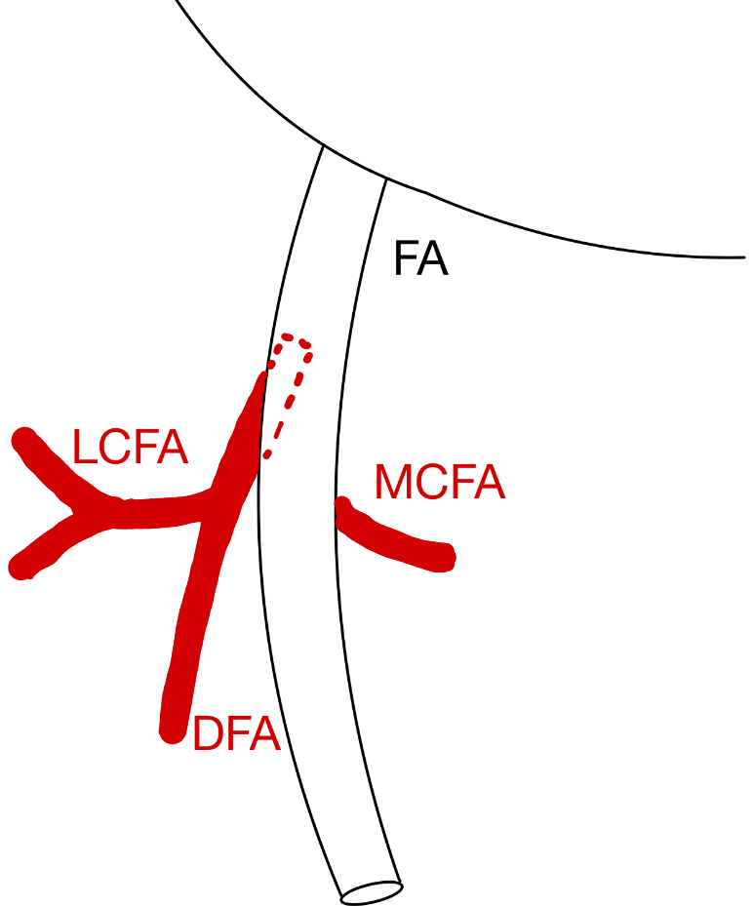 |  | 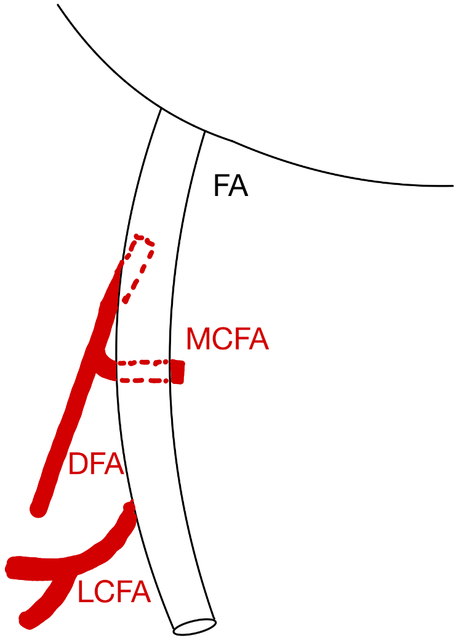
LCFA splits off DFA and MCFA off FA (77.8%). |  | MCFA splits off DFA and LCFA off FA (22.2%).
Pattern III
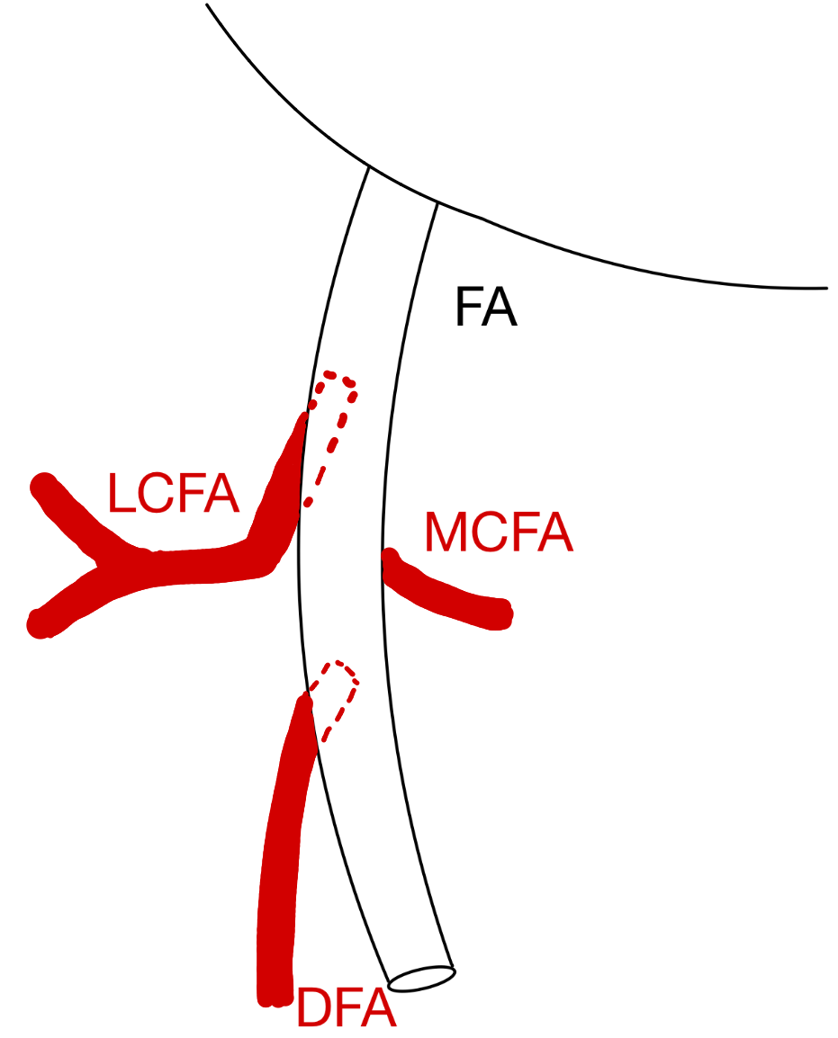
Both circumflex split off FA and their origin is superior to DFA (0.5%).
Figure 6
Variant branching patterns of the lateral circumflex artery (LCFA), the medial circumflex artery (MCFA) and the deep femoral artery (DFA) according to Vazquez et al. ⁴⁴.

Labetowicz et al.⁴⁵ proposed another new classification based on the dissection of 80 lower limbs (46 men and 34 women). They proposed six categories with eight subcategories⁴⁵ (figure 7).

Pattern I ‘Both circumflex arteries splitt of from DFA’.
Ia | Ib | Ic | Id
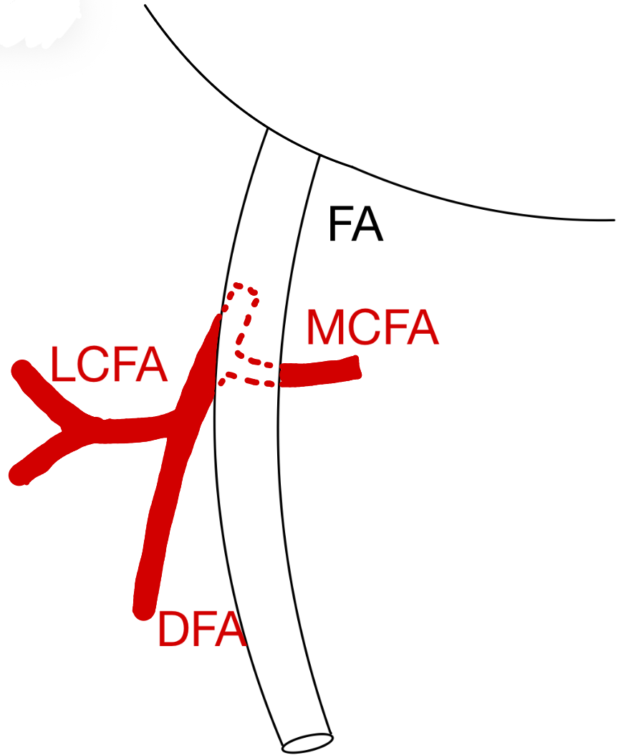 | 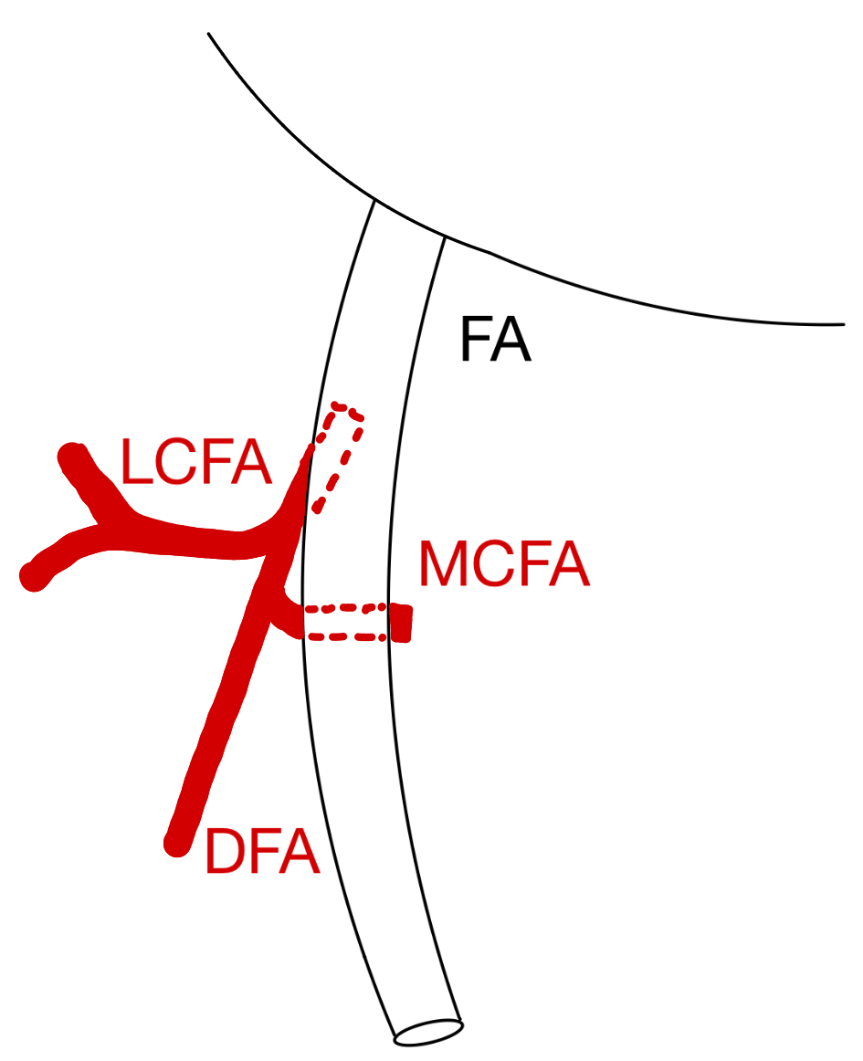 | 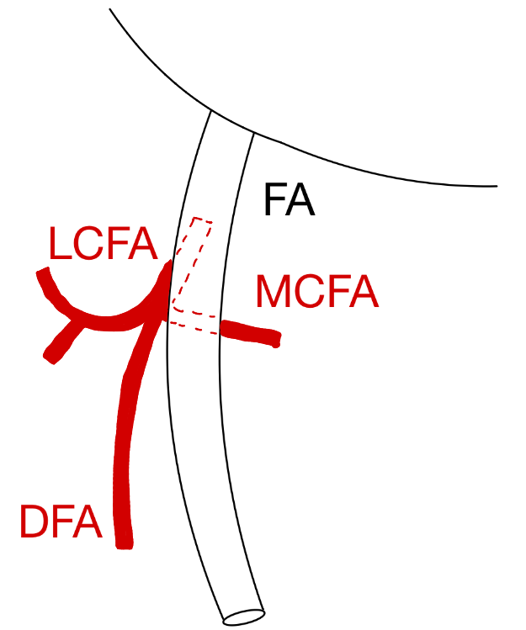 | 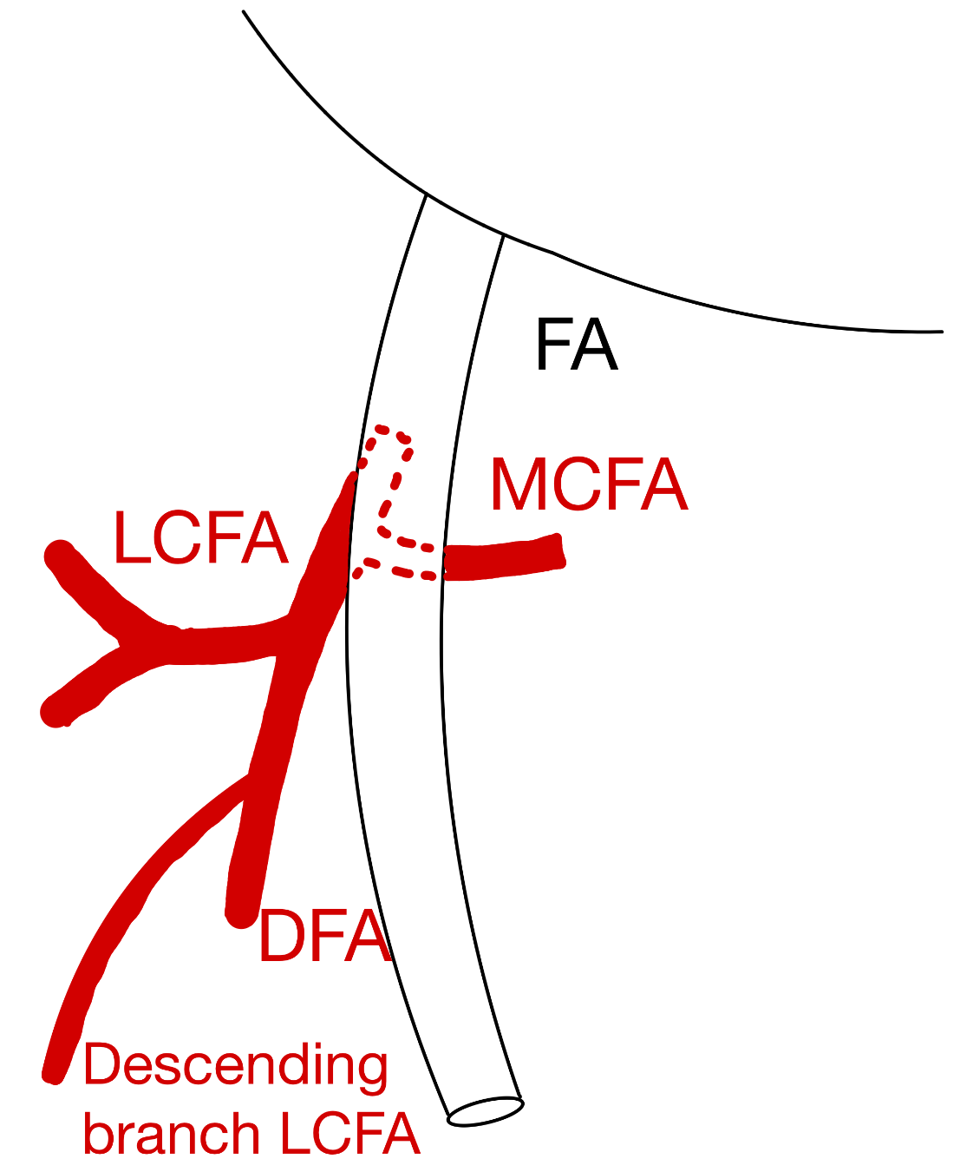
MCFA splits off above the LCFA (33.6%). | LCFA splits off above the MCFA (6.3%). | Both circumflex arteries split off as a common trunk (2.5%). | Origin of MCFA above LCFA, descending branch splits off separately from the DFA (2.5%).
Pattern II
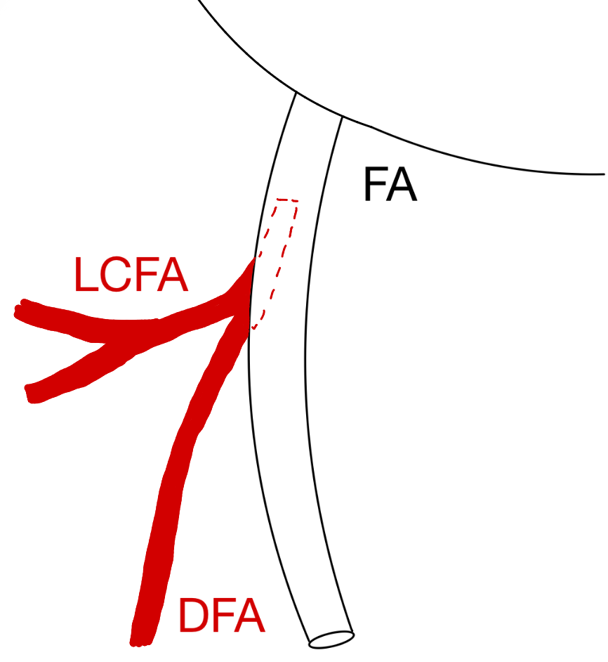
MCFA is absent and LCFA arises from DFA (2.5%).
Pattern III
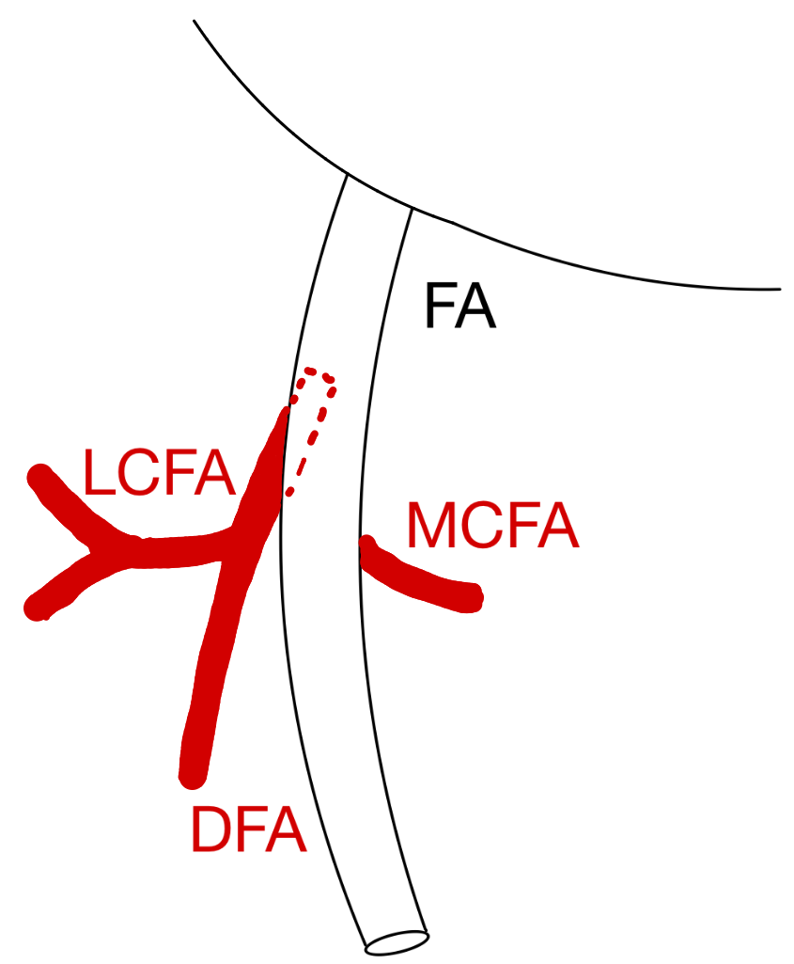
MCFA splits off FA and LCFA from DFA (15%).
Pattern IV
LCFA splits off FA (above origin of the DFA) and MCFA from DFA (10%).
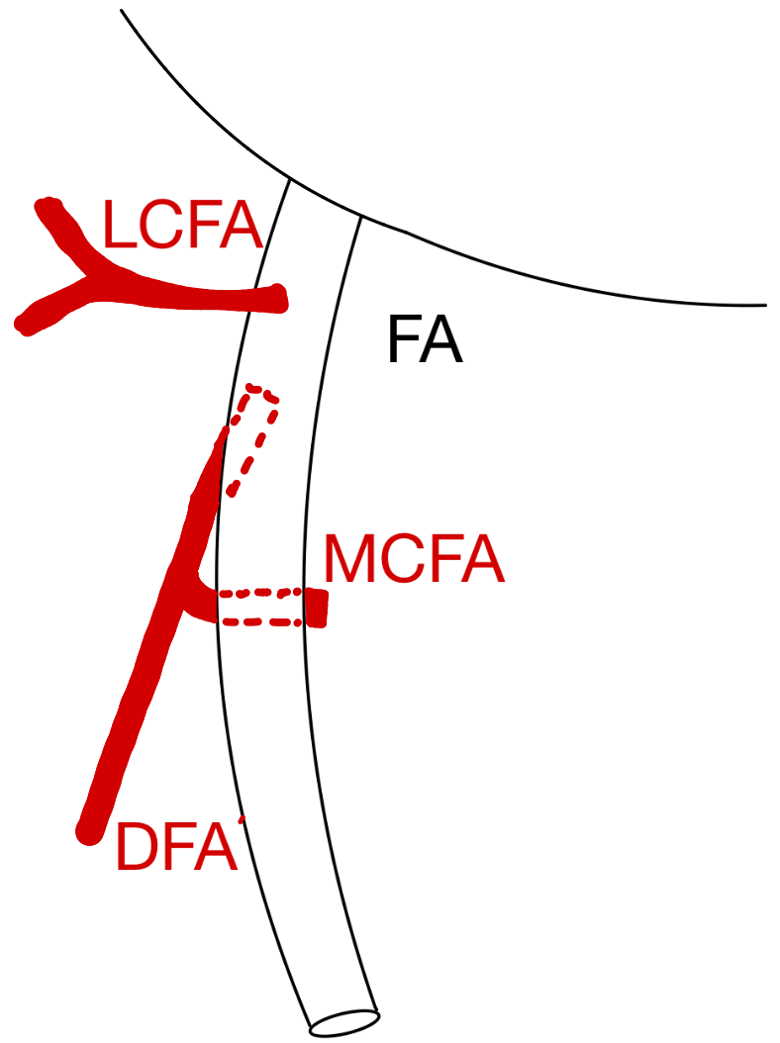
Pattern V
Va |  | Vb
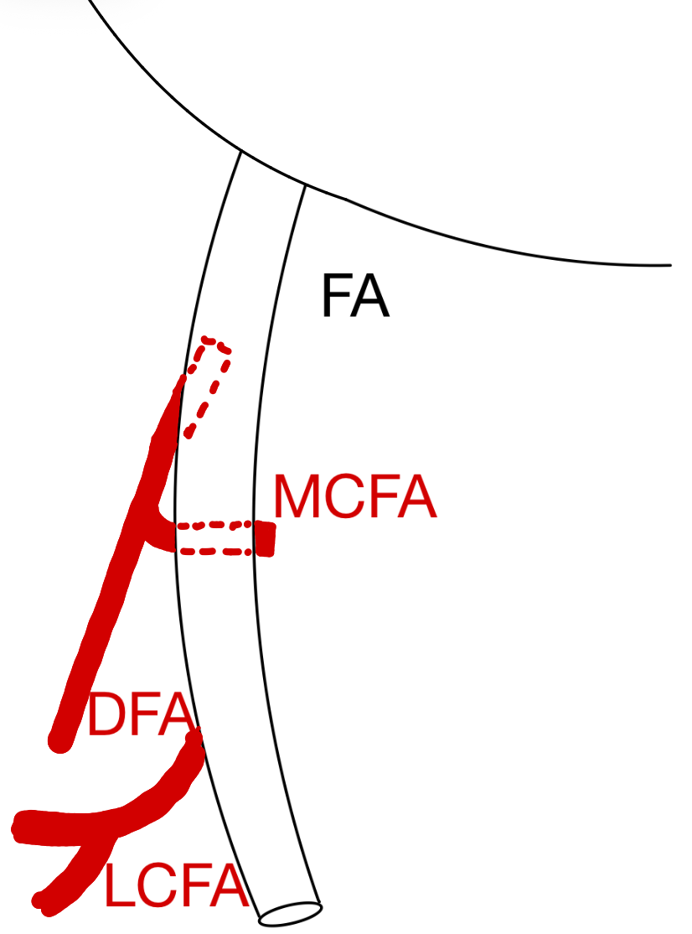 |  | 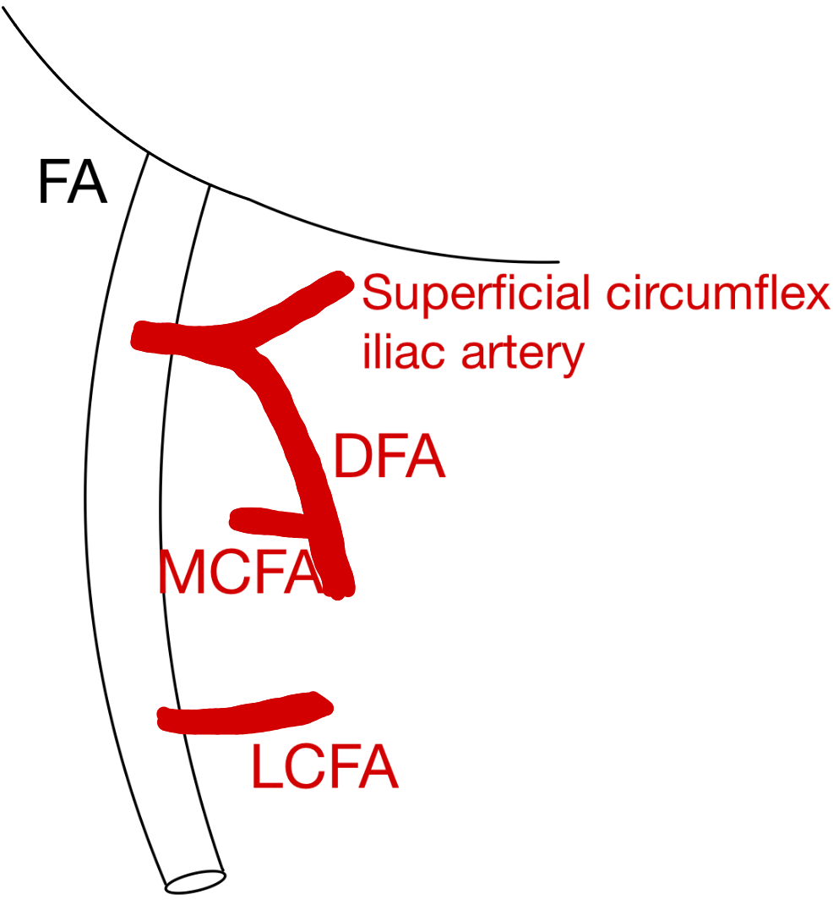
LCFA splits off FA below origin of DFA. MCFA originates from DFA (6.25%). |  | Common trunk with DFA and superficial circumflex iliac artery, MCFA splits off DFA and LCFA off FA below origin of DFA (1.25%).
Pattern VI
VIa |  | VIb
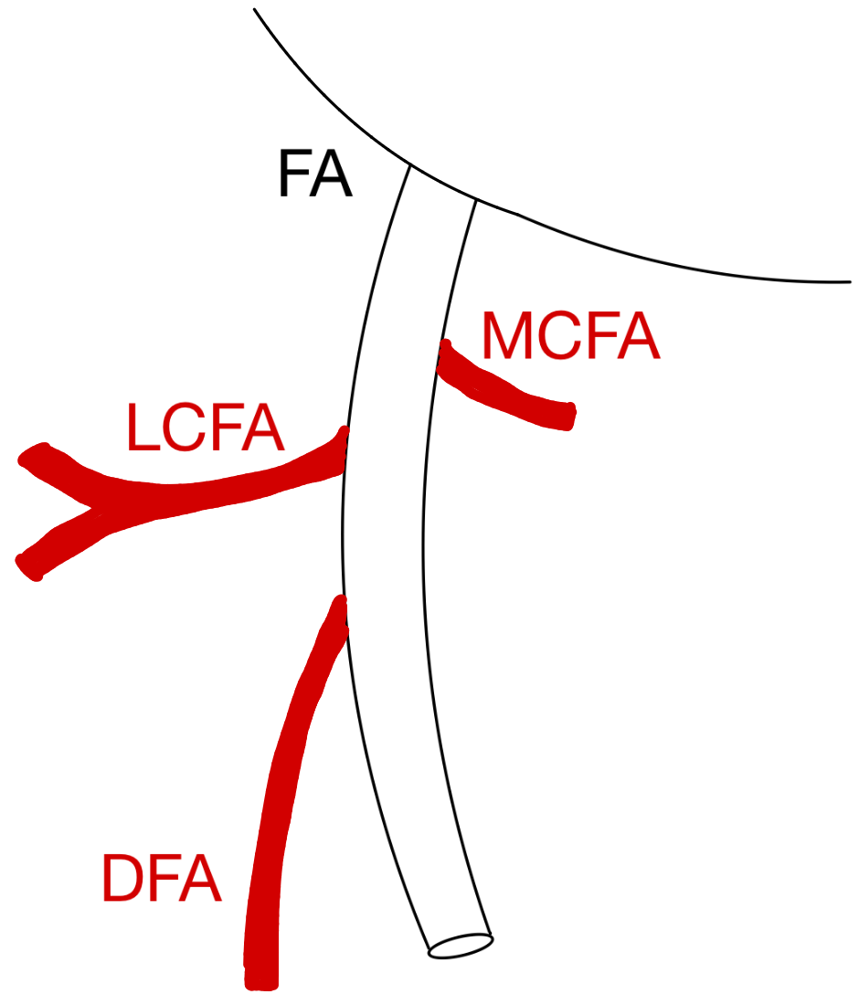 |  | 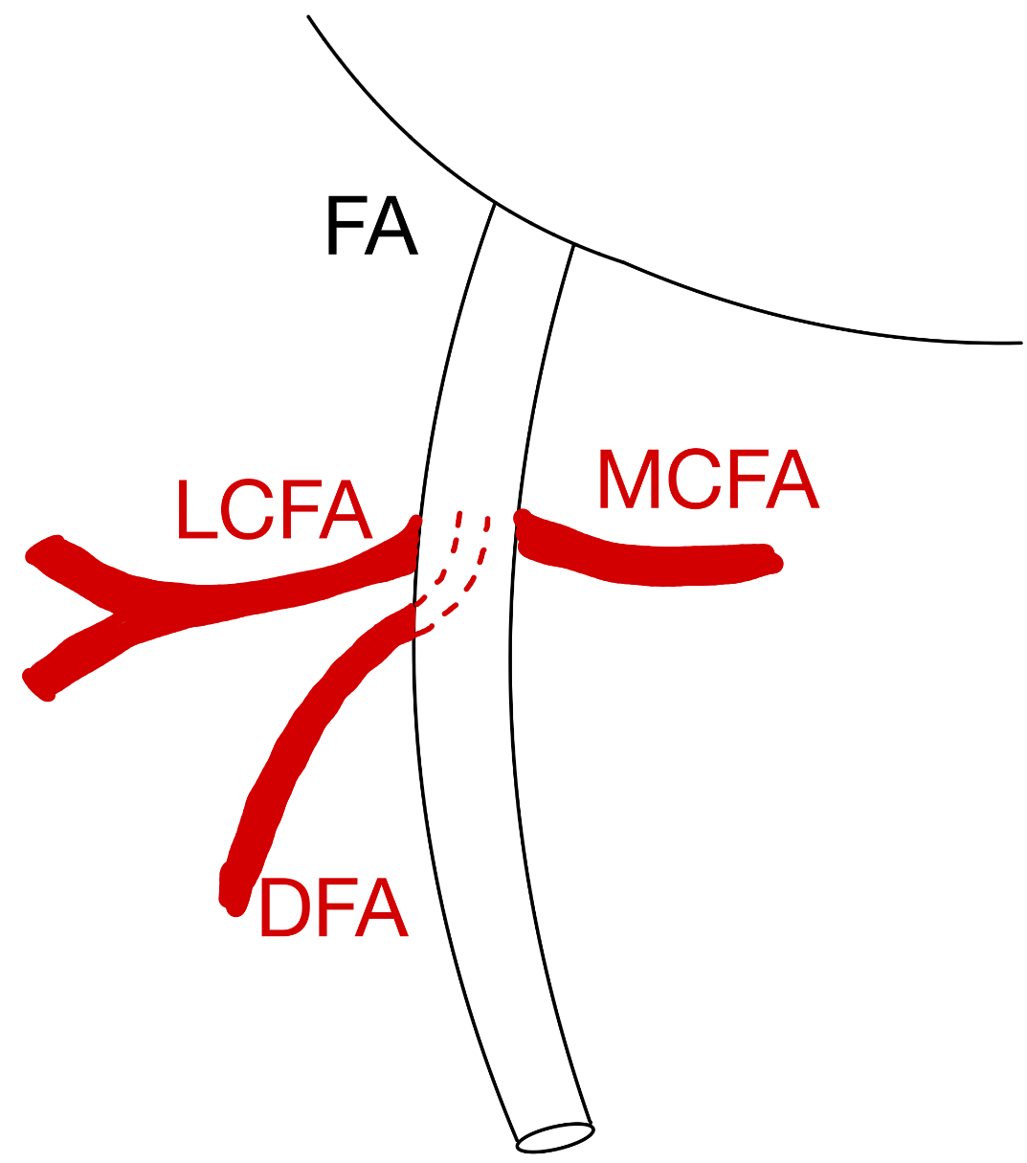
MCFA, LCFA and DFA all split off separately from FA at different heights (2.5%). |  | Three arteries split off separately but at same height (1.25%).
Figure 7
Variant branching patterns of the lateral circumflex artery (LCFA), the medial circumflex artery (MCFA) and the deep femoral artery (DFA) according to Labetowicz et al.⁴⁵.

Claassen et al.⁴⁶ did a study with 107 cadavers. They found that the LCFA arose in 70.2% from the DFA and in 19.8% from the FA. In 3.6% there was a missing DFA (47). The MCFA arose in 19.8% from the DFA and in 14.4% from the FA. In 9.9% all three branches arose from a common trunk. In 0.9% there was a double DFA seen in 4.5% an additional branch on the medial side of the DFA, in 3.6% an additional branch on the lateral side of the DFA and in 3.6% an additional branch of the FA. In 0.9% the LCFA and MCFA originated separately⁴⁶. The results found in this study can also be categorized according to Vazquez et al.⁴⁴: 78.7% of the results belonged to pattern I according to Vazquez et al., 20.5% to pattern II and 0,5% to pattern III^{44,46}. The results can also be classified according to Labetowicz et al.⁴⁵: 45% belonged to pattern I according to Labetowicz et al., 18.8% to pattern II, 15% to pattern III, 10% to pattern IV and 3.8% to pattern V^{45,46}. The classifications above include all 3 branches: DFA, MCFA and LCFA.

The study by Nasr et al.⁶ applied two separate classification systems, each comprising four patterns by the dissection of 45 cadavers of Indian and Turkish origin (figure 8). They further examined differences between men and women, but no statistically significant variations in branching patterns were observed. They did report considerable differences in ethnicity. In the Indian population in this study, both the LCFA and MCFA most commonly arose from the PFA, whereas in the Turkish population of this study, a higher proportion originated directly from the FA or via a common trunk with the other circumflex branch⁶.

Origin of LCFA
Pattern I | Pattern II | Pattern III | Pattern IV
 |  |  | 
LCFA arises from lateral site of PFA (69.5%). | LCFA arises from common stem with DFA from FA (14.5%). | LCFA arises above DFA from FA (10.3%). | LCFA arises from the SFA (LCFA arises below DFA) (14.5%).
Origin of MCFA
Pattern I | Pattern II | Pattern III | Pattern IV
 |  |  | 
MCFA arises from medial site of PFA (58.8%). | MCFA arises from common stem with DFA from FA (16.5%). | MCFA arises above DFA from FA (15.8%). | MCFA arises from the SFA (MCFA arises below DFA) (9%).
Figure 8
Variations in branching patterns of the lateral circumflex femoral artery (LCFA) and the medial circumflex femoral artery (MCFA) according to Nasr et al.⁶.

Three studies examined on which side of the FA the DFA originated (Massoud et al.²⁵, Lippert et al.⁴³ and Nasr et al.⁶) All found that the DFA originated mostly posterolateral on the DFA^{6,25,43}. Nasr et al.⁶ examined the difference in the origin of the DFA between men and women, but no statistically significant difference was found. Lippert and Pabst⁴³ also found in 2% a large branch of the DFA on the medial side of the FA and a large branch of the DFA on the lateral side of the FA^{25,43} (table 6).

Table 6
Comparison of the origin of the profunda femoris artery (DFA) from the femoral artery (FA) in three anatomical studies: Lippert et al.⁴³, Massoud et al.²⁵, and Nasr et al.⁶. The reported origins were classified as posterolateral, lateral, posterior, posteromedial, medial, or anterior ^{6,25,43} (NR not reported).
 | Lippert^{25,43}  n = 100 cadavers | Massoud²⁵  n = 96 DSA | Nasr⁶  n = 45 cadavers
Posterior | 40% | 5.9% | 25.8%
Posterolateral | 48% | 91.4% | 42.3%
Lateral | NR | NR | 20%
Posteromedial | 10% | 2.7% | 12%

Massoud et al.²⁵, Claassen et al.⁴⁶, and Nasr et al.⁶ investigated the mean distance from the inguinal ligament to the origin of the DFA. They reported notably different mean distances: Claassen et al.⁴⁶ reported a relatively short mean distance of 33mm, Massoud et al.²⁵ found a mean distance of 38.3mm, and Nasr et al.⁶ observed a relatively long mean distance of 49.7mm. The latter also compared this distance between men and women but found no statistically significant difference⁶.

This review of the available literature revealed no reports describing the branching pattern of the superficial femoral artery (SFA).

Popliteal artery (PA)
The first to describe variant branching patterns of the PA was Adachi⁸ in ‘Das arteriensystem der Japaner’ in 1928. This descriptive classification divided the variations in the branching pattern of the PA as ‘normal’, when the first branch splitted off below or at the height of the inferior border of the popliteus muscle (97.3%) ‘high division’, when the first branch splitted off the PA at or above the inferior border of the popliteus muscle (2.7%); and as ‘trifurcation’, when the common trunk following the origin of the PA was 0.5cm or less in length⁸. Keen et al.⁴⁷ and Lippert et al.⁴³ suggested another descriptive classification. The studies from Adachi⁸ and Lippert et al.⁴³ were based on cadaveric studies.

Bardsley et al.⁴⁸ suggested a classification containing five categories based on DSAs of 155 patients, 92.8% of the patients had pattern I: ATA splitted of below (30-70mm) the tibial plateau and thereafter the PR arose from the PTA, 4.2% had pattern II: ATA splitted of just below or just above tibial plateau, 1.7% had pattern III: ATA splitted of high above the tibial plateau and gave off thereafter the PR, 0.4% had pattern IV: trifurcation, PTA, ATA and PR splitting off at the same hight from the PA, and 0.9% had pattern V, where there was no PTA found⁴⁸.

Kim et al.⁹ proposed a standardized classification with three categories and ten subcategories based on the analysis of 605 femoral angiograms (figure 9) (table 8).

Pattern I ‘Division of PA at normal level, below the knee joint‘
IA |  | IB | IC
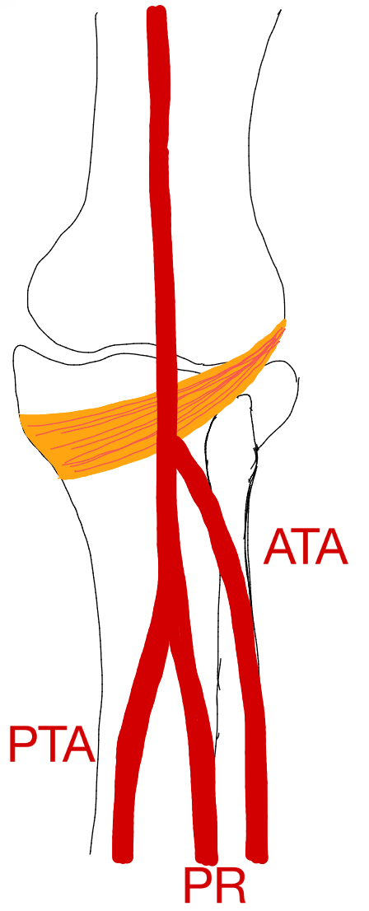 |  | 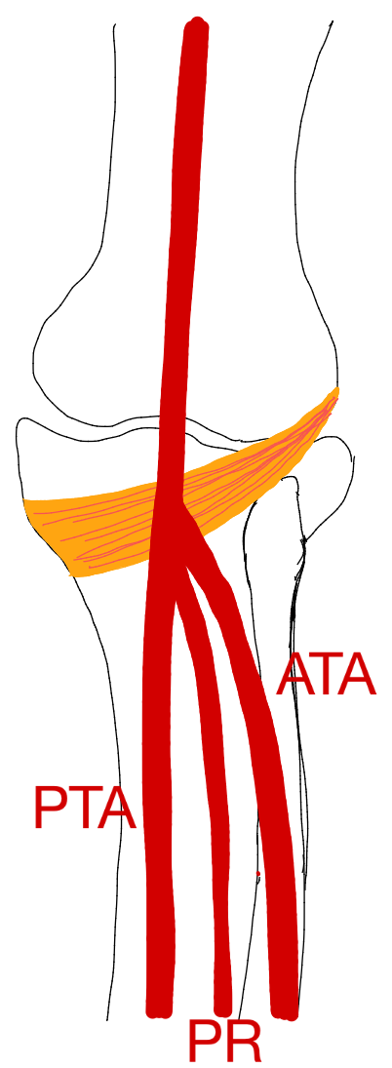 | 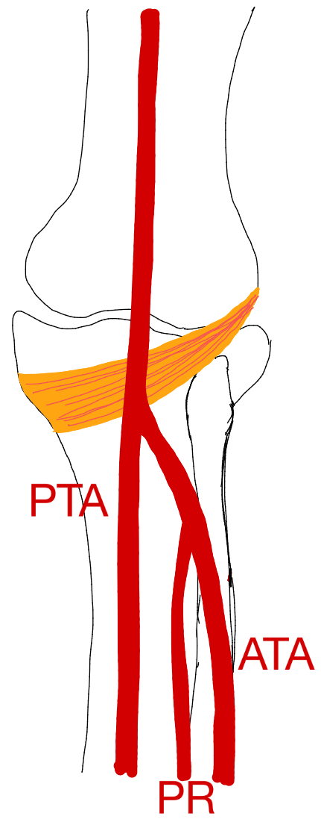
ATA splits off first, thereafter  tibioperoneal trunk splits into PR and PTA. |  | Trifurcation: ATA, PR and PTP arise within 0.5cm of each other. | PTA splits off first, thereafter tibioperoneal trunk splits into PR and ATA.
Pattern II ‘High division of popliteal artery: a branch given off at or above the knee joint’
IIA1 | IIA2 | IIB | IIC
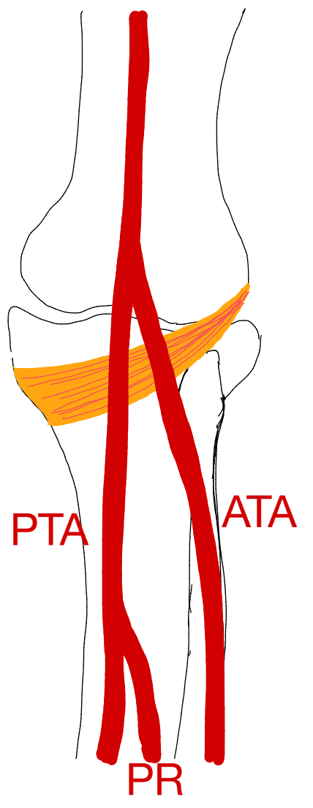 | 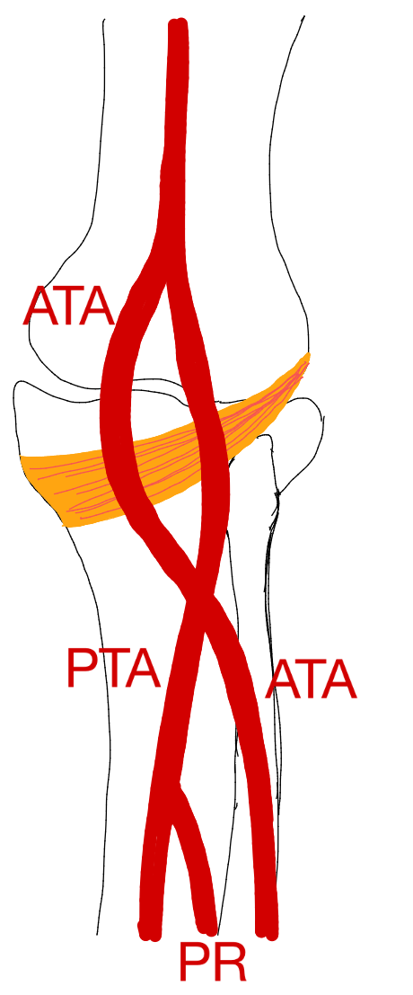 | 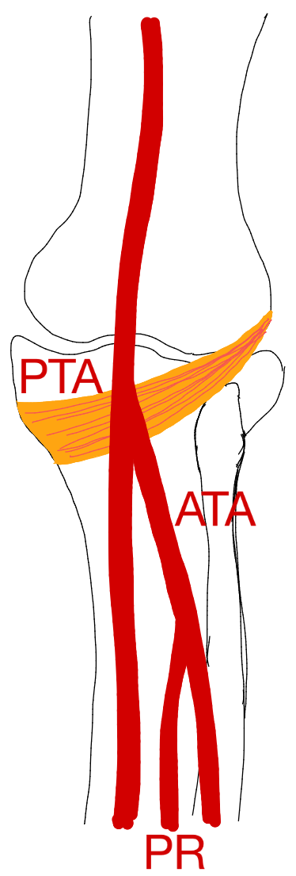 | 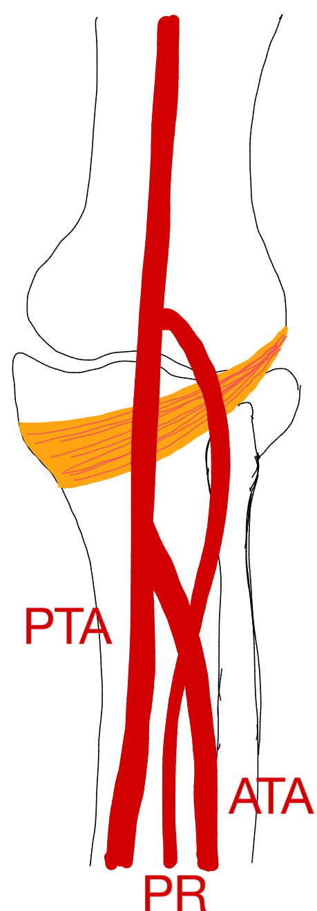
ATA arises at or above knee joint and has a normal downward course, thereafter PA splits into PTA and PR. | ATA arises at or above knee joint and makes a curve crossing PA (medial course), thereafter PA splits into PTA and PR. | PTA arises at or above knee joint and thereafter PA splits into ATA and PR. | PR arises at or above knee joint and thereafter PA splits into ATA and PTA.
Pattern III ‘Hypoplastic or aplastic branching with altered distal supply’
IIIA |  | IIIB | IIIC
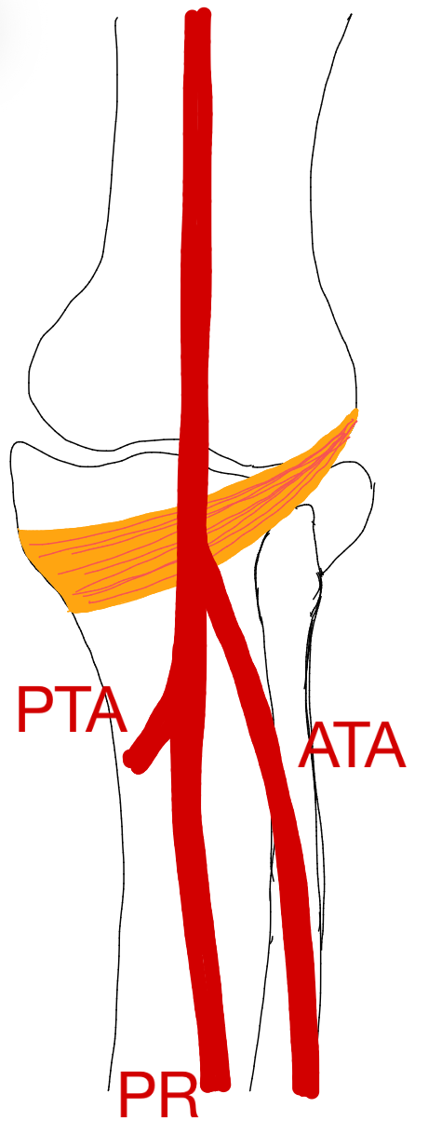 |  | 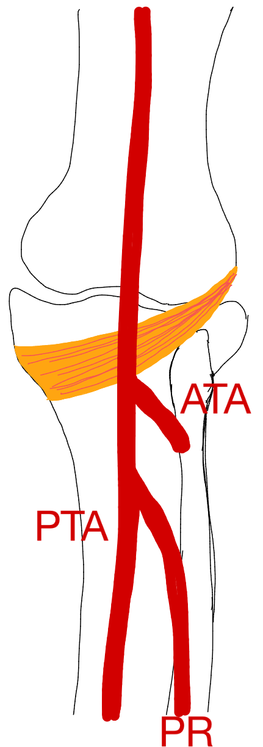 | 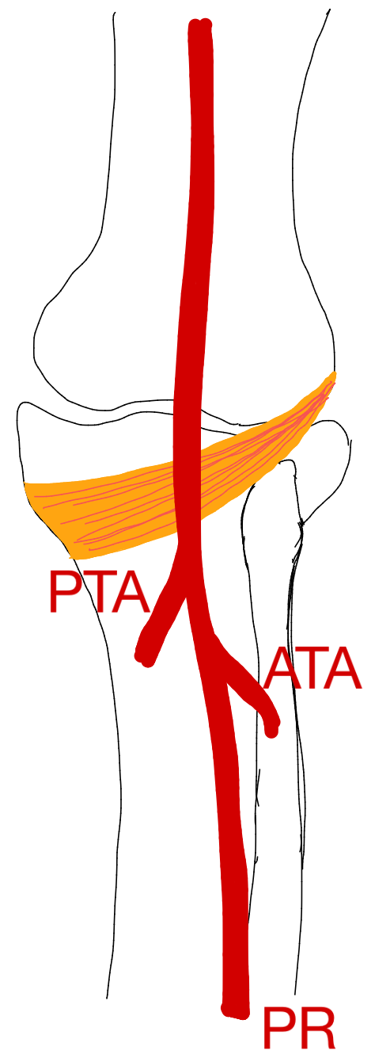
Hypo- or aplastic PTA and PR replace distal PTA, PR is large. |  | Hypo- or aplastic ATA and PR replace DPA at ankle, PR is large. | Hypo- or aplastic PTA and ATA, enlarged PR replaces distal PTA and DPA.
Figure 9
Variations in the branching pattern of the popliteal artery (PA) according to Kim et al⁹.

Kil et al.³ classified their DSAs (1242) according to Kim et al.⁹ (table 7). They documented that 72% had a variant branching pattern that was unilateral, and 28% had a bilateral variant branching pattern. In the patients with a bilateral variant branching pattern, 89% was symmetric and 11% asymmetric³.

Calisir et al.⁴⁹ performed a study in which they analyzed the CTAs of 342 patients. In total 13% had a variant branching pattern (meaning a branching pattern other than pattern IA). Of this 13%, 36% had a variant branching pattern on both sides. Of the people that had a bilateral variant pattern, 63.4% had a symmetric variant and 36.7% had an asymmetric one⁴⁹ (table 7).

A study with MRA (756 men) by Lorbeer et al.⁷ classified the popliteal branching pattern variants according to Kim et al.⁹ (table 7). This study focused on the difference between the right and left lower extremities. They found that 15% of individuals exhibited a different branching pattern on the right lower extremity compared to the left lower extremity⁷.

Oner et al.⁵⁰ studied the CTA of 170 patients and classified them according to Kim et al. (table 7). A variant branching pattern was observed unilaterally in 9.4% of cases and bilaterally in 5.9% of cases. This study also found that the PA variations were twice as frequent in women than in men⁵⁰. The shortest TPT length observed was 9.1mm and the longest 115.2mm. A new subclassification of pattern IA has been proposed because 69% of the TPT lengths were between 28.31mm and 31.65mm. Type IA-S (short) with a TPT length less than or equal to 20mm; type IA-N (standard) with a TPT length between 20 and 40mm and type IA-L (long) with a TPT length more than or equal to 40mm. The TPT length was significantly higher on the right side than on the left⁵⁰. This study found that the PTA was mostly the dominant artery in women (54%) and men (45.5%)⁵⁰.

Table 7
Percentages of variations in branching pattern of the popliteal artery (PA) according to Kim et al.^{3,7,9,49,50}.
Pattern | Kim⁹  n = 605 DSA | Kil³  n = 1242 DSA | Calisir⁴⁹  n= 343 CTA | Lorbeer⁷  n= 756 MRA | Oner⁵⁰  n=170 CTA
IA | 92.2% | 89.2% | 87% | 89.2% | 89.4%
IB | 2.0% | 1.5% | 4.2% | 2.7% | 9.4%
IC | 1.2% | 0.1% | 0.2% | 0.6% | 5.9%
IIA1 | 3.0% | 0.8% | 3.1% | 2.6% | 0.3%
IIA2 | 0.7% | 0.4% | 0.5% | 1.6% | 0.2%
IIB | 0.8% | 0.4% | 1.4% | 1.7% | 0.9%
IIC | <0.2% | 0% | 0% | 0% | 0%
IIIA | 3.8% | 5.1% | 2.7% | 2.1% | 2%
IIIB | 1.6% | 1.7% | 0.9% | 0% | 1.5%
IIIC | 0.2% | 0.8% | 0% | 0% | 0.6%

Olewnik et al.²⁸ recommended a ‘total’ new classification. This classification is based on 100 lower extremities (47 men/53 women). Although the categories used in this classification seem to correspond to Kim et al.⁹, a new subclassification based on diameter has been introduced²⁸ (table 8). Type I seems to correspond to type IA according to Kim et al.⁹, type II to type IC according to Kim et al.⁹, type III to type IB of Kim et al.⁹ and type IV to type IIIA of Kim et al.⁹ (table 8).

Table 8
Variant branching pattern of the popliteal artery (PA) and its branches: the anterior tibial artery (ATA), posterior tibial artery (PTA) and peroneal artery (PR) according to Olewnik et al.²⁸.
Branching pattern |  | Definition | Frequency
Type I |  | ATA splits off from PA, thereafter a common junction containing PTA and PR, splits off more distally. | 72%
 | Ia | ATA has a larger diameter. | 42%
 | Ib | common junction containing PTA and PR has a larger diameter. | 30%
Type II |  | PA divides into PTA and ATA at the same height and ATA gives rise to PR. | 8%
Type III |  | PA trifurcates into ATA, PTA and PR at same height. | 12%
Type IV |  | PTA was absent and PA divided into ATA and PR. | 8%

In 2021 Aragones et al.⁴ proposed a simplification of the classification of Kim et al.⁹ based on the dissection of 130 cadavers. Pattern 1 (94.7%): the PA divides into ATA and PTA at the level or distal to the inferior border of the popliteus muscle⁴. Pattern 2 (3.3%): the PA divides into ATA and PTA proximal of the border of the popliteus muscle. This category also has 3 subcategories: pattern 2a (1.8%) in which the PR originates from the PTA and the ATA runs posterior to the surface of the popliteus muscle, pattern 2b (0.8%) in which the PR originates from the PTA and the ATA runs anterior to the surface of the popliteus muscle. Lastly, pattern 2c (0.8%) in which the PR originates from the ATA. The last pattern, pattern 3 (2%): consists of the PA that divides into the ATA, PTA and PR at the same height, forming a trifurcation⁴.

Genicular artery
The results regarding the branching pattern of the genicular artery can be consulted in the supplementary information (supplementary 6C).

Tibial anterior/posterior artery (ATA/PTA)
Candir et al.³³ examined the morphometry and morphology of the ATA (n=15). The mean vertical distance of the origin of ATA to the head of the fibula and tibial tuberosity measured 38 ±10.2mm and ±8mm. Leg length was observed to be significantly greater in men. Candir et al.³³ divided the ATA into five types according to branching morphology from the PA, place of origin and course. Type-1 (80%): classical pattern, after the PA passes the lower edge or more distal of the popliteus muscle, it divides into ATA and the tibiofibular trunk (TFT). The TFT is divided into PTA and FA. Type-2: (3.3%) the PA is divided into the PTA and TFT. TFT is then split into ATA and FA. Type-3 (10%): trifurcation, the separation of ATA, FA and PTA less than 5mm apart. Type-4 (3.3%): high division, PA gives ATA proximal to the lower edge of the popliteus muscle. Type-5 (3.3%) hypoplasia/aplasia of the ATA was found³³. Candir et al.³³ concluded that the branching pattern of the ATA differed from the classical pattern in 20% of the cases included in this study. Tindall et al.⁵¹ conducted a study evaluating the high origin of the ATA from the PA. In their analysis of ultrasound examinations of 100 knees, a high origin was observed in 6% of cases⁵¹.

The study of Karip et al.³⁴ described the course, branches and variance pattern of the PTA (n=25). Most of the variances were observed in the medial plantar artery (MPA), with a rate of 27.08%. Variation rates in terminal branches of MPA, which are deep branch of MPA (DB-MPA) and superficial branch of MPA (SB-MPA), were 22.91% and 20.83% respectively³⁴.

Dorsal pedis artery
Three main branching patterns have been reported in the literature, based on the findings of Kulkarni et al.⁵² (16 cadavers), Ntuli et al.³⁵ (33 lower limbs) and the study of Luckrajh et al.³⁶ (40 cadavers). Kulkarni et al.⁵² divided the branching pattern of the DPA into five categories (figure 10).

Type A | Type B | Type C
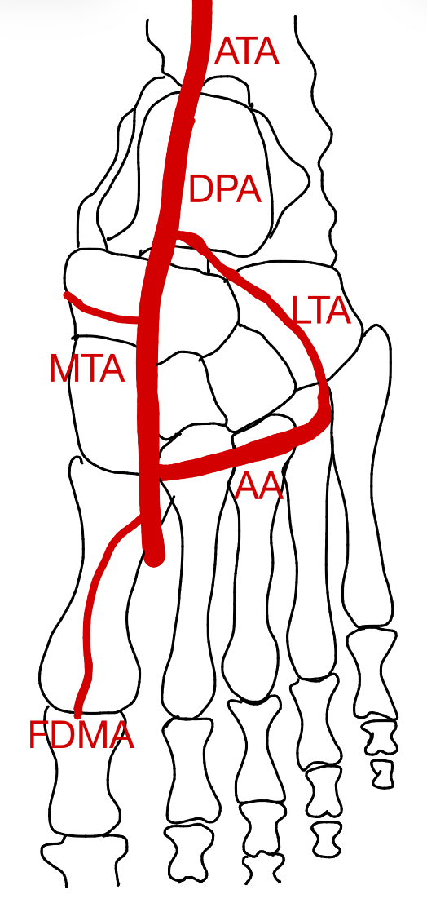 | 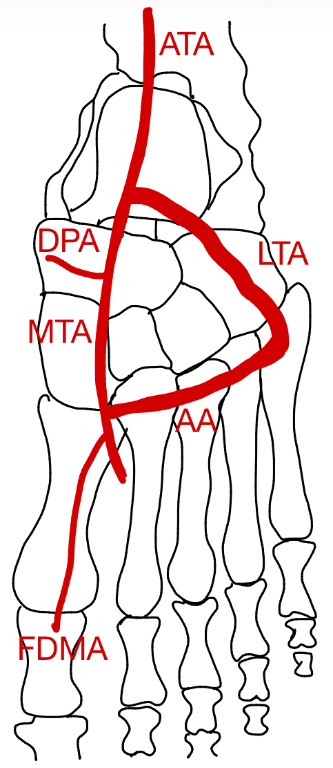 | 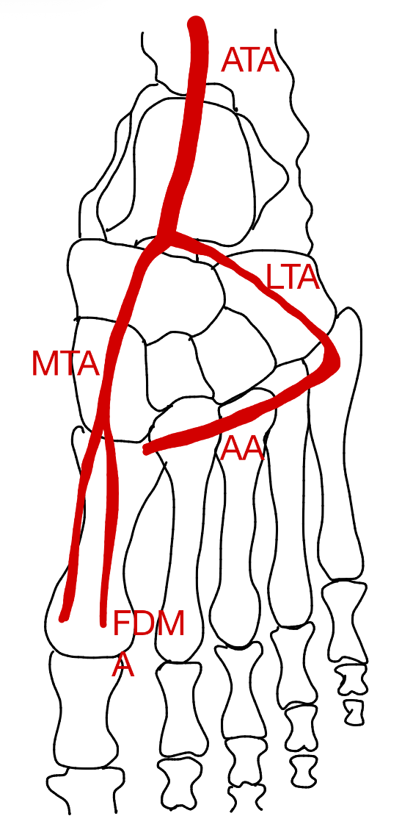
Usual pattern of the arterial tree of the dorsum of the foot. DPA along its course divided into LTA and MTA, FDMA and AA (15.2%). | ATA divides into a larger LTA and a smaller DPA (9.1%). | DPA is absent as an independent vessel and becomes merely a loop in the dorsum arterial pattern (42.4%).
Pattern D | Pattern E | Pattern DC
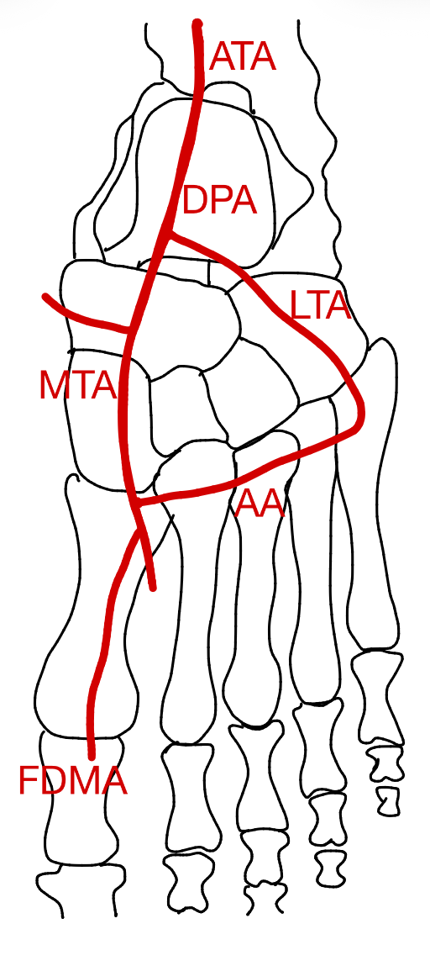 | 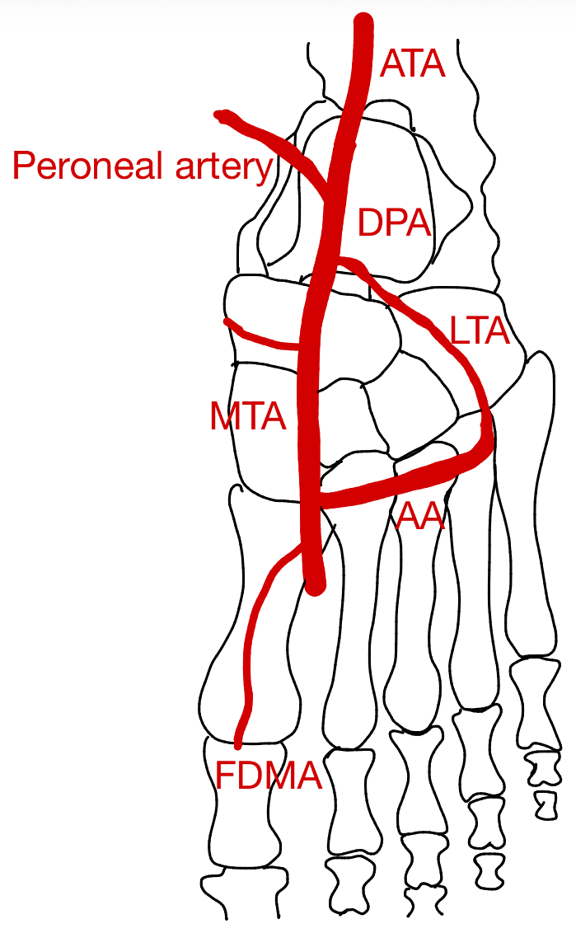 | 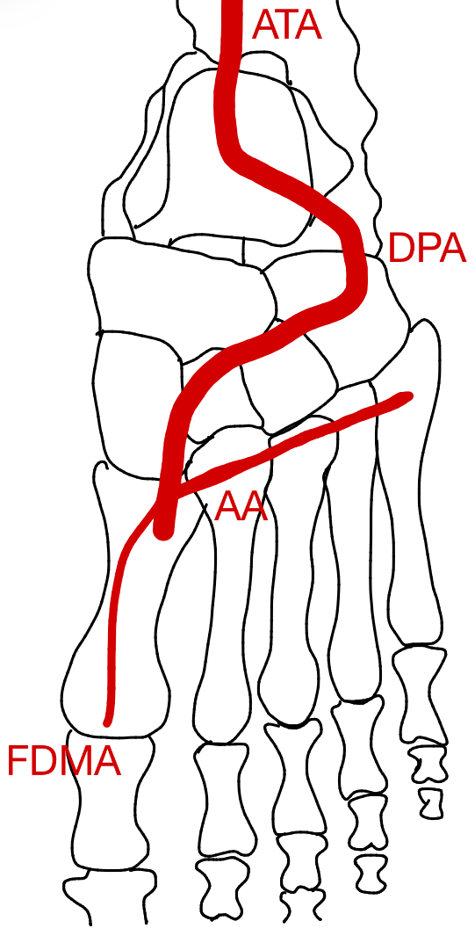
Reduction of the ATA and its branches and increasing participation of arteries of sole in the supply of dorsum. DPA is still recognizable even as a loop and ATA continue downwards as a central channel with reduced size. Pulses not clinically palpable (6.1%). | Increasing presence of anterior peroneal branch from the PTA. Plantar tibial vessels still take a prominent part in arterial supply. DPA along with its branch LTA is clinically not palpable (12.1%). | DPA exhibits lateral deviation (NR).
Figure 10
Variants in branching pattern of the dorsal pedis artery (DPA) according to Kulkarni et al.⁵². Containing the anterior tibial atery (ATA), the dorsal pedis artery (DPA), the arcuate artery (AA), the medial tarsal artery (MTA), the lateral tarsal artery (LTA) and the first dorsal metatarsal artery (FDMA).

In 2018 Ntuli et al.³⁵ investigated different branching patterns of the DPA in a South-African population. Nine DPA patterns were observed in the studied sample (figure 11). Type A is the most common type and was present equally amongst men and women³⁵.

Type A | Type B | Type C
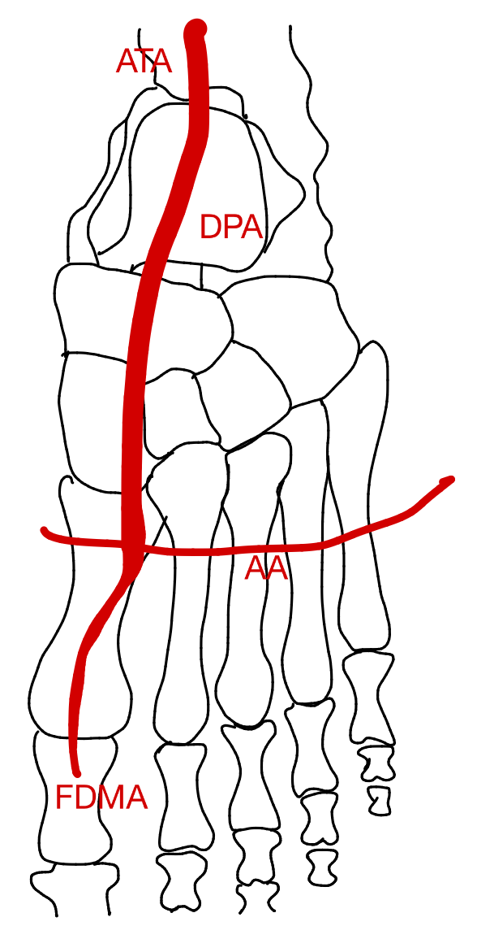 | 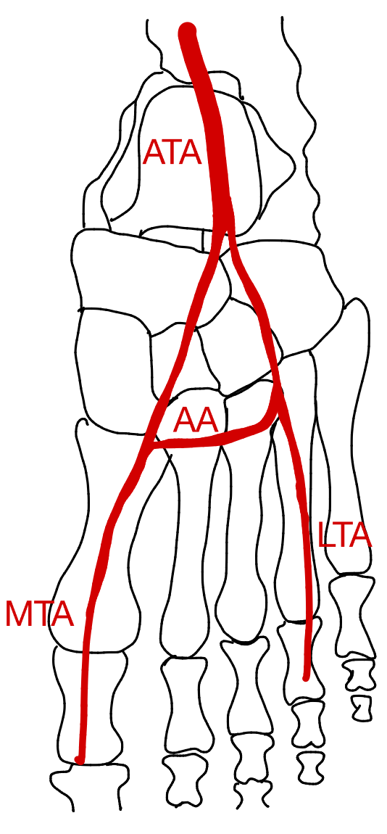 | 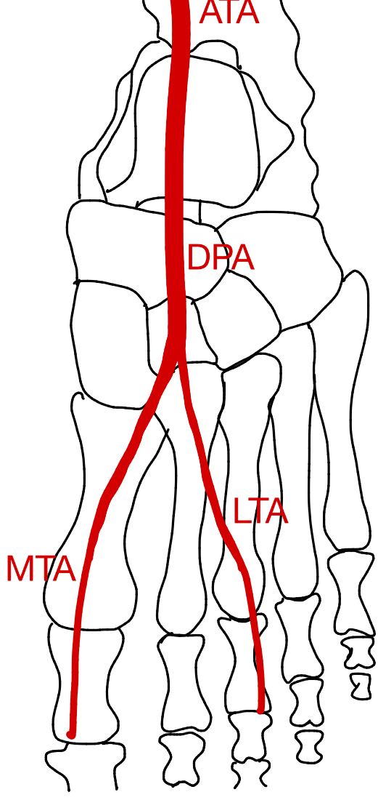
Standard vascular pattern. Most observed pattern noted predominantly in Black Africans.  (36.4%) | DPA absent. Observed only in Black Africans.  (6.1%) | AA absent. Observed predominantly in women.  (15.2%)
Type D | Type E | Type F
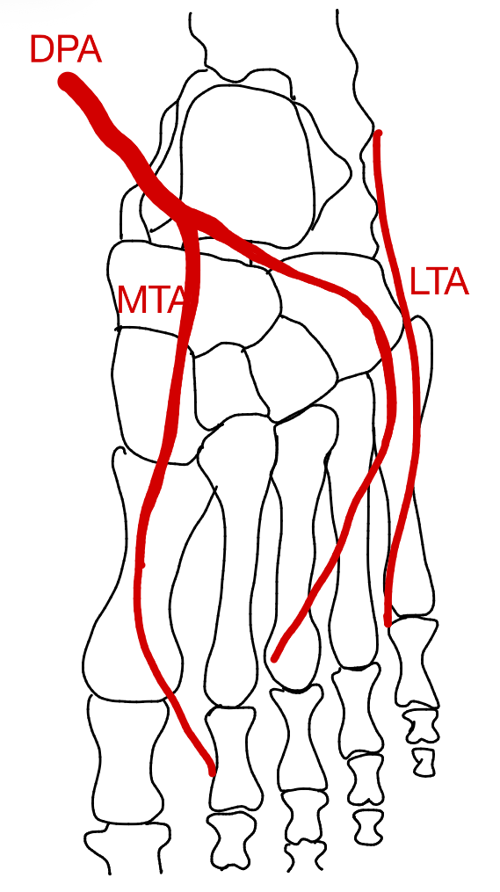 | 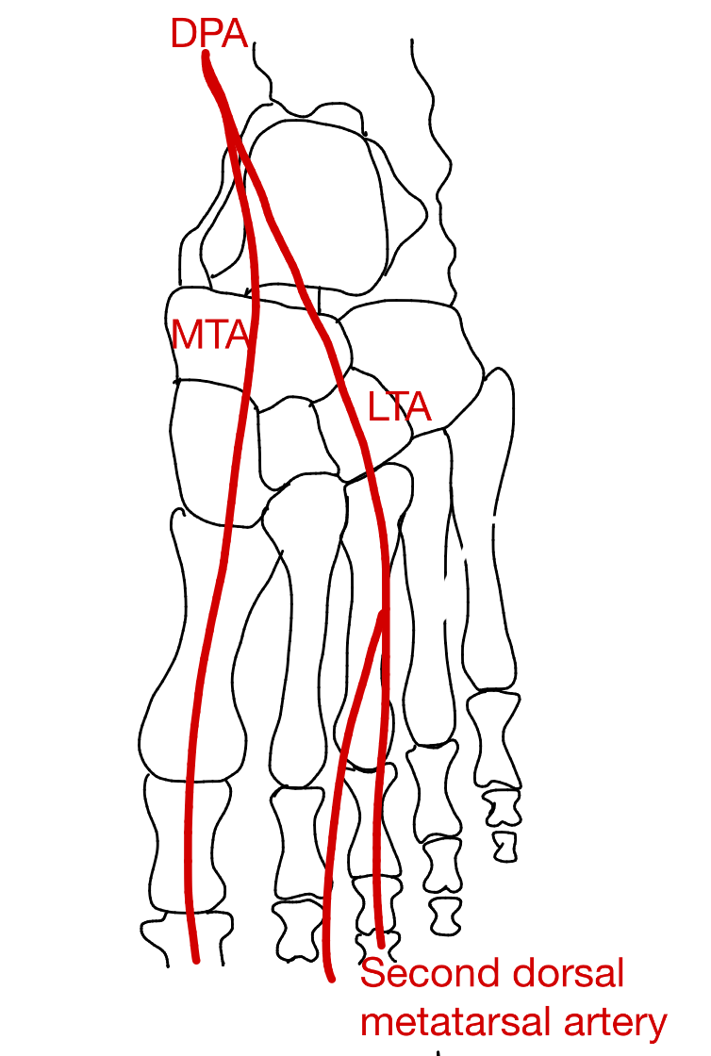 | 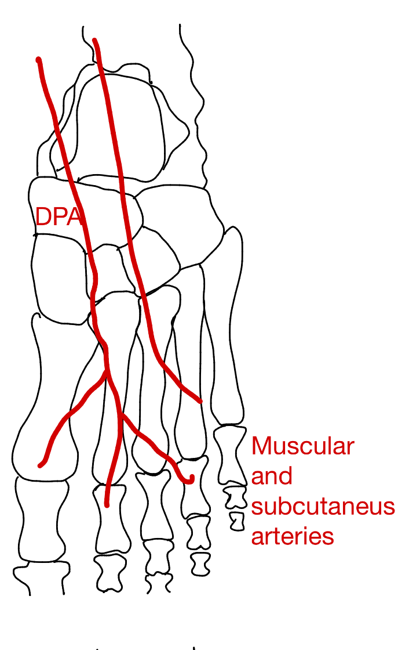
Absence of AA and variation in the number of LTAs. Observed predominantly in women of both population groups but predominantly in Whites.  (12.1%) | Variation in the origin of second dorsal metatarsal artery.  Observed predominantly in Black African Women.  (12.1%) | DPA present with variation in branching pattern. Observed only in Black Africans.  (6.1%)
Type G | Type H | Type I
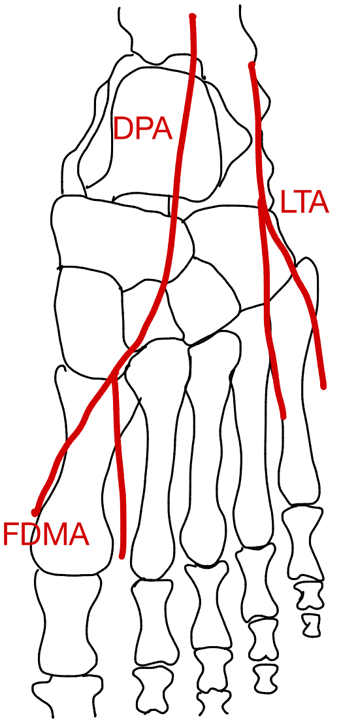 | 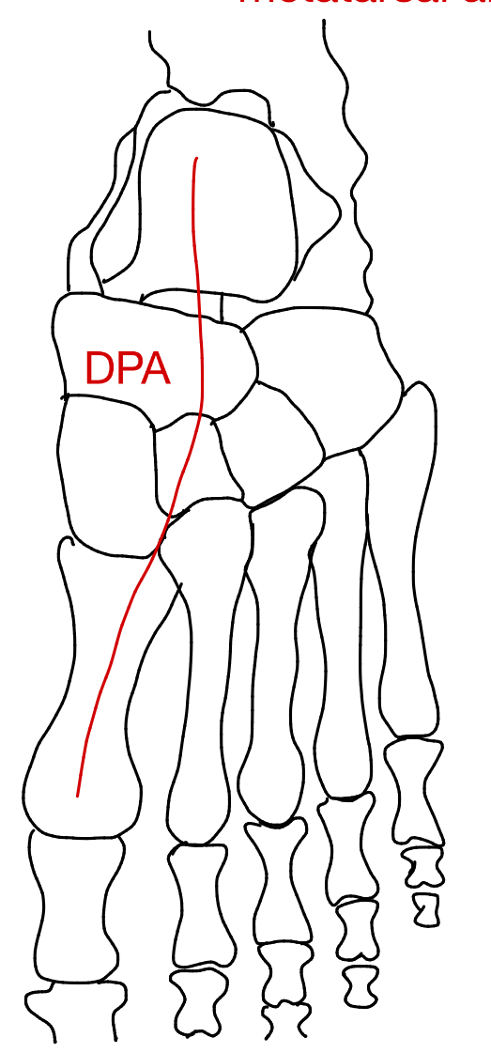 | 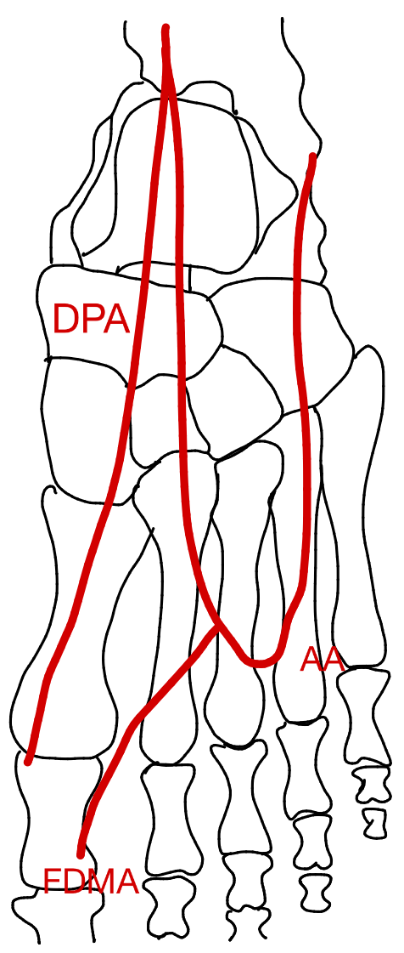
Variation of origin of DPA and LTA. Observed only in men.  (6.1%) | Poorly formed DPA and LTA. Observed only in Black Africans.  (6.1%) | AA forms a U-shaped loop. Observed only in Black African men.  (3%)
Figure 11
Variants in branching pattern of the dorsal pedis artery (DPA) according to Ntuli et al.³⁵. Containing the anterior tibial atery (ATA), the dorsal pedis artery (DPA), the arcuate artery (AA), the medial tarsal artery (MTA), the lateral tarsal artery (LTA) and the first dorsal metatarsal artery (FDMA).

In the study conducted by Luckrajh et al.³⁶ (n=40) the DPA was found to pass from midpoint between malleoli to proximal end of the first intermetatarsal space in 42.5% of the sample size. In 25% of the cases, the DPA crossed the lateral malleolus and passed forward along the lateral dorsum of the foot to reach the proximal end of the first intermetatarsal space. In 5% of the cases, the DPA arose from peroneal artery (PR) and passed to the first metatarsal space. The anomalous course of the DPA was observed in 50% of the cases, these variations were classified into six different types³⁶ (table 9).

Table 9
Variants in branching pattern of the dorsal pedis artery (DPA) according to Luckrajh et al.³⁶.
Branching pattern type | Definition | Frequency
1 | Arcuate artery absent. | 32.5%
2 | DPA gave rise to the first and second dorsal metatarsal artery DMA. | 10%
3 | DPA gave rise to the first and second DMA and the lateral tarsal artery LTA gave rise to the 3rd and 4th DMA. | 7.5%
4 | Second, third and fourth DMA arose from a large LTA. | 5%
5 | U-shaped loop. | 5%
6 | U-shaped loop with a recurrent branch. | 2.5%

Patel et al.⁵³ conducted a study to investigate the morphometry and asymmetry of DPA and its branching pattern DPA was present in all the studied limbs (n=25). Absent AA was seen in 12% of the cases. In 4% of the cases three tarsal metatarsal arteries were seen. In 16% of the cases two tarsal metatarsal arteries were seen⁵³.

Diameter

Common iliac artery (CIA), external iliac artery (EIA)
Nayak et al.⁵ found that the mean diameter of EIA was 0.9mm on the right, 0.99mm on the left. Lorbeer et al.⁷ noted that arterial diameters decreased progressively from proximal to distal segments and increased with advancing age. They also reported that left sided arteries were slightly larger than right sided ones. The mean diameter measured for the CIA in the Caucasian study population was 11.8mm and 10.3mm for the EIA⁷. Chiam et al.¹⁵ examined the vessel size of iliac arteries in an Asian population. The mean iliac diameter was 7.6± 1.7mm, with significant smaller diameters in women than in men (7.2± 1.7mm vs 7.8± 1.7mm). Mean iliac diameter decreased significantly with age: 7.9± 1.7mm, 7.4± 1.9mm and 7.3± 1.6mm for ages <70 years, 70-79 years and ≥80 years respectively. Women showed a significantly higher proportion with a mean iliac diameter under 6mm. (20% vs 12%)¹⁵.

(Deep) femoral artery ((D)FA)
Lorbeer et al.⁷ examined the mean diameter of the FA (10.2mm) and the DFA (7.7mm) in a Caucasian study population. Chiam et al.¹⁵ examined the mean femoral diameter (7mm) in an Asian study population and found that there was a significant difference between women and men (6.3 ± 1.5mm vs 7.3 ± 1.8mm). Women more often had a mean femoral artery diameter below 6mm (34% vs. 21%)¹⁵.

Labetowicz et al.⁴⁵ found that a greater diameter of the FA at the level of the inguinal ligament correlated with a greater distance to where the DFA arose. They found also that the diameters of the artery were significantly greater in men than women and that the mean diameter of the FA at the origin of the DFA was the greatest in type II (10.6mm) and the least in type VI (7.9mm)⁴⁵.

Popliteal artery (PA)
Lorbeer et al.⁷ found the mean diameter of the PA in a Caucasian study population to be 6.9mm and Candir et al.³³ found it to be 5.8mm ± 1.0mm (study population not reported). Olewnik et al.²⁸ noted in the Caucasian study population, a mean diameter of the PA in men of 6.4mm and women of 5.6mm, no significant difference was found. This study also found that in pattern IA (according to Kim et al.⁹) the origin of the ATA had a larger diameter; in pattern IB the origins of the PTA and PR had a larger diameter and in pattern IC the diameters of the PTA and FA were larger. The diameter of the PTA and the FA were significantly smaller in type I²⁸.

Tibial anterior/posterior artery (ATA/PTA)
Candir et al.³³ found that the mean diameters of the ATA, PTA and PR were 4.1 ±0.6mm, 3.5 ±0.6mm and 3.7 ±0.7mm, respectively.

Lorbeer et al.⁷ described the mean diameters of the ATA (4.2mm), PTA (3.8mm) and the PR (4mm) in the Caucasian study population. The differences in mean diameter between men and women were studied by Olewnik et al.²⁸. The mean diameter of the ATA was 5mm in men and 4.5mm in women; of the PTA 3.9mm and 3.8mm, and of the PR 3.5mm and 3mm respectively. Again, these were not significant²⁸.

Dorsalis pedis artery (DPA)
Kulkarni et al.⁵² examined the diameter of dorsalis pedis artery and its branching pattern. The diameter of DPA at its origin varied between 1.5-5mm, with an average of 3.31mm. The mean diameter at origin is 3mm in 33.3% of the cases, followed by 4mm in 24.2%, 5mm in 15.2% and 2mm in 6.1% of the cases. DPA at its origin is 1.5mm and 3.5mm in 3% of the cases⁵². Candir et al.³³ found the diameter of the DPA to be 2.8 ±0.4mm.

Tortuosity

Iliac artery (CIA)
Chiam et al.¹⁵ found that in the Asian study population, 11.8% of patients demonstrated significant iliac tortuosity with a significant higher prevalence in men compared to women (15% vs 6%). Tortuosity was considered significant if both longitudinal and transverse sections of the vessel were visualized within a single ultrasound field, indicating that the vessel was markedly angulated or rotated. Tortuosity was classified as mild or absent if the entire longitudinal section of the iliac artery could be visualized within one ultrasound field without magnification¹⁵.

Kazim et al.²³ reported that tortuosity increased with age in the American study population. Also, Nayak et al.⁵ reported tortuosity in the CIA and EIA, who showed tortuosity in 1.76% and 20%, respectively (study population was not reported).

Superficial femoral artery (SFA)
Wood et al.¹³ studied the curvature and tortuosity of the SFA and their role in the development of peripheral arterial disease by examining 18 healthy subjects. They found that the tortuosity increased from proximal to distal and that the adductor canal showed most tortuosity. Furthermore, they also noted that men had more tortuosity than women although this difference was largely normalized when correcting for body size between men and women. The wall sheer stress was found to be more uniform and less disturbed in women than in men¹³. Li et al.¹² studied the impact of tortuosity on the flow dynamics of vessels using 20 CTAs, ten on people with atherosclerosis and ten on people without atherosclerosis. They found that there was more tortuosity, lower wall shear stress and disturbed flow in the group with atherosclerosis than without atherosclerosis. Again there was more tortuosity seen in the distal part of the FA compared to the proximal part¹².

Velocity
The results regarding the velocity of the arteries can be consulted in the supplementary information (supplementary 6D).

Discussion
This systematic review has searched the existing literature to evaluate the branching pattern, diameters and tortuosity of the arterial system of the lower extremities in the human body. Additionally, the review has also focused on the differences between gender and ethnicity. The most frequently reported findings concerned variant branching patterns of the lower limb arteries, followed by arterial diameter and tortuosity. Variant branching patterns were reported for all arteries examined in this review. Variations of CIA were grouped into three categories. Multiple studies have proposed numerous classification systems to describe the branching pattern of the
deep femoral artery. Likewise, several systems have been described for the popliteal artery, however most are based on the classification by Kim et al.⁹. While some authors have chosen to simplify or to

extend this system, other studies preferred to introduce an entirely new classification. Two different classifications were mentioned for the anterior tibial artery. For the dorsalis pedis artery, three different branching patterns were described. One study examined the diameters of all lower extremity arteries extensively⁷, while other studies mentioned arterial diameters only sporadically. Finally, a few studies addressed tortuosity, but only in the iliac artery and the femoral artery^{12,13}.

Branching pattern
The explanation for arterial anatomical variation differs among the studies reviewed. Some authors attribute these differences to embryological development, whereas others propose that they develop later in life, for instance, as a consequence of atherosclerosis.

Iliac artery (CIA)
The study of Nayak et al.⁵ was the only one to describe the branching pattern and length of the EIA, whereas Panagouli et al.²² provided information only on the length of the CIA. Nayak et al.⁵ found that 41.7% of their cases showed branching and morphological variations. This high incidence of EIA variants may be explained by exposure of the artery to hemodynamic factors. The EIA lies between the abdominal aorta and the femoral artery and follows a slightly curved course, it is prone to turbulent blood flow and areas of low shear stress. These conditions may induce vascular remodeling and tortuosity, leading to more morphological variability in this artery⁵. Panagouli et al.²² showed that the CIA was longer in men than in women, reflecting influence of sex-related factors or individual variations in physical characteristics. According to anatomical textbooks, the length of the right and left CIA differs (left CIA: 40mm and right CIA: 50mm)²². Panagouli et al.²² attribute this difference to the course of the vessels: the left CIA has a straight downward course, whereas the right follows a more oblique downward course.

Deep femoral artery (DFA)
Almost every author proposed a different classification system. To date, this systematic review is the first to compare the different classification systems for the DFA. The classification system proposed by Lippert and Pabst⁴³ was adopted by two other studies and is thus the most widely used framework for describing variations in the branching pattern of the DFA. However, Massoud et al.²⁵ reported different frequencies for several patterns compared with Basar et al.⁴² and Lippert and Pabst⁴³. These discrepancies may be explained by the smaller study population of Massoud et al.²⁵. Nasr et al.⁵ reported data on ethnicity and gender, identifying clear differences between Indian and Turkish populations. However, these conclusions should be interpreted with caution, as the study was based on a relatively small sample (n = 45).

Furthermore, the posterolateral origin of the DFA from the femoral artery was most frequently observed^{6,25}, a predominance that is likely explained by embryological development⁶. A systematic review by Tomaszewski et al.²⁴ investigated the anatomical origin of the DFA. They included 25 studies in total, 12 of which also met the inclusion criteria of the present review. Among these 12 articles, the majority were rated as low quality in the present review and were therefore not reported (n = 10)⁵⁴⁻⁶³ (table 4). Only two articles were of moderate quality (n = 2)^{6,25}. The remaining 13 studies were excluded in this review because the predefined inclusion criteria were not met. Some had a study population of fewer than ten participants (n = 2), others had no full text available (n = 9), one was a case report and one study included participants younger than 18 years. In contrast with this review, Tomazewski et al.²⁴ concluded that the DFA most frequently originates from the posterior aspect of the femoral artery (FA), followed by the posterolateral aspect. In both the study by Tomaszewski et al.²⁴ and this review, the anterior wall was the least common site of origin. Additionally, Tomaszewski et al.²⁴ reported that posterior and lateral origins are more common in the right lower extremity than in the left, whereas a posterolateral origin is more frequently observed in the left leg. He also noted that in the Chinese population the prevalence of the lateral origin (8.7%) was significantly lower than in Indian (17.2%) and Thai (19.2%) populations²⁴. The present review did not identify any data concerning ethnic variation in the origin of the DFA, and as such, no comparisons regarding ethnicity could be made.

Moreover, Tomaszewski et al.²⁴ pooled all mean distances reported in the articles included in their systematic review, resulting in a mean distance of 41.2 mm from the inguinal ligament to the origin of the DFA. The wide range of reported mean distances from the inguinal ligament to the origin of the DFA across studies may be attributed to differences in measurement techniques or study populations^{6,25,46}. Therefore the mean distance of 41.2mm should be interpreted with caution. Tomaszewski et al. also observed that this distance tended to be greater in the left lower extremity compared with the right and was generally longer in men than in women. The latter finding may be explained by the smaller total limb length or a relatively higher origin of the DFA in this population²⁴.

Popliteal artery (PA)
Most authors follow the classification system proposed by Kim et al.⁹, for the variants in branching pattern of the PA. The most used imaging-based method is DSA, followed by CTA and MRA⁹. In contrast, two studies (Olewnik et al.²⁸ and Aragones et al.⁴) employed cadaveric dissection and proposed entirely new classification systems. Interestingly, the study by Olewnik et al.²⁸ reported a greater number of variants in branching patterns than any other study included in this review and the study of Aragones et al.⁴ reported a higher proportion of the ‘normal’ branching pattern. These findings indicate that the detection of anatomical variants is influenced by both the chosen study method, cadaveric or imaging-based, and the precision of the dissection technique. Cadaveric dissection may reveal smaller and more detailed branches that are often missed with imaging-based approaches, because they are typically performed in patients with arterial disease, which can obscure distal vascular patterns. Nonetheless, imaging remains the only practical tool for identifying vascular variations preoperatively⁴. Another possible explanation for the variability in the reported prevalence of a high origin of the tibial arteries is the limited visibility of the popliteus muscle during angiography, making it difficult to detect a high division of the tibial arteries⁵¹. The addition of the TPT by Oner et al.⁵⁰ into the classification system of Kim et al.⁹ could be valuable, since it may allow a more detailed anatomical description and improve the consistency of comparisons between studies, particularly when assessing variants of the distal PA. In addition, this was the only study that found that variants were more frequent in men than women (x2)⁵⁰. However, this observation could also be due to variability in the classification criteria used to define a ‘variant’. A systematic review by Kropman et al.³² included 15 articles, six of which met the inclusion criteria of this review (table 4). Three were rated as moderate quality^{3,9,48} and three as low quality, and therefore not reported in the present study^{47,64,65}. The remaining nine articles did not meet the inclusion criteria because these were written in another language than English (n = 2), the full text was not available (n = 4), one was a case report (n = 1), one lacked sufficient detail (n = 1), and one focused on a diseased study population (n = 1). Kropman et al.³² identified type IA as the most common branching pattern, which is consistent with the findings of this systematic review. In contrast, the second most frequent variant was type IIA in the review of Kropman et al.³², while it was type IB in this present review. This discrepancy may be explained by methodological differences, as Kropman et al.³² included both angiographic and cadaveric studies, whereas the present review was limited to imaging-based studies (DSA, MRA, and CTA) when applying the classification of Kim et al.⁹ Pattern IIC was the least frequently reported both in the review of Kropman et al.³² and the present review. Another systematic review conducted by Tomaszewski et al.⁶⁶, included 28 studies based on both imaging and cadaveric dissection. Ten of these studies were also included in this review (table 5), five were rated as moderate quality^{3,9,48,49,51} and five as low quality^{47,64,65,67,68}. The remaining 18 articles were not included in this review for the following reasons: some were written in another language than English (n = 3), some were case reports (n = 2), some had no full text available (n = 8), some involved diseased study populations (n = 2), two were not relevant, and one lacked sufficient detail. Despite the inclusion of different articles, the findings were in agreement, Tomaszewski et al.⁶⁶ reported type IA as the most common branching pattern, followed by type IB. But their review identified type IIIC as the least frequent pattern. Unlike the present study, Tomaszewski et al.⁶⁶ analyzed differences across ethnic groups. They found that Asian populations exhibited a higher prevalence of type III branching patterns according to the classification of Kim et al.⁹, particularly type IIIB. No other significant geographical differences were reported⁶⁶.

Tibial anterior/posterior artery (ATA/PTA)
The five-type classification introduced by Candir et al.³³ offers a refined description of ATA morphology and supports interstudy comparability. Candir et al. found variations in branching pattern of the PA in 20% of their cases. This classification can essentially be considered equivalent to that of Kim et al.⁹; however, it is noteworthy that their study reported a higher percentage of variants than any other study employing the of Kim et al. classification system. The study of Karip et al.³⁴ found a frequency of branching variations of the PTA of 27.08%, these studies both reflect the morphological diversity of the ATA and the PTA.

Dorsalis pedis artery (DPA)
Three distinct classifications of the branching pattern of the DPA have been reported across various studies; Kulkarni et al.⁵² describes five types, Ntuli et al.³⁵ nine types and Luckrajh et al.³⁶ six types. Ntuli et al.³⁵ and Luckrajh et al.³⁶ were reported as high quality studies, whereas Kulkarni⁵² is only classified as moderate quality. Furthermore, the classification proposed by Luckrajh et al.³⁶ is based on the largest study population and can therefore possibly be considered a more reliable classification. However, there remains no consensus on which classification is the most appropriate. The study by Ntuli et al.³⁵ was conducted on a South African population, whereas Luckrajh et al.³⁶ examined a Caucasian population. The variations observed between these studies may therefore be influenced by population-related anatomical differences.

Diameter
The diameters reported for the iliac artery and FA by Chiam et al. (7.6mm and 7mm, respectively) were markedly smaller than those reported by Lorbeer et al. (10.2mm and 7.7mm, respectively)^{7,15}. This difference is likely explained by the study populations, as Chiam et al.¹⁷ examined an Asian cohort and Lorbeer et al.⁷ a Caucasian cohort, suggesting that arterial diameters in the Asian population are generally smaller than those in the Caucasian population. However, since both studies failed to provide a clear definition of the anatomical location at which the measurements were taken and did not specify whether the inner or outer diameter was measured, definitive conclusions cannot be drawn. This lack of standardization was observed across all studies reporting mean arterial diameters of the lower limb, making it difficult to compare arterial measurements between studies^{5,7,15,28,33,45,52}.

Nayak et al.⁵ and Lorbeer et al.⁷ found a significant difference in diameter between the left and right lower limb arteries. This may be explained by leg dominance, the dominant leg has more muscle mass which may lead to more compressed vessels and thus larger vessels on the other leg⁷.

The reduction of CIA diameter with age was found by Chiam et al.¹⁵ and may indicate age-related vascular remodeling. This may potentially influence the outcomes of surgical interventions and should be considered an important factor when treating older patients¹⁵. In contrast, Lorbeer et al.⁷ found that the diameter of lower limb arteries increased with age. These discrepancies may be explained by methodological differences as described above and the measurement techniques used, imaging versus dissection. Population characteristics may also play a role, including differences in age range, sex distribution, comorbidities, and lifestyle factors such as hypertension, diabetes, or obesity. Finally, biological processes contribute to these variations: atherosclerotic plaque formation may lead to arterial narrowing, whereas age-related degeneration of elastic fibers or compensatory arterial remodeling may result in local dilatation. In summary, these factors highlight the complexity of age-related changes in lower limb arteries and may account for the divergent findings reported in the literature. The two studies of Sandgren et al.^{69,70} also reported that the diameter of the FA and PA increased with age, aligning with Lorbeer et al.⁷ and in contrast with Chiam et al.¹⁵.

The systematic review by Tomaszewski et al.⁶⁶ reported that a popliteal artery diameter between 5mm and 12mm is associated with the highest likelihood of successful surgical outcomes. They found a mean popliteal artery diameter of 8.0mm, whereas the study of Lorbeer et al.⁷ reported a mean diameter of 6.9mm. This discrepancy is caused by different or non-standardized measurement techniques. Tomaszewski et al.⁶⁶ measured the diameter at the ‘subcondylar transverse plane’, a clearly defined anatomical landmark, while Lorbeer et al.⁷ obtained measurements across nine predefined arterial segments that were not anatomically specified. Moreover, Lorbeer et al.⁷ measured the inner luminal diameter, whereas Tomaszewski et al.⁶⁶ did not specify whether their measurements referred to the inner or outer arterial diameter.

Only one study reported a significant difference in femoral artery (FA) diameter between men and women¹⁵. Although not statistically significant, some studies reported that measurements of the popliteal artery (PA), posterior tibial artery (PTA), and anterior tibial artery (ATA) tended to be larger in men^{7,28}. This trend may reflect underlying sex-related anatomical differences. Data on gender-related variations was limited in the present systematic review. Sandgren et al.^{69,70} reported that arterial diameters were larger in men than in women for both the femoral and popliteal arteries, with these differences reaching statistical significance from the age of 25 years onward. Despite Sandgren et al.^{69,70} being one of the few studies to report sex-related differences, their inclusion criteria did not align with those of the present review, as they included participants younger than 18 years.

The observed differences in DPA diameters among cases underscore the population-level variability of this artery. Such knowledge is essential for informed device selection in surgical procedures and may reduce the risk of complications.

Tortuosity
Chiam et al.¹⁵ reported a significantly higher prevalence of marked tortuosity among Asian men, suggesting that tortuosity could represent a sex-related anatomical variant. Notably, only Chiam et al.¹⁵ provided a clear definition of ‘significant’ tortuosity. Furthermore, Chiam et al.¹⁵, Kazim et al.²³, and Nayak et al.⁵ all observed that tortuosity increased with age, possibly reflecting age-related changes in vessel wall elasticity, body morphology, or hormonal influences. Nayak et al.⁵ also identified an association between tortuosity and stenosis. They further suggested that mild tortuosity is a common anatomical variant without clinical symptoms, however, Nayak et al.⁵ did not define what constitutes ‘mild’ tortuosity.

Wood et al.¹³ and Li et al.¹² showed that tortuosity progressively increases from the proximal to distal segments in the DFA. This pattern likely reflects the mechanical constraints imposed by surrounding musculature and joint movement. The finding that wall shear stress is more uniform and less disturbed in women suggests potential protective hemodynamic differences^{12,13}.

Limitations and future directions
Overall, the literature demonstrates heterogeneity across several domains, including dissection protocols, imaging measurement techniques (invasive and non-invasive), study populations, and the men/women ratio. This limited consistency makes it difficult to perform meaningful comparisons across studies. Nevertheless, a detailed understanding of the variability in branching patterns and arterial diameters remains essential for improving surgical planning and patient outcomes⁶. Furthermore, important anatomical differences may not be noticed because basic demographic information such as sex or ethnicity has not been reported. Some investigations were conducted exclusively among men. This limited and unbalanced gender representation across studies may restrict the comparability of findings and introduce potential bias in the interpretation of vascular patterns. Similarly, the scarce reporting of ethnicity prevented meaningful subgroup analyses or cross-ethnic comparisons. Moreover, this review highlights a disconnect between the researchers conducting anatomical investigations and the clinicians who apply this knowledge in practice, such as vascular and orthopedic surgeons or interventional radiologists. This gap may contribute to differences in research focus, terminology, and interpretation, ultimately hindering the direct clinical translation of anatomical findings. In general, there is a lack of standardized definitions across the literature, regarding classification systems, the measurement of diameters and a quantitative threshold for defining ‘significant’ tortuosity.

This review itself may be subject to several limitations. The findings of this study may be influenced by language bias, since only studies published in English were considered. Furthermore, several included studies had relatively small sample sizes, which reduces statistical power and increases the risk of sampling bias. Lastly, the presence of publication bias may have influenced the overall findings of this review.

A more homogeneous study design should be used. Population characteristics, including age, sex, ethnicity, physical activity and comorbidities, should be thoroughly reported. Future studies should aim for a more disaggregated reporting of data considering gender and ethnicity. This would allow for a better understanding of how biological sex and demographic factors influence the anatomy of the lower limb arteries. Establishing large-scale, multicenter studies with standardized protocols could help bridge the current knowledge gaps and provide data that are both anatomically accurate and clinically relevant⁷¹.

Standardization of the imaging and assessment techniques used to identify branching variants and measure diameters is necessary. Establishing clear protocols would help clarify how methodological differences influence observed variability. Including standardized data on anatomical variations in preoperative imaging and surgical planning could improve procedural safety and patient outcomes.
A standardized classification system is needed for the variant branching patterns of the lower limb arteries. Clear and universally accepted definitions for each branching variant would allow researchers and clinicians to apply a consistent framework, thereby improving comparability across studies. Achieving this requires close collaboration between anatomists and clinicians to ensure that anatomical research aligns with clinical needs. Ideally, a multidisciplinary working group could develop comprehensive guidelines and propose a standardized classification system for each artery, reaching consensus through a Delphi process. Similarly, methods for measuring arterial diameter should be standardized, with the exact anatomical location of measurement clearly defined. Standardized approaches are also needed for the quantification of tortuosity.

For future research, similar systematic reviews should be conducted focusing specifically on diseased study populations. This would provide a more comprehensive and clinically relevant overview of arterial anatomy and its variations, allowing for better translation of anatomical knowledge to patient care.

Conclusion
This review provides a comprehensive overview of lower limb arterial variability, mostly in healthy patients, focusing on branching pattern, diameters and tortuosity. Special attention was given to gender differences and ethnicity, because information about these topics is essential for mapping anatomical variability. Therefore, future studies should be required to report this information consistently. The various authors propose an excessive number of classifications, making it difficult to maintain an overview of the existing data. Future research should focus on standardizing classification systems and measurement protocols, as well as promoting closer collaboration between anatomists and clinicians to improve clinical applicability. Clinical awareness about these variations may minimize iatrogenic trauma and improve patient outcomes.

References
1. Mateus S, Paulo R, Coelho P, Rodrigues F, Marques V, Neiva HP, et al. Evaluation of Lower Limb Arteriovenous Diameters in Indoor Soccer Athletes: Arterial Doppler Ultrasound Study. Frontiers in Physiology. 2021;12.
2. Klein WM, Bartels LW, Bax L, van der Graaf Y, Mali W. Magnetic resonance imaging measurement of blood volume flow in peripheral arteries in healthy subjects. Journal of Vascular Surgery. 2003;38(5):1060-6.
3. Kil SW, Jung GS. Anatomical variations of the popliteal artery and its tibial branches: analysis in 1242 extremities. Cardiovasc Intervent Radiol. 2009;32(2):233-40.
4. Aragonés P, Rodríguez-Niedenführ M, Quinones S, de Blas CS, Konschake M, Sanudo JR, et al. Popliteal artery: Anatomical study and review of the literature. Ann Anat. 2021;234:151654.
5. Badagabettu Nayak S, Padur Aithal A, Kumar N, Regunathan D, Shetty P, Alathady Maloor P. A cadaveric study of variations of external iliac artery and its implication in trauma and radiology. Morphologie. 2019;103(341):24-31.
6. Nasr AY, Badawoud MH, Al-Hayani AA, Hussein AM. Origin of profunda femoris artery and its circumflex femoral branches: anatomical variations and clinical significance. Folia Morphol (Warsz). 2014;73(1):58-67.
7. Lorbeer R, Grotz A, Dörr M, Völzke H, Lieb W, Kühn JP, et al. Reference values of vessel diameters, stenosis prevalence, and arterial variations of the lower limb arteries in a male population sample using contrast-enhanced MR angiography. Plos One. 2018;13(6).
8. Adachi B, Hasebe K, Kyōto Teikoku D, Kenkyūsha, History of Medicine C, Paul Kligfield C. Das Arteriensystem der Japaner. Kyoto: Verlag der Kaiserlich-Japanischen Universität zu Kyoto; 1928.
9. Kim D, Orron DE, Skillman JJ. Surgical significance of popliteal arterial variants. A unified angiographic classification. Ann Surg. 1989;210(6):776-81.
10. Daniele A, Lucas SJE, Rendeiro C. Variability of flow-mediated dilation across lower and upper limb conduit arteries. European journal of applied physiology. 2024;124(11):3265-78.
11. Takahashi N, Higuchi T, Hirose Y, Yamanouchi H, Takatsuka H, Funayama K. Changes in aortic shape and diameters after death: comparison of early postmortem computed tomography with antemortem computed tomography. Forensic Sci Int. 2013;225(1-3):27-31.
12. Li X, Liu X, Li X, Xu L, Chen X, Liang F. Tortuosity of the superficial femoral artery and its influence on blood flow patterns and risk of atherosclerosis. Biomech Model Mechanobiol. 2019;18(4):883-96.
13. Wood NB, Zhao SZ, Zambanini A, Jackson M, Gedroyc W, Thom SA, et al. Curvature and tortuosity of the superficial femoral artery: a possible risk factor for peripheral arterial disease. J Appl Physiol (1985). 2006;101(5):1412-8.
14. Bruno A. Are There Differences in Vascular Disease Between Ethnic and Racial Groups? Stroke. 1998;29(1):2-3.
15. Chiam PT, Koh AS, Ewe SH, Sin YK, Chao VT, Ng CK, et al. Iliofemoral anatomy among Asians: implications for transcatheter aortic valve implantation. Int J Cardiol. 2013;167(4):1373-9.
16. Zhang T, Tsang W, Wijeysundera HC, Ko DT. Reporting and representation of ethnic minorities in cardiovascular trials: A systematic review. American Heart Journal. 2013;166(1):52-7.
17. Groman R, Ginsburg J. Racial and ethnic disparities in health care: a position paper of the American College of Physicians. Ann Intern Med. 2004;141(3):226-32.
18. Li JK. Arterial Wall Properties in Men and Women: Hemodynamic Analysis and Clinical Implications. Adv Exp Med Biol. 2018;1065:291-306.
19. Ji H, Kwan AC, Chen MT, Ouyang D, Ebinger JE, Bell SP, et al. Sex Differences in Myocardial and Vascular Aging. Circ Res. 2022;130(4):566-77.
20. Lee H, Kim H. How South Korea can build better gender diversity into research. Nature. 2024;632(8026):S13.
21. Gailloud P. Normal, accessory, and aberrant branches of the common iliac artery: angiographic prevalence and clinical implications. Surg Radiol Anat. 2024;46(11):1845-57.
22. Panagouli E, Antonopoulos I, Protogerou V, Troupis T. Anatomical study of the common iliac arteries. Folia Morphol (Warsz). 2021;80(4):845-9.
23. Kazim M, Razian SA, Zamani E, Varandani D, Shahbad R, Zolfaghari Sichani A, et al. Mechanical, structural, and morphological differences in the iliac arteries. J Mech Behav Biomed Mater. 2024;155:106535.
24. Tomaszewski KA, Henry BM, Vikse J, Pękala P, Roy J, Svensen M, et al. Variations in the origin of the deep femoral artery: A meta-analysis. Clinical Anatomy. 2017;30(1):106-13.
25. Massoud TF, Fletcher EWL. Anatomical variants of the profunda femoris artery: An angiographic study. Surgical and Radiologic Anatomy. 1997;19(2):99-103.
26. Demirtaş H, Değirmenci B, Çelik AO, Umul A, Kara M, Aktaş AR, et al. Anatomic variations of popliteal artery: Evaluation with 128-section CT-angiography in 1261 lower limbs. Diagn Interv Imaging. 2016;97(6):635-42.
27. Celtikci P, Ergun O, Durmaz HA, Conkbayir I, Hekimoglu B. Evaluation of popliteal artery branching patterns and a new subclassification of the 'usual' branching pattern. Surg Radiol Anat. 2017;39(9):1005-15.
28. Olewnik Ł, Łabętowicz P, Podgórski M, Polguj M, Ruzik K, Topol M. Variations in terminal branches of the popliteal artery: cadaveric study. Surg Radiol Anat. 2019;41(12):1473-82.
29. Shahid S, Saghir N, Cawley O, Saujani S. A Cadaveric Study of the Branching Pattern and Diameter of the Genicular Arteries: A Focus on the Middle Genicular Artery. J Knee Surg. 2015;28(5):417-24.
30. Jethwa B, Sharma R, Tanner J, Rahimi OB. Collateral circulation of the femoral and genicular systems in human lower limbs is highly uncommon. Journal of Anatomy. 2020;237(4):791-7.
31. Callese TE, Cusumano L, Redwood KD, Genshaft S, Plotnik A, Stewart J, et al. Classification of Genicular Artery Anatomic Variants Using Intraoperative Cone-Beam Computed Tomography. Cardiovascular and Interventional Radiology. 2023;46(5):628-34.
32. Kropman RH, Kiela G, Moll FL, de Vries JP. Variations in anatomy of the popliteal artery and its side branches. Vasc Endovascular Surg. 2011;45(6):536-40.
33. Çandir BN, Gayretli Ö, Gürses IA, Coskun O, Saglam L, Öztürk A, et al. MORPHOMETRIC AND MORPHOLOGIC EVALUATION OF ANTERIOR TIBIAL ARTERY. Journal of Istanbul Faculty of Medicine-Istanbul Tip Fakultesi Dergisi. 2023;86(4):360-7.
34. Karip B, Ertaş A, Balcıoğlu HA. Anatomical study of the distal course of the posterior tibial artery: A cadaver study. Acta orthopaedica et traumatologica turcica. 2023;57(3):92-8.
35. Ntuli S, Nalla S, Kiter A. Anatomical variation of the Dorsalis pedis artery in a South African population - A Cadaveric Study. Foot (Edinb). 2018;35:16-27.
36. Luckrajh JS, Lazarus L, Naidoo N, Rennie C, Satyapal KS. Anatomy of the Dorsalis Pedis Artery. International Journal of Morphology. 2018;36(2):730-6.
37. Jordan Z, Lockwood C, Munn Z, Aromataris E. The updated Joanna Briggs Institute Model of Evidence-Based Healthcare. Int J Evid Based Healthc. 2019;17(1):58-71.
38. Zeng X, Zhang Y, Kwong JS, Zhang C, Li S, Sun F, et al. The methodological quality assessment tools for preclinical and clinical studies, systematic review and meta-analysis, and clinical practice guideline: a systematic review. J Evid Based Med. 2015;8(1):2-10.
39. Moola S, Munn Z, Sears K, Sfetcu R, Currie M, Lisy K, et al. Conducting systematic reviews of association (etiology): The Joanna Briggs Institute's approach. Int J Evid Based Healthc. 2015;13(3):163-9.
40. Munn Z, Moola S, Lisy K, Riitano D, Tufanaru C. Methodological guidance for systematic reviews of observational epidemiological studies reporting prevalence and cumulative incidence data. Int J Evid Based Healthc. 2015;13(3):147-53.
41. George PP, DeCastro Molina JA, Heng BH. The methodological quality of systematic reviews comparing intravitreal bevacizumab and alternates for neovascular age related macular degeneration: A systematic review of reviews. Indian J Ophthalmol. 2014;62(7):761-7.
42. Başar R, Sargon MF, Cumhur M, Bayramoğlu A, Demiryürek D. Distinct intergender difference in the femoral artery ramification patterns found in the Turkish population: angiographic study. Anat Sci Int. 2002;77(4):250-3.
43. Lippert H. Arterial variation in the hand and foot. Handchirurgie Mikrochirurgie Plastische Chirurgie. 1984;16(4):254-8.
44. Vazquez MT, Murillo J, Maranillo E, Parkin I, Sanudo J. Patterns of the circumflex femoral arteries revisited. Clin Anat. 2007;20(2):180-5.
45. Łabętowicz P, Olewnik Ł, Podgórski M, Majos M, Stefańczyk L, Topol M, et al. A morphological study of the medial and lateral femoral circumflex arteries: a proposed new classification. Folia Morphol (Warsz). 2019;78(4):738-45.
46. Claassen H, Schmitt O, Schulze M, Wree A. Deep femoral artery: A new point of view based on cadaveric study. Annals of Anatomy. 2021;237.
47. Keen JA. A STUDY OF ARTERIAL VARIATIONS IN LIMBS, WITH SPECIAL REFERENCE TO SYMMETRY OF VASCULAR PATTERNS. American Journal of Anatomy. 1961;108(3):245-+.
48. Bardsley JL, Staple TW. Variations in branching of the popliteal artery. Radiology. 1970;94(3):581-7.
49. Calisir C, Simsek S, Tepe M. Variations in the popliteal artery branching in 342 patients studied with peripheral CT angiography using 64-MDCT. Jpn J Radiol. 2015;33(1):13-20.
50. Oner S, Oner Z. Popliteal Artery Branching Variations: A Study on Multidetector CT Angiography. Sci Rep. 2020;10(1):8147.
51. Tindall AJ, Shetty AA, James KD, Middleton A, Fernando KW. Prevalence and surgical significance of a high-origin anterior tibial artery. J Orthop Surg (Hong Kong). 2006;14(1):13-6.
52. Kulkarni V, Ramesh B. A Morphological Study of Dorsalis Pedis Artery and Its Clinical Correlation. International organisation of scientific research. 2012;2:2278-3008.
53. Patel D, Shinde A. Variations of branching pattern of the dorsalis pedis artery: A cadaveric study. National Journal of Clinical Anatomy. 2023;12(1):42-5.
54. Siddharth P, Smith NL, Mason RA, Giron F. Variational anatomy of the deep femoral artery. Anat Rec. 1985;212(2):206-9.
55. Samarawickrama MB, Nanayakkara BG, Wimalagunarathna KWR, Nishantha DG, Walawage UB. Branching pattern of the femoral artery at the femoral triangle: a cadaver study. Galle Medical Journal. 2009.
56. Prakash, Kumari J, Kumar Bhardwaj A, Jose BA, Kumar Yadav S, Singh G. Variations in the origins of the profunda femoris, medial and lateral femoral circumflex arteries: a cadaver study in the Indian population. Rom J Morphol Embryol. 2010;51(1):167-70.
57. Dixit D, Kubavat DM, Rathod SP, Patel MM, Singel TC. A study of variations in the origin of profunda femoris artery and its circumflex branches. Int J Biol Med Res. 2011;2(4):1084-9.
58. Thitilertdecha S, Rungruang T, Voraphattropas C. The origin of profunda femoris artery in Thais. 2012;64.
59. Rajani SJ, Ravat MK, Rajani JK, Bhedi AN. Cadaveric Study of Profunda Femoris Artery with Some Unique Variations. J Clin Diagn Res. 2015;9(5):Ac01-3.
60. Manjappa T, Prasanna LC. Anatomical variations of the profunda femoris artery and its branches-a cadaveric study in South Indian population. Indian J Surg. 2014;76(4):288-92.
61. Kulkarni S, Nikade V. A study of branching pattern of femoral artery in femoral triangle in cadavers. Int J Recent Trends Technol. 2013;6:53-5.
62. Sabnis A. Anatomical variations of profunda femoris artery. Journal of clinical research letters. 2013;4(1):54.
63. Suthar K, Patil D, Mehta C, Patel V, Prajapati B, Bhatt C. Cadaveric study: morphological study of branches of femoral artery in front of thigh. CIBTech Journal of Surgery. 2013;2(2):16-22.
64. Day CP, Orme R. Popliteal artery branching patterns - an angiographic study. Clinical Radiology. 2006;61(8):696-9.
65. Ozgur Z, Ucerler H, Aktan Ikiz ZA. Branching patterns of the popliteal artery and its clinical importance. Surg Radiol Anat. 2009;31(5):357-62.
66. Tomaszewski KA, Popieluszko P, Graves MJ, Pękala PA, Henry BM, Roy J, et al. The evidence-based surgical anatomy of the popliteal artery and the variations in its branching patterns. J Vasc Surg. 2017;65(2):521-9.e6.
67. Mavili E, Dönmez H, Kahriman G, Özaşlamacı A, Özcan N, Taşdemir K. Popliteal artery branching patterns detected by digital subtraction angiography. Diagn Interv Radiol. 2011;17(1):80-3.
68. Lappas D, Stavropoulos NA, Noussios G, Sakellariou V, Skandalakis P. Anatomic study of infrapopliteal vessels. Folia Morphol (Warsz). 2012;71(3):164-7.
69. Sandgren T, Sonesson B, Ahlgren ÅR, Länne T. The diameter of the common femoral artery in healthy human: influence of sex, age, and body size. Journal of vascular surgery. 1999;29(3):503-10.
70. Sandgren T, Sonesson B, Ahlgren ÅR, Länne T. Factors predicting the diameter of the popliteal artery in healthy humans. Journal of vascular surgery. 1998;28(2):284-9.
71. Tsai J, Brown T, van Herzeele I, Prendes C, Pouncey AL. Editor's Choice - Evaluation of Sex Specific Representation and Sex Disaggregated Reporting in European Society for Vascular Surgery 2024 Clinical Practice Guidelines on the Management of Abdominal Aorto-iliac Artery Aneurysms. Eur J Vasc Endovasc Surg. 2025;70(4):458-65.
72. Duarte-Mendes P, Paulo R, Coelho P, Rodrigues F, Marques V, Mateus S. Variability of Lower Limb Artery Systolic-Diastolic Velocities in Futsal Athletes and Non-Athletes: Evaluation by Arterial Doppler Ultrasound. International Journal of Environmental Research and Public Health. 2020;17(2).
73. Fonkoue L, Behets C, Steyaert A, Kouassi JEK, Detrembleur C, Cornu O. Anatomical study of the descending genicular artery and implications forimage-guidedinterventions for knee pain. Clinical Anatomy. 2021;34(4):634-43.
74. Fukuda H, Ashida M, Ishii R, Abe S, Ibukuro K. Anatomical variants of the lateral femoral circumflex artery: an angiographic study. Surg Radiol Anat. 2005;27(3):260-4.
75. Hemamalini, Manjunatha HN. Variations in the origin, course and branching pattern of dorsalis pedis artery with clinical significance. Sci Rep. 2021;11(1):1448.
76. Ziegler T, Kamolz LP, Vasilyeva A, Schintler M, Neuwirth M, Parvizi D. Descending genicular artery. Branching patterns and measuring parameters: A systematic review and meta-analysis of several anatomical studies. J Plast Reconstr Aesthet Surg. 2018;71(7):967-75.
77. García-Pumarino R, Franco JM. Anatomical variability of descending genicular artery. Ann Plast Surg. 2014;73(5):607-11.

Supplementaries

Table of 56 included articles
number | title | author
1 | Popliteal artery: Anatomical study and review of the literature | Paloma Aragonés et al.
2 | Anatomical variation of the Dorsalis pedis artery in a South African population - A Cadaveric Study | Ntuli et al.
3 | anatomy of the dorsalis pedis artery | Luckrajh, J. S. et al.
4 | Reference values of vessel diameters, stenosis prevalence, and arterial variations of the lower limb arteries in a male population sample using contrast-enhanced MR angiography | Lorbeer, Roberto et al.
5 | Variations in terminal branches of the popliteal artery: cadaveric study | Olewnik, Lukasz et al.
6 | Popliteal Artery Branching Variations: A Study on Multidetector CT Angiography | Oner et al.
7 | A cadaveric study of variations of external iliac artery and its implication in trauma and radiology | S. Badagabettu Nayak et al.
8 | Variations in the popliteal artery branching in 342 patients studied with peripheral CT angiography using 64-MDCT | Cuneyt Calisir et al.
9 | Classification of Genicular Artery Anatomic Variants Using Intraoperative Cone-Beam Computed Tomography | Tyler E. Callese et al.
10 | morphometric and morphological evaluation of anterior tibial artery | Çandir et al.
11 | Iliofemoral anatomy among Asians: implications for transcatheter aortic valve implantation | Paul T.L. Chiam et al.
12 | Anatomical study of the common iliac arteries | E Panagouli et al.
13 | Variations of branching pattern of the dorsalis pedis artery: A cadaveric study | Patel D. et al.
14 | Variability of lower limb artery systolic–diastolic velocities in futsal athletes and non-athletes: Evaluation by arterial doppler ultrasound | Pedro Duarte-Mendes et al.
15 | The evidence-based surgical anatomy of the popliteal artery and the variations in its branching patterns | Tomaszewski K.A. et al.
16 | Variations in the origin, course and branching pattern of dorsalis pedis artery with clinical significance | Hemamalini et al.
17 | Collateral circulation of the femoral and genicular systems in human lower limbs is highly uncommon | Beeran Jethwa et al.
18 | Anatomical study of the distal course of the posterior tibial artery: A cadaver study | Karip B. et al.
19 | Mechanical, structural, and morphological differences in the iliac arteries | Madihah Kazim et al.
20 | A study of the arterial variations in the limbs, with special reference to symmetry of vascualr patterns | Keen et al.
21 | Tortuosity of the superficial femoral artery and its influence on blood flow patterns and risk of atherosclerosis | Xuanyu Li et al.
22 | Deep femoral artery: A new point of view based on cadaveric study | Claasen et al.
23 | Popliteal artery branching patterns -- an angiographic study | Day et al.
24 | Anatomical variations of the popliteal artery and its tibial branches: analysis in 1242 extremities | Kil et al.
25 | Magnetic resonance imaging measurement of blood volume flow in peripheral arteries in healthy subjects | klein et al.
26 | Variations in anatomy of the popliteal artery and its side branches | Rogier H J Kropman et al.
27 | Anatomical variants of the profunda femoris artery: An angiographic study | Massoud T.F. et al.
28 | Evaluation of Lower Limb Arteriovenous Diameters in Indoor Soccer Athletes: Arterial Doppler Ultrasound Study | Mateus, S et al.
29 | Origin of profunda femoris artery and its circumflex femoral branches: anatomical variations and clinical significance | Ashraf Y Nasr et al.
30 | A Cadaveric Study of the Branching Pattern and Diameter of the Genicular Arteries: A Focus on the Middle Genicular Artery | Shahab Shahid et al.
31 | Variations in the origin of the deep femoral artery: A meta-analysis | Tomaszewski, Krzysztof A. et al.
32 | Curvature and tortuosity of the superficial femoral artery: a possible risk factor for peripheral arterial disease | N B Wood et al.
33 | surgical significance of popliteal arterial | kim et al.
34 | A Study Of Variations In The Origin Of Profunda Femoris Artery And Its Circumflex Branches. | Dixit et al.
35 | Anatomical variants of the lateral femoral circumflex artery: an angiographic study | Fukuda et al.
36 | Branching pattern of the femoral artery at the femoral triangle: a cadaver study | Samarawickrama et al.
37 | Distinct intergender difference in the femoral artery ramification patterns found in the Turkish population: angiographic study | Basar et al.
38 | Patterns of the Circumflex Femoral Arteries Revisited | Vasquez et al.
39 | The Origin of Profunda Femoris Artery in Thais | Siriporn et al.
40 | Variations in the origins of the profunda femoris, medial and lateral femoral circumflex arteries: a cadaver study in the Indian population | Prakash et al.
41 | A morphological study of the medial and lateral femoral circumflex arteries: a proposed new classification | Labetowicz et al.
42 | Popliteal artery branching patterns detected by digital subtraction angiographym | Mavili et al.
43 | Variation in branching pattern of the popliteal artery | Bradsley et al.
44 | A morphological study of dorsalis pedis artery and its clinical correlation | Kulkarni and ramesh et al.
45 | Descending genicular artery. Branching patterns and measuring parameters: A systematic review and meta-analysis of several anatomical studies | Ziegler et al.
46 | Variational Anatomy of the Deep Femoral Artery | Siddharth et al.
47 | A Study of Branching Pattern of Femoral Artery in Femoral Triangle in Cadavers | Kulkarni et al.
48 | Anatomical Variations of the Profunda Femoris Artery and Its Branches—A Cadaveric Study in South Indian Population | Manjappa et al.
49 | Cadaveric Study of Profunda Femoris Artery with Some Unique Variations | Rajani et al.
50 | ANATOMICAL VARIATIONS OF PROFUNDA FEMORIS ARTERY | Sabnis et al.
51 | CADAVERIC STUDY: MORPHOLOGICAL STUDY OF BRANCHES OF FEMORAL ARTERY IN FRONT OF THIGH | Suthar et al.
52 | Branching patterns of the popliteal artery and its clinical importance | Ozgur et al.
53 | Anatomic study of infrapopliteal vessels | Lappas et al.
54 | Prevalence and surgical significance of a high-origin anterior tibial artery | Tindall et al.
55 | Anatomical Variability of Descending Genicular Artery | García-Pumarino et al.
56 | Anatomical study of the descending genicular artery and implications for image-guided interventions for knee pain | Fonkoue et al.

Final selection articles
Can be consulted in accompanying Excel file.

Checklist used for assessment of risk of bias

3A. JBI Critical Appraisal Checklist for analytical cross-sectional studies
Reviewer ______________________________________ Date_______________________________
Author_______________________________________ Year_________ Record Number_________
 | Yes | No | Unclear | Not applicable
Were the criteria for inclusion in the sample clearly defined? | □ | □ | □ | □
Were the study subjects and the setting described in detail? | □ | □ | □ | □
Was the exposure measured in a valid and reliable way? | □ | □ | □ | □
Were objective, standard criteria used for measurement of the condition? | □ | □ | □ | □
Were confounding factors identified? | □ | □ | □ | □
Were strategies to deal with confounding factors stated? | □ | □ | □ | □
Were the outcomes measured in a valid and reliable way? | □ | □ | □ | □
Was appropriate statistical analysis used? | □ | □ | □ | □
Overall appraisal: Include □ Exclude □ Seek further info □
Comments (Including reason for exclusion)
________________________________________________________________________________________________________________________________________________________________________________________________________________________________________________________________________________________________

Explanation of analytical cross sectional studies critical appraisal
How to cite: Moola S, Munn Z, Tufanaru C, Aromataris E, Sears K, Sfetcu R, Currie M, Qureshi R, Mattis P, Lisy K, Mu P-F. Chapter 7: Systematic reviews of etiology and risk . In: Aromataris E, Munn Z (Editors). JBI Manual for Evidence Synthesis. JBI, 2020. Available from https://synthesismanual.jbi.global
Analytical cross sectional studies Critical Appraisal Tool
Answers: Yes, No, Unclear or Not/Applicable

1. Were the criteria for inclusion in the sample clearly defined?
The authors should provide clear inclusion and exclusion criteria that they developed prior to recruitment of the study participants. The inclusion/exclusion criteria should be specified (e.g., risk, stage of disease progression) with sufficient detail and all the necessary information critical to the study.

2. Were the study subjects and the setting described in detail?
The study sample should be described in sufficient detail so that other researchers can determine if it is comparable to the population of interest to them. The authors should provide a clear description of the population from which the study participants were selected or recruited, including demographics, location, and time period.

3. Was the exposure measured in a valid and reliable way?
The study should clearly describe the method of measurement of exposure. Assessing validity requires that a 'gold standard' is available to which the measure can be compared. The validity of exposure measurement usually relates to whether a current measure is appropriate or whether a measure of past exposure is needed.
Reliability refers to the processes included in an epidemiological study to check repeatability of measurements of the exposures. These usually include intra-observer reliability and inter-observer reliability.

4. Were objective, standard criteria used for measurement of the condition?
It is useful to determine if patients were included in the study based on either a specified diagnosis or definition. This is more likely to decrease the risk of bias. Characteristics are another useful approach to matching groups, and studies that did not use specified diagnostic methods or definitions should provide evidence on matching by key characteristics

5. Were confounding factors identified?
Confounding has occurred where the estimated intervention exposure effect is biased by the presence of some difference between the comparison groups (apart from the exposure investigated/of interest). Typical confounders include baseline characteristics, prognostic factors, or concomitant exposures (e.g. smoking). A confounder is a difference between the comparison groups and it influences the direction of the study results. A high quality study at the level of cohort design will identify the potential confounders and measure them (where possible). This is difficult for studies where behavioral, attitudinal or lifestyle factors may impact on the results.

6. Were strategies to deal with confounding factors stated?
Strategies to deal with effects of confounding factors may be dealt within the study design or in data analysis. By matching or stratifying sampling of participants, effects of confounding factors can be adjusted for. When dealing with adjustment in data analysis, assess the statistics used in the study. Most will be some form of multivariate regression analysis to account for the confounding factors measured.

7. Were the outcomes measured in a valid and reliable way?
Read the methods section of the paper. If for e.g. lung cancer is assessed based on existing definitions or diagnostic criteria, then the answer to this question is likely to be yes. If lung cancer is assessed using observer reported, or self-reported scales, the risk of over- or under-reporting is increased, and objectivity is compromised. Importantly, determine if the measurement tools used were validated instruments as this has a significant impact on outcome assessment validity.
Having established the objectivity of the outcome measurement (e.g. lung cancer) instrument, it’s important to establish how the measurement was conducted. Were those involved in collecting data trained or educated in the use of the instrument/s? (e.g. radiographers). If there was more than one data collector, were they similar in terms of level of education, clinical or research experience, or level of responsibility in the piece of research being appraised?

8. Was appropriate statistical analysis used?
As with any consideration of statistical analysis, consideration should be given to whether there was a more appropriate alternate statistical method that could have been used. The methods section should be detailed enough for reviewers to identify which analytical techniques were used (in particular, regression or stratification) and how specific confounders were measured.
For studies utilizing regression analysis, it is useful to identify if the study identified which variables were included and how they related to the outcome. If stratification was the analytical approach used, were the strata of analysis defined by the specified variables? Additionally, it is also important to assess the appropriateness of the analytical strategy in terms of the assumptions associated with the approach as differing methods of analysis are based on differing assumptions about the data and how it will respond.

3B. JBI Critical Appraisal Checklist for systematic reviews and research syntheses

Reviewer ______________________________________ Date_______________________________

Author_______________________________________ Year_________ Record Number_________
 | Yes | No | Unclear | Not applicable
Is the review question clearly and explicitly stated? | □ | □ | □ | □
Were the inclusion criteria appropriate for the review question? | □ | □ | □ | □
Was the search strategy appropriate? | □ | □ | □ | □
Were the sources and resources used to search for studies adequate? | □ | □ | □ | □
Were the criteria for appraising studies appropriate? | □ | □ | □ | □
Was critical appraisal conducted by two or more reviewers independently? | □ | □ | □ | □
Were there methods to minimize errors in data extraction? | □ | □ | □ | □
Were the methods used to combine studies appropriate? | □ | □ | □ | □
Was the likelihood of publication bias assessed? | □ | □ | □ | □
Were recommendations for policy and/or practice supported by the reported data? | □ | □ | □ | □
Were the specific directives for new research appropriate? | □ | □ | □ | □
Overall appraisal: Include □ Exclude □ Seek further info □
Comments (Including reason for exclusion)
________________________________________________________________________________________________________________________________________________________________________________________________________________________________________________________________________________________________

jbi critical appraisal checklist for systematic reviews and research synthesis
How to cite: Aromataris E, Fernandez R, Godfrey C, Holly C, Kahlil H, Tungpunkom P. Summarizing systematic reviews: methodological development, conduct and reporting of an Umbrella review approach. Int J Evid Based Healthc. 2015;13(3):132-40.
When conducting an umbrella review using the JBI method, the critical appraisal instrument for Systematic Reviews should be used.
The primary and secondary reviewer should discuss each item in the appraisal instrument for each study included in their review. In particular, discussions should focus on what is considered acceptable to the aims of the review in terms of the specific study characteristics. When appraising systematic reviews this discussion may include issues such as what represents an adequate search strategy or appropriate methods of synthesis. The reviewers should be clear on what constitutes acceptable levels of information to allocate a positive appraisal compared with a negative, or response of “unclear”. This discussion should ideally take place before the reviewers independently conduct the appraisal.
Within umbrella reviews, quantitative or qualitative systematic reviews may be incorporated, as well as meta-analyses of existing research. There are 11 questions to guide the appraisal of systematic reviews or meta-analyses. Each question should be answered as “yes”, “no”, or “unclear”. Not applicable “NA” is also provided as an option and may be appropriate in rare instances.

1. Is the review question clearly and explicitly stated?
The review question is an essential step in the systematic review process. A well-articulated question defines the scope of the review and aids in the development of the search strategy to locate the relevant evidence. An explicitly stated question, formulated around its PICO (Population, Intervention, Comparator, Outcome) elements aids both the review team in the conduct of the review and the reader in determining if the review has achieved its objectives. Ideally the review question should be articulated in a published protocol; however this will not always be the case with many reviews that are located.

2. Were the inclusion criteria appropriate for the review question?
The inclusion criteria should be identifiable from, and match the review question. The necessary elements of the PICO should be explicit and clearly defined. The inclusion criteria should be detailed and the included reviews should clearly be eligible when matched against the stated inclusion criteria. Appraisers of meta-analyses will find that inclusion criteria may include criteria around the ability to conduct statistical analyses which would not be the norm for a systematic review. The types of included studies should be relevant to the review question, for example, an umbrella review aiming to summarize a range of effective non-pharmacological interventions for aggressive behaviors amongst elderly patients with dementia will limit itself to including systematic reviews and meta-analyses that synthesize quantitative studies assessing the various interventions; qualitative or economic reviews would not be included.

3. Was the search strategy appropriate?
A systematic review should provide evidence of the search strategy that has been used to locate the evidence. This may be found in the methods section of the review report in some cases, or as an appendix that may be provided as supplementary information to the review publication. A systematic review should present a clear search strategy that addresses each of the identifiable PICO components of the review question. Some reviews may also provide a description of the approach to searching and how the terms that were ultimately used were derived, though due to limits on word counts in journals this may be more the norm in online only publications. There

should be evidence of logical and relevant keywords and terms and also evidence that Subject
Headings and Indexing terms have been used in the conduct of the search. Limits on the search should also be considered and their potential impact; for example, if a date limit was used, was this appropriate and/or justified? If only English language studies were included, will such a language bias have an impact on the review? The response to these considerations will depend, in part, on the review question.

4. Were the sources and resources used to search for studies adequate?
A systematic review should attempt to identify “all” the available evidence and as such there should be evidence of a comprehensive search strategy. Multiple electronic databases should be searched including major bibliographic citation databases such as MEDLINE and CINAHL. Ideally, other databases that are relevant to the review question should also be searched, for example, a systematic review with a question about a physical therapy intervention should also look to search the PEDro database, whilst a review focusing on an educational intervention should also search the ERIC. Reviews of effectiveness should aim to search trial registries. A comprehensive search is the ideal way to minimize publication bias, as a result, a well conducted systematic review should also attempt to search for grey literature, or “unpublished” studies; this may involve searching websites relevant to the review question, or thesis repositories.
5. Were the criteria for appraising studies appropriate?

The systematic review should present a clear statement that critical appraisal was conducted and provide the details of the items that were used to assess the included studies. This may be presented in the methods of the review, as an appendix of supplementary information, or as a reference to a source that can be located. The tools or instruments used should be appropriate for the review question asked and the type of research conducted. For example, a systematic review of effectiveness should present a tool or instrument that addresses aspects of validity for experimental studies and randomized controlled trials such as randomization and blinding – if the review includes observational research to answer the same question a different tool would be more appropriate. Similarly, a review assessing diagnostic test accuracy may refer to the recognized QUADAS¹ tool.

6. Was critical appraisal conducted by two or more reviewers independently?
Critical appraisal or some similar assessment of the quality of the literature included in a systematic review is essential. A key characteristic to minimize bias or systematic error in the conduct of a systematic review is to have the critical appraisal of the included studies completed independently and in duplicate by members of the review team. The systematic review should present a clear statement that critical appraisal was conducted by at least two reviewers working independently from each other and conferring where necessary to reach decision regarding study quality and eligibility on the basis of quality.

7. Were there methods to minimize errors in data extraction?
Efforts made by review authors during data extraction can also minimize bias or systematic errors in the conduct of a systematic review. Strategies to minimize bias may include conducting all data extraction in duplicate and independently, using specific tools or instruments to guide data extraction and some evidence of piloting or training around their use.

8. Were the methods used to combine studies appropriate?
A synthesis of the evidence is a key feature of a systematic review. The synthesis that is presented should be appropriate for the review question and the stated type of systematic review and evidence it refers to. If a meta-analysis has been conducted this needs to be reviewed carefully.
Was it appropriate to combine the studies? Have the reviewers assessed heterogeneity statistically and provided some explanation for heterogeneity that may be present? Often, where heterogeneous studies are included in the systematic review, narrative synthesis will be an appropriate method for presenting the results of multiple studies. If a qualitative review, are the methods that have been used to synthesize findings congruent with the stated methodology of the review? Is there adequate descriptive and explanatory information to support the final synthesized findings that have been constructed from the findings sourced from the original research?

9. Was the likelihood of publication bias assessed?
As mentioned, a comprehensive search strategy is the best means by which a review author may alleviate the impact of publication bias on the results of the review. Reviews may also present statistical tests such as Egger’s test or funnel plots to also assess the potential presence of publication bias and its potential impact on the results of the review. This question will not be applicable to systematic reviews of qualitative evidence.

10. Were recommendations for policy and/or practice supported by the reported data?
Whilst the first nine (9) questions specifically look to identify potential bias in the conduct of a systematic review, the final questions are more indictors of review quality rather than validity. Ideally a review should present recommendations for policy and practice. Where these recommendations are made there should be a clear link to the results of the review. Is there evidence that the strength of the findings and the quality of the research been considered in the formulation of review recommendations?

11. Were the specific directives for new research appropriate?
The systematic review process is recognized for its ability to identify where gaps in the research, or knowledge base, around a particular topic exist. Most systematic review authors will provide some indication, often in the discussion section of the report, of where future research direction should lie. Where evidence is scarce or sample sizes that support overall estimates of effect are small and effect estimates are imprecise, repeating similar research to those identified by the review may be necessary and appropriate. In other instances, the case for new research questions to investigate the topic may be warranted.

JBI quality assessment for cross-sectional studies
Can be consulted in accompanying Excel file.

JBI quality assessment for systematic reviews
Can be consulted in accompanying Excel file.

Results

6A. branching pattern of the deep femoral artery (DFA): Variations in branching patterns of the lateral circumflex femoral artery (LCFA) and the medial circumflex femoral artery (MCFA) according to Siddharth et al.⁵⁴.
Origin of LCFA
L1 | L2 |  | L3
 |  |  | 
The LCFA arose from the DFA | The LCFA arose from the FA |  | The ascending branch from the LCFA arose from the FA and the descending branch from the LCFA arose from the DFA’
L4 | L5 |  | L6
 |  |  | 
A common origin with the MCFA and the DFA from the FA | A common origin with the MCFA alone |  | The ascending and descending branches arise separately from the DFA
Origin of MCFA
M1 | M2 |  | M3
 |  |  | 
The MCFA arose from the DFA | The MCFA arose from the FA |  | A common origin with the LCFA and the DFA from the FA
M4 |  | M5
 |  | 
A common origin with the LCFA alone |  | - MCFAs

6B. branching pattern of the popliteal artery: A new variant branching pattern ‘IID’ introduced by Mavili et al.⁶⁷.
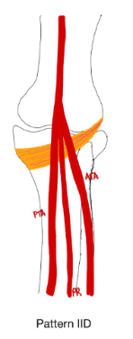

6C. branching pattern of the genicular arteries
In 2023 Callese et al.³¹ described the genicular artery anatomy utilizing intraprocedural cone-beam tomography (CBCT). The descending genicular artery (DGA) was present in 96% CBCT’s with two branches in 77%. The SMGA was present in 91%, SLGA in 99%, IMGA in 95% and MGA in 97%. Four distinct branching patterns were observed: a common origin of the SLGA and MGA (56%), separate origins (22%), a trifurcation of the SLGA, SMGA and MGA (15.5%), and a common origin of the SMGA and MGA (6%). The recurrent ascending tibial artery was observed in 76% of the CBCT’s while the superior patellar artery was identified in 85%. The study of Fonkoue et al.⁷² Investigated the anatomical distribution of the descending genicular artery (DGA). The DGA was identified in all specimens, originating from the FA at a mean distance of 130.5 ± 17.5mm proximal to the knee joint. Seven branching patterns of the DGA were observed according to the Dubois et al.⁷² (figure 12).
Branching pattern |  | Definition | figure | Frequency
TYPE 1 |  | Three branches emerge from common trunk: the DGA |  | 59.3% (16/27)
 | 1A | DGA divides into the three terminal branches |  | 18.5% (5/27)
 | 1B | The muscular branch (MB) occurs first, leaving behind a sapheno-articular trunk | 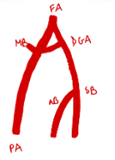 | 26.0% (7/27)
 | 1C | The saphenous branch (SB) occurs first leaving behind a musculo-articular trunk | 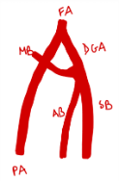 | 14.8% (4/27)
 | ID |  | 
TYPE 2 |  | One of the three branches arises directly from FA |  | 33.3% (9/27)
 | 2A | Articular branch (AB) arises directly from the FA | 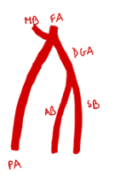 | 0.0% (0/27)
 | 2B | SB originates directly from FA |  | 14.8% (4/27)
 | 2C | MB originates directly from FA |  | 18.5% (5/27)
TYPE 3 |  | Three branches originate separately from FA | 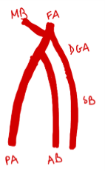 | 3.7% (1/27)
Nonapplicable |  | Three branches emerge from a common trunk, AB occuring first, leaving behand a sapheno-muscular trunk |  | 3.7% (1/27)
Branching pattern of the descending genicular artery (DGA) according to Dubois et al.⁷².

The study of Shahid et al.²⁹ Investigated the branching pattern and diameters of the genicular arteries, namely, the SMGA, SLGA, IMGA, the ILGA and the MGA. The SMGA was identified as the first branch in 45% of the cases and as the second branch in 20% of the cases. The SLGA was the second branch in 30% and the first branch in 25%, and it branched from a common trunk in 45% of the cases. The MGA arose as the second branch in 40% of the specimens. The MGA arose from a common trunk in 40% of the cases. The IMGA was observed as the third branch in 25% of the cases, fourth branch in 35%, and the fifth branch in 15%. In 25% of the specimens, the IMGA originated from a common trunk. The ILGA was identified as the third branch in 15% of the cases, fourth branch in 40%, and the fifth branch in 25%. In men, inferior genicular branches originated more frequently from a common trunk, whereas in women this pattern was more common among the superior genicular arteries²⁹. Regarding the mean diameter of the genicular arteries, men exhibited a larger superior common stem than women (2.1mm vs 1.8mm). Women demonstrated a larger diameter of the inferior common trunk⁵⁰.

6D. Velocity
The study by Duarte-Mendes et al.⁷¹ provides valuable insight into the physiological adaptations of the arterial system to regular physical activity. These results highlight the importance of considering physical activity level as a potential confounding factor when comparing arterial characteristics across different populations⁷¹.

